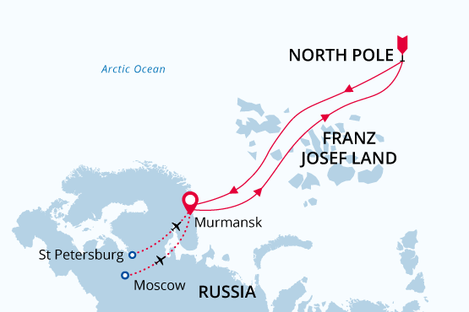

North Pole
Top of the World
18 Jul - 30 Jul 2019
13 days
Embarkation: Murmansk (Russia)
Disembarkation: Murmansk (Russia)
I/b 50 Years of Victory
Activities:

Itinerary
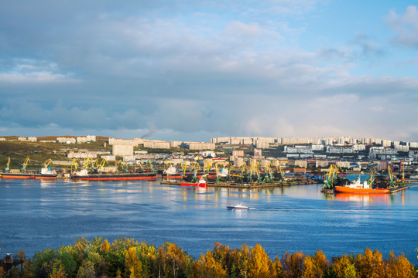Day 1: Murmansk, Russia
Welcome to the city of Murmansk on Russia’s Kola Peninsula, starting point of our adventure. Upon your arrival at the airport we provide a transfer to your hotel, which has been arranged by us and is included in the price of the voyage.
Murmansk is easy to reach by regular flights with stopovers in Moscow or Saint Petersburg. You may wish to extend your stop in Moscow.
Here are our suggestions on pre-post trip options in Moscow.
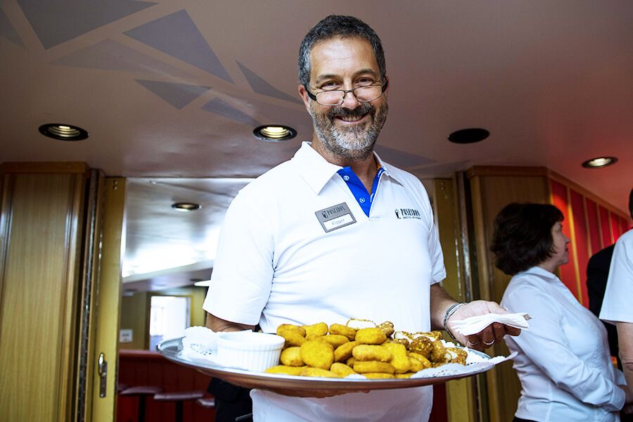Day 2: Embarkation in Murmansk
Today we provide a group transfer to the port where we welcome you aboard the nuclear-powered icebreaker 50 Let Pobedy. Explore the ship and get orientated as we slip our moorings and sail north out of Kola Bay.
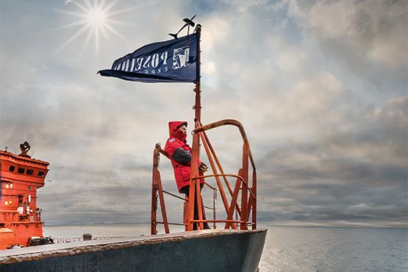Day 3-6: The Voyage North
Nowhere can it be more truly said that “getting there is half the fun”. As we cruise northward through the Barents Sea there is always the possibility of seeing whales. Meanwhile, you have the opportunity to learn about the unique icebreaking capabilities of the ship. You are also treated to a tour of the engine room. As we make our way across the ice cap, you witness firsthand the ship’s awesome power as massive ice blocks give way under the enormous bulk of the spoon-shaped bow. The sensation of being on deck at this time is surreal and unforgettable. We also take advantage of 24-hour daylight to offer helicopter flightseeing tours. From the air you can observe the ship crushing a path through the ice. You also have a unique vantage point from which to witness the stunning beauty of this vast polar icescape.
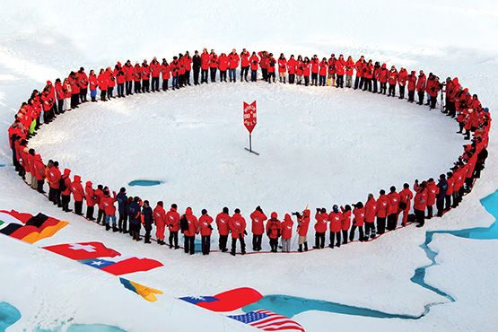Day 7: North Pole
Welcome to the geographic North Pole! After carefully navigating to 90 degrees North, we ceremoniously drop the anchor on a sturdy stretch of ice and disembark onto the frozen sea.Now is the time to experiencing the long-anticipated thrill of standing at the top of the world. Join hands with your fellow passengers and literally walk around the world during our special International Round Dance. You are also treated to a barbeque meal on the ice. You may even have the chance to take a plunge into the icy water!After our memorable time at the North Pole we turn around and head south. But the adventure is not over yet. The High Arctic archipelago of Franz Josef Land is still to come!
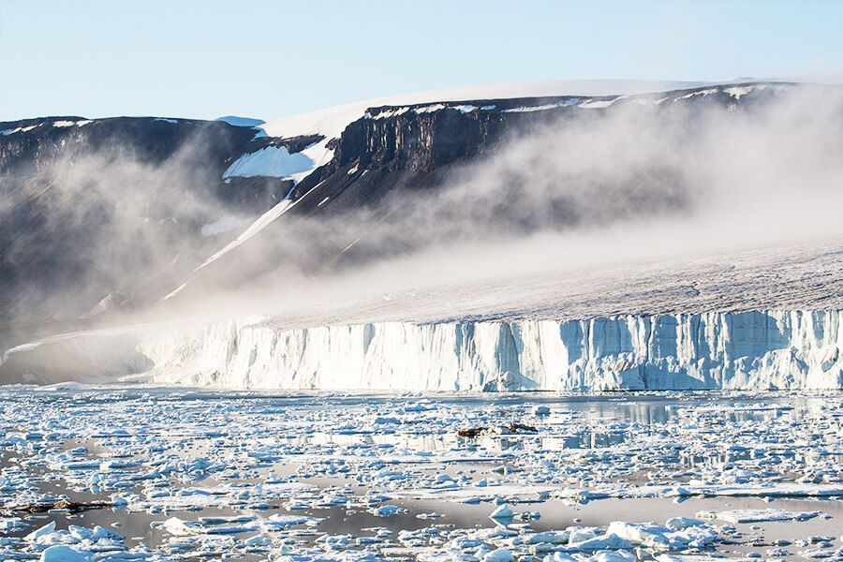Day 8-10: Exploration of Franz Josef Land
The Franz Josef Land archipelago, part of the Russian Arctic National Park since 2012, is a nature sanctuary. Polar bears and other quintessential High Arctic wildlife—such as walruses and some rare whale species—can be spotted anytime, anywhere in and around Franz Josef Land. Scree slopes and cliffs around the islands host enormous nesting colonies of migratory seabirds such as guillemots, dovekies, and ivory gulls. We take advantage of 24-hour daylight to exploit every opportunity for wildlife viewing and excursions via Zodiac and helicopter. Franz Josef Land is home to some interesting geological features, such as the mysterious stone spheres on Champ Island. Collectors of geographical extremes may take note that Cape Fligely on Rudolf Island is the northernmost point of land in the Eastern Hemisphere. Franz Josef Land also offers visitors the opportunity to walk in the footsteps of famous polar explorers at well-preserved historical sites. The journals of explorers such as Julius von Payer, Benjamin Leigh Smith, Frederick George Jackson, and Fridtjof Nansen come alive at Cape Norway, Cape Flora, Eira Harbour, and Cape Tegetthoff. Memorials, monuments, crosses, and the remains of dwellings are testimony to incredible historical events that are further illuminated by our expert lecturers. Tikhaya Bukhta is currently a Russian Arctic National Park ranger station occupying Soviet-era research buildings and was also a major base for polar expeditions. Nearby, the fascinating columnar basalt cliffs of Rubini Rock are home to thousands of nesting seabirds.
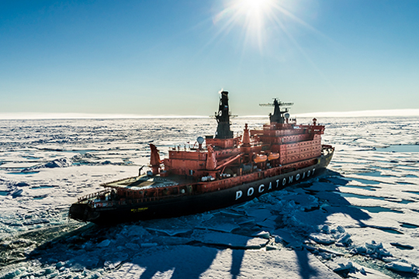Day 11-12: The Voyage South
After our amazing time in Franz Josef Land we cross back south through the bountiful waters of the Barents Sea. Presentations and workshops by our expert staff ensure that these days at sea are not idly spent. You may also take advantage of onboard facilities and amenities such as a polar library, volleyball court, gym, two saunas, warm seawater pool, gift shop, and massage treatments. Seabird viewing and whale sightings can be enjoyed from panoramic open decks as well as exterior stateroom windows.
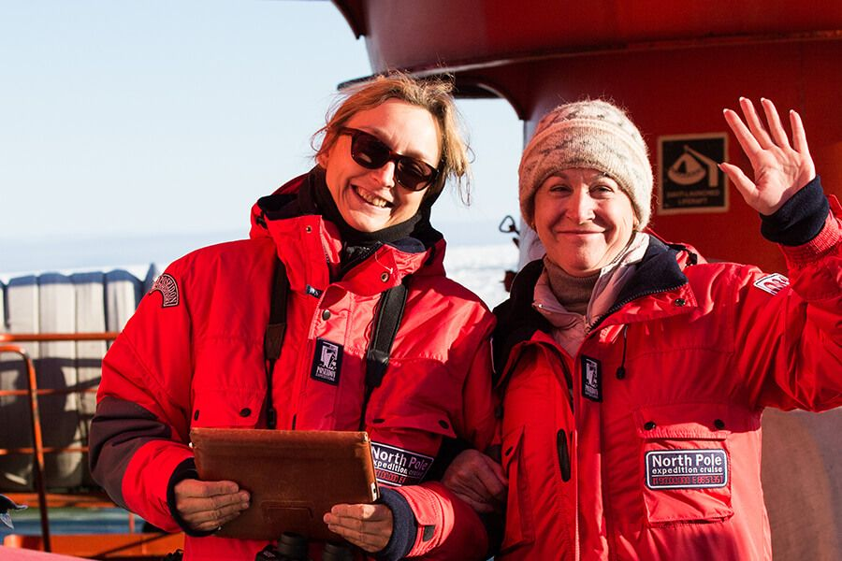Day 13: Disembarkation in Murmansk
Our once-in-a-lifetime journey comes to an end. After breakfast we say farewell in Murmansk. We provide you with a transfer to the airport for your flight home.

I/b 50 Years of Victory
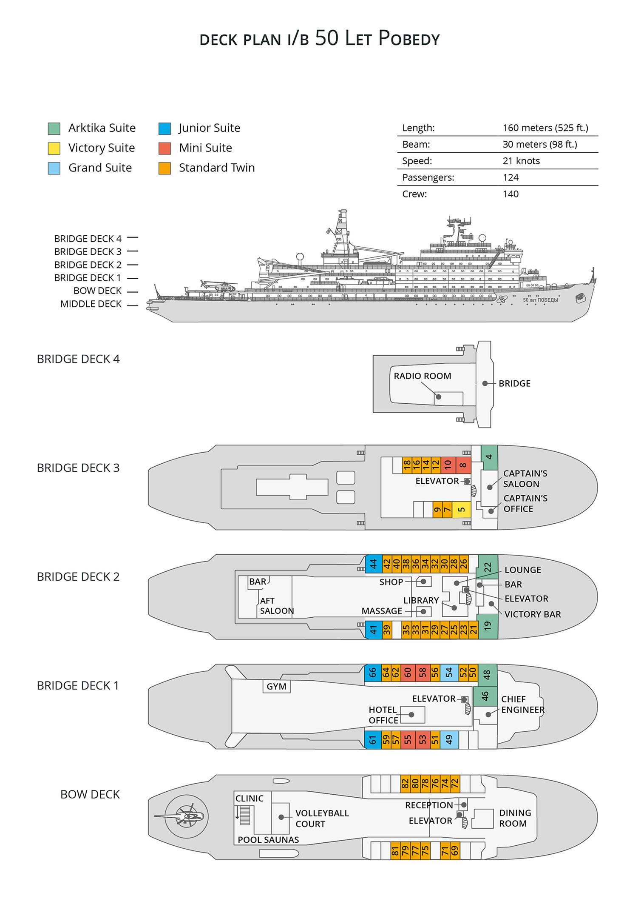

Standard Twin  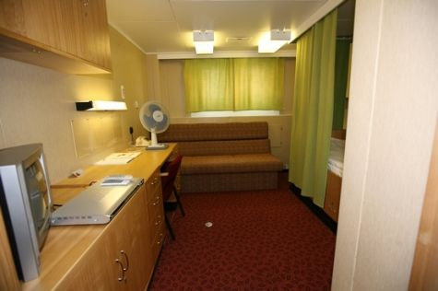  One lower berth, one sofa bed, private facilities with a shower, TV set and DVD player, opening windows. | Mini Suite  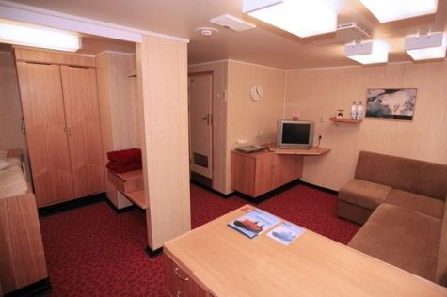  Sitting area with sofa bed, sleeping bed separated from the sitting area, private facilities with a shower, TV set and DVD player, refrigerator, opening windows.
Junior Suite  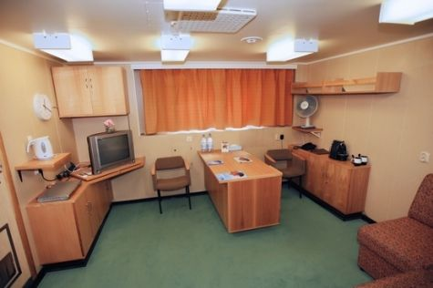  Sitting area with sofa bed, sleeping bed separated from the sitting area, private facilities with a shower, TV set and DVD player, refrigerator, opening windows. | Grand Suite  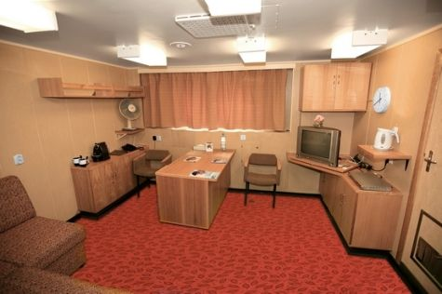  Sitting area with sofa bed, sleeping bed separated from the sitting area, private facilities with a bath, TV set and DVD player, refrigerator, opening windows.
Victory Suite  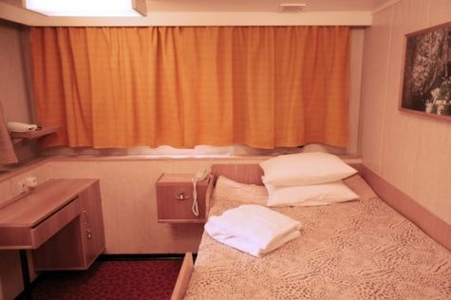  Large bedroom and sitting room, sofa bed in sitting room, private facilities with a bathtub, refrigerator, TV set and DVD player, opening windows. | Arktika Suite  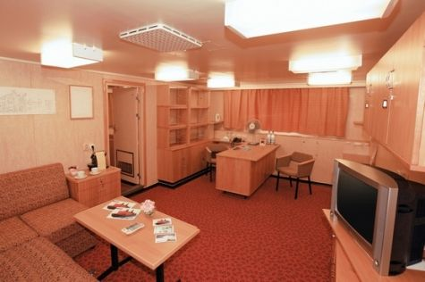  Very spacious bedroom and sitting room, sofa bed in sitting room, private facilities with a bathtub, refrigerator, TV set and DVD player, coffee maker, opening windows.

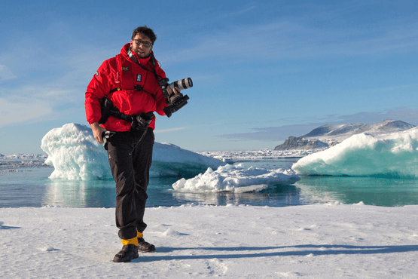 | Photography  Free option  The Polar Regions are perhaps the most photogenic on earth, with countless beautiful scenes presenting themselves every day. Endless expanses of ice, beaches crowded with seals or penguins, sunsets over unbroken horizons, starlit skies, and even the majestic northern lights – they all present fantastic photographic opportunities – and in order to make sure that you come home with some spectacular images we offer you the chance to learn and practice your photography alongside an experienced professional.  Our expert Photographer will be on hand to answer your questions and give advice, both in the form of on-board lectures and workshops on shore. Explore the key elements of photography in a fun and relaxed setting, with plenty of opportunities for questions and feedback. Learn how to see light in a new way and experiment with the techniques of composition and framing.

Rates Include  1 night pre-cruise hotel accommodation in Murmansk, Russia, with breakfast;  Transfer from airport to the hotel in Murmansk 1 day prior to departure;  Transfer from hotel to the port in Murmansk on embarkation day;  Transfer from the port to the airport or central location in Murmansk upon disembarkation;  Shipboard accommodation with housekeeping;  Shipboard breakfasts, lunches and dinners;  Coffee, tea and cocoa available around the clock;  All shore excursions and activities throughout the voyage by helicopter;  All shore excursions and activities throughout the voyage by zodiacs;  Shore landings included in daily program;  Program of lectures and informal discussions by experienced Expedition Team and guest lecturers;  Professional Expedition Leadership;  Branded Poseidon Expeditions parka;  Rubber boots for shore landings for the time of the cruise;  Hair dryer and bathrobes in each cabin;  Informative pre-departure materials;  Digital Voyage Log;  All miscellaneous service taxes and port charges throughout the program;  All shipboard luggage handling;  Personalized medical insurance covering the risks of evacuation and repatriation. Coverage: 100,000 EUR. Duration: cruise days only. This is only for passengers under 85 years old. | Rates Do Not Include  Airfare to and from your hometown to Murmansk;  Helicopter flying time in excess of that offered for the group;  Passport and visa expenses (if required); a Russian visa is required for the trip. The visa must be obtained by the customer and is at his or her expense. Please, contact your local Russian Consulate to learn more about the procedure for obtaining a Visa.  State arrival and departure taxes (if levied);  Meals ashore and supplements in respect of single hotel accommodation (if required);  Excess luggage charges on international and local flights;  Telecommunication services; laundry, bar and beverage charges aboard the vessel;  Luggage, cancellation insurance (strongly recommended);  Tips for stewards and other service personnel aboard (at your discretion).
Itinerary, landings and all other activities during the cruise depend strongly on ice and weather conditions and are subject to the decisions of the Expedition Leader and the Captain of the vessel. Encounters with any mentioned wildlife cannot be guaranteed.

