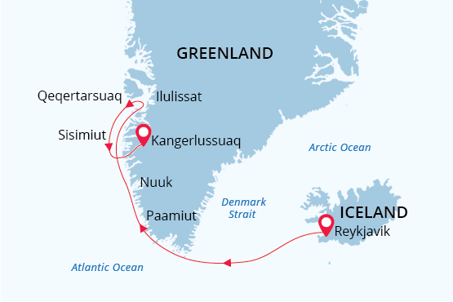

South & West Greenland and Disko Bay
Welcome to the Land of Vikings
25 May - 07 Jun 2023
14 days
Embarkation: Reykjavik (Iceland)
Disembarkation: Kangerlussuaq (Greenland)
M/v Sea Spirit
Activities:

Itinerary
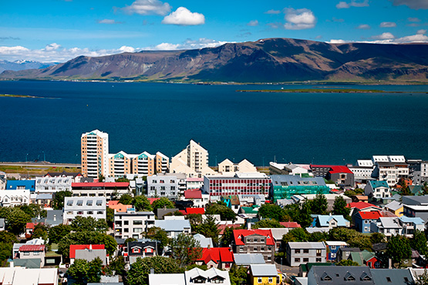Day 1: Welcome to Reykjavik; Embarkation
Welcome to Reykjavík, the capital of Iceland and starting point of our expedition cruise! Even though this country lies below the Arctic Circle, Reykjavik is the world's northernmost capital of a sovereign state. Visitors needn’t travel far to find geysers and waterfalls, mountains, and glaciers. Today we will welcome you aboard our expedition ship the Sea Spirit. With excitement and anticipation building, we'll spend our first night aboard dreaming of the wonders that await us as we set sail towards Greenland the next day.
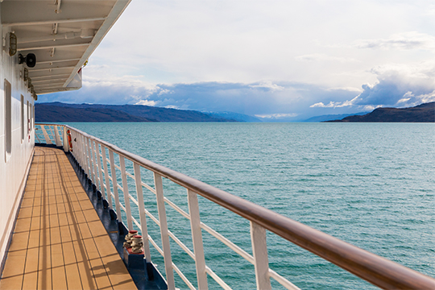Day 2: Reykjavik; Departure
Today is an exciting day as we set off towards Greenland, the world's largest island. We are all eagerly anticipating the breathtaking views and unique experiences that await us. After getting underway, a full schedule of events kicks off with informative briefings and introductions from your expedition staff. Keep an eye out for our first whales (humpback and Minke whales are most common) as we sail out of the picturesque bay.
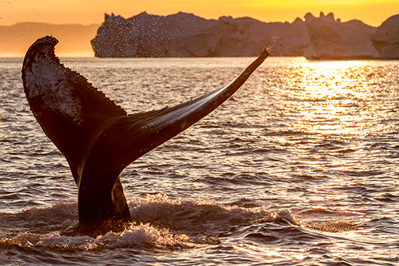Day 3-4: At sea
Enjoy a few restful days at sea, as we get ready for icebergs, Inuit villages, whales and much more! Along with our expedition team, watch for whales and seabirds from the deck, or participate in their presentations in the Oceanus Lounge on the flora, fauna, geology and cultural heritage to be found along West Greenland’s western coast.
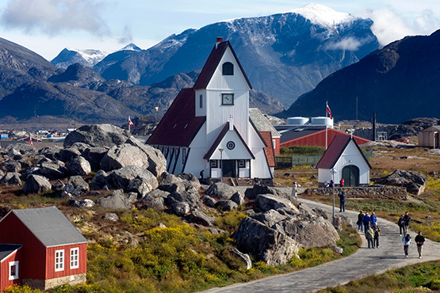Days 5-9: Exploring South and West Greenland
The Sea Spirit rounds Cape Farewell, the southernmost point in Greenland, and calls in at Greenland’s most southerly town Nanortalik. The town lies at the mouth of beautiful Tasermiut Fjord surrounded by steep mountains that flank an intricate fjord system. The local open-air museum demonstrates the fascinating history from Viking and Inuit times to the present days.
The Uunartoq area is famous for its natural hot springs, where we can soak in the geothermal waters watching the icebergs pass by.
During the next few days, we head further north to visit some enchanting Greenlandic settlements and explore the beautiful fjords of Greenland’s western side.
Hvalsey, or "Whale Island", is the site of Greenland’s largest and best-preserved Norse ruins. It was originally settled by an ancestor of Erik the Red in the late 10th century. There’s time to wander and learn about the ancient farmstead that includes a granite stone Christian church, likely built in the early 14th century, and several adjacent buildings. The fells and fjord around the farmstead have not changed at all over the centuries, and the site is believed to have been a meeting place for festivals and banquets throughout the year.
Set amidst breathtaking scenery, our visit to Qaqortoq gives us some additional cultural and Viking background on the region. Placed on a beautiful hillside, the small settlement boasts colorful houses and a museum.
We continue north in the wake of the Vikings as our Sea Spirit navigates through the picturesque Eriksfjord to the settlement of Qassiarsuk. The town was founded back in the 10th century by Eric the Red following his exile from Iceland for murder. We will see the foundation remains of his manor house and other buildings. Nowadays, the area is known as a sheep farming settlement.
As we approach, Paamiut, there are good opportunities to see humpback and fin whales along the coastline. It is also an especially good place to spot white-tailed eagles. Inhabited by incredibly welcoming locals, Paamiut justifiably proud of their church that was built in 1909. The architecture reflects the Danish colonization of Greenland.
Nuuk, the capital of Greenland, is lively and surrounded by natural beauty. Here, old traditions meet modern change. Fashion shops and a cultural center represent the modern Greenland; the picturesque old port area, however, testifies to the island’s long history. The town was founded by the danish missionary Hans Egede in the early 18th century, and you’ll learn much more about the area on an included tour. In the National Museum, you’ll be fascinated by the mummies of Qilakotsoq – evidence of a bygone era.
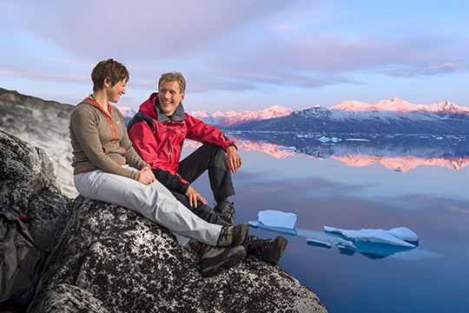Days 10-13: Exploring Disko Bay
Fjords and scenic Inuit villages shape the landscape of this icy region of western Greenland. The Sea Spirit holds her course north, and landings and activities are adapted to the current ice and weather conditions. Accordingly, we will plan to visit some of the following:
Sisimiut, the second-largest city in Greenland with about 5,400 inhabitants, is located 40 km north of the Arctic Circle. While there are modern elements, you’ll also find an outdoors hunting and fishing culture. A small museum depicts the history of trade, shipping and industry in the region.
Ilulissat, the “city of icebergs”, is the a focal point of West Greenland tourism. The fjord is a UNESCO World Heritage Site and pushes unimagable amounts of icebergs into the bay. A hike to the historic Sermermiut settlement offers some spectacular views. The famous Danish polar explorer Knut Rasmussen is a son of the city and an interesting museum here is dedicated to his life.
Itilleq is a typical Greelandic fishing village on a small island just above the Arctic Circle, with a local population of about 120. The residents make a living from fishing and hunting and there are probably more dog sleds than residents.
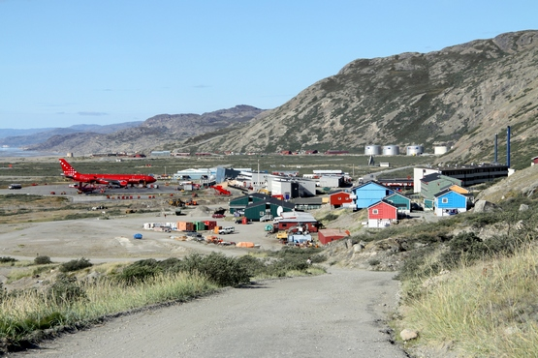Day 14: Disembarkation in Kangerlussuaq (Greenland); Homeward flights.
Our adventure finishes at the port of Kangerlussuaq. We disembark after breakfast and transfer to the airport for our outbound flight and further connection flights home.

M/v Sea Spirit
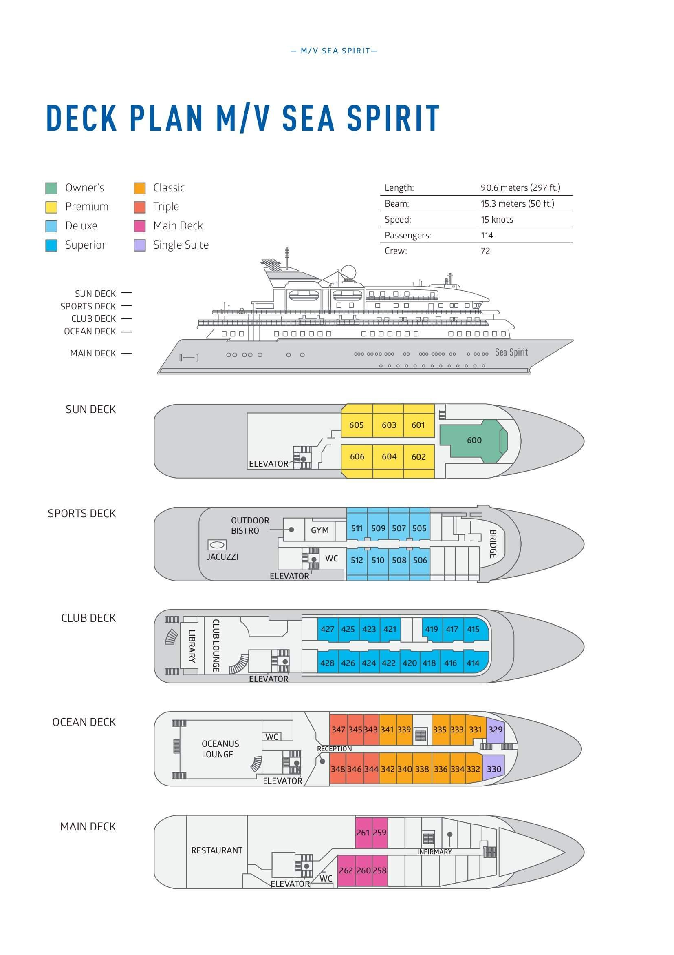

Triple Suite  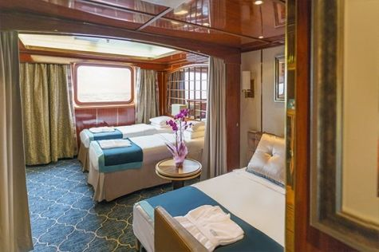  Averaging 21 square metres/226 square feet, these staterooms have two twins and a comfortable sofa bed. The twins also convert to a King, if desired. Located on Oceanus Deck, these suites have a picture window, two wardrobes and en suite facilities. Amenities include: in-room safe, refrigerator, satellite telephone access, TV/DVD, individual temperature control, and hair dryer. | Main Deck Suite  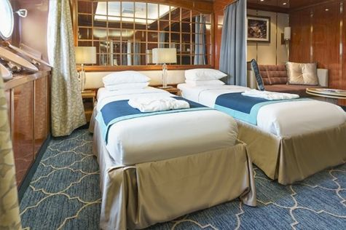  Averaging 23 square metres/248 square feet, Main Deck cabins are equipped with either two twins or a King Size bed. They are located on the Main Deck with a minimum of two portholes for exterior views. Amenities include: en suite facilities, in-room safe, refrigerator, satellite telephone access, TV/DVD individual temperature control and hair dryer.
Single Suite  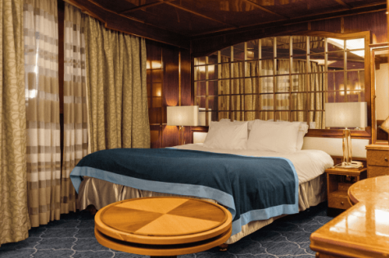  Averaging 21 square meters/226 square feet, these cabins are located on the Oceanus Deck. They feature a picture window (it may be covered during rough sea crossings), two wardrobes, and a King Size bed. Amenities include: en suite facilities, in-room safe, refrigerator, satellite telephone access, TV/VCR, individual temperature control, and hair dryer. | Classic Suite  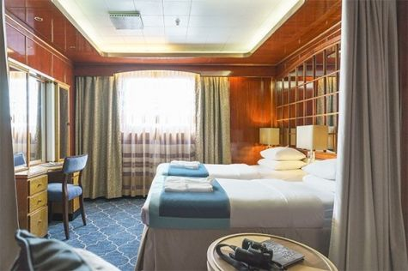  Averaging 21 square metres/226 square feet, these cabins are located on the Oceanus Deck. They feature a picture window, two wardrobes and a choice of either two twin beds or a King Size bed. Amenities include: en suite facilities, in-room safe, refrigerator, satellite telephone access, TV/DVD, individual temperature control and hair dryer.
Superior Suite  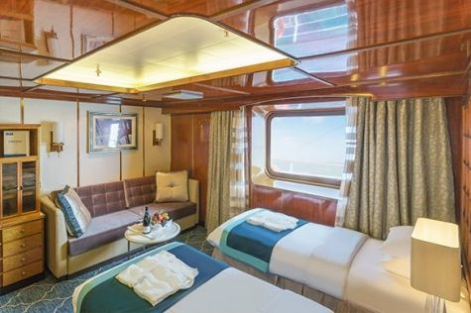  Superior Suites are located on the Club Deck. Averaging 20 square metres/ 215 square feet, these cabins feature two twin beds or a King Size bed. The picture window overlooks an outside walkway on the Club Deck. Amenities include: en suite facilities, walk-in closet or wardrobe, in-room safe, refrigerator, satellite telephone access, TV/DVD, individual temperature control, hair dryer. | Deluxe Suite  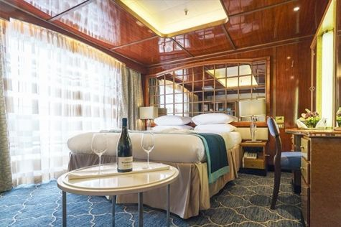  The Deluxe Suites with balconies are located on the Sports Deck. Averaging 24 square metres/ 258 square feet means plenty of room. Choose from either two twin beds or a King Size bed. A sliding glass door leads to a private balcony. These suites feature a walk-in closet or wardrobe. Amenities include en suite facilities, in-room safe, refrigerator, satellite telephone access, TV/DVD, individual temperature control, and a hair dryer.
Premium Suite  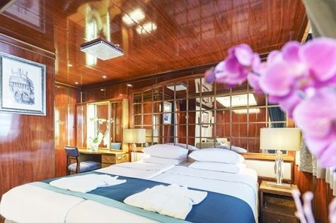  The Premium Suites are located on the Sun Deck. Averaging a generous 30 square metres/ 323 square feet, with two twin beds or a King Size bed. Access the private balcony by a sliding glass door. Amenities include: en suite facilities, lounge area, in-room safe, refrigerator, satellite telephone access, TV/DVD, individual temperature control, and hair dryer. | Owners Suite  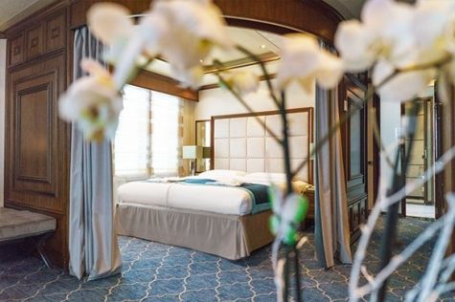  Super-spacious (63 square metres/ 678 square feet) elegant suite on the Sun Deck. Designed for entertaining, the Owner's Suite has a separate living room with game and meeting area. A BOSE stereo system provides background music, or watch videos on the HD plasma TV. Sliding glass doors lead to a private deck. Refresh in the jetted bathtub in en suite facilities. Slumber in the King Size bed. A sofa bed can accommodate a third person.

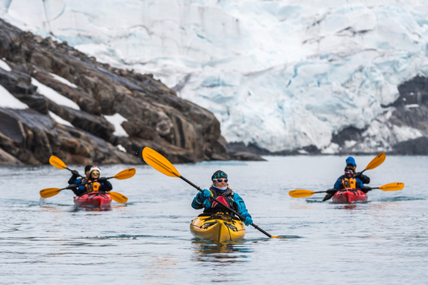 | Sea Kayaking  Kayaking fee $655 - A$885 - £505 - €625  Sea Kayak Club is typically offered on voyages that include High Arctic destinations such as Greenland, Svalbard (Spitsbergen), Franz Josef Land, or a combination of these thrilling places. Experience calving glaciers in Svalbard, cathedral-like icebergs in Greenland, or labyrinthine expanses of sea ice in the Arctic Ocean, all from our sturdy and stealthy sea kayaks. Join us for an unscripted kayaking adventure as we explore rugged coastlines and remote waters that very few people have ever paddled.
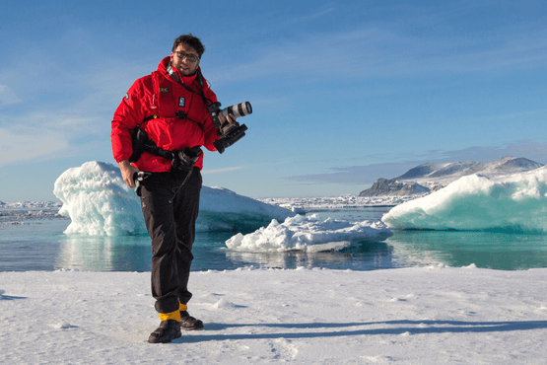 | Photography  Free option  The Polar Regions are perhaps the most photogenic on earth, with countless beautiful scenes presenting themselves every day. Endless expanses of ice, beaches crowded with seals or penguins, sunsets over unbroken horizons, starlit skies, and even the majestic northern lights – they all present fantastic photographic opportunities – and in order to make sure that you come home with some spectacular images we offer you the chance to learn and practice your photography alongside an experienced professional.  Our expert Photographer will be on hand to answer your questions and give advice, both in the form of on-board lectures and workshops on shore. Explore the key elements of photography in a fun and relaxed setting, with plenty of opportunities for questions and feedback. Learn how to see light in a new way and experiment with the techniques of composition and framing.

Rates Include  Pre-voyage night on Day 1 in Reykjavik;  Shipboard accommodation;  All meals on board throughout the voyage;  Tea and coffee station 24 hours daily;  All scheduled landings/excursions (subject to weather and ice conditions);  Leadership throughout the voyage by our experienced Expedition Leader and Expedition Team;  Branded Poseidon Expeditions parka;  Rubber boots for shore landings for the time of the cruise;  Welcome and Farewell cocktails;  All port fees;  Group transfer to airport or central location upon disembarkation;  Pre-departure materials;  Digital Voyage Log;  Wi-Fi on board. | Rates Do Not Include  Mandatory charter flight Kangerlussuaq - Reykjavik on the day of disembarkation (details below)  International airfare;  Transfers from the airport on Day 1;  Visa and passport fees (if applicable);  Luggage and trip cancellation insurance;  Soft drinks and alcoholic beverages other than those for special events and celebrations;  Personal expenses such as laundry and telecommunication charges;  Mandatory Emergency Evacuation Insurance to a minimum benefit of US$ 200,000 per person;  Kayaking;  The cost of any applicable medical tests (such as COVID-19) or vaccinations required either by a national government or Poseidon Expeditions before, during or after the cruise;  Staff gratuities.
Itinerary, landings and all other activities during the cruise depend strongly on ice and weather conditions and are subject to the decisions of the Expedition Leader and the Captain of the vessel. Encounters with any mentioned wildlife cannot be guaranteed.

