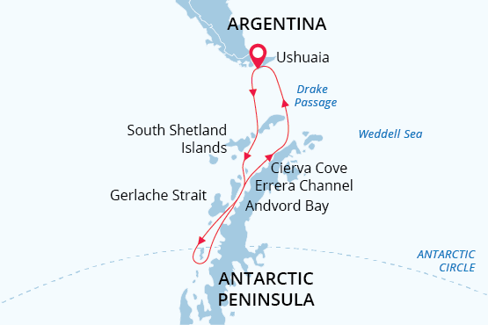

Antarctic Circle
Crossing 66º South Latitude
24 Jan - 07 Feb 2025
15 days
Embarkation: Ushuaia (Argentina)
Disembarkation: Ushuaia (Argentina)
M/v Sea Spirit
Activities:

Itinerary
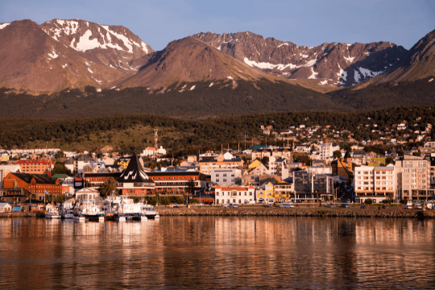Day 1 (Jan 24): Arrival in Ushuaia, Argentina (hotel night)
Welcome to Ushuaia, the world’s southernmost city and starting point of our Antarctic expedition! Upon your arrival at the airport, you will be greeted by our staff and transferred to a quality hotel, which has been arranged by us and is included in the price of the itinerary. For the rest of the day, you are free to explore this vibrant port city and adventure hub.
For an introduction to local history and wildlife, the interesting Museo del Fin del Mundo is worth a visit. If you have time to spare, a variety of nature activities can be arranged to suit all interests and fitness levels, from hiking in nearby Tierra del Fuego National Park to wildlife viewing in the Beagle Channel. For dinner, Ushuaia offers a wide range of restaurants featuring Patagonian lamb and delectable Fuegian seafood.
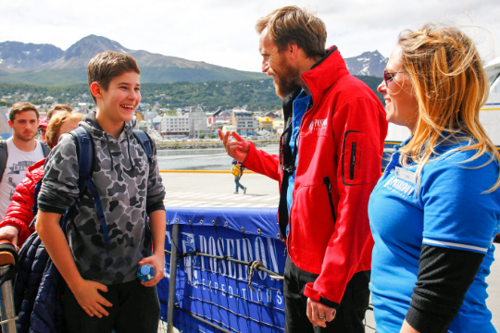Day 2 (Jan 25): Welcome Aboard!
After breakfast at your hotel, the morning is yours to enjoy Ushuaia. Explore the delightful waterfront and savor views of the snowcapped Martial Range, the southernmost peaks of the Andes. Take advantage of shopping for souvenirs or some last-minute necessities such as cold-weather gear. Just remember, you will soon receive your very own parka to keep and waterproof boots to borrow on board the ship. For lunch, the many cafés, parrillas and gelato shops on Avenida San Martín will be sure to satisfy any appetite.
In the afternoon, you will be transferred to the pier where we will warmly welcome you aboard the deluxe expedition vessel M/V Sea Spirit. Get settled in your spacious suite and explore the ship that will be your comfortable home during the extraordinary adventure to come. After getting underway, a full schedule of events kicks off with informative briefings and introductions from your expedition staff. After the first of many delicious dinners on board, step out onto the open decks to admire the scenery and gorgeous evening light as we pass through the Beagle Channel.
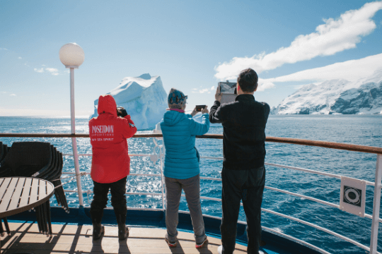Day 3-4 (Jan 26-27): Across the Drake Passage
After passing the islands of Tierra del Fuego, we turn south to begin our crossing of the Drake Passage. We watch for humpback and fin whales along the way. The majestic wandering albatross and other graceful subantarctic seabirds are common in these waters and can readily be viewed from panoramic open decks and balconies. We also cross the Antarctic Convergence, the biological boundary of the Southern Ocean. The ship’s stabilizing fins provide comfort in the event of rough seas. Briefings, bio-security procedures and presentations by our lecture staff prepare you for our arrival in Antarctica. We hope to arrive in the South Shetland Islands on the evening of our second day at sea.
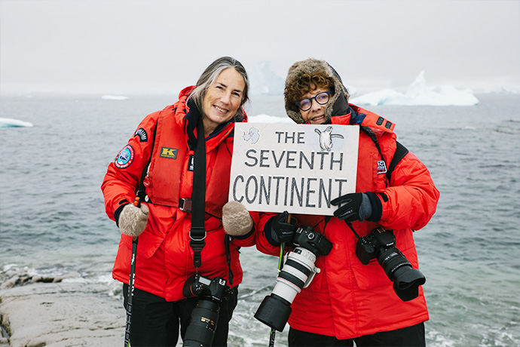Day 5-12 (Jan 28-Feb 4): South Shetland Islands and Antarctic Peninsula
Within the next days, we undertake an in-depth exploration of the South Shetland Islands and the Antarctic Peninsula. This region contains some of the world’s most impressive scenery and the best wildlife viewing in Antarctica. Sheltered bays and channels sparkle with ice and reflect towering mountain peaks coated in permanent snow and immense glaciers. Icebergs of every size and description complete an image of incomparable beauty. Waters rich with krill are home to huge numbers of marine mammals and seabirds. The whole area is alive with penguins foraging at sea and forming large rookeries at special places on land. Here we also find Antarctic research bases of various nationalities.
The South Shetland Islands are the northernmost islands in Antarctica and will likely be our first area of exploration. This wildly beautiful island chain contains many landing sites with historical significance and abundant wildlife. We will also explore the supremely picturesque Gerlache Strait area of the Antarctic Peninsula, a pristine wilderness of spectacular white landscapes, colossal icebergs, obliging marine mammals and bustling penguin colonies. We plan to pass through the famous Lemaire Channel, also known as “Kodak Gap” because of the photogenic way the narrow channel reflects the image of sheer snowy mountains.
On this special voyage, we have additional days devoted to pushing even farther south in our attempt to cross the Antarctic Circle. The sublime icescapes in Crystal Sound and beyond are particularly austere, the weather is especially wild, and the waters are full of constantly shifting ice. Very few people have ventured this far south. This is a true expedition.
Throughout the islands and on the mainland, we find large colonies of gentoo, chinstrap and Adélie penguins, sometimes side by side. It is a dramatic time at the colonies. While some parents remain at the nest to guard against skua attack, others go fishing in seas patrolled by predatory leopard seals and killer whales. Meanwhile, fluffy chicks are starting to explore away from their nests. Also at this time, humpback and minke whales have arrived in great numbers and the feeding frenzy in is full swing. Crabeater and Weddell seals abound in these highly productive waters.
In this rugged yet accessible environment, superb wildlife viewing is best complemented by active adventure. For sea kayakers, the wildlife-rich waters of Antarctica offer many chances to paddle with seals and penguins in some of the world’s most scenic waterways. To make the most of your time on the White Continent, you can also spend a night camping ashore, surrounded by untamed Antarctic nature.
This is expedition cruising at its most authentic. Our precise route and exploration opportunities will be shaped by weather and ice. Our experienced captain and expedition leader will continually adjust plans to take maximum advantage of the conditions in this challenging polar environment.
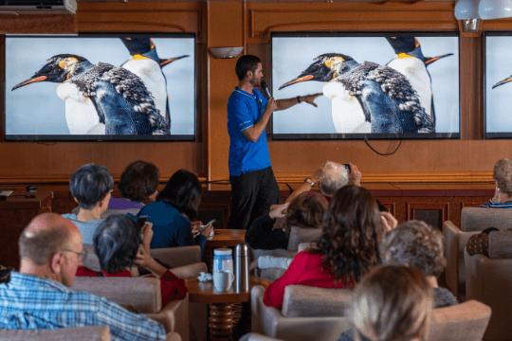Day 13-14 (Feb 5-6): Back across the Drake Passage
It is now time to head back across the Drake Passage toward South America, but the adventure is not quite over. Seabirds are our constant companions and there is always the possibility of whale encounters in these wild waters. This is also the time for festivities such as the Captain’s Farewell Cocktail and the end-of-voyage slideshow. Finally, as we enter the calm Beagle Channel, we enjoy a night of smooth sailing toward Ushuaia.
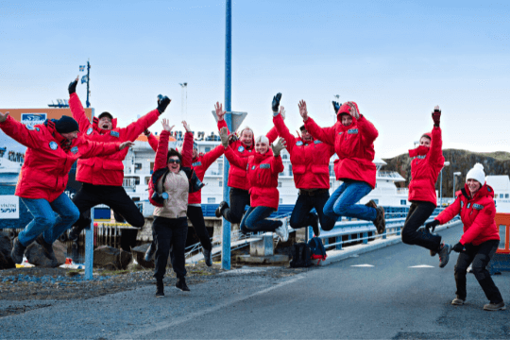Day 15 (Feb 7): Disembarkation in Ushuaia, Argentina
After yet another delicious breakfast on board, we bid you a fond farewell in Ushuaia. We provide a group transfer to the airport or to the city center if you wish to spend more time here. As you look back on your wonderful experience in Antarctica, you may already be looking forward to your next polar adventure!

M/v Sea Spirit
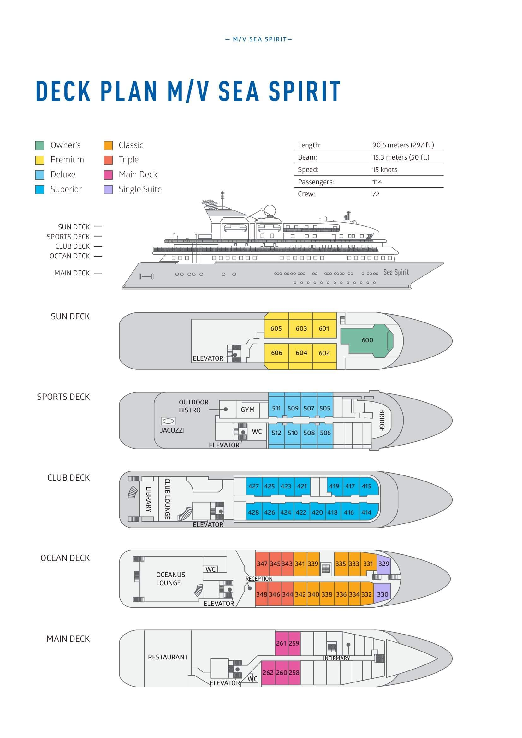

Triple Suite  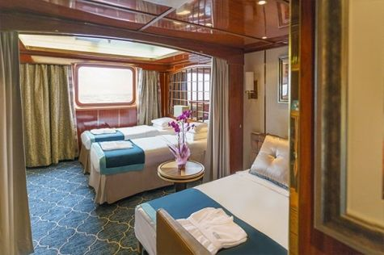  Averaging 21 square metres/226 square feet, these staterooms have two twins and a comfortable sofa bed. The twins also convert to a King, if desired. Located on Oceanus Deck, these suites have a picture window, two wardrobes and en suite facilities. Amenities include: in-room safe, refrigerator, satellite telephone access, TV/DVD, individual temperature control, and hair dryer. | Main Deck Suite  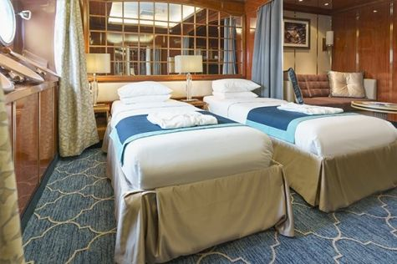  Averaging 23 square metres/248 square feet, Main Deck cabins are equipped with either two twins or a King Size bed. They are located on the Main Deck with a minimum of two portholes for exterior views. Amenities include: en suite facilities, in-room safe, refrigerator, satellite telephone access, TV/DVD individual temperature control and hair dryer.
Single Suite  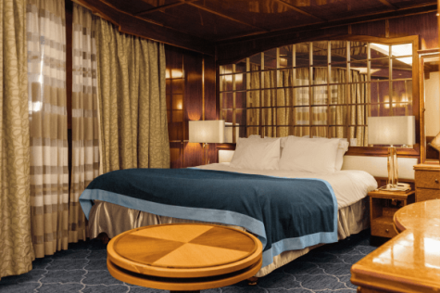  Averaging 21 square meters/226 square feet, these cabins are located on the Oceanus Deck. They feature a picture window (it may be covered during rough sea crossings), two wardrobes, and a King Size bed. Amenities include: en suite facilities, in-room safe, refrigerator, satellite telephone access, TV/VCR, individual temperature control, and hair dryer. | Classic Suite  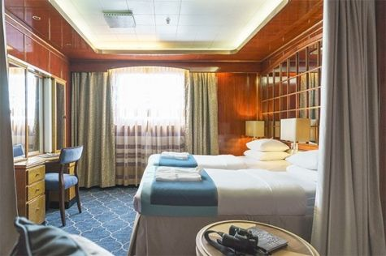  Averaging 21 square metres/226 square feet, these cabins are located on the Oceanus Deck. They feature a picture window, two wardrobes and a choice of either two twin beds or a King Size bed. Amenities include: en suite facilities, in-room safe, refrigerator, satellite telephone access, TV/DVD, individual temperature control and hair dryer.
Superior Suite  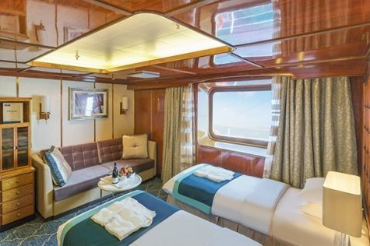  Superior Suites are located on the Club Deck. Averaging 20 square metres/ 215 square feet, these cabins feature two twin beds or a King Size bed. The picture window overlooks an outside walkway on the Club Deck. Amenities include: en suite facilities, walk-in closet or wardrobe, in-room safe, refrigerator, satellite telephone access, TV/DVD, individual temperature control, hair dryer. | Deluxe Suite  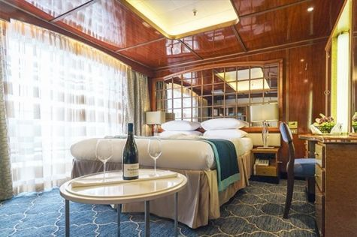  The Deluxe Suites with balconies are located on the Sports Deck. Averaging 24 square metres/ 258 square feet means plenty of room. Choose from either two twin beds or a King Size bed. A sliding glass door leads to a private balcony. These suites feature a walk-in closet or wardrobe. Amenities include en suite facilities, in-room safe, refrigerator, satellite telephone access, TV/DVD, individual temperature control, and a hair dryer.
Premium Suite  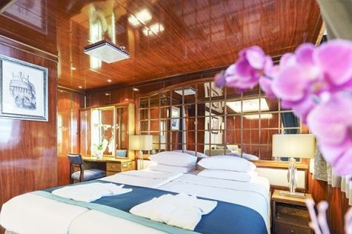  The Premium Suites are located on the Sun Deck. Averaging a generous 30 square metres/ 323 square feet, with two twin beds or a King Size bed. Access the private balcony by a sliding glass door. Amenities include: en suite facilities, lounge area, in-room safe, refrigerator, satellite telephone access, TV/DVD, individual temperature control, and hair dryer. | Owners Suite  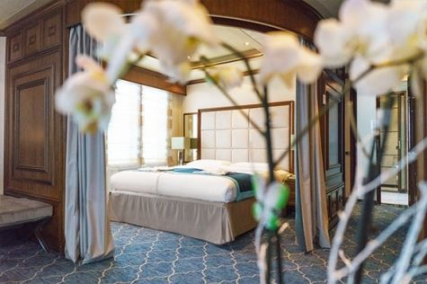  Super-spacious (63 square metres/ 678 square feet) elegant suite on the Sun Deck. Designed for entertaining, the Owner's Suite has a separate living room with game and meeting area. A BOSE stereo system provides background music, or watch videos on the HD plasma TV. Sliding glass doors lead to a private deck. Refresh in the jetted bathtub in en suite facilities. Slumber in the King Size bed. A sofa bed can accommodate a third person.

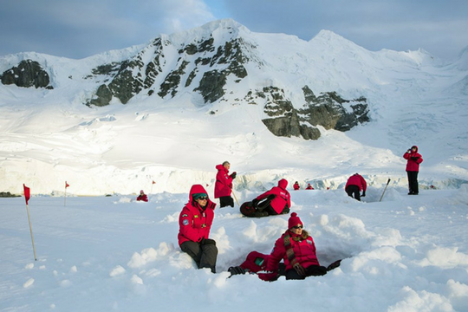 | Camping  Camping fee $285 - A$385 - £220 - €275  If you’re looking for an unforgettable way to expand your experience on the White Continent, then Antarctica Camping may be the perfect choice for you. This optional activity is your unique opportunity to meet Antarctica on its own terms by spending a night out on the snow and ice!  Camping is a great way to immerse yourself in Antarctica. As the sun slowly sets you can unwind and let your senses fully absorb the awesome sights and mysterious sounds of this legendary wilderness. Spend an hour — or all night-simply watching the drama of endlessly changing light upon the landscape. Build a snowman or capture that perfect photo. Whatever joy Antarctica holds for you, you can take the time to experience it fully on your Antarctica Camping night. Gain lasting memories, undeniable bragging rights, and a new appreciation for your warm bed back on the ship.  Please contact our office for availability.
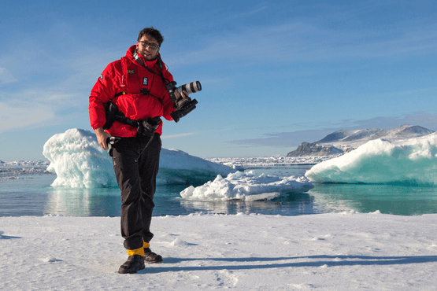 | Photography  Free option  The Polar Regions are perhaps the most photogenic on earth, with countless beautiful scenes presenting themselves every day. Endless expanses of ice, beaches crowded with seals or penguins, sunsets over unbroken horizons, starlit skies, and even the majestic northern lights – they all present fantastic photographic opportunities – and in order to make sure that you come home with some spectacular images we offer you the chance to learn and practice your photography alongside an experienced professional.  Our expert Photographer will be on hand to answer your questions and give advice, both in the form of on-board lectures and workshops on shore. Explore the key elements of photography in a fun and relaxed setting, with plenty of opportunities for questions and feedback. Learn how to see light in a new way and experiment with the techniques of composition and framing.
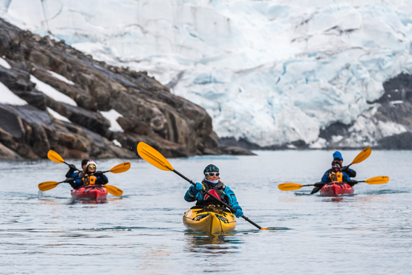 | Sea Kayaking  Kayaking fee $795 - A$1075 - £610 - €760  Antarctica is a paddlers’ paradise. The White Continent boasts some of the world’s most impressive landscapes and is home to incredible marine wildlife. Sea Kayak Club members will have the opportunity to paddle through tranquil waters filled with glittering icebergs and porpoising penguins while surrounded by magnificent glaciers and mountains.  The protected and picturesque waters of the Antarctic Peninsula offer the best sea kayaking opportunities in Antarctica. Sea Kayak Club is also offered on selected voyages to South Georgia, where members may have the rare opportunity to encounter the island’s legendary abundance of wildlife from a kayaker’s perspective, if the area’s notoriously inclement weather permits.

Rates
Triple Suite | Main Deck Suite | Single Suite | Classic Suite | Superior Suite | Deluxe Suite | Premium Suite | Owners Suite
US$ 12 795 | US$ 16 995 | US$ 25 595 | US$ 18 295 | US$ 18 595 | US$ 20 695 | US$ 22 295 | US$ 28 195

Cruise rates are quoted per person. Sharing is available in Triple, Main Deck, Classic, and Superior Suites. If you prefer a cabin for yourself, the following categories are available with the single supplement: x1.7 for Main Deck, Classic, and Superior Suites; x2 for Deluxe, Premium, and Owner's Suite.

Rates Include  1 pre-voyage night on Day 1 in Arakur Ushuaia Resort and Spa Hotel;  Group transfer from the airport to the hotel on the day prior to embarkation;  Group transfer to the ship for embarkation on Day 2;  Shipboard accommodation;  IAATO fees and governmental taxes.  All meals on board throughout the voyage;  Tea and coffee station 24 hours daily;  All scheduled landings/excursions (subject to weather and ice conditions);  Leadership throughout the voyage by our experienced Expedition Leader and Expedition Team;  Branded Poseidon Expeditions parka;  Rubber boots for shore landings for the time of the cruise;  Welcome and Farewell cocktails;  All port fees;  Group transfer to airport or central location right after disembarkation;  Pre-departure materials;  Digital Voyage Log;  Wi-Fi on board. | Rates Do Not Include  Airfare;  Transfers from the airport to the hotel if arriving prior to Day 1 of the program;  Visa and passport fees (if applicable);  Luggage and trip cancellation insurance;  Soft drinks and alcoholic beverages other than those for special events and celebrations;  Personal expenses such as laundry and telephone calls;  Fuel surcharge may be applied for all bookings;  Mandatory Emergency Evacuation Insurance to a minimum benefit of US$ 200,000 per person;  Staff gratuities;  Camping;  Kayaking;  The cost of any applicable medical tests (such as COVID-19) or vaccinations required either by a national government or Poseidon Expeditions before, during or after the cruise;  Pre- or post-cruise travel expenses.
Itinerary, landings and all other activities during the cruise depend strongly on ice and weather conditions and are subject to the decisions of the Expedition Leader and the Captain of the vessel. Encounters with any mentioned wildlife cannot be guaranteed.

