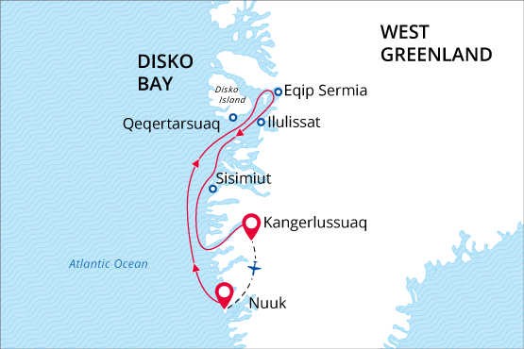

West Greenland and Disko Bay
Icebergs, Whales & Inuit Heritage
30 May - 06 Jun 2018
8 days
Embarkation: Nuuk (Greenland)
Disembarkation: Kangerlussuaq (Greenland)
M/v Sea Spirit
Activities:

Itinerary
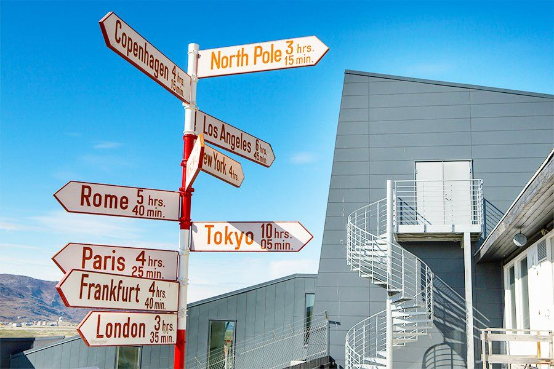Day 1: Air flight from Kangerlussuaq, Greenland to Nuuk, Greenland; Embarkation
Your individual arrival to Kangerlussuaq is followed by flight to Nuuk (Kangerlussuaq – Nuuk flight is provided by Poseidon Expeditions and included in the price of the voyage). Our voyage starts in the capital of Greenland – city of Nuuk. It has a population of over 16,000, making it one of the smallest capital cities in the world by population. It is also the world’s northernmost capital, located only a few kilometers further north than Reykjavík. Today we welcome you aboard the luxury expedition ship M/V Sea Spirit. Explore the ship and get comfortable in your home away from home for the extraordinary adventure to come. Savor the anticipation of your Arctic dreams coming true as we slip our moorings and sail along the picturesque fjord.
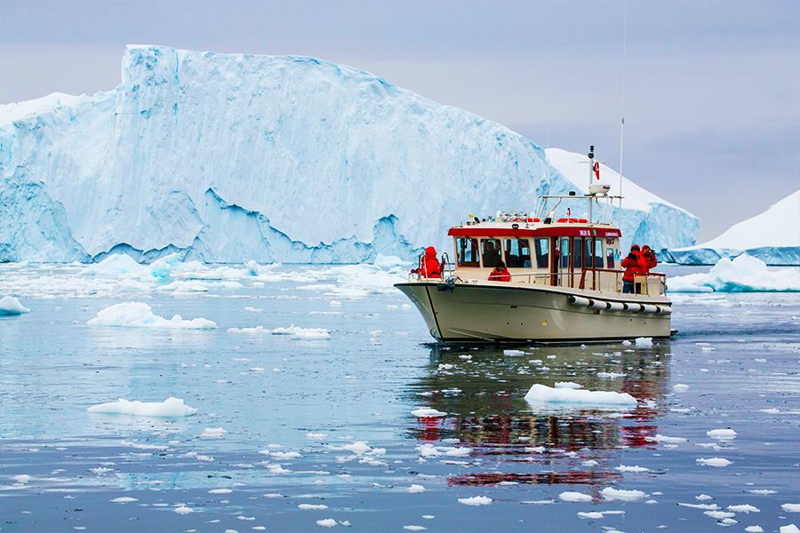Day 2-7: Exploration of West Greenland
Though settlements abound in this part of Greenland, unpredictable weather and dearth of docking facilities nevertheless make this a real expedition. As such, our route and exploration opportunities along this coast are heavily dependent on the weather and ice conditions we encounter. Our experienced captain and expedition leader decide the itinerary and continually adjust plans as conditions and opportunities warrant. You can be sure that the best possible advantage will be taken of the circumstances presented to us by Nature in this wild and remote region. Possible sites of exploration include: Sisimiut – The second-largest town in Greenland boasts a youthful, urban vibe and is also is known for adventure sports, especially dog sledding. The Sisimiut Museum offers insight into the local culture and a history of human habitation dating back 4,500 years. Qeqertarsuaq – Located on volcanic Disko Island, the small town of Qeqertarsuaq enjoys views of basaltic mountains and the huge icebergs of Disko Bay. Founded in 1773 as a whaling station, Qeqertarsuaq is one of the oldest towns in Greenland. Cultural attractions include a distinctive octagonal church called the “Lord’s Ink Pot”. Some hiking options are available in the area: a longer hike to the basalt cliffs and a shorter one to the waterfall. Eqip Sermia – This active tidewater glacier is situated in a wild and scenic fjord. In the period after the Second World War, this area functioned as a starting point for expeditions onto the ice cap conducted by the French explorer Paul Emile Victor, whose hut still stands today. Ilulissat – Formerly called Jakobshavn, the town of Ilulissat is best known for unbelievable quantities of icebergs issuing from the nearby Ilulissat Icefjord, into which one of the world’s fastest moving and most active glaciers calves 46 cubic kilometers of ice annually. Attractions in town include the Inuit Art Museum, which contains a large collection of paintings by Greenlandic, Faroese, and Danish artists.
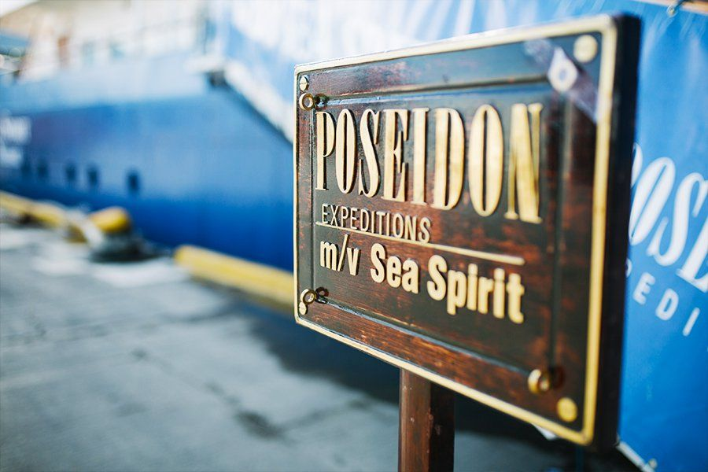Day 8: Disembarkation in Kangerlussuaq, Greenland
After breakfast we say farewell in Kangerlussuaq, the site of Greenland's largest commercial airport.

Special guest
Joanna Kafarowski, PhD
Geographer, Writer
Joanna has worked extensively with Indigenous women in the Arctic and has a passion for the North. She has a strong interest in women in polar history and is the author of “The Polar Adventures of a Rich American Dame A Life of Louise Arner Boyd" (Dundurn Press, 2017) and editor of "Gender, Culture and Northern Fisheries" (Canadian Circumpolar Institute, 2009). She is a Fellow of the Royal Geographical Society and a Member of the Society of Woman Geographers.

M/v Sea Spirit
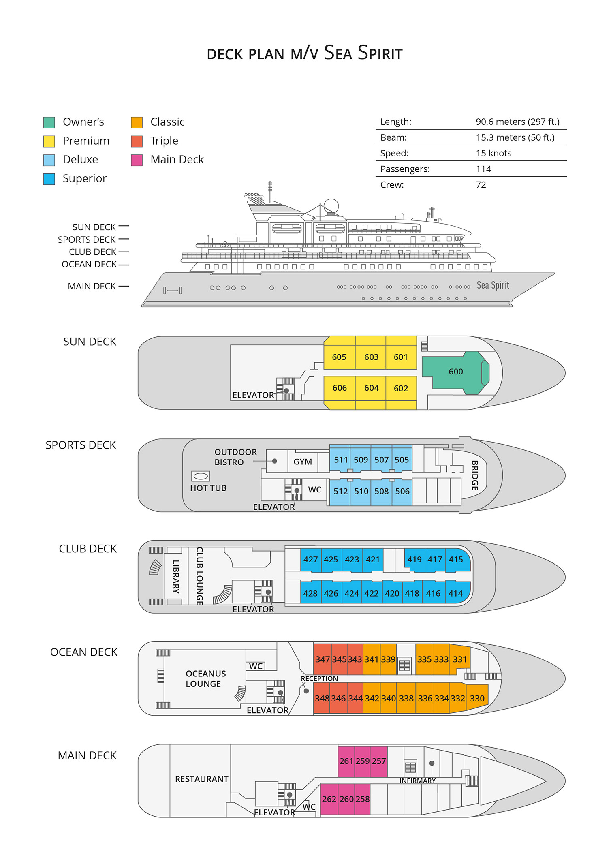

Triple Suite  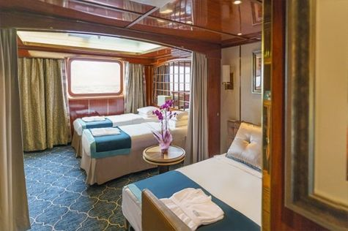  Averaging 21 square metres/226 square feet, these staterooms have two twins and a comfortable sofa bed. The twins also convert to a King, if desired. Located on Oceanus Deck, these suites have a picture window, two wardrobes and en suite facilities. Amenities include: in-room safe, refrigerator, satellite telephone access, TV/DVD, individual temperature control, and hair dryer. | Main Deck Suite  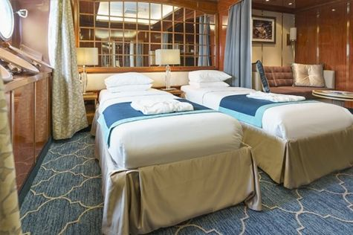  Averaging 23 square metres/248 square feet, Main Deck cabins are equipped with either two twins or a King Size bed. They are located on the Main Deck with a minimum of two portholes for exterior views. Amenities include: en suite facilities, in-room safe, refrigerator, satellite telephone access, TV/DVD individual temperature control and hair dryer.
Single Suite  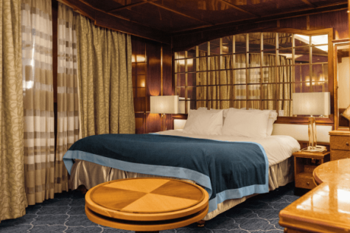  Averaging 21 square meters/226 square feet, these cabins are located on the Oceanus Deck. They feature a picture window (it may be covered during rough sea crossings), two wardrobes, and a King Size bed. Amenities include: en suite facilities, in-room safe, refrigerator, satellite telephone access, TV/VCR, individual temperature control, and hair dryer. | Classic Suite  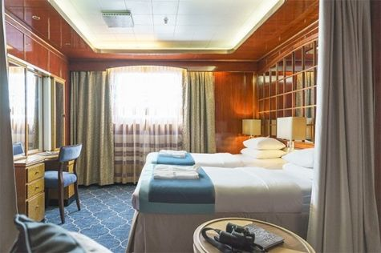  Averaging 21 square metres/226 square feet, these cabins are located on the Oceanus Deck. They feature a picture window, two wardrobes and a choice of either two twin beds or a King Size bed. Amenities include: en suite facilities, in-room safe, refrigerator, satellite telephone access, TV/DVD, individual temperature control and hair dryer.
Superior Suite  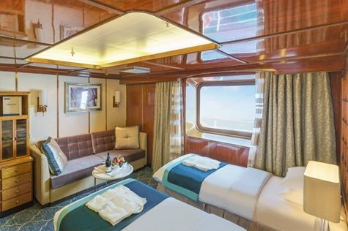  Superior Suites are located on the Club Deck. Averaging 20 square metres/ 215 square feet, these cabins feature two twin beds or a King Size bed. The picture window overlooks an outside walkway on the Club Deck. Amenities include: en suite facilities, walk-in closet or wardrobe, in-room safe, refrigerator, satellite telephone access, TV/DVD, individual temperature control, hair dryer. | Deluxe Suite  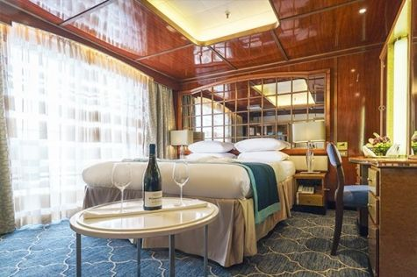  The Deluxe Suites with balconies are located on the Sports Deck. Averaging 24 square metres/ 258 square feet means plenty of room. Choose from either two twin beds or a King Size bed. A sliding glass door leads to a private balcony. These suites feature a walk-in closet or wardrobe. Amenities include en suite facilities, in-room safe, refrigerator, satellite telephone access, TV/DVD, individual temperature control, and a hair dryer.
Premium Suite  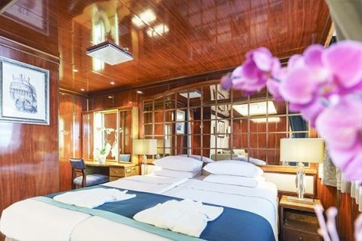  The Premium Suites are located on the Sun Deck. Averaging a generous 30 square metres/ 323 square feet, with two twin beds or a King Size bed. Access the private balcony by a sliding glass door. Amenities include: en suite facilities, lounge area, in-room safe, refrigerator, satellite telephone access, TV/DVD, individual temperature control, and hair dryer. | Owners Suite  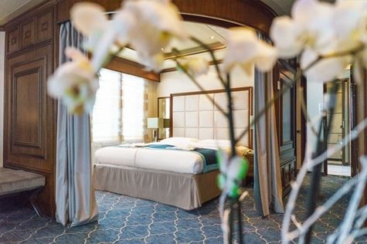  Super-spacious (63 square metres/ 678 square feet) elegant suite on the Sun Deck. Designed for entertaining, the Owner's Suite has a separate living room with game and meeting area. A BOSE stereo system provides background music, or watch videos on the HD plasma TV. Sliding glass doors lead to a private deck. Refresh in the jetted bathtub in en suite facilities. Slumber in the King Size bed. A sofa bed can accommodate a third person.

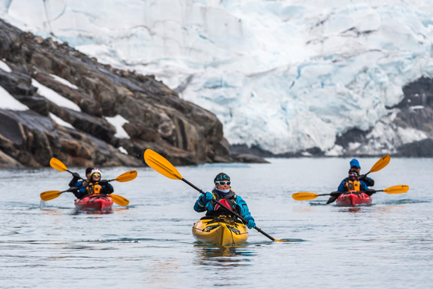 | Sea Kayaking  Kayaking fee $655 - A$885 - £505 - €625  Sea Kayak Club is typically offered on voyages that include High Arctic destinations such as Greenland, Svalbard (Spitsbergen), Franz Josef Land, or a combination of these thrilling places. Experience calving glaciers in Svalbard, cathedral-like icebergs in Greenland, or labyrinthine expanses of sea ice in the Arctic Ocean, all from our sturdy and stealthy sea kayaks. Join us for an unscripted kayaking adventure as we explore rugged coastlines and remote waters that very few people have ever paddled.
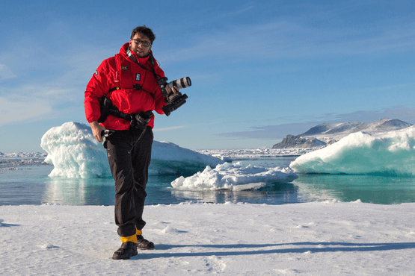 | Photography  Free option  The Polar Regions are perhaps the most photogenic on earth, with countless beautiful scenes presenting themselves every day. Endless expanses of ice, beaches crowded with seals or penguins, sunsets over unbroken horizons, starlit skies, and even the majestic northern lights – they all present fantastic photographic opportunities – and in order to make sure that you come home with some spectacular images we offer you the chance to learn and practice your photography alongside an experienced professional.  Our expert Photographer will be on hand to answer your questions and give advice, both in the form of on-board lectures and workshops on shore. Explore the key elements of photography in a fun and relaxed setting, with plenty of opportunities for questions and feedback. Learn how to see light in a new way and experiment with the techniques of composition and framing.

Rates Include  Air flight Kangerlussuaq – Nuuk on the first day of the cruise;  Group transfer to the ship on day of embarkation;  Shipboard accommodation;  All meals on board throughout the voyage;  Tea and coffee station 24 hours daily;  All scheduled landings/excursions (subject to weather and ice conditions);  Museum entrance fee;  Leadership throughout the voyage by our experienced Expedition Leader and Expedition Team;  Branded Poseidon Expeditions parka;  Rubber boots for shore landings for the time of the cruise;  Welcome and Farewell cocktails;  All port fees;  Group transfer to airport or central location upon disembarkation;  Pre-departure materials;  Digital Voyage Log;  Emergency Evacuation Insurance to a maximum benefit of USD 150,000 per person. | Rates Do Not Include  Air flights other than included;  Visa and passport fees (if applicable);  Luggage and trip cancellation insurance;  Soft drinks and alcoholic beverages other than those for special events and celebrations;  Personal expenses such as laundry and telecommunication charges;  Staff gratuities.
Itinerary, landings and all other activities during the cruise depend strongly on ice and weather conditions and are subject to the decisions of the Expedition Leader and the Captain of the vessel. Encounters with any mentioned wildlife cannot be guaranteed.

