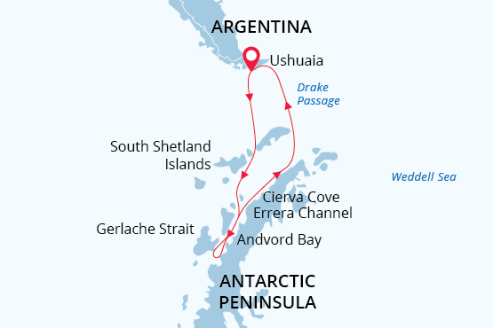

Antarctic Peninsula
Antarctica Through the Camera Lens
21 Nov - 01 Dec 2023
11 days
Embarkation: Ushuaia (Argentina)
Disembarkation: Ushuaia (Argentina)
M/v Sea Spirit
Activities:

Itinerary
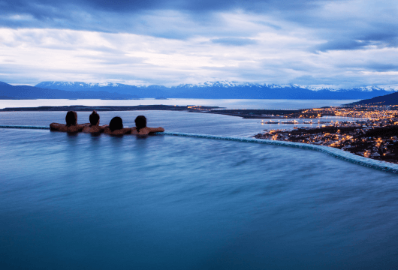Day 1: Arrival in Ushuaia, Argentina (hotel night)
Welcome to Ushuaia, the southernmost city in the world and the gateway to our Antarctic expedition! As you arrive at the airport, our friendly staff will be there to welcome you and provide a comfortable transfer to a quality hotel, included in your itinerary. Take the rest of the day to explore this lively port city and adventure hub.
Before our thrilling photo adventure commences, ensure you check your photo equipment and make any necessary preparations. It's always wise to have an extra pack of batteries and memory cards on hand. Get ready for a remarkable and unforgettable experience that combines exploration and creativity.
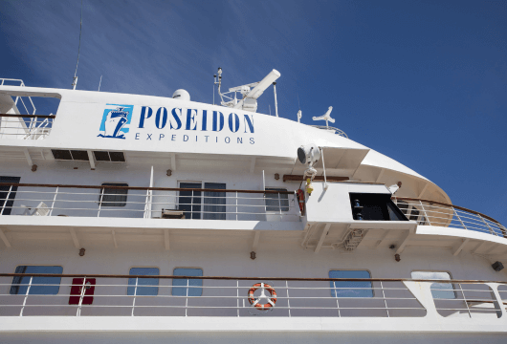Day 2: Welcome Aboard!
After breakfast at your hotel, the morning is yours to enjoy Ushuaia. Explore the delightful waterfront and savor views of the snowcapped Martial Range, the southernmost peaks of the Andes.
In the afternoon, you will be transferred to the pier where we will warmly welcome you aboard the deluxe expedition vessel M/V Sea Spirit. Get settled in your spacious suite and explore the ship that will be your comfortable home during the extraordinary adventure to come. After getting underway, a full schedule of events kicks off with informative briefings and introductions from your expedition staff.
This is not just any cruise, but a photo cruise, designed specifically for professional photographers and amateurs of all skill levels. It will be a cool and unforgettable journey. You will have the opportunity to photograph some of the most pristine and remote wilderness areas in the world, and to develop your photography skills in the company of like-minded fellow travelers.
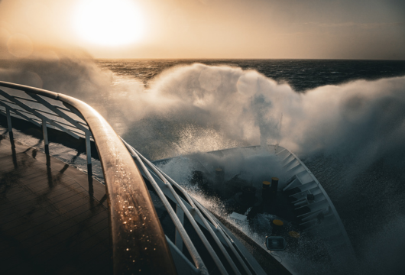Day 3-4: Across the Drake Passage
As we leave behind the islands of Tierra del Fuego, our journey continues southward across the Drake Passage. The ship’s stabilizing fins provide comfort in the event of rough seas. Briefings, bio-security procedures and presentations by our lecture staff will prepare you for our arrival in Antarctica. We hope to arrive in the South Shetland Islands on the evening of our second day at sea.
This cruise was designed for amateur photographers of all skill levels, so use this chance to make new friends, exchange your photo experience and attend our photography workshops. Discussing ISO and exposure is always better in our cozy bar, restaurant, or lounge.
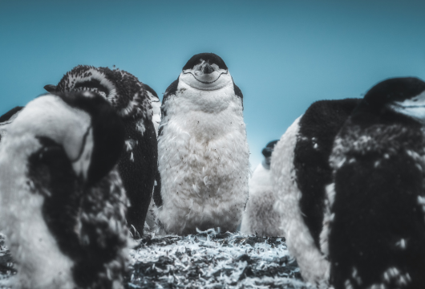Day 5-8: South Shetland Islands and Antarctic Peninsula
Get ready for an unforgettable four-day exploration of the Antarctic Peninsula. This extraordinary journey presents abundant opportunities to capture stunning photographs of penguins, seals, whales, and the diverse array of unique creatures that call this region home.
November marks the beginning of the Antarctic summer, which means you'll have the chance to photograph the pristine white snow that blankets the landscape, creating a picturesque backdrop for your shots. Additionally, you'll witness breathtaking sunrises and sunsets, as the polar day hasn't come into full power yet. We carefully plan our landings during the golden hour, ensuring optimal lighting for capturing your perfect shot. Our itinerary includes visits to the enchanting Shetland Islands, the picturesque Gerlache Strait, and the renowned Lemaire Channel, also known as the "Kodak Gap" for its photogenic reflection of the snow-capped mountains.
During this time, penguin pairs will be diligently taking turns incubating their precious eggs, so get your cameras ready! This is expedition cruising at its most authentic. Our precise route and exploration opportunities will be shaped by weather and ice. Our experienced captain and expedition leader will continually adjust plans to take maximum advantage of the conditions in this challenging polar environment. However, rest assured that we will make the most of each moment, embracing exceptional wildlife sightings and breathtaking scenery during our shore excursions and photo Zodiac cruises.
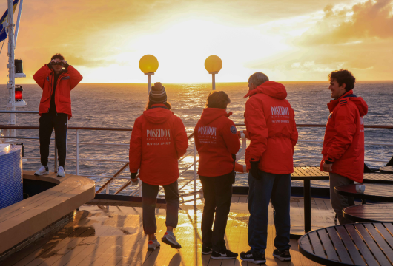Day 9-10: Back across the Drake Passage
As we navigate the Drake Passage towards South America, keep your camera ready as seabirds and the possibility of whale sightings accompany our journey through these untamed waters. Join us in festive events like the Captain's Farewell Cocktail and the end-of-voyage slideshow, where we share our impressions and celebrate the incredible photos we've taken along the way. As we peacefully sail through the calm Beagle Channel, our expedition concludes with a smooth journey towards Ushuaia, leaving us with lasting memories of this extraordinary adventure.
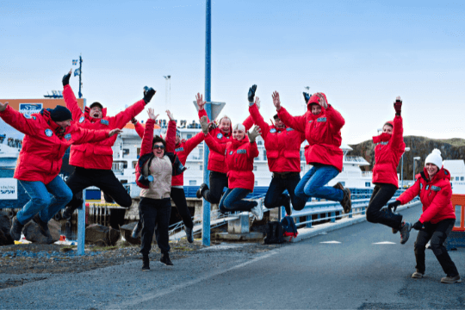Day 11: Disembarkation in Ushuaia, Argentina
After yet another delicious breakfast on board, we bid you a fond farewell in Ushuaia. We provide a group transfer to the airport or to the city center if you wish to spend more time here. In this journey, you became a part of our close-knit photo family, capturing unforgettable moments together. The spirit of exploration and the desire for new adventures will surely guide us in the future. Until we meet again, safe travels and keep the excitement alive!

Special guest
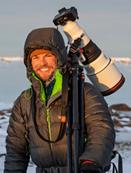Nate Luebbe
Photographer
Utah-based Nate Luebbe is a self-taught photographer and lifelong explorer of the outdoors, an avid environmentalist, conservationist, and raconteur of experiences. His passion for photography started as a way to catalog all his outdoor experiences and to live in the moment. He describes standing on a summit watching the sun fade beyond the horizon, and the stars slowly emerge from the inky blackness as an event that consumes one on a level that’s nearly indescribable. Taking those feelings and attempting to freeze them into a single still frame is an incredible challenge, something that truly motivates him to get out and experience the world. As an ambassador for the Sony Alpha Imaging Collective, Nate pushes the limits of Sony cameras and lenses to create dynamic and inspiring photographs and videos that reveal the spirit of adventure. Nate has photographed grizzlies in Alaska and Yellowstone Park, northern lights in Norway, and polar bears on the Hudson Bay coast. His portfolio also includes a stunning array of landscape and wilderness photos from around the world.
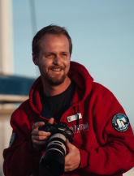Piet van den Bemd
Photographer
During his childhood, Piet developed a fascination for nature and wildlife, which intensified when he got his first camera at 16. His visit to the Arctic at 17 stole his heart with its diverse wildlife, landscapes, and culture. With an ecology background, he soon realized the rapid changes and threats these places face. After working as a whale watching guide, he decided to live in the North. Inspired by the oceans' beauty and freedom and the North's pure wilderness, he aims to create awareness through photography and secure the future of these "untouched" places. With a camera in hand and a lot of motivation, he wants to share his passion with everyone.

M/v Sea Spirit
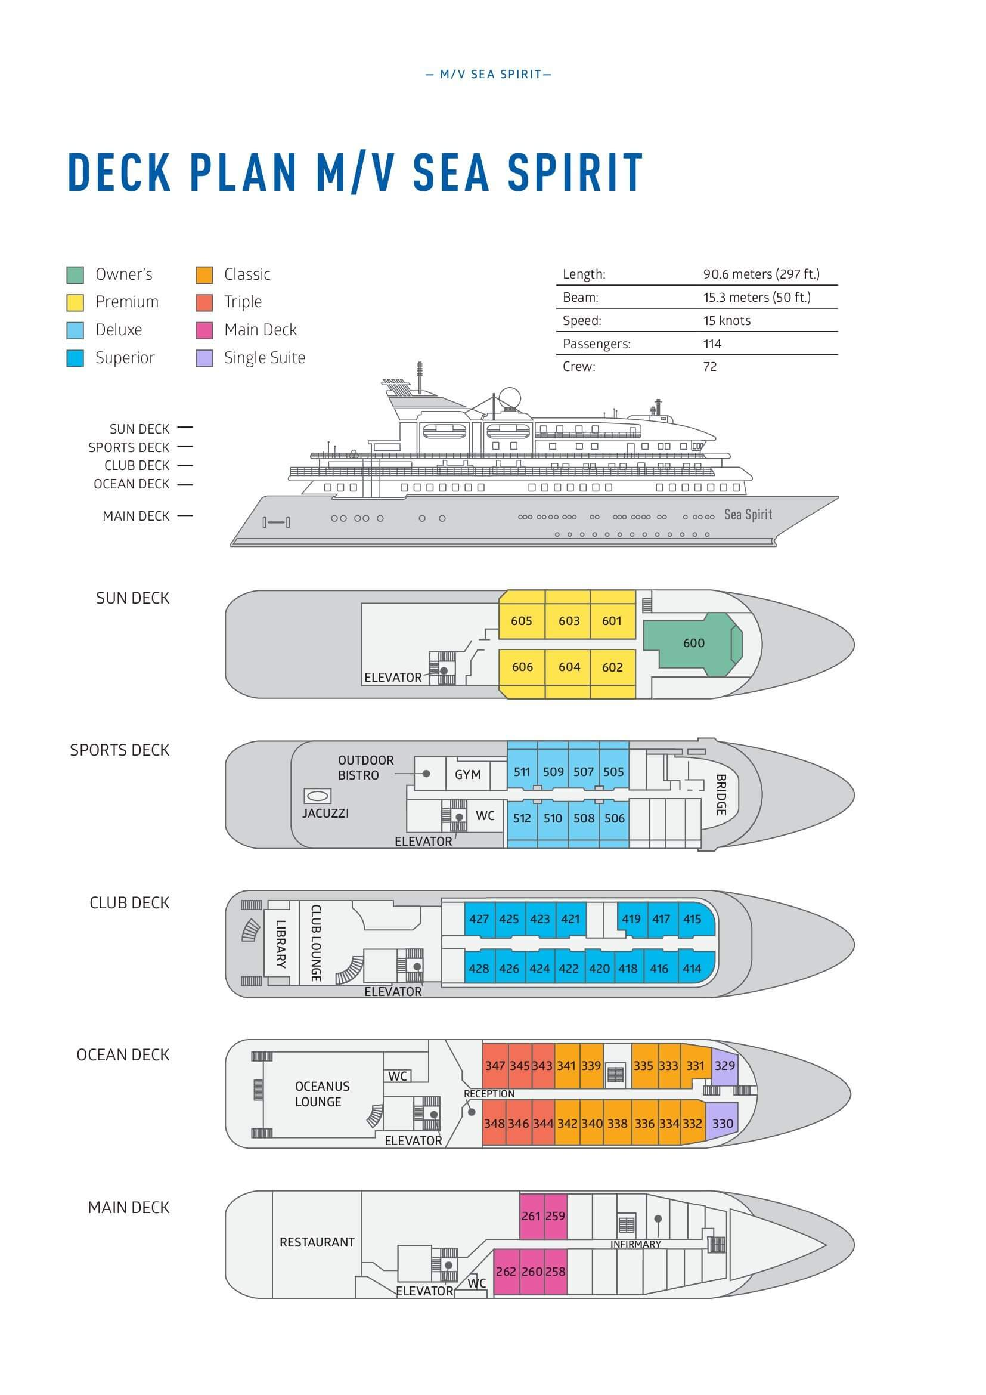

Triple Suite  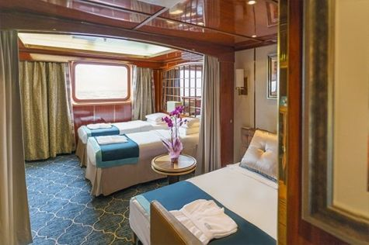  Averaging 21 square metres/226 square feet, these staterooms have two twins and a comfortable sofa bed. The twins also convert to a King, if desired. Located on Oceanus Deck, these suites have a picture window, two wardrobes and en suite facilities. Amenities include: in-room safe, refrigerator, satellite telephone access, TV/DVD, individual temperature control, and hair dryer. | Main Deck Suite  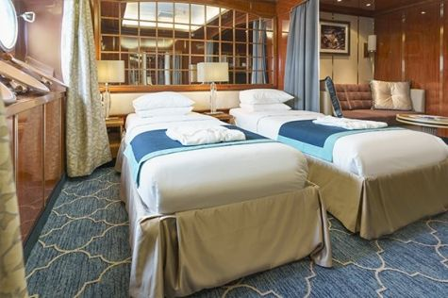  Averaging 23 square metres/248 square feet, Main Deck cabins are equipped with either two twins or a King Size bed. They are located on the Main Deck with a minimum of two portholes for exterior views. Amenities include: en suite facilities, in-room safe, refrigerator, satellite telephone access, TV/DVD individual temperature control and hair dryer.
Single Suite  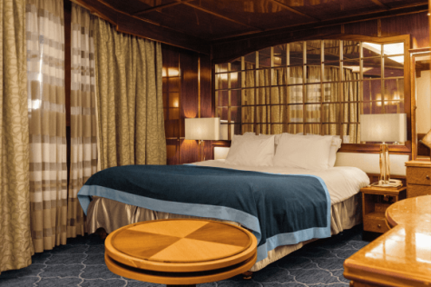  Averaging 21 square meters/226 square feet, these cabins are located on the Oceanus Deck. They feature a picture window (it may be covered during rough sea crossings), two wardrobes, and a King Size bed. Amenities include: en suite facilities, in-room safe, refrigerator, satellite telephone access, TV/VCR, individual temperature control, and hair dryer. | Classic Suite  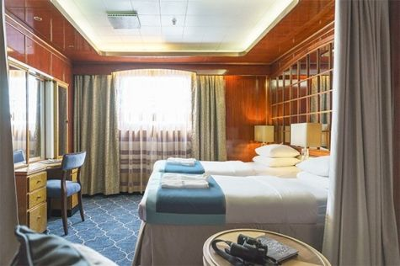  Averaging 21 square metres/226 square feet, these cabins are located on the Oceanus Deck. They feature a picture window, two wardrobes and a choice of either two twin beds or a King Size bed. Amenities include: en suite facilities, in-room safe, refrigerator, satellite telephone access, TV/DVD, individual temperature control and hair dryer.
Superior Suite  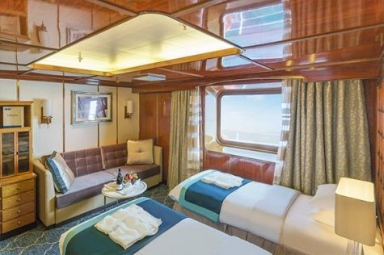  Superior Suites are located on the Club Deck. Averaging 20 square metres/ 215 square feet, these cabins feature two twin beds or a King Size bed. The picture window overlooks an outside walkway on the Club Deck. Amenities include: en suite facilities, walk-in closet or wardrobe, in-room safe, refrigerator, satellite telephone access, TV/DVD, individual temperature control, hair dryer. | Deluxe Suite  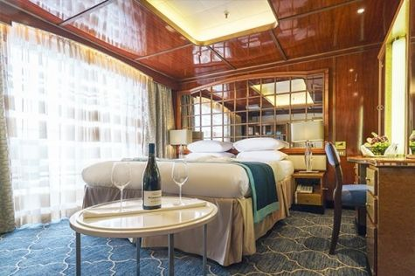  The Deluxe Suites with balconies are located on the Sports Deck. Averaging 24 square metres/ 258 square feet means plenty of room. Choose from either two twin beds or a King Size bed. A sliding glass door leads to a private balcony. These suites feature a walk-in closet or wardrobe. Amenities include en suite facilities, in-room safe, refrigerator, satellite telephone access, TV/DVD, individual temperature control, and a hair dryer.
Premium Suite  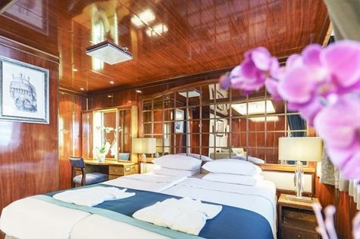  The Premium Suites are located on the Sun Deck. Averaging a generous 30 square metres/ 323 square feet, with two twin beds or a King Size bed. Access the private balcony by a sliding glass door. Amenities include: en suite facilities, lounge area, in-room safe, refrigerator, satellite telephone access, TV/DVD, individual temperature control, and hair dryer. | Owners Suite  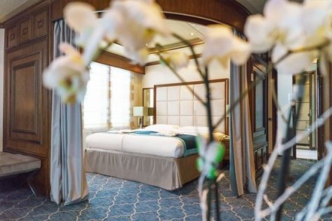  Super-spacious (63 square metres/ 678 square feet) elegant suite on the Sun Deck. Designed for entertaining, the Owner's Suite has a separate living room with game and meeting area. A BOSE stereo system provides background music, or watch videos on the HD plasma TV. Sliding glass doors lead to a private deck. Refresh in the jetted bathtub in en suite facilities. Slumber in the King Size bed. A sofa bed can accommodate a third person.

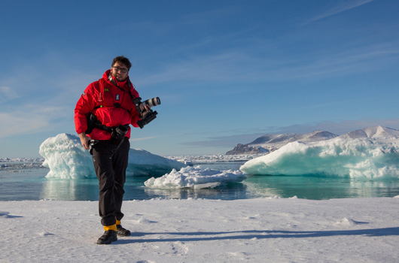 | Photography  What to expect on your photo tour  A polar cruise designed for photographers of all skill levels is a perfect way to experience the beauty and grandeur of the polar regions while also improving your photography skills.  - Watch breathtaking scenery and mesmerizing landscapes in one of the most remote places on Earth  - See the contrast of unique locations and their iconic wildlife  - Join our onboard photo workshops and get guidance from professional photographers  - Learn about the history and most significant spots in the area, and capture polar exploration history on your camera  - See an abundance of wildlife  - Discover the best wildlife viewing and photo ops with your expedition team and our onboard naturalists  - Scout the best locations on foot, on Zodiac excursions or while kayaking  - Our professional expedition team and experienced captain will maneuver and bring you safely to the places with the best photo ops
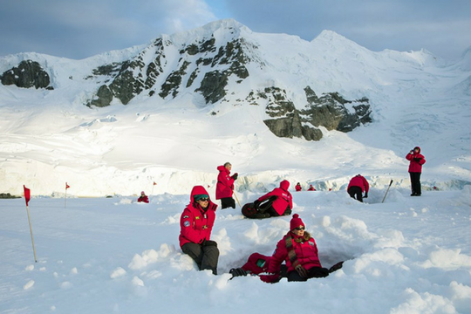 | Camping  Camping fee $285 - A$385 - £220 - €275  If you’re looking for an unforgettable way to expand your experience on the White Continent, then Antarctica Camping may be the perfect choice for you. This optional activity is your unique opportunity to meet Antarctica on its own terms by spending a night out on the snow and ice!  Camping is a great way to immerse yourself in Antarctica. As the sun slowly sets you can unwind and let your senses fully absorb the awesome sights and mysterious sounds of this legendary wilderness. Spend an hour — or all night-simply watching the drama of endlessly changing light upon the landscape. Build a snowman or capture that perfect photo. Whatever joy Antarctica holds for you, you can take the time to experience it fully on your Antarctica Camping night. Gain lasting memories, undeniable bragging rights, and a new appreciation for your warm bed back on the ship.  Please contact our office for availability.

Rates Include  1 pre-voyage night on Day 1 in Arakur Ushuaia Resort and Spa Hotel;  Group transfer from the airport to the hotel on the day prior to embarkation;  Group transfer to the ship for embarkation on Day 2;  Shipboard accommodation;  All meals on board throughout the voyage;  Tea and coffee station 24 hours daily;  All scheduled landings/excursions (subject to weather and ice conditions);  Leadership throughout the voyage by our experienced Expedition Leader and Expedition Team;  Branded Poseidon Expeditions parka;  Rubber boots for shore landings for the time of the cruise;  Welcome and Farewell cocktails;  All port fees;  Group transfer to airport or central location right after disembarkation;  Pre-departure materials;  Digital Voyage Log;  Wi-Fi on board. | Rates Do Not Include  Airfare;  Transfers from the airport to the hotel if arriving prior to Day 1 of the program;  Visa and passport fees (if applicable);  Luggage and trip cancellation insurance;  Soft drinks and alcoholic beverages other than those for special events and celebrations;  Personal expenses such as laundry and telephone calls;  Fuel surcharge may be applied for all bookings;  Mandatory Emergency Evacuation Insurance to a minimum benefit of US$ 200,000 per person;  Staff gratuities;  Kayaking, camping;  The cost of any applicable medical tests (such as COVID-19) or vaccinations required either by a national government or Poseidon Expeditions before, during or after the cruise;  Pre- or post-cruise travel expenses.
Itinerary, landings and all other activities during the cruise depend strongly on ice and weather conditions and are subject to the decisions of the Expedition Leader and the Captain of the vessel. Encounters with any mentioned wildlife cannot be guaranteed.

