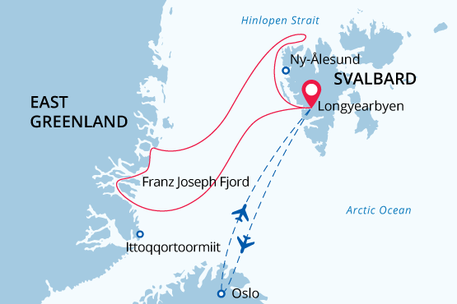

Svalbard & NE Greenland National Park
Icebergs, Fjords, Polar bears and Arctic wildlife
08 Aug - 21 Aug 2024
14 days
Embarkation: Longyearbyen (Svalbard)
Disembarkation: Longyearbyen (Svalbard)
M/v Sea Spirit
Activities:

Itinerary
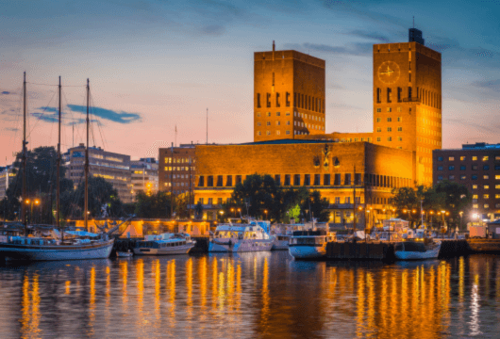Day 1 (Aug 8): Arrival in Oslo (hotel night)
Welcome to Oslo, which in 2019 was awarded the prestigious title “Green Capital of Europe”. We’ve arranged a comfortable stay for you at an Oslo Airport hotel so that you’re conveniently close for your flight to Longyearbyen on Day 2.
If you’re adventurous and have the time, take the handy airport train into central Oslo – it’s a 20-minute ride and trains depart and arrive frequently during the day. Near Oslo Central Station are shops, cafes, the Botanical Garden, cultural attractions and the attractive waterfront area.
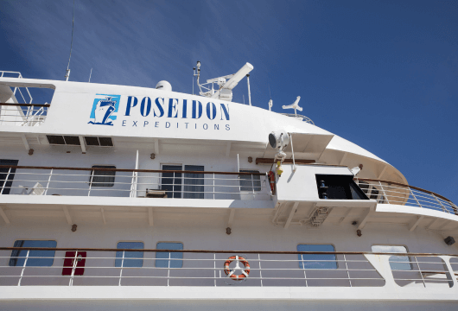Day 2 (Aug 9): Embarkation in Longyearbyen
Today you have a flight to Longyearbyen (regular airline flight), the administrative center of Svalbard and starting point of our Arctic expedition! At the Longyearbyen airport, you will be greeted by our staff and transferred to the pier where we will warmly welcome you aboard our expedition vessel, the M/V Sea Spirit. Get settled in your spacious suite and explore the ship that will be your comfortable home during the extraordinary adventure to come. Once underway, a full schedule of events kicks off with informative briefings and introductions from your expedition staff. After the first of many delicious dinners on board, step out onto the open decks to admire the gorgeous scenery in endless evening light as we pass through the wildlife-rich waters of Isfjorden, one of the largest fjords in Svalbard.
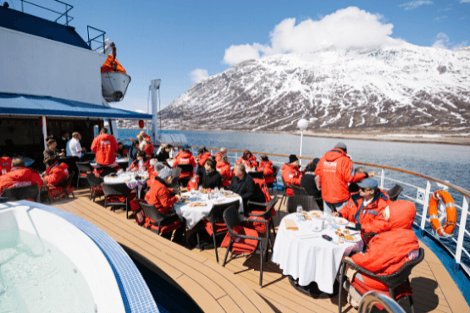Day 3-4 (Aug 10-11): Across the Greenland Sea
From Svalbard we head southwest across the Greenland Sea toward East Greenland. In these far northern latitudes, it is possible to encounter sea ice any time of the year. All along the way, we remain vigilant for sightings of marine mammals. In previous eras, a large number of different species of whales, especially bowhead whales, lived in the Greenland Sea. But due to hunting which lasted into the 20th centur, the whales were on the verge of extinction. Now, fortunately, the populations are recovering, and sometimes we can see these majestic animals passing by.
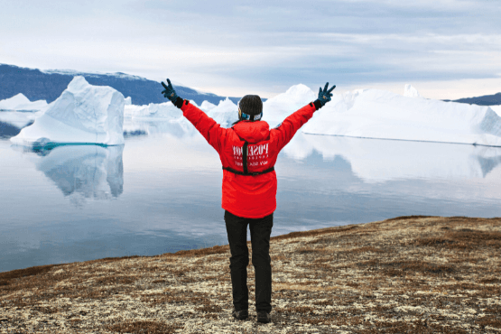Day 5-8 (Aug 12-15): East Greenland Adventure
This is expedition cruising at its most authentic and it brings us new opportunities to explore. We will go on a true arctic adventure and feel the real breath of the Arctic. Our itinerary and exploration opportunities in East Greenland are dependent on weather and sea ice conditions. Again, you can be sure that our experienced captain and expedition leader will take advantage of every opportunity so that you can experience excellent wildlife viewing, discover incredible scenery and go ashore wherever possible. The Franz Josef Fjord and Kong Oscar Fjord systems are part of Northeast Greenland National Park, the world’s largest and perhaps most remote. This whole area contains some of the Arctic’s most magnificent scenery. Deep fjords and narrow channels, flanked by ice-clad peaks up to 2000 meters high, reach far into the mountainous heart of Greenland. Tidewater glaciers create colossal icebergs that float with wind and tide throughout the fjord system. On shore, fields of multicolored tundra are home to musk oxen and Arctic hare. The landscape — vast, open, and seemingly untouched since the beginning of time—is a hiker’s paradise. Throughout this area, we also find ancient Thule archeological sites, historical trappers’ huts, and modern Inuit hunters’ cabins. To provide you with the best experience possible.
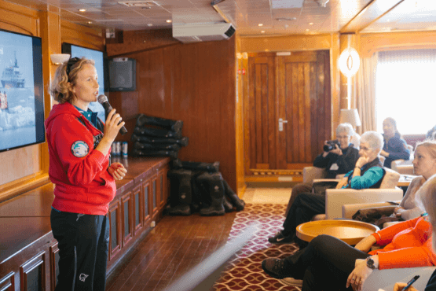Day 9-10 (Aug 16-17): At sea
Following our exploration of the Northeast Greenland coastline and fjords, we head back across the Greenland Sea toward Svalbard. Presentations and workshops by our expert staff ensure that these days at sea are not idly spent; but that’s up to you! Seabird viewing and whale sightings can be enjoyed from panoramic open decks as well as exterior stateroom windows and balconies.
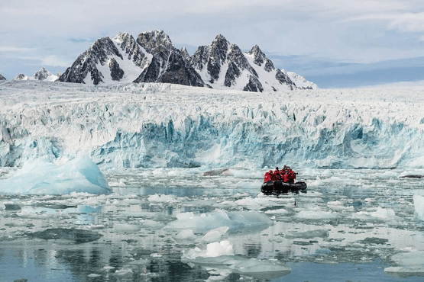Day 11-13 (Aug 18-20): Exploration of Svalbard
In the High Arctic wilderness of Svalbard, our itinerary is flexible to maximize your experience. Weather and sea ice conditions determine our route and exploration opportunities. Our experienced captain and expedition leader adapt plans accordingly. Majestic mountains, deep fjords, and turquoise waters create a stunning backdrop. Spot grazing reindeer, playful Arctic foxes, and diverse marine mammals. Keep an eye out for polar bears throughout Svalbard. Visit Ny Ålesund, a former mining town now occupied by Arctic researchers. Discover its museum, gift shop, and post office. This area also played a role in historic North Pole expeditions.
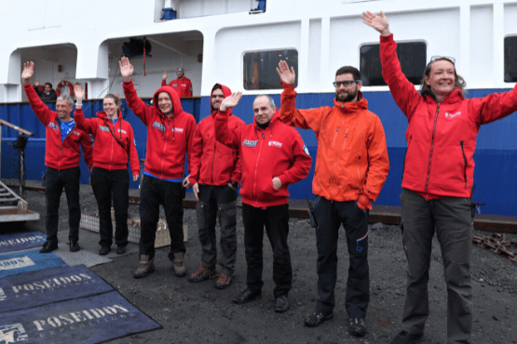Day 14 (Aug 21): Disembarkation in Longyearbyen
After filling up with one last buffet breakfast on board, we bid you farewell in Longyearbyen and provide transfer to the airport and a regular flight to Oslo. By this time, you may already be making plans for your next amazing trip with us into the polar worlds!

Special guest
Kari Herbert
Author, Public speaker
Kari is an author, publisher, and public speaker. She started travelling at the age of ten months with her father. Kari’s father Sir Wally Herbert was the first man to walk to the North Pole, crossing from Alaska to Spitsbergen in 1969. Kari was ten months old when Sir Wally Herbert took his family to live with a tribe of Polar Inuit for over two years on a remote island off the coast of Northwest Greenland. At the age of four Kari accompanied her parents on another trip that took them through winter blizzards in a caravan to spend time with the Sami of Lapland. Kari has continued to travel extensively ever since. Her writings have been published in magazines and newspapers all over the world. She has regularly taken part in many radio programmes including BBC Radio 4, Radio 3 and BBC World Service. She is a popular public speaker, lecturing at venues such as the Royal Geographical Society, the Explorers Club in New York, the National Maritime Museum and the British Library.

M/v Sea Spirit
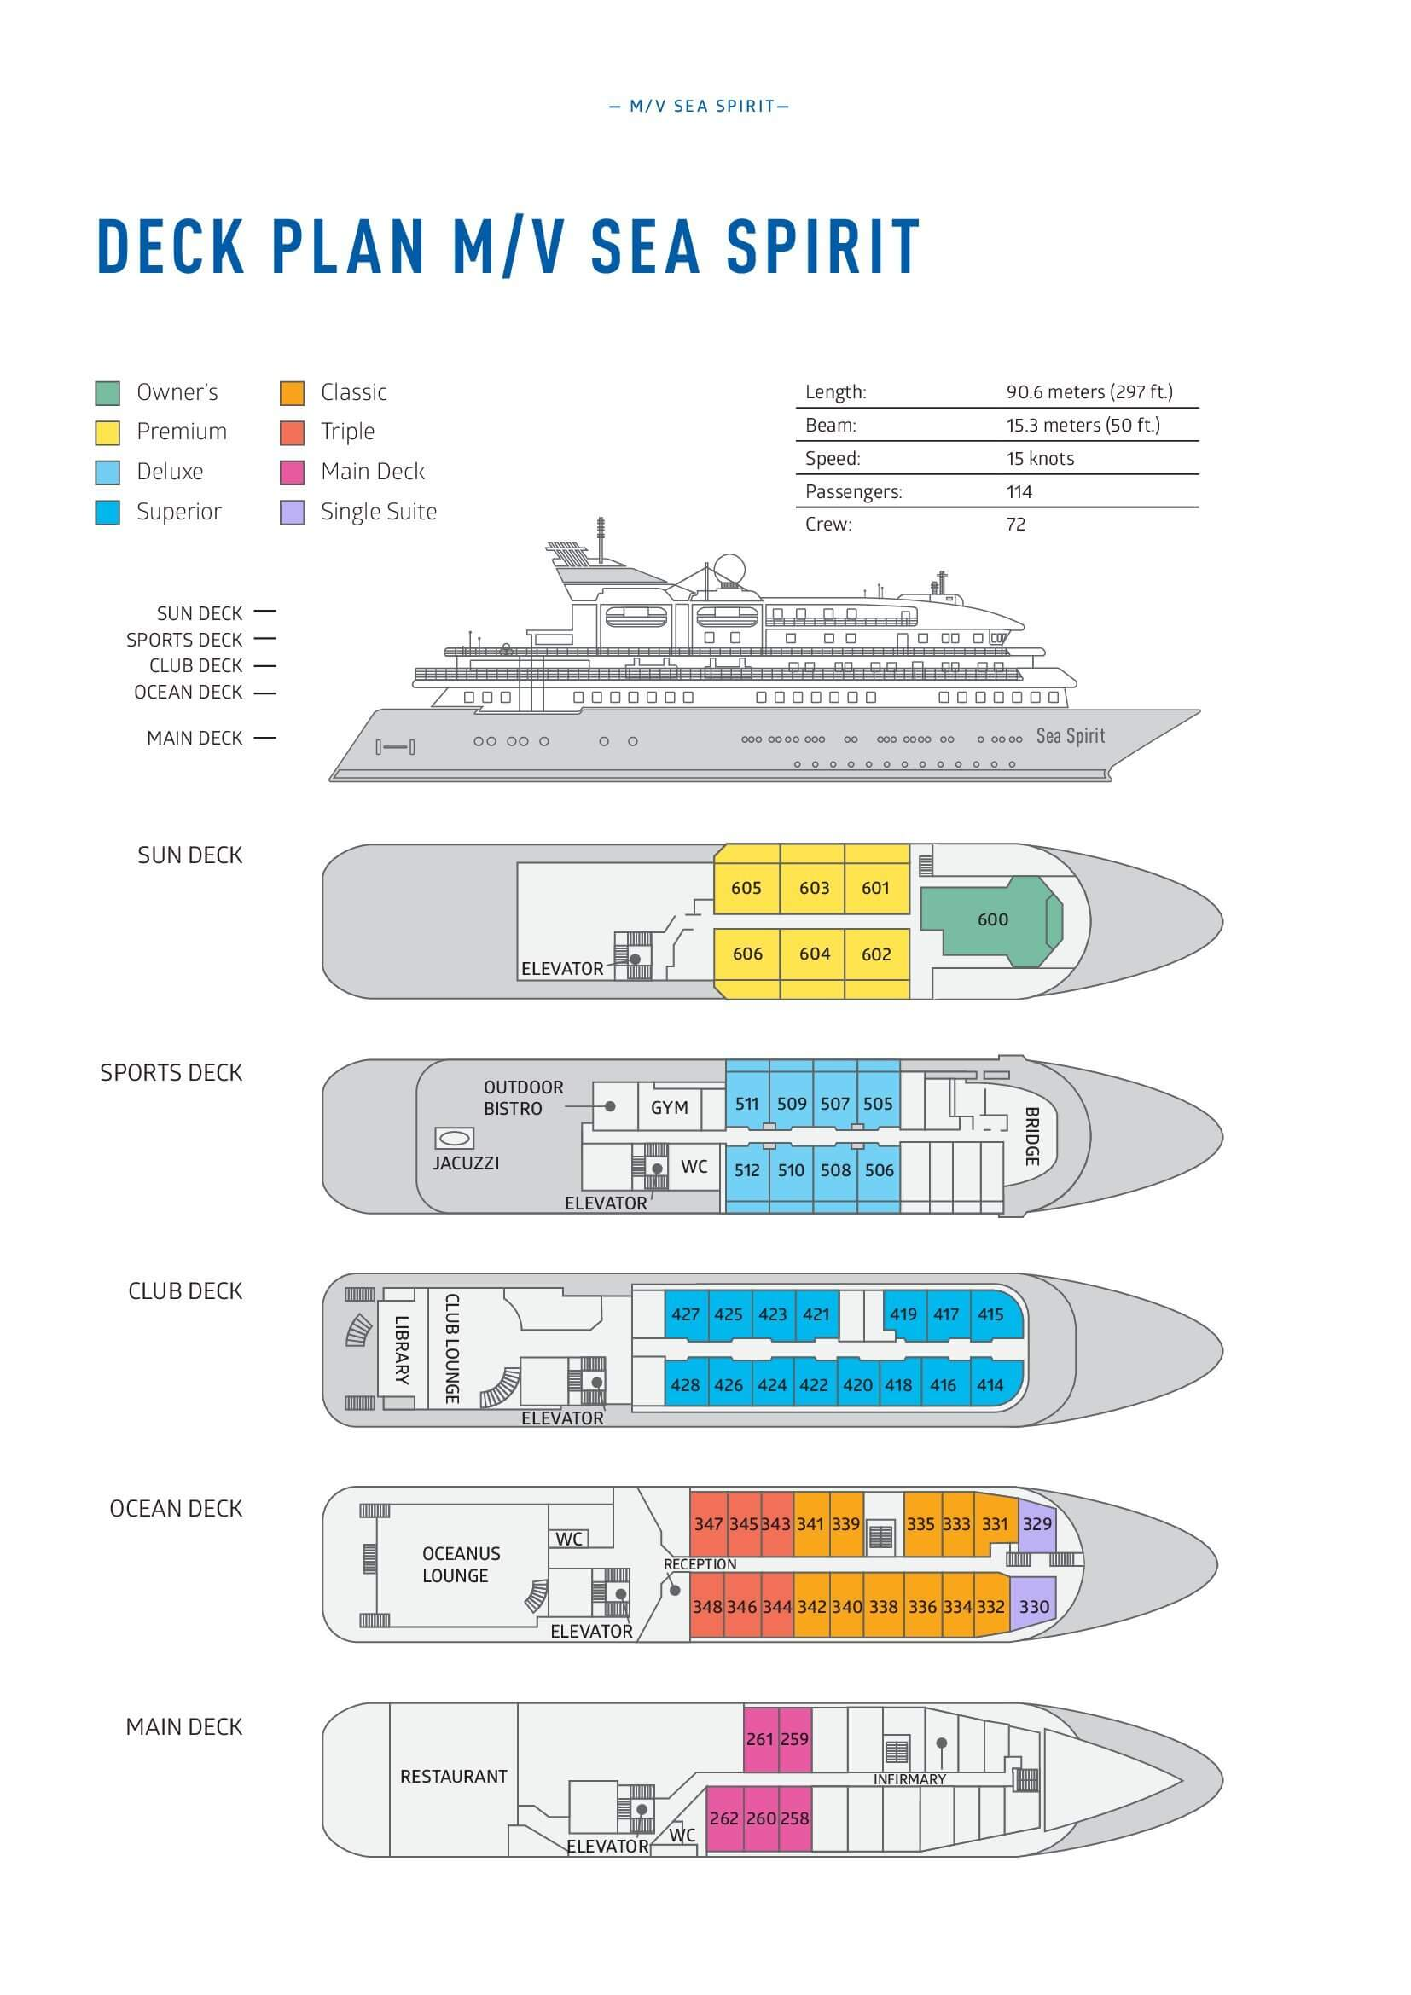

Triple Suite  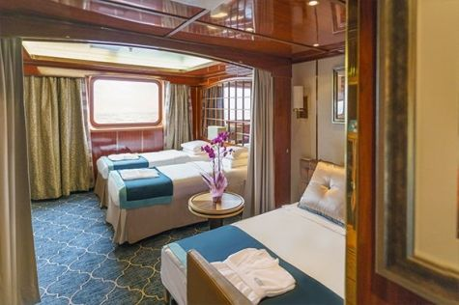  Averaging 21 square metres/226 square feet, these staterooms have two twins and a comfortable sofa bed. The twins also convert to a King, if desired. Located on Oceanus Deck, these suites have a picture window, two wardrobes and en suite facilities. Amenities include: in-room safe, refrigerator, satellite telephone access, TV/DVD, individual temperature control, and hair dryer. | Main Deck Suite  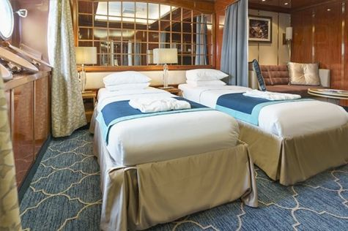  Averaging 23 square metres/248 square feet, Main Deck cabins are equipped with either two twins or a King Size bed. They are located on the Main Deck with a minimum of two portholes for exterior views. Amenities include: en suite facilities, in-room safe, refrigerator, satellite telephone access, TV/DVD individual temperature control and hair dryer.
Single Suite  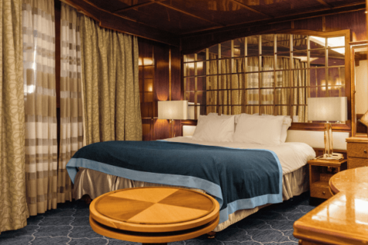  Averaging 21 square meters/226 square feet, these cabins are located on the Oceanus Deck. They feature a picture window (it may be covered during rough sea crossings), two wardrobes, and a King Size bed. Amenities include: en suite facilities, in-room safe, refrigerator, satellite telephone access, TV/VCR, individual temperature control, and hair dryer. | Classic Suite  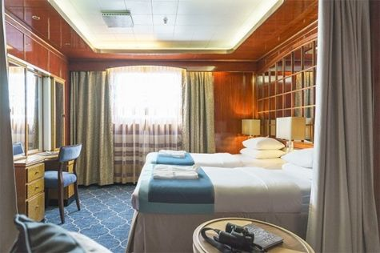  Averaging 21 square metres/226 square feet, these cabins are located on the Oceanus Deck. They feature a picture window, two wardrobes and a choice of either two twin beds or a King Size bed. Amenities include: en suite facilities, in-room safe, refrigerator, satellite telephone access, TV/DVD, individual temperature control and hair dryer.
Superior Suite  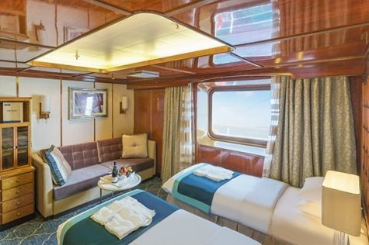  Superior Suites are located on the Club Deck. Averaging 20 square metres/ 215 square feet, these cabins feature two twin beds or a King Size bed. The picture window overlooks an outside walkway on the Club Deck. Amenities include: en suite facilities, walk-in closet or wardrobe, in-room safe, refrigerator, satellite telephone access, TV/DVD, individual temperature control, hair dryer. | Deluxe Suite  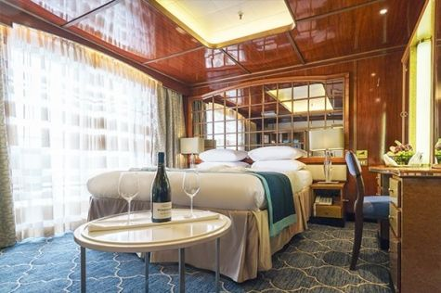  The Deluxe Suites with balconies are located on the Sports Deck. Averaging 24 square metres/ 258 square feet means plenty of room. Choose from either two twin beds or a King Size bed. A sliding glass door leads to a private balcony. These suites feature a walk-in closet or wardrobe. Amenities include en suite facilities, in-room safe, refrigerator, satellite telephone access, TV/DVD, individual temperature control, and a hair dryer.
Premium Suite  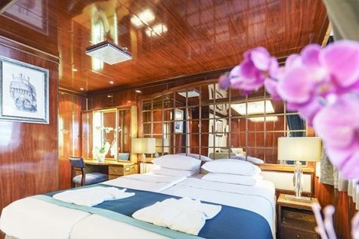  The Premium Suites are located on the Sun Deck. Averaging a generous 30 square metres/ 323 square feet, with two twin beds or a King Size bed. Access the private balcony by a sliding glass door. Amenities include: en suite facilities, lounge area, in-room safe, refrigerator, satellite telephone access, TV/DVD, individual temperature control, and hair dryer. | Owners Suite  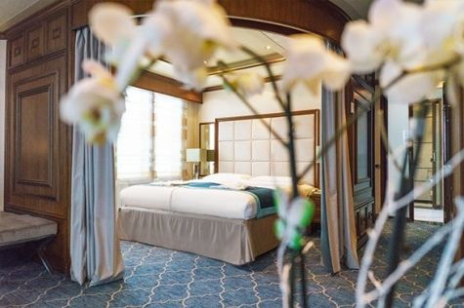  Super-spacious (63 square metres/ 678 square feet) elegant suite on the Sun Deck. Designed for entertaining, the Owner's Suite has a separate living room with game and meeting area. A BOSE stereo system provides background music, or watch videos on the HD plasma TV. Sliding glass doors lead to a private deck. Refresh in the jetted bathtub in en suite facilities. Slumber in the King Size bed. A sofa bed can accommodate a third person.

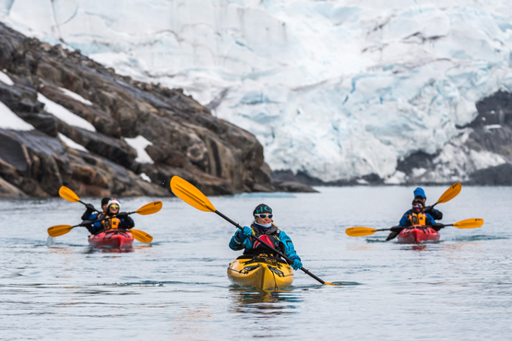 | Sea Kayaking  Kayaking fee $655 - A$885 - £505 - €625  Sea Kayak Club is typically offered on voyages that include High Arctic destinations such as Greenland, Svalbard (Spitsbergen), Franz Josef Land, or a combination of these thrilling places. Experience calving glaciers in Svalbard, cathedral-like icebergs in Greenland, or labyrinthine expanses of sea ice in the Arctic Ocean, all from our sturdy and stealthy sea kayaks. Join us for an unscripted kayaking adventure as we explore rugged coastlines and remote waters that very few people have ever paddled.
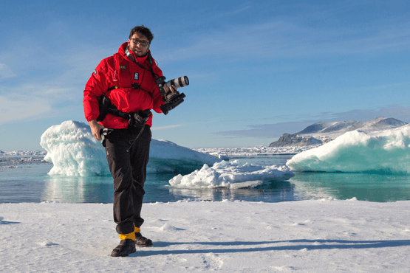 | Photography  Free option  The Polar Regions are perhaps the most photogenic on earth, with countless beautiful scenes presenting themselves every day. Endless expanses of ice, beaches crowded with seals or penguins, sunsets over unbroken horizons, starlit skies, and even the majestic northern lights – they all present fantastic photographic opportunities – and in order to make sure that you come home with some spectacular images we offer you the chance to learn and practice your photography alongside an experienced professional.  Our expert Photographer will be on hand to answer your questions and give advice, both in the form of on-board lectures and workshops on shore. Explore the key elements of photography in a fun and relaxed setting, with plenty of opportunities for questions and feedback. Learn how to see light in a new way and experiment with the techniques of composition and framing.

Rates
Triple Suite | Main Deck Suite | Single Suite | Classic Suite | Superior Suite | Deluxe Suite | Premium Suite | Owners Suite
US$ 10 395 | US$ 14 395 | US$ 21 395 | US$ 15 295 | US$ 15 595 | US$ 17 595 | US$ 19 195 | US$ 24 695
*Anniversary Deal is available for new individual bookings confirmed by May 20, 2024.
Cruise rates are quoted per person. Sharing is available in Triple, Main Deck, Classic, and Superior Suites. If you prefer a cabin for yourself, the following categories are available with the single supplement: x1.7 for Main Deck, Classic, and Superior Suites; x2 for Deluxe, Premium, and Owner's Suite.

Rates Include  1 pre-voyage night on Day 1 in Oslo;  Group transfer to the ship for embarkation on Day 2;  Shipboard accommodation;  All meals on board throughout the voyage;  Tea and coffee station 24 hours daily;  All scheduled landings/excursions (subject to weather and ice conditions);  Leadership throughout the voyage by our experienced Expedition Leader and Expedition Team;  Branded Poseidon Expeditions parka;  Rubber boots for shore landings for the time of the cruise;  Welcome and Farewell cocktails;  All port fees;  Group transfer to Longyearbyen airport;  Pre-departure materials;  Digital Voyage Log;  Wi-Fi on board.  AECO fees and governmental taxes. | Rates Do Not Include  International Airfare;  Visa and passport fees (if applicable);  Luggage and trip cancellation insurance;  Soft drinks and alcoholic beverages other than those for special events and celebrations;  Personal expenses such as laundry and telecommunication charges;  Fuel surcharge may be applied for all bookings;  Mandatory Emergency Evacuation Insurance to a minimum benefit of US$ 200,000 per person;  Kayaking;  The cost of any applicable medical tests (such as COVID-19) or vaccinations required either by a national government or Poseidon Expeditions before, during or after the cruise;  Staff gratuities.
In order to get the best experience and weather conditions, the sequence of cruise destinations to visit is subject to be inversed and you could feel a true expedition spirit.Itinerary, landings and all other activities during the cruise depend strongly on ice and weather conditions and are subject to the decisions of the Expedition Leader and the Captain of the vessel. Encounters with any mentioned wildlife cannot be guaranteed.

