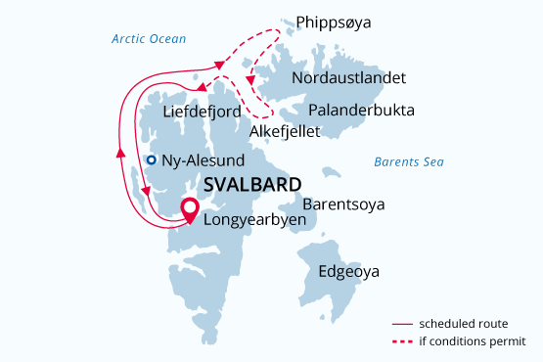

West Svalbard & Polar Ice Edge
Best of Svalbard
29 Jun - 10 Jul 2019
12 days
Embarkation: Longyearbyen (Spitsbergen)
Disembarkation: Longyearbyen (Spitsbergen)
M/v Sea Spirit
Activities:

Itinerary
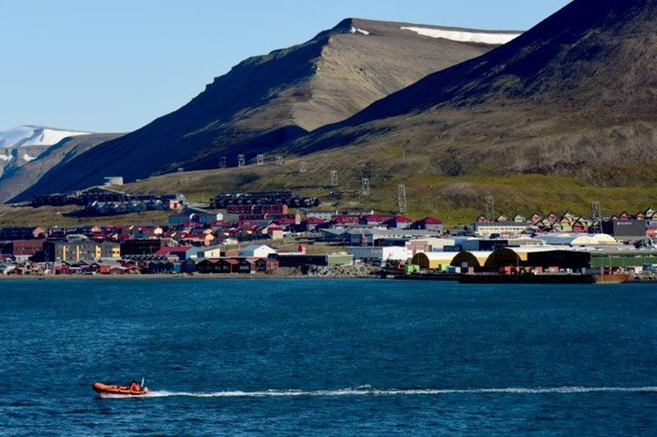Day 1: Longyearbyen, Svalbard
Welcome to Longyearbyen, the administrative capital of the Norwegian territory of Svalbard and starting point of our expedition. After arriving via scheduled commercial flight service, you are free to explore this fascinating Arctic settlement. Be sure to see the excellent Svalbard Museum and take advantage of quality shopping and dining opportunities in the town center. Your hotel for the night has been arranged by us and is included in the price of the voyage.
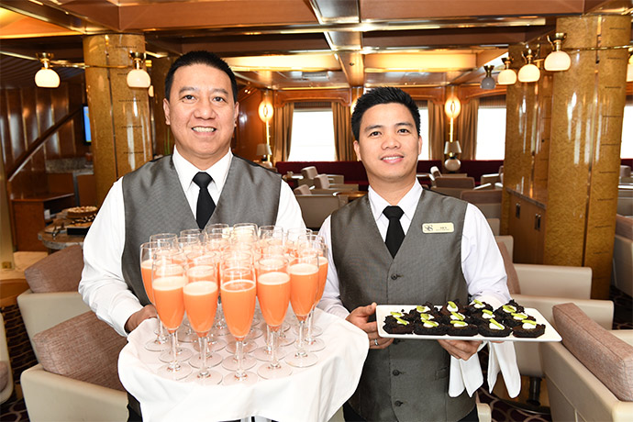Day 2: Embarkation in Longyearbyen
In the afternoon we welcome you aboard the luxury expedition ship M/V Sea Spirit. Explore the ship and get comfortable in your home away from home for the extraordinary adventure to come. Savor the anticipation of your Arctic dreams coming true as we slip our moorings and sail into a true wilderness where wildlife abounds. The scenery as we sail through Isfjorden on our first evening is spectacular and there is already the possibility of marine mammal encounters.
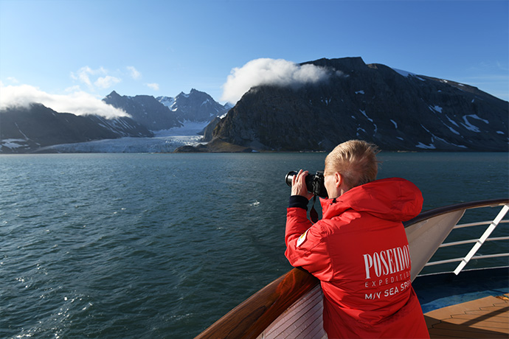Day 3-11: Exploration of West Svalbard
This is a real expedition in a true High Arctic wilderness. As such, our route and exploration opportunities here are heavily dependent on the weather and sea ice conditions we encounter. Our experienced captain and expedition leader decide the itinerary and continually adjust plans as conditions and opportunities warrant.
You can be sure that the best possible advantage will be taken of the circumstances presented to us by Nature in this wild and remote corner of the Arctic. Polar bears and other quintessential Arctic wildlife can be spotted anytime, anywhere in and around Svalbard. We exploit every opportunity to experience excellent wildlife viewing, to discover incredible scenery, and to walk in the footsteps of the historic polar expeditions that came before us. We anticipate exploring the spectacular fjords, coasts, and islands in the northwestern part of Svalbard.
This area contains the archipelago’s most impressive scenery and some of the Arctic’s best wildlife viewing opportunities. Deep fjords and narrow channels are flanked by jagged snowy mountain peaks. Immense tidewater glaciers calve icebergs into turquoise waters. On ice floes and on fast ice several species of seals watch vigilantly for polar bears. Fields of flowering tundra are home to grazing reindeer and playful Arctic fox. Bountiful inshore and offshore waters are home to walrus and a wide variety of whales. The whole area is alive with migratory birds, including numerous rare species, taking advantage of summer’s fecundity in 24-hour daylight. And over it all presides the polar bear, monarch of the North. This wild corner of Svalbard is one of the best places in the world to observe polar bears hunting in their preferred habitat: the pack ice. We take the ship as close as safely possible to the jumbled and broken edge of the polar ice cap, where polar bears stalk the frozen sea in search of seals. To complete the Arctic experience we also explore places rich with history.
Our area of exploration contains the historical remnants of whaling camps, coal mining operations, trappers’ cabins, staging areas for historic attempts to discover the North Pole, and even an abandoned polar research station. Human habitation in this area can be found only at Ny Ålesund, a former mining town that is now home to an international community of Arctic researchers. This is one of the world’s most northerly settlements, complete with museum, gift shop, and post office. The days are filled with memorable excursions, sumptuous meals, presentations by our experts, and enough stunning scenery and wildlife to fill your camera and overwhelm your emotions.
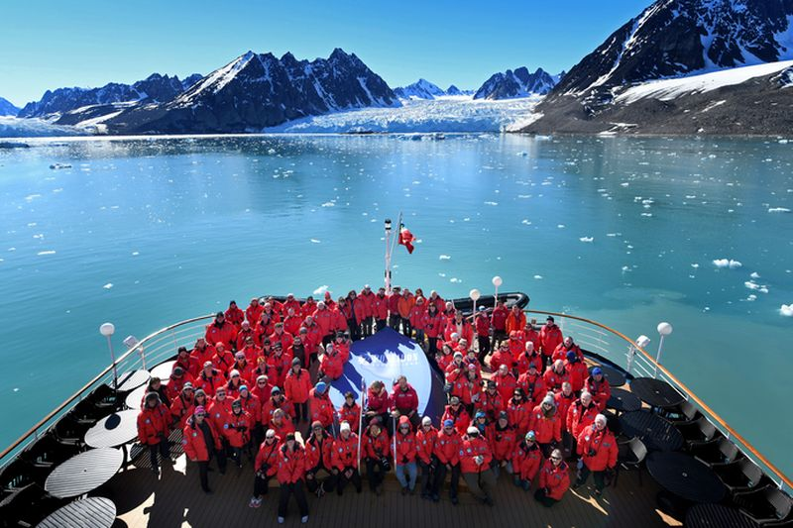Day 12: Disembarkation in Longyearbyen, Svalbard
After breakfast we say farewell in the town of Longyearbyen, where we started. We provide a transfer to the airport or to the town center if you wish to spend more time here. As you look back on your wonderful experience in Svalbard, you may already be looking forward to your next incredible adventure to the ice!

M/v Sea Spirit
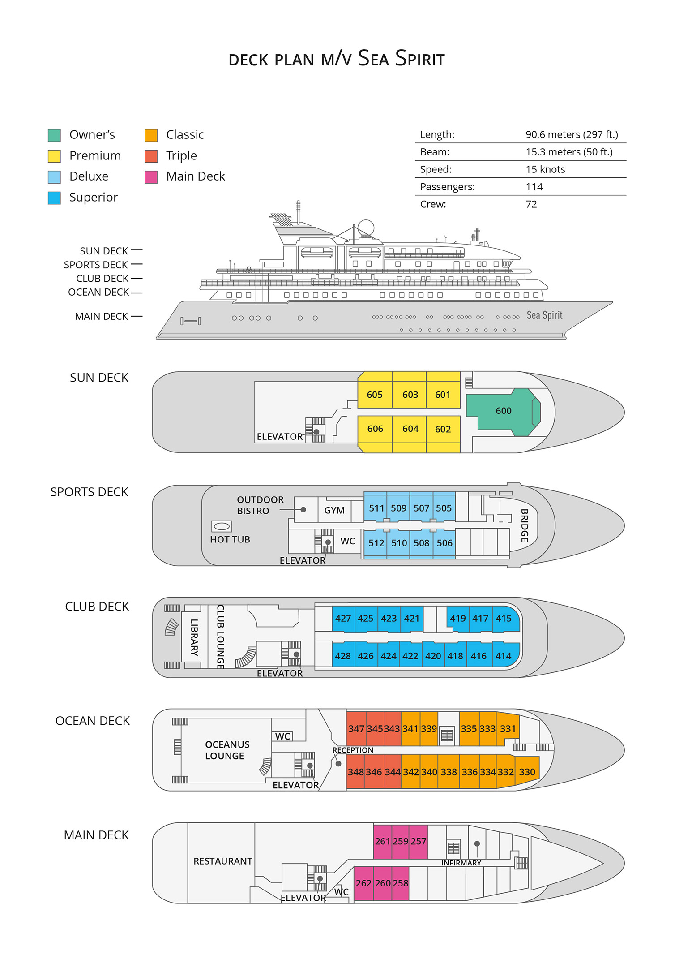

Triple Suite  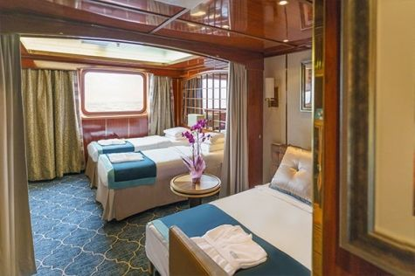  Averaging 21 square metres/226 square feet, these staterooms have two twins and a comfortable sofa bed. The twins also convert to a King, if desired. Located on Oceanus Deck, these suites have a picture window, two wardrobes and en suite facilities. Amenities include: in-room safe, refrigerator, satellite telephone access, TV/DVD, individual temperature control, and hair dryer. | Main Deck Suite  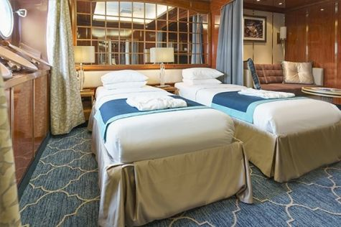  Averaging 23 square metres/248 square feet, Main Deck cabins are equipped with either two twins or a King Size bed. They are located on the Main Deck with a minimum of two portholes for exterior views. Amenities include: en suite facilities, in-room safe, refrigerator, satellite telephone access, TV/DVD individual temperature control and hair dryer.
Single Suite  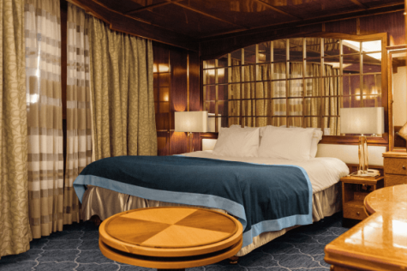  Averaging 21 square meters/226 square feet, these cabins are located on the Oceanus Deck. They feature a picture window (it may be covered during rough sea crossings), two wardrobes, and a King Size bed. Amenities include: en suite facilities, in-room safe, refrigerator, satellite telephone access, TV/VCR, individual temperature control, and hair dryer. | Classic Suite  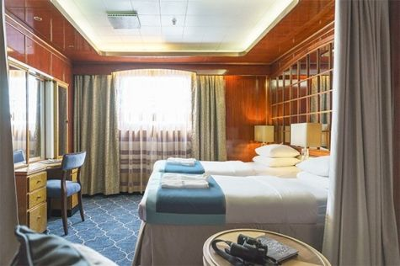  Averaging 21 square metres/226 square feet, these cabins are located on the Oceanus Deck. They feature a picture window, two wardrobes and a choice of either two twin beds or a King Size bed. Amenities include: en suite facilities, in-room safe, refrigerator, satellite telephone access, TV/DVD, individual temperature control and hair dryer.
Superior Suite  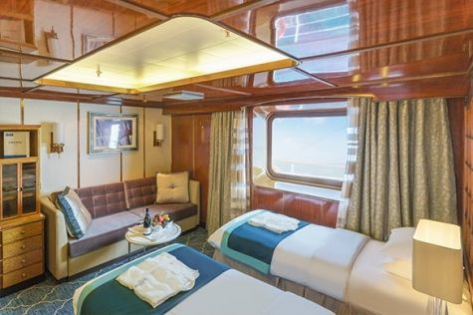  Superior Suites are located on the Club Deck. Averaging 20 square metres/ 215 square feet, these cabins feature two twin beds or a King Size bed. The picture window overlooks an outside walkway on the Club Deck. Amenities include: en suite facilities, walk-in closet or wardrobe, in-room safe, refrigerator, satellite telephone access, TV/DVD, individual temperature control, hair dryer. | Deluxe Suite  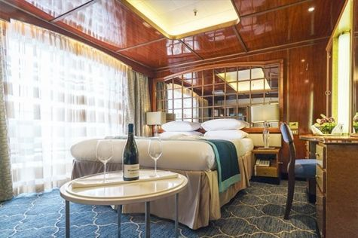  The Deluxe Suites with balconies are located on the Sports Deck. Averaging 24 square metres/ 258 square feet means plenty of room. Choose from either two twin beds or a King Size bed. A sliding glass door leads to a private balcony. These suites feature a walk-in closet or wardrobe. Amenities include en suite facilities, in-room safe, refrigerator, satellite telephone access, TV/DVD, individual temperature control, and a hair dryer.
Premium Suite  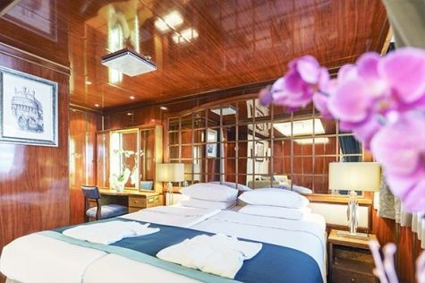  The Premium Suites are located on the Sun Deck. Averaging a generous 30 square metres/ 323 square feet, with two twin beds or a King Size bed. Access the private balcony by a sliding glass door. Amenities include: en suite facilities, lounge area, in-room safe, refrigerator, satellite telephone access, TV/DVD, individual temperature control, and hair dryer. | Owners Suite  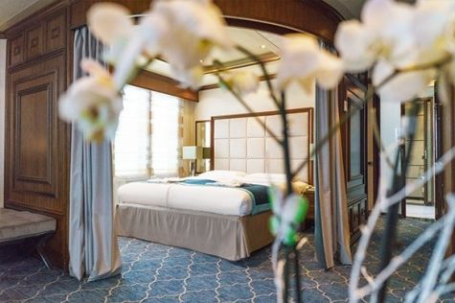  Super-spacious (63 square metres/ 678 square feet) elegant suite on the Sun Deck. Designed for entertaining, the Owner's Suite has a separate living room with game and meeting area. A BOSE stereo system provides background music, or watch videos on the HD plasma TV. Sliding glass doors lead to a private deck. Refresh in the jetted bathtub in en suite facilities. Slumber in the King Size bed. A sofa bed can accommodate a third person.

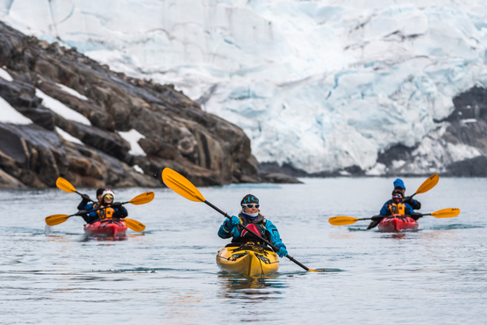 | Sea Kayaking  Kayaking fee $655 - A$885 - £505 - €625  Sea Kayak Club is typically offered on voyages that include High Arctic destinations such as Greenland, Svalbard (Spitsbergen), Franz Josef Land, or a combination of these thrilling places. Experience calving glaciers in Svalbard, cathedral-like icebergs in Greenland, or labyrinthine expanses of sea ice in the Arctic Ocean, all from our sturdy and stealthy sea kayaks. Join us for an unscripted kayaking adventure as we explore rugged coastlines and remote waters that very few people have ever paddled.
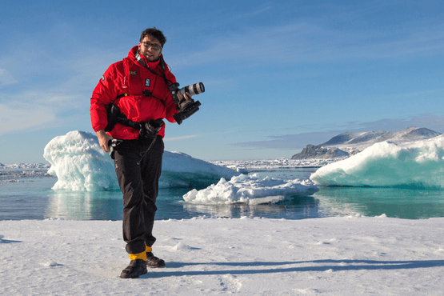 | Photography  Free option  The Polar Regions are perhaps the most photogenic on earth, with countless beautiful scenes presenting themselves every day. Endless expanses of ice, beaches crowded with seals or penguins, sunsets over unbroken horizons, starlit skies, and even the majestic northern lights – they all present fantastic photographic opportunities – and in order to make sure that you come home with some spectacular images we offer you the chance to learn and practice your photography alongside an experienced professional.  Our expert Photographer will be on hand to answer your questions and give advice, both in the form of on-board lectures and workshops on shore. Explore the key elements of photography in a fun and relaxed setting, with plenty of opportunities for questions and feedback. Learn how to see light in a new way and experiment with the techniques of composition and framing.

Rates Include  1 pre-voyage hotel night;  Group transfer from the airport to the hotel on a day prior to departure;  Group transfer to the ship on day of embarkation;  Shipboard accommodation;  All meals on board throughout the voyage;  Tea and coffee station 24 hours daily;  All scheduled landings/excursions (subject to weather and ice conditions);  Leadership throughout the voyage by our experienced Expedition Leader and Expedition Team;  Branded Poseidon Expeditions parka;  Rubber boots for shore landings for the time of the cruise;  Welcome and Farewell cocktails;  All port fees;  Group transfer to airport or central location upon disembarkation;  Pre-departure materials;  Digital Voyage Log; | Rates Do Not Include  Airfare;  Visa and passport fees (if applicable);  Luggage and trip cancellation insurance;  Soft drinks and alcoholic beverages other than those for special events and celebrations;  Personal expenses such as laundry and telecommunication charges;  Emergency Evacuation Insurance to a minimum benefit of USD 150,000;  Staff gratuities.
Itinerary, landings and all other activities during the cruise depend strongly on ice and weather conditions and are subject to the decisions of the Expedition Leader and the Captain of the vessel. Encounters with any mentioned wildlife cannot be guaranteed.

