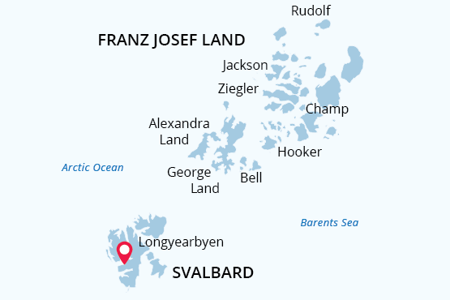

Franz Josef Land Archipelago
The Unexplored Frontier
09 Jul - 22 Jul 2021
14 days
Embarkation: Longyearbyen (Spitsbergen)
Disembarkation: Longyearbyen (Spitsbergen)
M/v Sea Spirit
Activities:

Itinerary
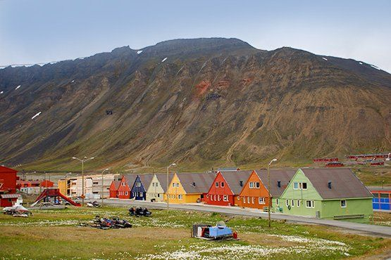Day 1: Arrival in Longyearbyen, Svalbard (hotel night)
Welcome to Longyearbyen, the administrative center of Svalbard and starting point of our Arctic expedition! At the Longyearbyen airport, you will be greeted by our staff and transferred to a quality hotel, which has been arranged by us and is included in the price of the itinerary. You will then be free to explore the charming, walkable town center.
We recommend starting your discovery of the High Arctic at the excellent Svalbard Museum, where you can also purchase hard-to-find polar books and maps. Afterward, you can enjoy an excellent dinner at one of Longyearbyen’s many delightful restaurants. If you are still awake at midnight, you will notice the sun has not set. In fact, the sun will not set for the entire duration of our time in Svalbard and Franz Josef Land.
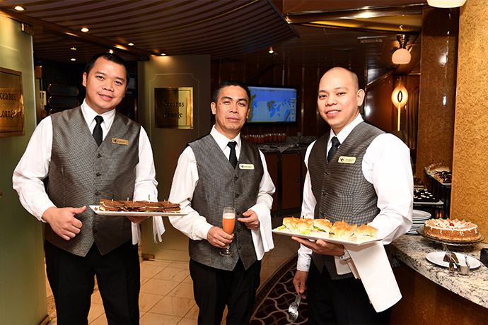Day 2: Welcome Aboard!
After breakfast at your hotel, the morning is yours to enjoy Longyearbyen. Take in the views of icy fjords and glaciated mountains surrounding this historic coal-mining town. Take advantage of shopping for souvenirs or some last-minute necessities such as cold-weather gear. Just remember, you will soon receive your very own parka to keep and waterproof boots to borrow on board the ship. For lunch, Longyearbyen offers quick and easy meal options including the most northerly pizzas and kebabs in the world.
In the afternoon, you will be transferred to the pier where we will warmly welcome you aboard the deluxe expedition vessel M/V Sea Spirit. Get settled in your spacious suite and explore the ship that will be your comfortable home during the extraordinary adventure to come. Once underway, a full schedule of events kicks off with informative briefings and introductions from your expedition staff. After the first of many delicious dinners on board, step out onto the open decks to admire the gorgeous scenery in endless evening light as we pass through the wildlife-rich waters of Isfjorden, one of the largest fjords in Svalbard.
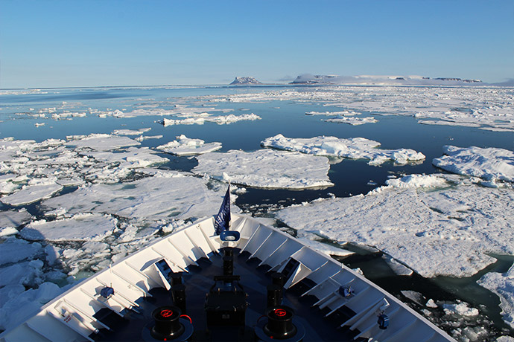Days 3-4: Across the Barents Sea
From Isfjorden, we sail south along the beautiful western coast of Spitsbergen, the largest island in the Svalbard archipelago, before rounding Sørkapp to enter the wild Barents Sea. During our northeastward crossing to Franz Josef Land, we are likely to encounter large swaths of sea ice. Such conditions were the bane of early explorers in wooden sailing ships. But for us, with the benefit of an ice-strengthened ship and advanced navigation systems, the ice is a welcome opportunity for finding harp seals and polar bears. These cold, nutrient-rich waters are also home to numerous whale species, including humpback whales, fin whales and endangered bowhead whales. Our veteran wildlife guides are on duty around the clock to point the way to marine mammals and Arctic seabirds in this vast frontier of ice and water. Sometime during the second day of sailing, we expect to see the massive ice dome of Alexandra Land come into view through the icy mists—our first sighting of the enigmatic Franz Josef Land archipelago.
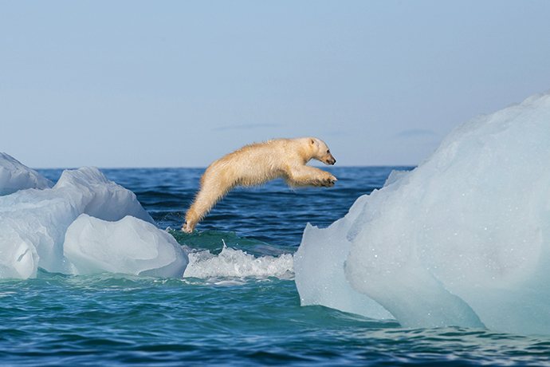Days 5-11: Franz Josef Land Archipelago
Upon reaching Russian waters, we head directly to the extremely remote military base at Nagurskoye for immigration clearance into the Russian Federation. During this process, we will be anchored in Cambridge Bay, one of the best places in Franz Josef Land for spotting marine mammals.
For the rest of our time in Franz Josef Land, we will be free to explore the many islands of this dramatic High Arctic wilderness in whatever way best suits the conditions we encounter. As with any true polar expedition, our schedule and route will be shaped by weather and ice. At this time of year, we expect to find sea ice almost everywhere. This will give us plenty of chances to enjoy the incredible sight of polar bears and walrus on ice. With the advantage of 24-hour daylight, we will make the most of every opportunity for exploration and wildlife viewing, no matter where we may find ourselves in this vast polar wilderness.
The entirety of Franz Josef Land belongs to the Russian Arctic National Park, one of the most remote and inaccessible nature sanctuaries on our planet. Ubiquitous glaciers and ice caps create a scene of otherworldly beauty. Polar bears and Arctic foxes are especially abundant in the stark and primeval icescapes of this virgin wilderness. Icy channels and fjords are home to ice-dependent seals, including harp seals, bearded seals and a large population of walrus. Keen observers are also likely to spot Arctic whales such as bowheads, belugas or even narwhal. Mountainsides and sea cliffs throughout the islands host enormous nesting colonies of migratory seabirds such as guillemots, little auks, northern fulmars, ivory gulls, and many more. Arctic flora is particularly abundant now at the peak of the blooming season.
Since its discovery in 1873, Franz Josef Land has been a stage for incredible events in the history of polar exploration. The heroic struggles of Fridtjof Nansen and other famous explorers feel unexpectedly poignant at well-preserved historical sites such as Cape Norway and Cape Flora. Memorials, monuments, crosses and the remains of dwellings are testimony to incredible events that are further illuminated by our polar historians.
Additional highlights on our itinerary include Tikhaya Bukhta, a Russian Arctic National Park ranger station occupying Soviet-era research buildings. Here you can talk to station personnel and buy unique souvenirs at the gift shop. We also hope to explore some fascinating geological features, such as the mysterious stone spheres on Champ Island and the amazing basaltic columns at the Rubini Rock seabird colony. Collectors of geographical extremes may also take note that Cape Fligely on Rudolf Island is the northernmost point of land in Eurasia and the Eastern Hemisphere.
This exciting Arctic cruise is your chance to explore one of the world’s most intriguing polar environments. Each trip to Franz Josef Land is a one-of-a-kind adventure. Your custom voyage map will reflect an expedition as unique and memorable as this incomparable destination, full of unscripted wildlife encounters and unforgettable discoveries.
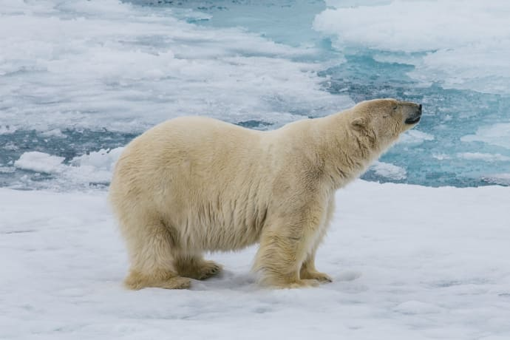Days 12-13: Back to Svalbard
After our amazing time in Franz Josef Land, we head back across the icy Barents Sea toward Svalbard. Seabird viewing and whale sightings can be enjoyed from panoramic open decks and from the windows or balcony of your suite. Presentations by our expert staff and range of onboard recreation facilities also ensure that these sea days are not idly spent.
As we head back toward Longyearbyen, we round the southern tip of Spitsbergen, the largest island in the Svalbard archipelago. As time and conditions permit, we may have the opportunity to visit the magnificent South Spitsbergen National Park, a pristine polar wilderness abounding with Arctic animals. The centerpiece of this park is Hornsund, a picture-perfect fjord system where countless mighty glaciers cascade from soaring mountaintops into icy inlets. This is a prime location to spot polar bears and other marine wildlife from the ship.
We also have a chance to explore North Isforden National Park. This outstanding protected area is characterized by lush and beautiful landscapes, striking geological features and excellent wildlife-viewing opportunities. Along these virgin coastlines, it is possible to observe endemic Svalbard reindeer and playful Arctic fox romping in flowering tundra meadows. The area also hosts huge flocks of migratory seabirds, including Brünnich’s guillemots, little auks and Atlantic puffins.
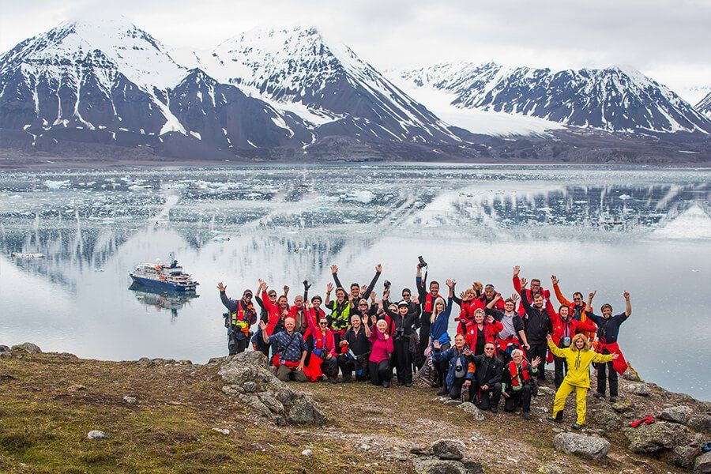Day 14: Disembarkation in Longyearbyen, Svalbard
After filling up at your final buffet breakfast on board, we bid you farewell in Longyearbyen. We provide transfers to the airport or to the town center in case you plan to stay longer in Svalbard. As you look back on your wonderful experience in Franz Josef Land, you may already be planning to your next polar expedition with us!

M/v Sea Spirit
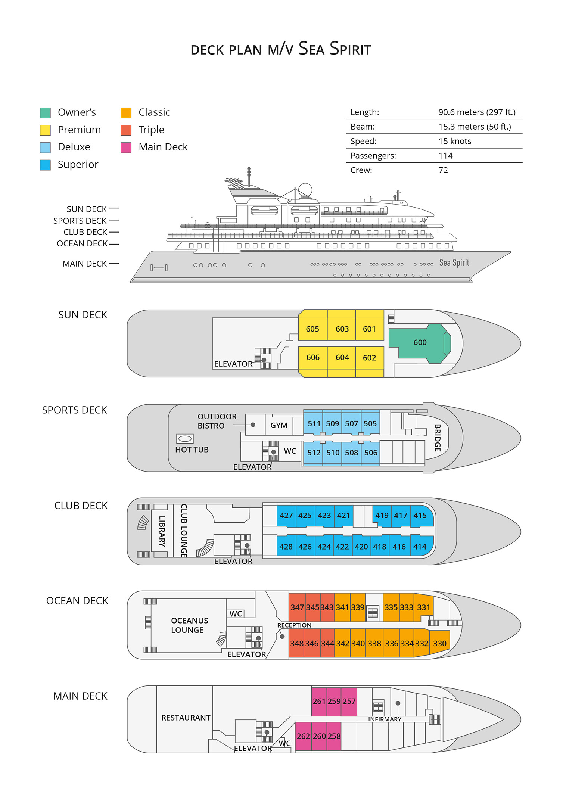

Triple Suite  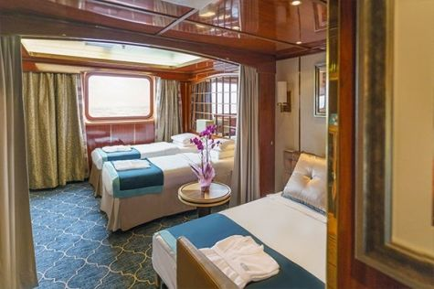  Averaging 21 square metres/226 square feet, these staterooms have two twins and a comfortable sofa bed. The twins also convert to a King, if desired. Located on Oceanus Deck, these suites have a picture window, two wardrobes and en suite facilities. Amenities include: in-room safe, refrigerator, satellite telephone access, TV/DVD, individual temperature control, and hair dryer. | Main Deck Suite  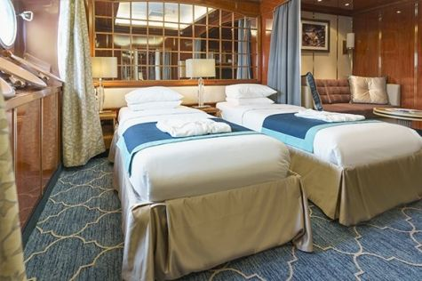  Averaging 23 square metres/248 square feet, Main Deck cabins are equipped with either two twins or a King Size bed. They are located on the Main Deck with a minimum of two portholes for exterior views. Amenities include: en suite facilities, in-room safe, refrigerator, satellite telephone access, TV/DVD individual temperature control and hair dryer.
Single Suite  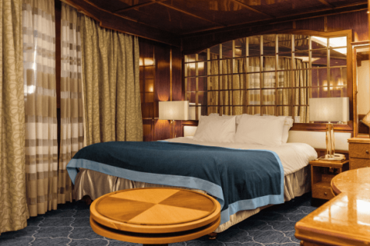  Averaging 21 square meters/226 square feet, these cabins are located on the Oceanus Deck. They feature a picture window (it may be covered during rough sea crossings), two wardrobes, and a King Size bed. Amenities include: en suite facilities, in-room safe, refrigerator, satellite telephone access, TV/VCR, individual temperature control, and hair dryer. | Classic Suite  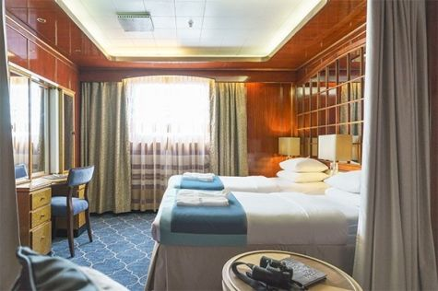  Averaging 21 square metres/226 square feet, these cabins are located on the Oceanus Deck. They feature a picture window, two wardrobes and a choice of either two twin beds or a King Size bed. Amenities include: en suite facilities, in-room safe, refrigerator, satellite telephone access, TV/DVD, individual temperature control and hair dryer.
Superior Suite  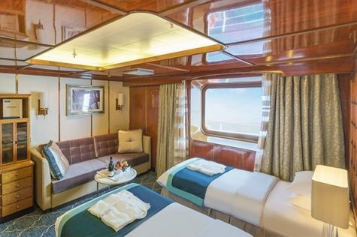  Superior Suites are located on the Club Deck. Averaging 20 square metres/ 215 square feet, these cabins feature two twin beds or a King Size bed. The picture window overlooks an outside walkway on the Club Deck. Amenities include: en suite facilities, walk-in closet or wardrobe, in-room safe, refrigerator, satellite telephone access, TV/DVD, individual temperature control, hair dryer. | Deluxe Suite  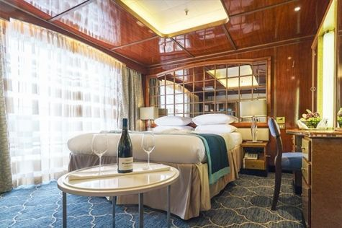  The Deluxe Suites with balconies are located on the Sports Deck. Averaging 24 square metres/ 258 square feet means plenty of room. Choose from either two twin beds or a King Size bed. A sliding glass door leads to a private balcony. These suites feature a walk-in closet or wardrobe. Amenities include en suite facilities, in-room safe, refrigerator, satellite telephone access, TV/DVD, individual temperature control, and a hair dryer.
Premium Suite  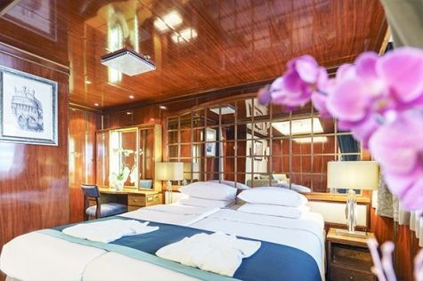  The Premium Suites are located on the Sun Deck. Averaging a generous 30 square metres/ 323 square feet, with two twin beds or a King Size bed. Access the private balcony by a sliding glass door. Amenities include: en suite facilities, lounge area, in-room safe, refrigerator, satellite telephone access, TV/DVD, individual temperature control, and hair dryer. | Owners Suite  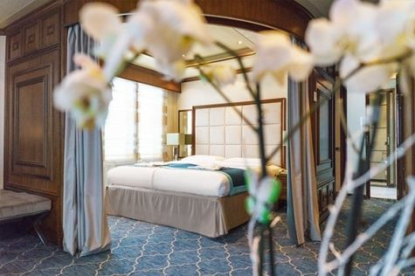  Super-spacious (63 square metres/ 678 square feet) elegant suite on the Sun Deck. Designed for entertaining, the Owner's Suite has a separate living room with game and meeting area. A BOSE stereo system provides background music, or watch videos on the HD plasma TV. Sliding glass doors lead to a private deck. Refresh in the jetted bathtub in en suite facilities. Slumber in the King Size bed. A sofa bed can accommodate a third person.

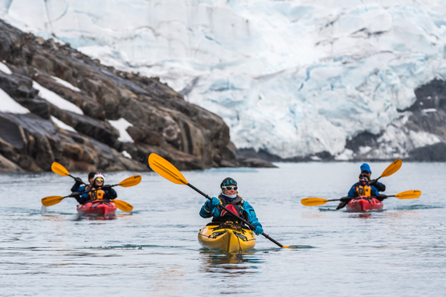 | Sea Kayaking  Kayaking fee $655 - A$885 - £505 - €625  Sea Kayak Club is typically offered on voyages that include High Arctic destinations such as Greenland, Svalbard (Spitsbergen), Franz Josef Land, or a combination of these thrilling places. Experience calving glaciers in Svalbard, cathedral-like icebergs in Greenland, or labyrinthine expanses of sea ice in the Arctic Ocean, all from our sturdy and stealthy sea kayaks. Join us for an unscripted kayaking adventure as we explore rugged coastlines and remote waters that very few people have ever paddled.
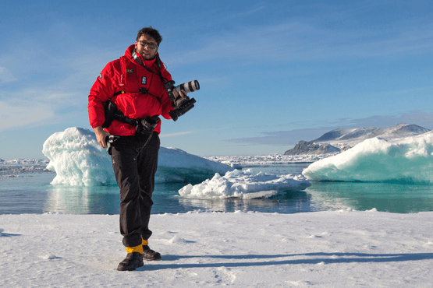 | Photography  Free option  The Polar Regions are perhaps the most photogenic on earth, with countless beautiful scenes presenting themselves every day. Endless expanses of ice, beaches crowded with seals or penguins, sunsets over unbroken horizons, starlit skies, and even the majestic northern lights – they all present fantastic photographic opportunities – and in order to make sure that you come home with some spectacular images we offer you the chance to learn and practice your photography alongside an experienced professional.  Our expert Photographer will be on hand to answer your questions and give advice, both in the form of on-board lectures and workshops on shore. Explore the key elements of photography in a fun and relaxed setting, with plenty of opportunities for questions and feedback. Learn how to see light in a new way and experiment with the techniques of composition and framing.

Rates Include  1 pre-voyage night on Day 1 in Radisson Blu Polar Hotel Spitsbergen in Longyearbyen;  Group transfer from the airport to the hotel on the day prior to embarkation;  Group transfer to the ship for embarkation on Day 2;  Shipboard accommodation;  All meals on board throughout the voyage;  Tea and coffee station 24 hours daily;  All scheduled landings/excursions (subject to weather and ice conditions);  Leadership throughout the voyage by our experienced Expedition Leader and Expedition Team;  Branded Poseidon Expeditions parka;  Rubber boots for shore landings for the time of the cruise;  Welcome and Farewell cocktails;  All port fees;  Group transfer to airport or central location upon disembarkation;  Pre-departure materials;  Digital Voyage Log;  Wi-Fi on board. | Rates Do Not Include  Airfare;  Transfers from the airport to the hotel if arriving prior to Day 1 of the program;  Visa and passport fees. For this trip Russian visa is required. See your country’s Russian consulate or embassy for details;  Luggage and trip cancellation insurance;  Soft drinks and alcoholic beverages other than those for special events and celebrations;  Personal expenses such as laundry and telecommunication charges;  Mandatory Emergency Evacuation Insurance to a minimum benefit of US$ 200,000 per person;  Kayaking;  Staff gratuities.
Itinerary, landings and all other activities during the cruise depend strongly on ice and weather conditions and are subject to the decisions of the Expedition Leader and the Captain of the vessel. Encounters with any mentioned wildlife cannot be guaranteed.

