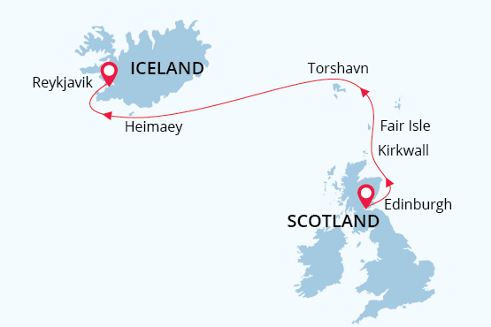

Best of British Isles
Scotland, Faroe Islands and Iceland
19 May - 28 May 2022
10 days
Embarkation: Edinburgh (Scotland)
Disembarkation: Reykjavik (Iceland)
M/v Sea Spirit
Activities:

Itinerary
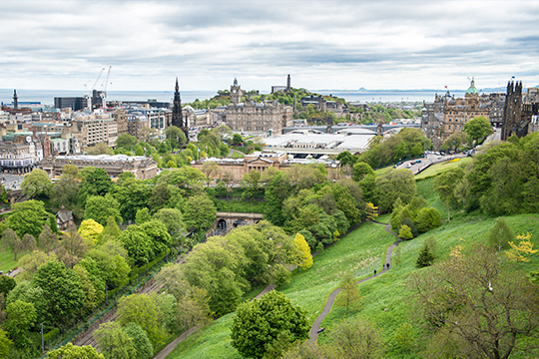Day 1: Arrival in Edinburgh, Scotland (hotel night)
Welcome to Edinburgh, the capital of Scotland and starting point of our trans-Atlantic expedition. To provide you with more time to enjoy this metropolis rich in history and culture, we’ve arranged pre-cruise hotel accommodations near the city center. Relax and take a stroll through town, enjoying both medieval and classic 18th-century architecture. The famous Edinburgh Castle rises majestically above it all.
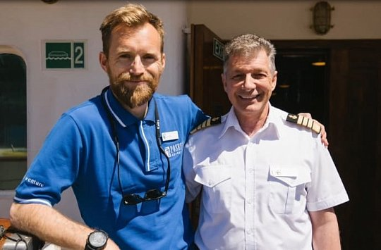Day 2: Welcome Aboard!
Enjoy the morning and early afternoon at leisure. Each corner of Edinburgh’s old streets opens beautiful unexpected vistas of green hills or a blue flash of the distant sea. In the afternoon, you will be transferred from the hotel to the ship in the nearby Port of Leith. Before dinner, there’s time to explore the Sea Spirit, your home-away-from home for the next nine days.
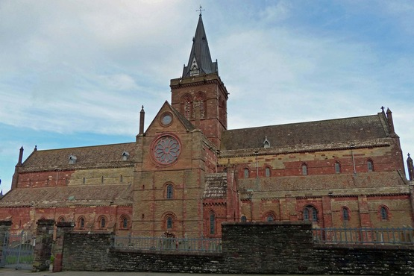Day 3: Kirkwall, Orkney Islands, Scotland
Kirkwall, capital of the Orkney Archipelago, is a small, quiet town, with a gentle pace of life. It was first mentioned in Orkneyinga saga in 1046. Such a long history has left a rich heritage which we explore today on an included tour. The most famous sites in town are the sandstone St. Magnus Cathedral, considered to be the finest medieval building in the north of Scotland, the Bishop’s Palace and the Earl’s Palace.
We leave town and head west, passing through the gentle rolling landscape of the Orkney’s largest island, Mainland, and into the Neolithic heartland, an area designated as a World Heritage Site due to its wealth of pre-historic archaeology. Passing the Standing Stones of Stenness, we will stop at the Ring of Brodgar – a huge ceremonial circle of stones dating back almost 5,000 years. We then continue on to the 5,000-year-old village of Skara Brae, with remarkable dwellings first revealed beneath the sand dunes by storms just 150 years ago. Return to the ship for dinner and a late evening departure.
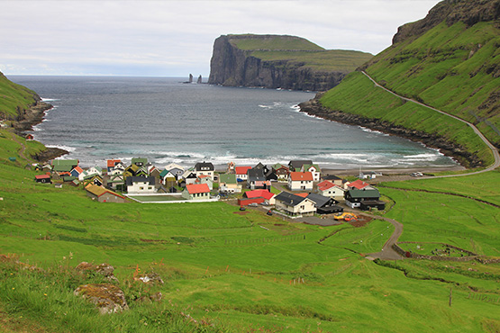Day 4: North Ronaldsay, Orkney Islands; Fair Isle, Shetland Islands, Scotland
You can expect a physically more active day, as the places we visit become more remote with less tourism infrastructure. This morning, we land at North Ronaldsay, the most distant isle of the Orkneys, with a population of about 70 people. The isle supports an extremely rich and diverse population of wild flowers, birdlife and flocks of the unusual seaweed-eating North Ronaldsay sheep. Many migrating species of birds stop here in spring and autumn, while there are also many breeding species which spend the spring and summer at the island. Escorted by our knowledgeable expedition staff, we’ll plan to hike and birdwatching in this picturesque landscape.
During lunch on board, we head to Fair Isle, a real paradise for birdwatchers. The lush grasslands and spectacular cliffs are inhabited by huge number of birds. Over 345 species have been recorded here – more than anywhere else in Britain. The variety of bird life inspired the ornithologist George Waterston to build a bird observatory here in 1948. Enjoy a pleasant afternoon walk across the island, visit the newly refurbished observatory and see thousands of northern fulmars, kittiwakes, northern gannets, puffins, and great and arctic skuas.
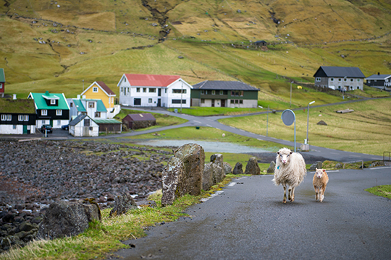Days 5-7:­ Exploring the Faroe Islands
National Geographic Traveler had designated the Faroe Islands as “authentic, unspoiled and likely to remain so”. Nature has spared no colors in painting the islands: deep-green hills, bright blue sea, colorful houses and boats, and puffins’ orange-red beaks make the landscape unforgettable.

The rugged Faroese are proud of their Viking heritage and their love of the sea. We will explore the archipelago with possible stops in:

Tórshavn. This would include a visit to Kirkjubøur, the ecclesiastical and cultural center of the Faroes in the Middle Ages. It was the site of the Bishop’s residence until the Reformation, when the Faroese diocese was abolished. The imposing Gothic ruin of the late 13th-century Saint Magnus Cathedral still dominates the site. The Roykstovan, standing on the wide, stone foundation of a portion of the Bishop’s palace, has been the home of farmers in Kirkjubøur for centuries and occupied by the same Faroese family for 17 generations. There are magnificent views to the west and the islands of Koltur, Hestur, Sandoy, and Vágar.

Klaksvík, the second-largest town in the Faroes and an important fishing and shipping port. Charcoal gray, snow-dusted mountains create a spectacular backdrop to our visit. The town originated from four farms which grew into four villages and ultimately into a modern town in the late 1939s. Some light hiking and birdwatching are possible in areas selected by local guides and our expedition team.

Our expedition team will also search for more remote areas of the archipelago to visit or pause, where we can take advantage of the ship and possibly Zodiacs to see bird cliffs and other natural wonders that are otherwise difficult to access.
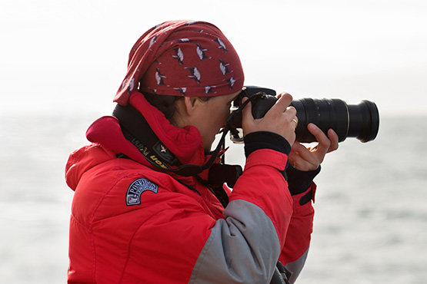Day 8: At Sea, En route to Iceland
Today is for relaxation on board or watching for seabirds and aquatic life in the Atlantic’s pelagic layers from the Sea Spirit’s decks or open bridge. When they’re not busy giving informative presentations on the geology, wildlife or Viking heritage of the Faroes and Iceland in the Oceanus Lounge, the expedition team will be happy to answer your questions.
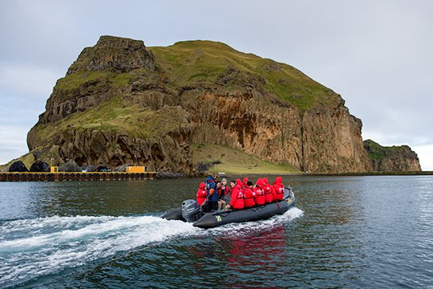Day 9: Vestmannaeyjar, Heimaey, Iceland
Sometimes anglicized as Westman Islands, Vestmannaeyjar is the name of the small town of 4,200 inhabitants as well as the 15-island archipelago that is located off the south coast of Iceland. It came to the world’s attention in 1973 with the eruption of the Eldfell volcano, which forced the evacuation of the entire population. It has a unique microclimate, and more than 30 species of birds nest in the millions in the high cliffs and grassyledges.
Vestmannaeyjar – literally “the islands of the westmen” – is named after the Irish slaves brought here by the Vikings. A full day here will provide us with time to tour the small town and travel into more windswept and remote areas for hiking and views of massive breeding colonies of migratory birdlife. Tonight, as the Sea Spirit departs Vestmannaeyjar, enjoy the Captain’s farewell cocktail party and festive dinner.
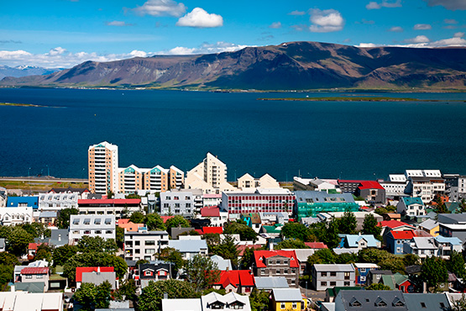Day 10: Reykjavik, Disembarkation, Iceland
We finish our journey in the capital city of Iceland where, after breakfast, guests will disembark and be transferred to either the International Airport or the city center.

Special guest
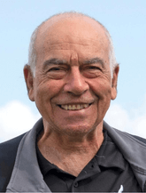Moshe Agami
Lecturer
Moshe is a Professor of Botany (ret.) from Tel Aviv University, Israel. He has published books and many research articles in international journals of botany and ecology. He held the position of Director of the Botanical Gardens in Tel Aviv University for 13 years. He gives lectures on phytogeography, ecology, and adaptations of plants to different environmental conditions, climatology and vegetation life zones on earth, etc. Moshe has substantial knowledge of wild plants (and animals too) and ecology, from 1972 he has exposed thousands of accompanying nature lovers to nature's wonders on more than 200 excursions and voyages across 7 continents. Guiding in expeditions in the Russian Far East, including Sea of Okhotsk, Kamchatka, Chukotka and Wrangle Island. He guided around Melanesia to Papua New Guinea, The Solomon’s and Vanuatu. Moshe has also guided in Antarctica, South Georgia and Falkland Islands as well as the Subantarctic Islands and the Ross Sea, Greenland, the Galapagos Islands, Svalbard, Seychelles (including Aldabra), etc.
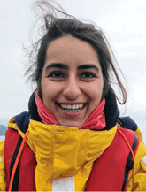Yaara Agami
Lecturer
An experienced and passionate journalist, formally the Foreign Affairs correspondent of GLZ, the most popular radio station in Israel, and the Editor in Chief of its foreign news magazine. She is writing comprehensive nature and history articles for Ynet, the most viewed Israeli news website, and giving lectures on the history of Asia, Europe, Africa and the North Pole. Interviewed Prime Ministers, Senators, Nobel prize winners, leading scientists, etc. An Expedition Leader to Seychelles and Aldabra Atoll in the Indian Ocean and a nature tours guide to the Galapagos, Ecuador and Tanzania. Traveled to more than 30 countries including Kamchatka and Wrangel in the Russian Far East, Mongolia, Sri Lanka, Japan, China, Nepal, Turkey, Namibia, Lapland, etc. UWC International College graduate in Bosnia and Herzegovina.

M/v Sea Spirit
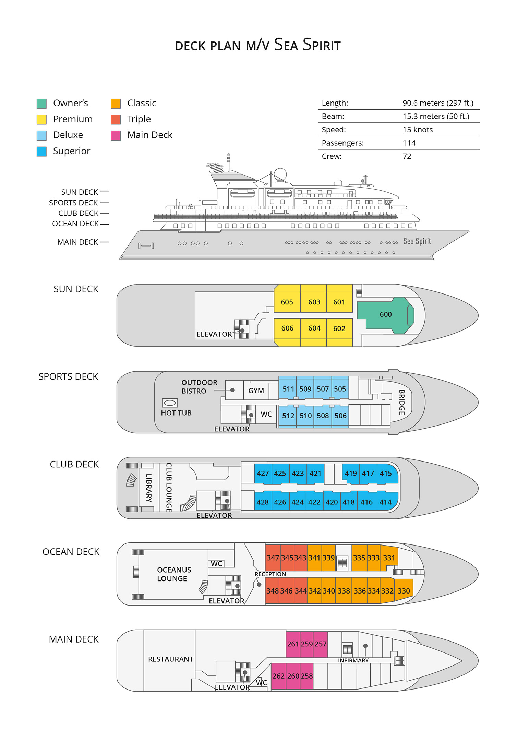

Triple Suite  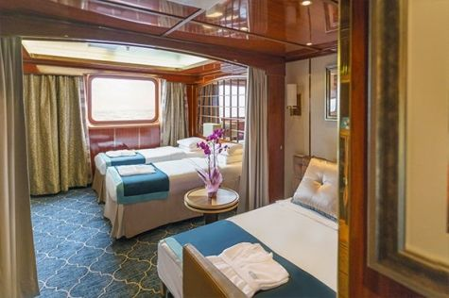  Averaging 21 square metres/226 square feet, these staterooms have two twins and a comfortable sofa bed. The twins also convert to a King, if desired. Located on Oceanus Deck, these suites have a picture window, two wardrobes and en suite facilities. Amenities include: in-room safe, refrigerator, satellite telephone access, TV/DVD, individual temperature control, and hair dryer. | Main Deck Suite  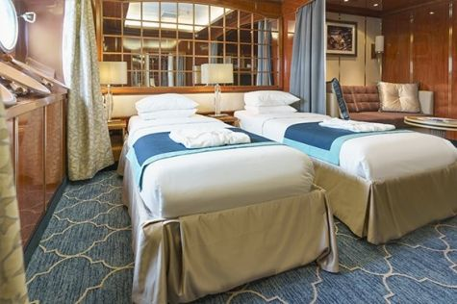  Averaging 23 square metres/248 square feet, Main Deck cabins are equipped with either two twins or a King Size bed. They are located on the Main Deck with a minimum of two portholes for exterior views. Amenities include: en suite facilities, in-room safe, refrigerator, satellite telephone access, TV/DVD individual temperature control and hair dryer.
Single Suite  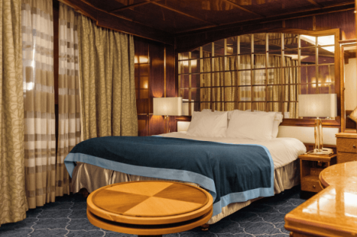  Averaging 21 square meters/226 square feet, these cabins are located on the Oceanus Deck. They feature a picture window (it may be covered during rough sea crossings), two wardrobes, and a King Size bed. Amenities include: en suite facilities, in-room safe, refrigerator, satellite telephone access, TV/VCR, individual temperature control, and hair dryer. | Classic Suite  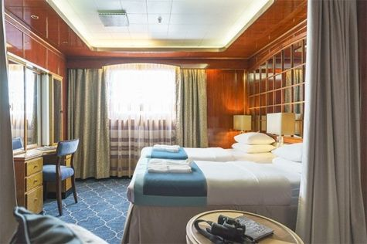  Averaging 21 square metres/226 square feet, these cabins are located on the Oceanus Deck. They feature a picture window, two wardrobes and a choice of either two twin beds or a King Size bed. Amenities include: en suite facilities, in-room safe, refrigerator, satellite telephone access, TV/DVD, individual temperature control and hair dryer.
Superior Suite  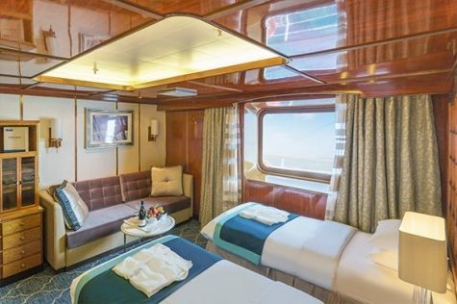  Superior Suites are located on the Club Deck. Averaging 20 square metres/ 215 square feet, these cabins feature two twin beds or a King Size bed. The picture window overlooks an outside walkway on the Club Deck. Amenities include: en suite facilities, walk-in closet or wardrobe, in-room safe, refrigerator, satellite telephone access, TV/DVD, individual temperature control, hair dryer. | Deluxe Suite  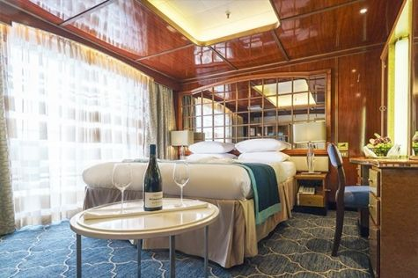  The Deluxe Suites with balconies are located on the Sports Deck. Averaging 24 square metres/ 258 square feet means plenty of room. Choose from either two twin beds or a King Size bed. A sliding glass door leads to a private balcony. These suites feature a walk-in closet or wardrobe. Amenities include en suite facilities, in-room safe, refrigerator, satellite telephone access, TV/DVD, individual temperature control, and a hair dryer.
Premium Suite  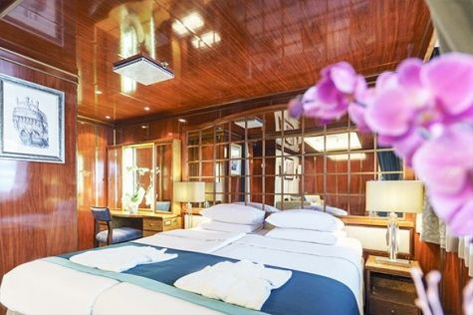  The Premium Suites are located on the Sun Deck. Averaging a generous 30 square metres/ 323 square feet, with two twin beds or a King Size bed. Access the private balcony by a sliding glass door. Amenities include: en suite facilities, lounge area, in-room safe, refrigerator, satellite telephone access, TV/DVD, individual temperature control, and hair dryer. | Owners Suite  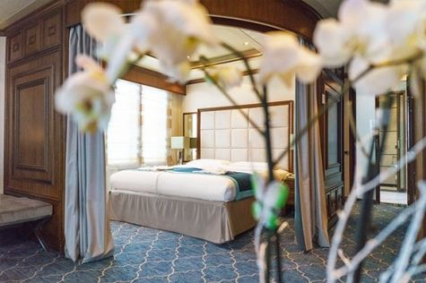  Super-spacious (63 square metres/ 678 square feet) elegant suite on the Sun Deck. Designed for entertaining, the Owner's Suite has a separate living room with game and meeting area. A BOSE stereo system provides background music, or watch videos on the HD plasma TV. Sliding glass doors lead to a private deck. Refresh in the jetted bathtub in en suite facilities. Slumber in the King Size bed. A sofa bed can accommodate a third person.

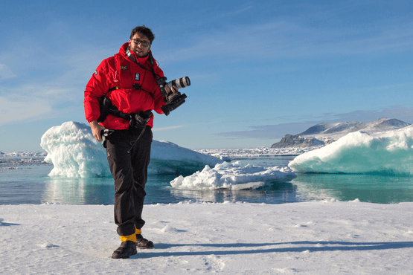 | Photography  Free option  The Polar Regions are perhaps the most photogenic on earth, with countless beautiful scenes presenting themselves every day. Endless expanses of ice, beaches crowded with seals or penguins, sunsets over unbroken horizons, starlit skies, and even the majestic northern lights – they all present fantastic photographic opportunities – and in order to make sure that you come home with some spectacular images we offer you the chance to learn and practice your photography alongside an experienced professional.  Our expert Photographer will be on hand to answer your questions and give advice, both in the form of on-board lectures and workshops on shore. Explore the key elements of photography in a fun and relaxed setting, with plenty of opportunities for questions and feedback. Learn how to see light in a new way and experiment with the techniques of composition and framing.

Rates Include  1 pre-voyage hotel night in the Radisson Blu Hotel in Edinburgh;  Group transfer to the ship for embarkation on Day 2;  Shipboard accommodation;  All meals on board throughout the voyage;  Tea and coffee station 24 hours daily;  All scheduled landings/excursions (subject to weather and ice conditions);  Leadership throughout the voyage by our experienced Expedition Leader and Expedition Team;  Branded Poseidon Expeditions parka;  Rubber boots for shore landings for the time of the cruise;  Welcome and Farewell cocktails;  All port fees;  Group transfer to airport or central location upon disembarkation;  Pre-departure materials;  Digital Voyage Log;  Wi-Fi on board. | Rates Do Not Include  Airfare;  Visa and passport fees (if applicable);  Luggage and trip cancellation insurance;  Soft drinks and alcoholic beverages other than those for special events and celebrations;  Personal expenses such as laundry and telecommunication charges;  Mandatory Emergency Evacuation Insurance to a minimum benefit of US$ 200,000 per person;  The cost of any applicable medical tests (such as COVID-19) or vaccinations required either by a national government or Poseidon Expeditions before, during or after the cruise;  Staff gratuities.
Itinerary, landings and all other activities during the cruise depend strongly on ice and weather conditions and are subject to the decisions of the Expedition Leader and the Captain of the vessel. Encounters with any mentioned wildlife cannot be guaranteed.

