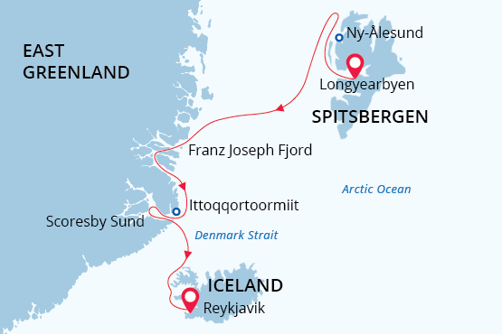

Svalbard, Greenland & Iceland
Arctic Odyssey
09 Aug - 23 Aug 2023
15 days
Embarkation: Longyearbyen (Svalbard)
Disembarkation: Reykjavik (Iceland)
M/v Sea Spirit
Activities:

Itinerary
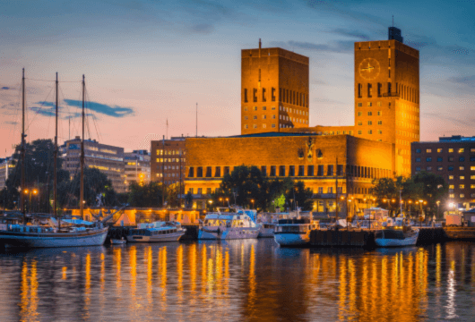Day 1: Arrival to Oslo
Welcome to Oslo, which in 2019 was awarded the prestigious title “Green Capital of Europe”. We’ve arranged a comfortable stay for you at an Oslo Airport hotel so that you’re conveniently close for your flight to Longyearbyen on Day 2.
If you’re adventurous and have the time, take the handy airport train into central Oslo – it’s a 20-minute ride and trains depart and arrive frequently during the day. Near Oslo Central Station are shops, cafes, the Botanical Garden, cultural attractions and the attractive waterfront area.
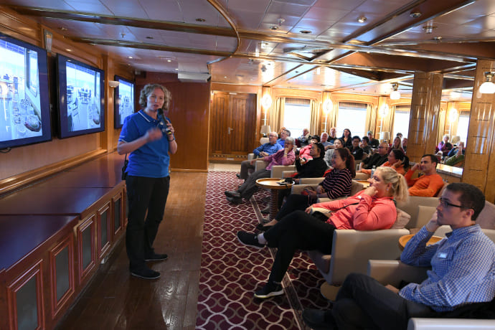Day 2: Embarkation in Longyearbyen
Today you have a flight to Longyearbyen, the administrative center of Svalbard and starting point of our Arctic expedition! At the Longyearbyen airport, you will be greeted by our staff and transferred to the pier where we will warmly welcome you aboard the deluxe expedition vessel M/V Sea Spirit. Get settled in your spacious suite and explore the ship that will be your comfortable home during the extraordinary adventure to come. Once underway, a full schedule of events kicks off with informative briefings and introductions from your expedition staff. After the first of many delicious dinners on board, step out onto the open decks to admire the gorgeous scenery in endless evening light as we pass through the wildlife-rich waters of Isfjorden, one of the largest fjords in Svalbard.
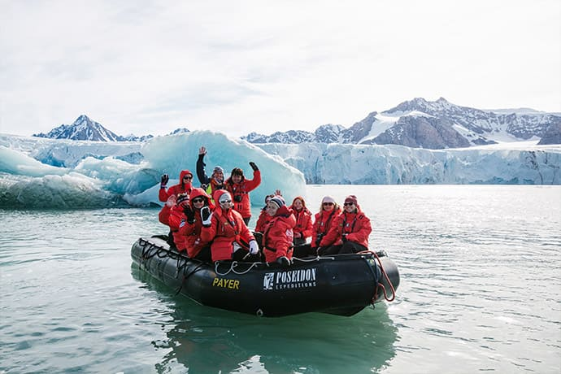Day 3-4: Exploration of Svalbard
Svalbard is a true High Arctic wilderness and this part of the voyage is a real expedition. Our route and exploration opportunities here are heavily dependent on the weather and sea ice conditions we encounter. Our experienced captain and expedition leader decide the itinerary and continually adjust plans as conditions and opportunities warrant. You can be sure that the best possible advantage will be taken of the circumstances presented to us by Nature in this wild and remote corner of the Arctic. We anticipate exploring in the northwestern part of the island of Spitsbergen. This area contains the archipelago’s most impressive scenery and some of the Arctic’s best wildlife viewing opportunities. Deep fjords and narrow channels are flanked by jagged snowy mountain peaks. Immense tidewater glaciers calve icebergs into turquoise waters. Fields of flowering tundra are home to grazing reindeer and playful Arctic fox. Bountiful inshore and offshore waters are home to a wide variety of marine mammals. Polar Bears can be spotted anytime, anywhere in and around Svalbard. Also in this area is Ny Ålesund, a former mining town that is now home to an international community of Arctic researchers, complete with museum, gift shop, and post office. This was also a staging area for historic attempts to discover the North Pole.
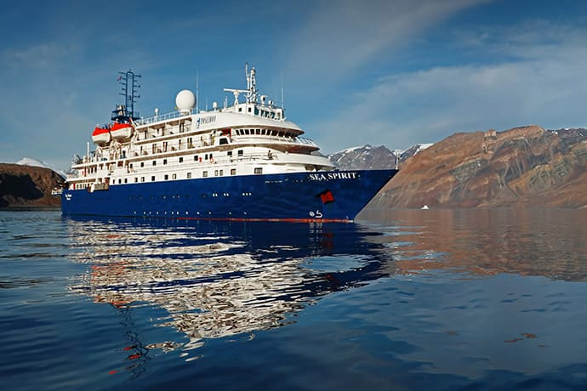Day 5-6: Across the Greenland Sea
From Svalbard we head southwest across the Greenland Sea toward East Greenland. In these far northern latitudes it is possible to encounter sea ice any time of the year. All along the way we remain vigilant for sightings of marine mammals such as whales, seals, and the majestic polar bear. As we head south, darker nights create a high possibility of seeing aurora borealis.
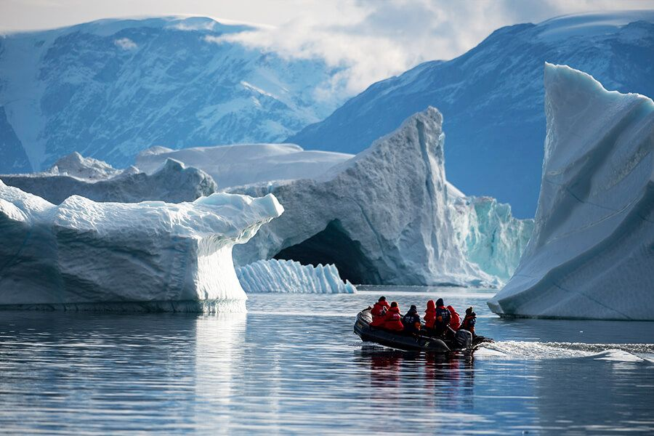Day 7-12: Exploration of East Greenland
This is expedition cruising at its most authentic. Our itinerary and exploration opportunities in East Greenland are dependent on weather and sea ice conditions. Again you can be sure that our experienced captain and expedition leader will take advantage of every opportunity to experience excellent wildlife viewing, to discover incredible scenery, and to go ashore wherever possible. The Franz Josef Fjord and Kong Oscar Fjord systems are part of Northeast Greenland National Park, the world’s largest national park. Scoresby Sund is the largest and longest fjord system in the world. We anticipate exploring these fjord systems to the extent made possible by ever-changing ice conditions. This whole area contains some of the Arctic’s most impressive scenery. Deep fjords and narrow channels, flanked by ice-clad peaks up to 2000 meters high, reach far into the mountainous heart of Greenland. Tidewater glaciers create colossal icebergs that float with wind and tide throughout the fjord system. On shore, fields of multicolored tundra are home to musk oxen and Arctic hare. The landscape—vast, open, and seemingly untouched since the beginning of time—is a hikers’ paradise. Throughout this area we also find ancient Thule archeological sites, historical trappers’ huts, and modern Inuit hunters’ cabins. The Inuit village of Ittoqqortoormiit is the only permanent settlement in the region. The community boasts an excellent museum, a gift shop, a post office, an abundance of Greenlandic sled dogs, and of course the opportunity to meet Inuit people. The days are filled with memorable excursions, sumptuous meals, presentations by our experts, and enough stunning scenery to fill your camera and overwhelm your emotions. Each night brings new possibilities for incredible displays of aurora borealis—the Northern Lights. This is the perfect time and one of the world’s best places to experience this otherworldly celestial phenomenon.
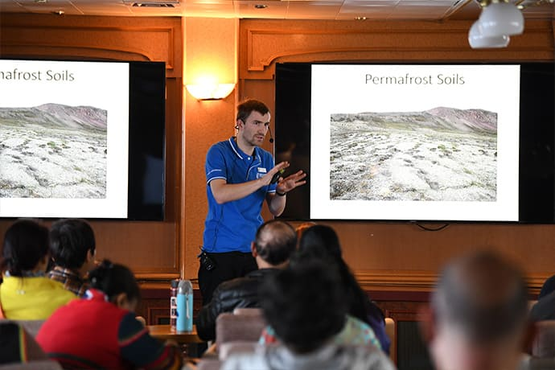Day 13: Across Denmark Strait
After our amazing time in East Greenland we cross Denmark Strait toward Iceland, crossing the Arctic Circle on the way. Presentations and workshops by our expert staff, as well as our range of onboard recreation facilities, ensure that this day at sea is not idly spent. Seabird viewing and whale sightings can be enjoyed from panoramic open decks as well as exterior stateroom windows and balconies.
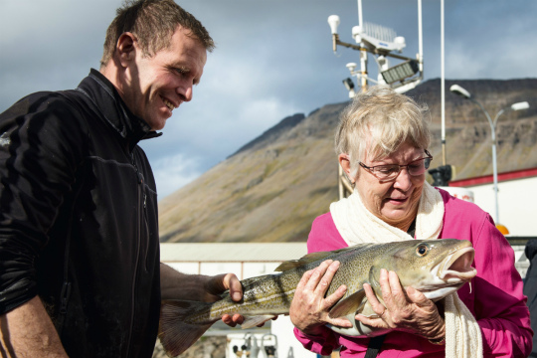Day 14: Westfjords, Iceland
Our last expedition day is spent in the beautiful Vestfirðir (Westfjords) of Iceland. This remote and sparsely populated region of crenulated coastlines, voluminous waterfalls and rugged mountains sees only 10% of Iceland’s visitors. Deep fjords are home to whales while estuaries abound with seals and birdlife.
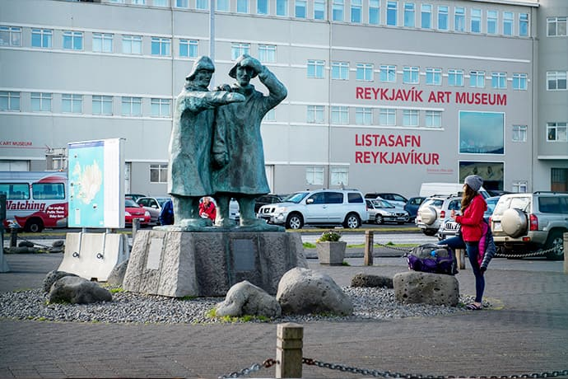Day 15: Disembarkation in Reykjavík, Iceland
After breakfast we say farewell in Reykjavík, the capital of Iceland and ending point of our expedition. We provide a transfer to the airport or to the city center if you wish to spend another day or more in Iceland before flying home. Reykjavík is home to a wealth of cultural institutions such as museums, galleries, and the Hallgrímskirkja church. Leisure possibilities inside the city include parks, gardens, and thermal baths. You can also take advantage of Reykjavík’s wide range of shopping possibilities, excellent dining options, and famous nightlife. And of course the entire country of Iceland is accessible through day tours or longer journeys by rental car. The options for additional adventures are endless!

M/v Sea Spirit
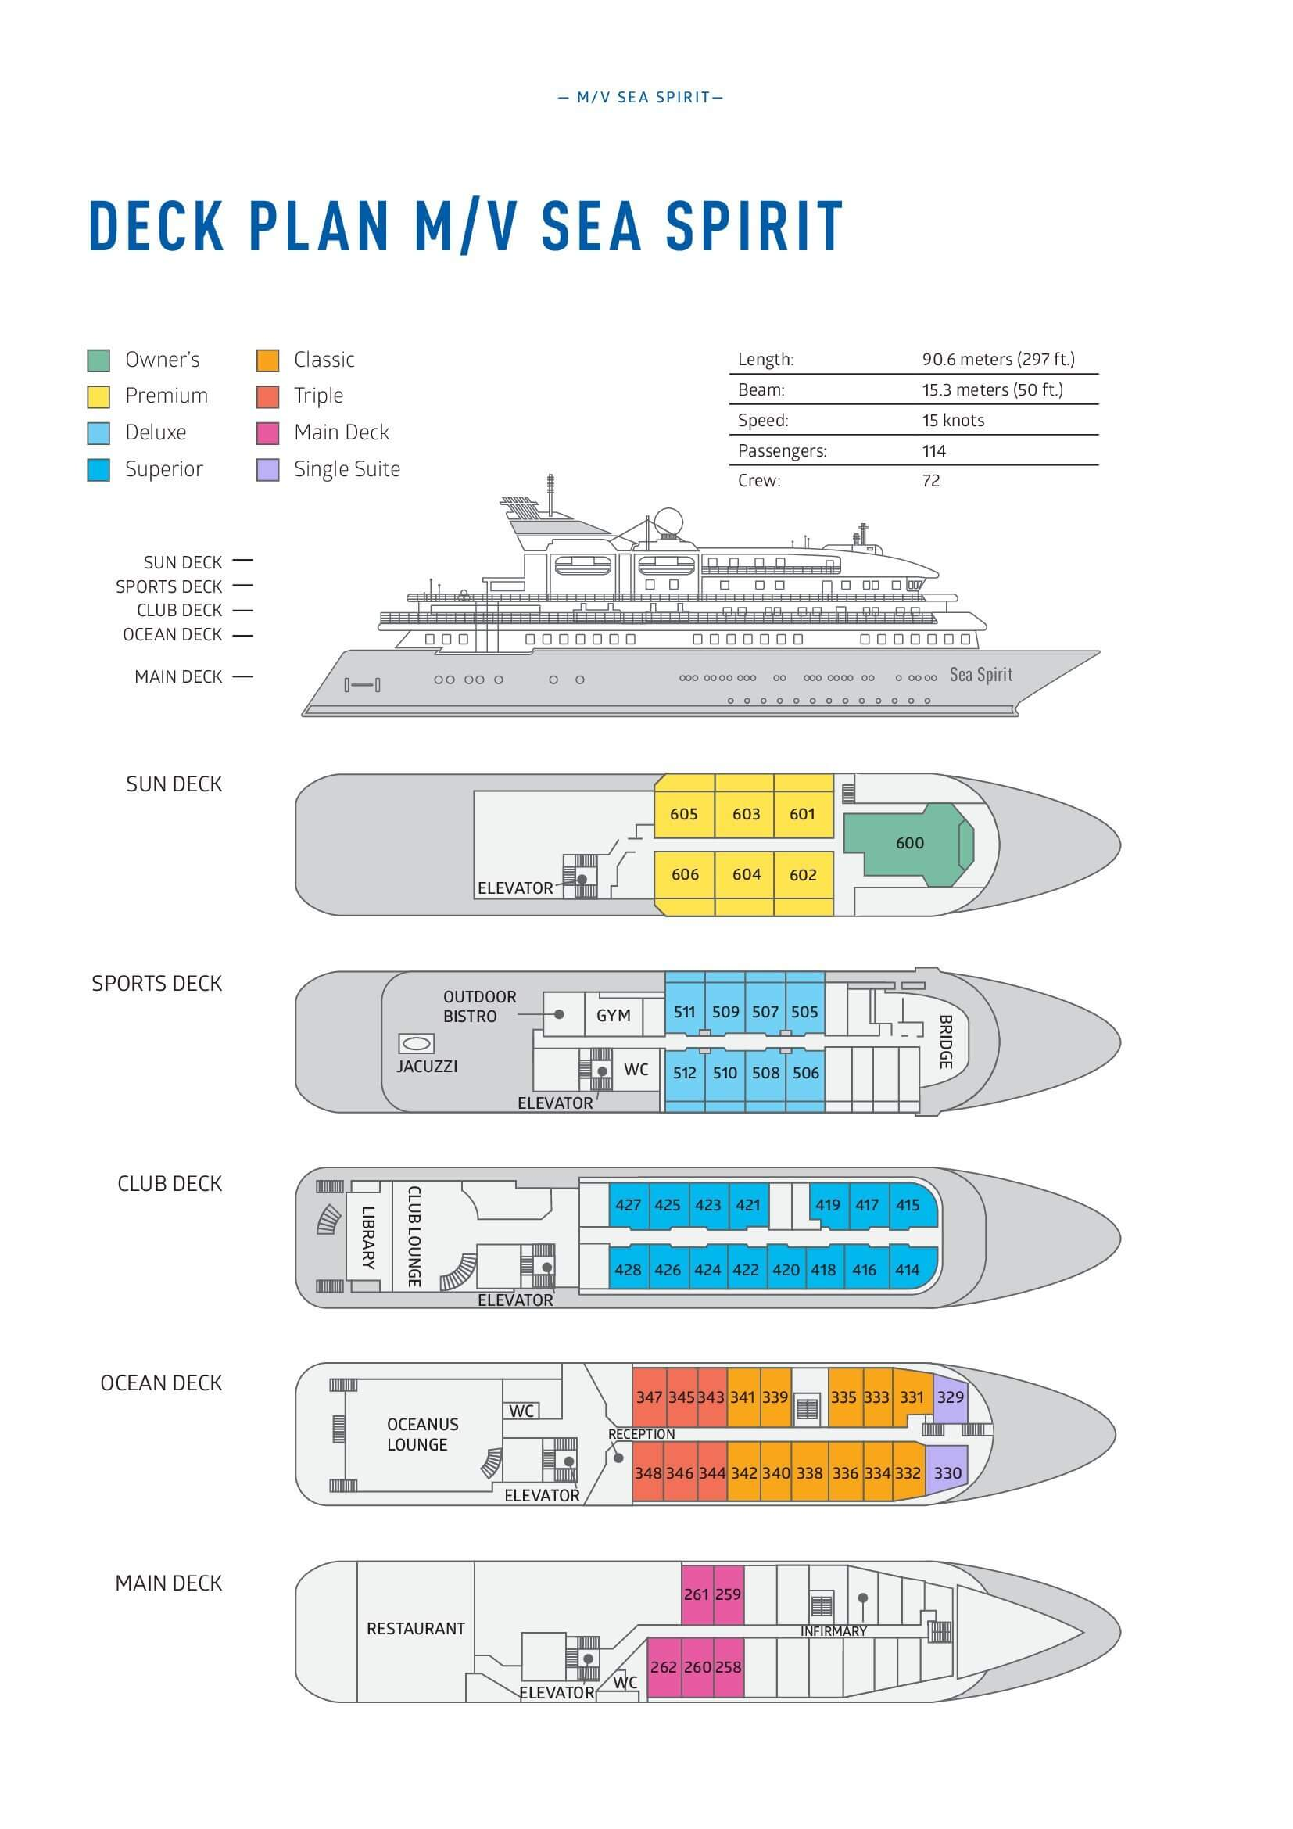

Triple Suite  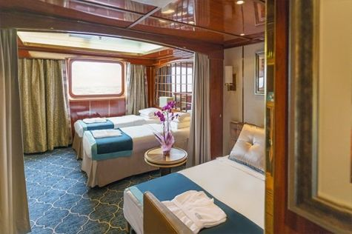  Averaging 21 square metres/226 square feet, these staterooms have two twins and a comfortable sofa bed. The twins also convert to a King, if desired. Located on Oceanus Deck, these suites have a picture window, two wardrobes and en suite facilities. Amenities include: in-room safe, refrigerator, satellite telephone access, TV/DVD, individual temperature control, and hair dryer. | Main Deck Suite  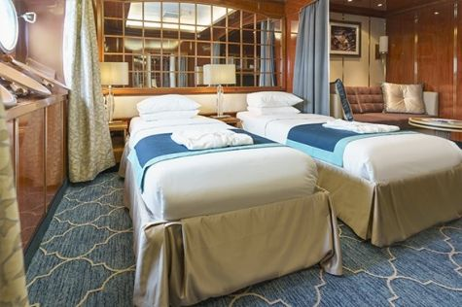  Averaging 23 square metres/248 square feet, Main Deck cabins are equipped with either two twins or a King Size bed. They are located on the Main Deck with a minimum of two portholes for exterior views. Amenities include: en suite facilities, in-room safe, refrigerator, satellite telephone access, TV/DVD individual temperature control and hair dryer.
Single Suite  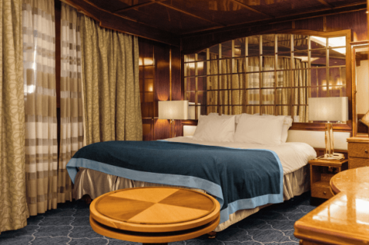  Averaging 21 square meters/226 square feet, these cabins are located on the Oceanus Deck. They feature a picture window (it may be covered during rough sea crossings), two wardrobes, and a King Size bed. Amenities include: en suite facilities, in-room safe, refrigerator, satellite telephone access, TV/VCR, individual temperature control, and hair dryer. | Classic Suite  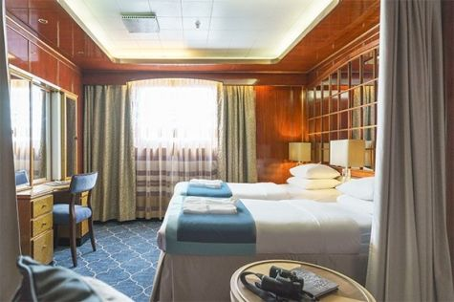  Averaging 21 square metres/226 square feet, these cabins are located on the Oceanus Deck. They feature a picture window, two wardrobes and a choice of either two twin beds or a King Size bed. Amenities include: en suite facilities, in-room safe, refrigerator, satellite telephone access, TV/DVD, individual temperature control and hair dryer.
Superior Suite  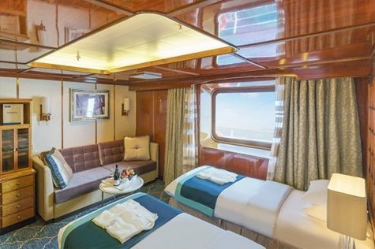  Superior Suites are located on the Club Deck. Averaging 20 square metres/ 215 square feet, these cabins feature two twin beds or a King Size bed. The picture window overlooks an outside walkway on the Club Deck. Amenities include: en suite facilities, walk-in closet or wardrobe, in-room safe, refrigerator, satellite telephone access, TV/DVD, individual temperature control, hair dryer. | Deluxe Suite  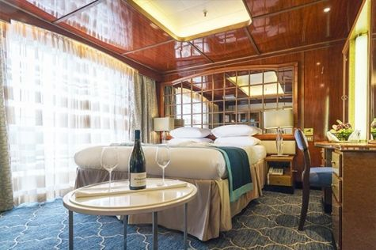  The Deluxe Suites with balconies are located on the Sports Deck. Averaging 24 square metres/ 258 square feet means plenty of room. Choose from either two twin beds or a King Size bed. A sliding glass door leads to a private balcony. These suites feature a walk-in closet or wardrobe. Amenities include en suite facilities, in-room safe, refrigerator, satellite telephone access, TV/DVD, individual temperature control, and a hair dryer.
Premium Suite  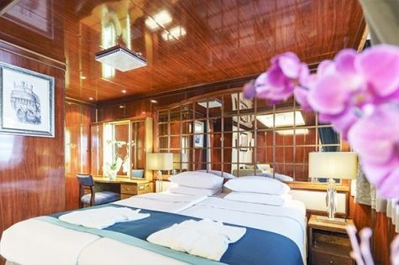  The Premium Suites are located on the Sun Deck. Averaging a generous 30 square metres/ 323 square feet, with two twin beds or a King Size bed. Access the private balcony by a sliding glass door. Amenities include: en suite facilities, lounge area, in-room safe, refrigerator, satellite telephone access, TV/DVD, individual temperature control, and hair dryer. | Owners Suite  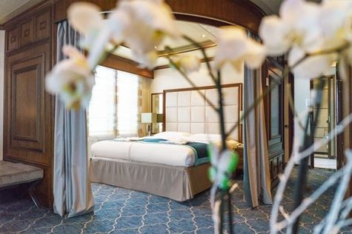  Super-spacious (63 square metres/ 678 square feet) elegant suite on the Sun Deck. Designed for entertaining, the Owner's Suite has a separate living room with game and meeting area. A BOSE stereo system provides background music, or watch videos on the HD plasma TV. Sliding glass doors lead to a private deck. Refresh in the jetted bathtub in en suite facilities. Slumber in the King Size bed. A sofa bed can accommodate a third person.

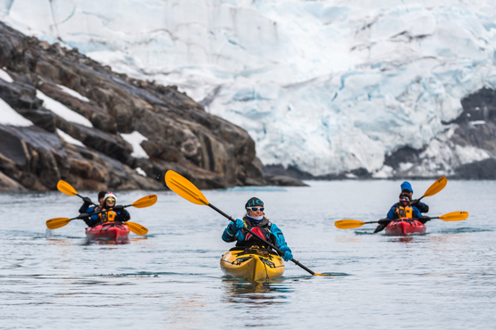 | Sea Kayaking  Kayaking fee $655 - A$885 - £505 - €625  Sea Kayak Club is typically offered on voyages that include High Arctic destinations such as Greenland, Svalbard (Spitsbergen), Franz Josef Land, or a combination of these thrilling places. Experience calving glaciers in Svalbard, cathedral-like icebergs in Greenland, or labyrinthine expanses of sea ice in the Arctic Ocean, all from our sturdy and stealthy sea kayaks. Join us for an unscripted kayaking adventure as we explore rugged coastlines and remote waters that very few people have ever paddled.
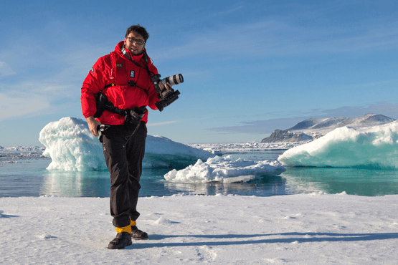 | Photography  Free option  The Polar Regions are perhaps the most photogenic on earth, with countless beautiful scenes presenting themselves every day. Endless expanses of ice, beaches crowded with seals or penguins, sunsets over unbroken horizons, starlit skies, and even the majestic northern lights – they all present fantastic photographic opportunities – and in order to make sure that you come home with some spectacular images we offer you the chance to learn and practice your photography alongside an experienced professional.  Our expert Photographer will be on hand to answer your questions and give advice, both in the form of on-board lectures and workshops on shore. Explore the key elements of photography in a fun and relaxed setting, with plenty of opportunities for questions and feedback. Learn how to see light in a new way and experiment with the techniques of composition and framing.

Rates Include  Flight from Oslo to Longyearbyen;  1 pre-voyage night on Day 1 in the Radisson Blu Airport Hotel, Oslo Gardermoen;  Group transfer to the ship for embarkation on Day 2;  Shipboard accommodation;  All meals on board throughout the voyage;  Tea and coffee station 24 hours daily;  All scheduled landings/excursions (subject to weather and ice conditions);  Leadership throughout the voyage by our experienced Expedition Leader and Expedition Team;  Branded Poseidon Expeditions parka;  Rubber boots for shore landings for the time of the cruise;  Welcome and Farewell cocktails;  All port fees;  Group transfer to airport or central location right after disembarkation;  Pre-departure materials;  Digital Voyage Log;  Wi-Fi on board. | Rates Do Not Include  Airfare from Reykjavik;  Visa and passport fees (if applicable);  Luggage and trip cancellation insurance;  Soft drinks and alcoholic beverages other than those for special events and celebrations;  Personal expenses such as laundry and telecommunication charges;  Mandatory Emergency Evacuation Insurance to a minimum benefit of US$ 200,000 per person;  Kayaking;  The cost of any applicable medical tests (such as COVID-19) or vaccinations required either by a national government or Poseidon Expeditions before, during or after the cruise;  Staff gratuities.
Itinerary, landings and all other activities during the cruise depend strongly on ice and weather conditions and are subject to the decisions of the Expedition Leader and the Captain of the vessel. Encounters with any mentioned wildlife cannot be guaranteed.

