Franz Josef Land Archipelago
Russian High Arctic
31 Jul - 14 Aug 2017
15 days
Embarkation: Longyearbyen (Spitsbergen)
Disembarkation: Longyearbyen (Spitsbergen)
M/v Sea Spirit
Activities:

Itinerary
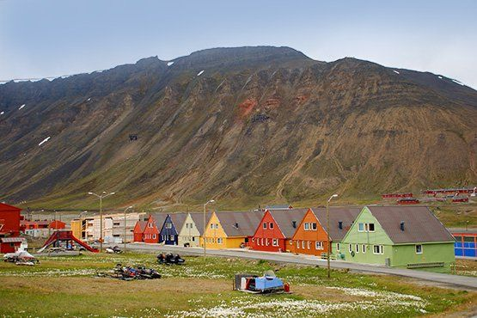Day 1: Longyearbyen, Svalbard
Welcome to Longyearbyen, the Arctic adventure capital of the Norwegian territory of Svalbard and starting point of our expedition. After arriving via scheduled commercial flight, you are free to explore this small but fascinating settlement. Be sure to see the excellent Svalbard Museum and enjoy the shops, cafes and restaurants in the town center. Your hotel for the night has been arranged by us and is included in the price of the voyage.
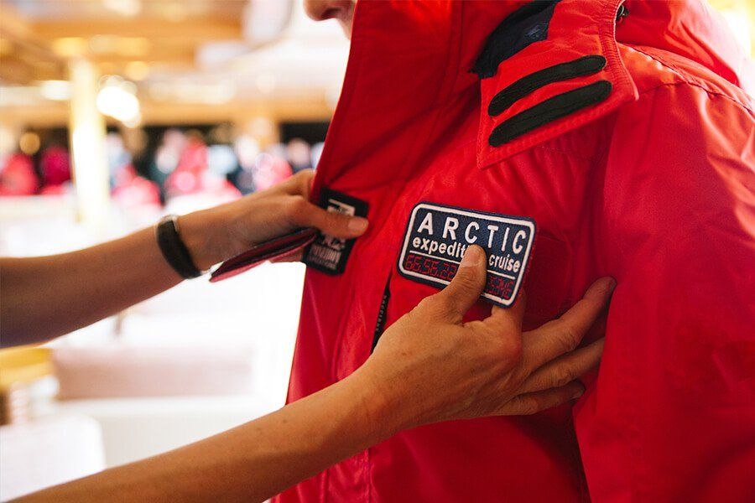Day 2: Embarkation in Longyearbyen
In the afternoon we welcome you aboard the expedition ship M/V Sea Spirit; transfers from the hotel are included. Explore the ship and get comfortable in your home-away-from-home for the extraordinary adventure to come. The long days of summer sunlight illuminate our surroundings as we slip our moorings and sail into a true wilderness where wildlife abounds. The scenery as we sail through Isfjorden on our first evening is spectacular and there is already the possibility of marine mammal encounters.
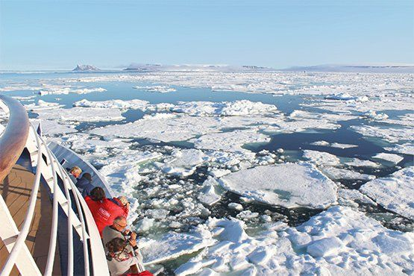Day 3-4: Across the Barents Sea
From Isfjorden we proceed straight to Franz Josef Land across the Barents Sea. Presentations and workshops by our expert staff prepare us for what lies ahead.In these far northern latitudes, it is possible to encounter sea ice even in summer. Along the way, we’ll remain vigilant for sightings of ice-dependent marine mammals such as the elusive bowhead whale, various Arctic seal species, and the majestic polar bear.
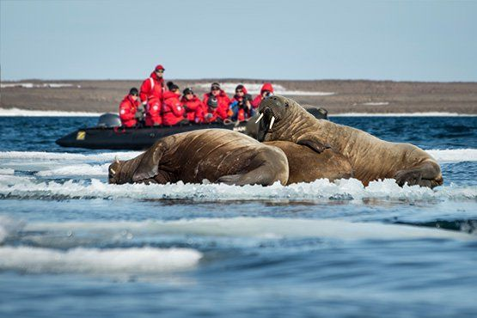Day 5-11: Exploration of Franz Josef Land
This is expedition cruising at its most authentic. As such, our route and exploration opportunities in Franz Josef Land are heavily dependent on weather and sea ice. Our experienced captain and expedition leader decide our best route and continually adjust plans as opportunities warrant in this wild and remote corner of the Arctic. Between obligatory initial and final calls at the Russian polar station Nagurskoye in Cambridge Bay we are free to explore the many waterways and islands of this unique Arctic wilderness. The archipelago, part of the Russian Arctic National Park since 2012, is a nature sanctuary. Polar bears and other quintessential High Arctic wildlife—such as walruses and some rare whale species—can be spotted anytime, anywhere in and around Franz Josef Land. Scree slopes and cliffs around the islands host enormous nesting colonies of seabirds such as guillemots, dovekies, and kittiwakes. We’ll take advantage of the 24-hour daylight to exploit every opportunity for wildlife viewing. Franz Josef Land is dominated by glaciation, which covers 85% of the archipelago. Immense tidewater glaciers and glittering icebergs provide a stunning backdrop to our voyage. Franz Josef Land is also home to some interesting geological features, such as the mysterious stone spheres on Champ Island. Collectors of geographical extremes may take note that Cape Fligely on Rudolf Island is the northernmost point of land in the Eastern Hemisphere. Franz Josef Land also offers visitors the opportunity to walk in the footsteps of famous polar explorers at well-preserved historical sites. The journals of explorers such as Julius von Payer, Benjamin Leigh Smith, Frederick George Jackson, and Fridtjof Nansen come alive at Cape Norway, Cape Flora, Eira Harbour, and Cape Tegetthoff. Memorials, monuments, crosses and the remains of dwellings are testimony to incredible historical events that are further illuminated by our expert lecturers. Tikhaya Bukhta is currently a Russian Arctic National Park ranger station occupying Soviet-era research buildings and was also a major base for polar expeditions. Nearby the fascinating columnar basalt cliffs of Rubini Rock are home to thousands of nesting seabirds.
Our primary focus during this expedition is the exploration of the Russian archipelago of Franz Josef Land. However, the number of days spent there depends on ice conditions. Final daily programs are subject to change and the decision of the captain and expedition leader.
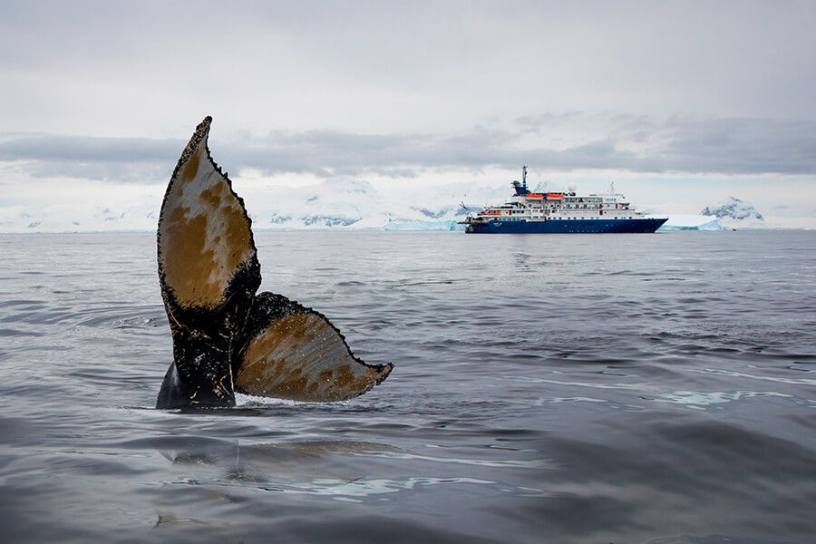Day 12-13: Along the coasts of Svalbard
Following our week of exploration in Franz Josef Land, we cross back through the bountiful waters of the Barents Sea and then along the coastal islands of the Svalbard Archipelago. From panoramic open decks, enjoy Arctic landscapes and wildlife sightings. Bountiful inshore and offshore waters are home to walrus and a wide variety of whales.The crossing also gives our expedition team the opportunity to offer a final presentation or two in the Oceanus Lounge. Weather and timing permit, we’ll launch our Zodiacs to have a closer look at wildlife as we head back to Longyearbyen.
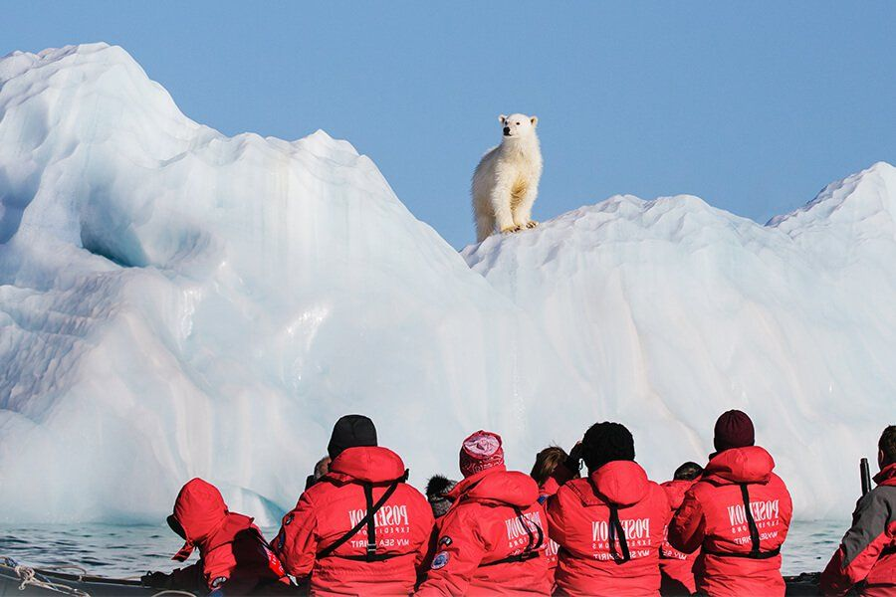Day 14: West Svalbard
After a technical stop in Longyearbyen, we explore the spectacular fjords and coasts in the western part of Svalbard. This area contains some of the archipelago’s most impressive scenery and wildlife viewing opportunities abound. Deep fjords and narrow channels are flanked by jagged snowy mountain peaks. Fields of flowering tundra are home to grazing reindeer and Arctic fox, always on the hunt. The whole area is alive with migratory birds, including some rare species, taking advantage of summer’s fecundity in 24-hour daylight. Among the historic sights, there are remnants of whaling camps, coal-mining operations, trappers’ cabins, staging areas for historic attempts to discover the North Pole, and the ruins of a WWII weather station.
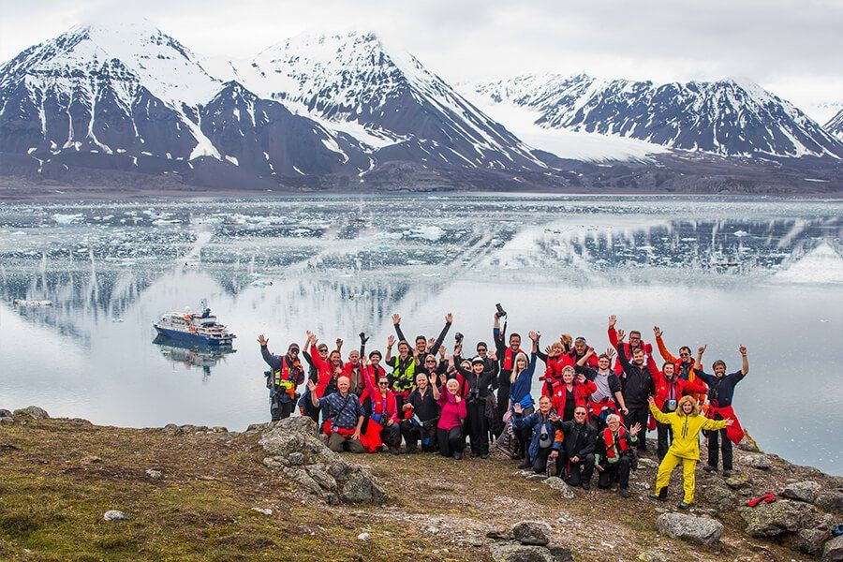Day 15: Disembarkation in Longyearbyen, Svalbard
After breakfast we say farewell in the town of Longyearbyen, where we started our expedition. We provide a transfer to the airport, or to the town center if you plan to spend more time here. As you look back on your wonderful experience, you may already be looking forward to your next incredible adventure to the ice!

M/v Sea Spirit
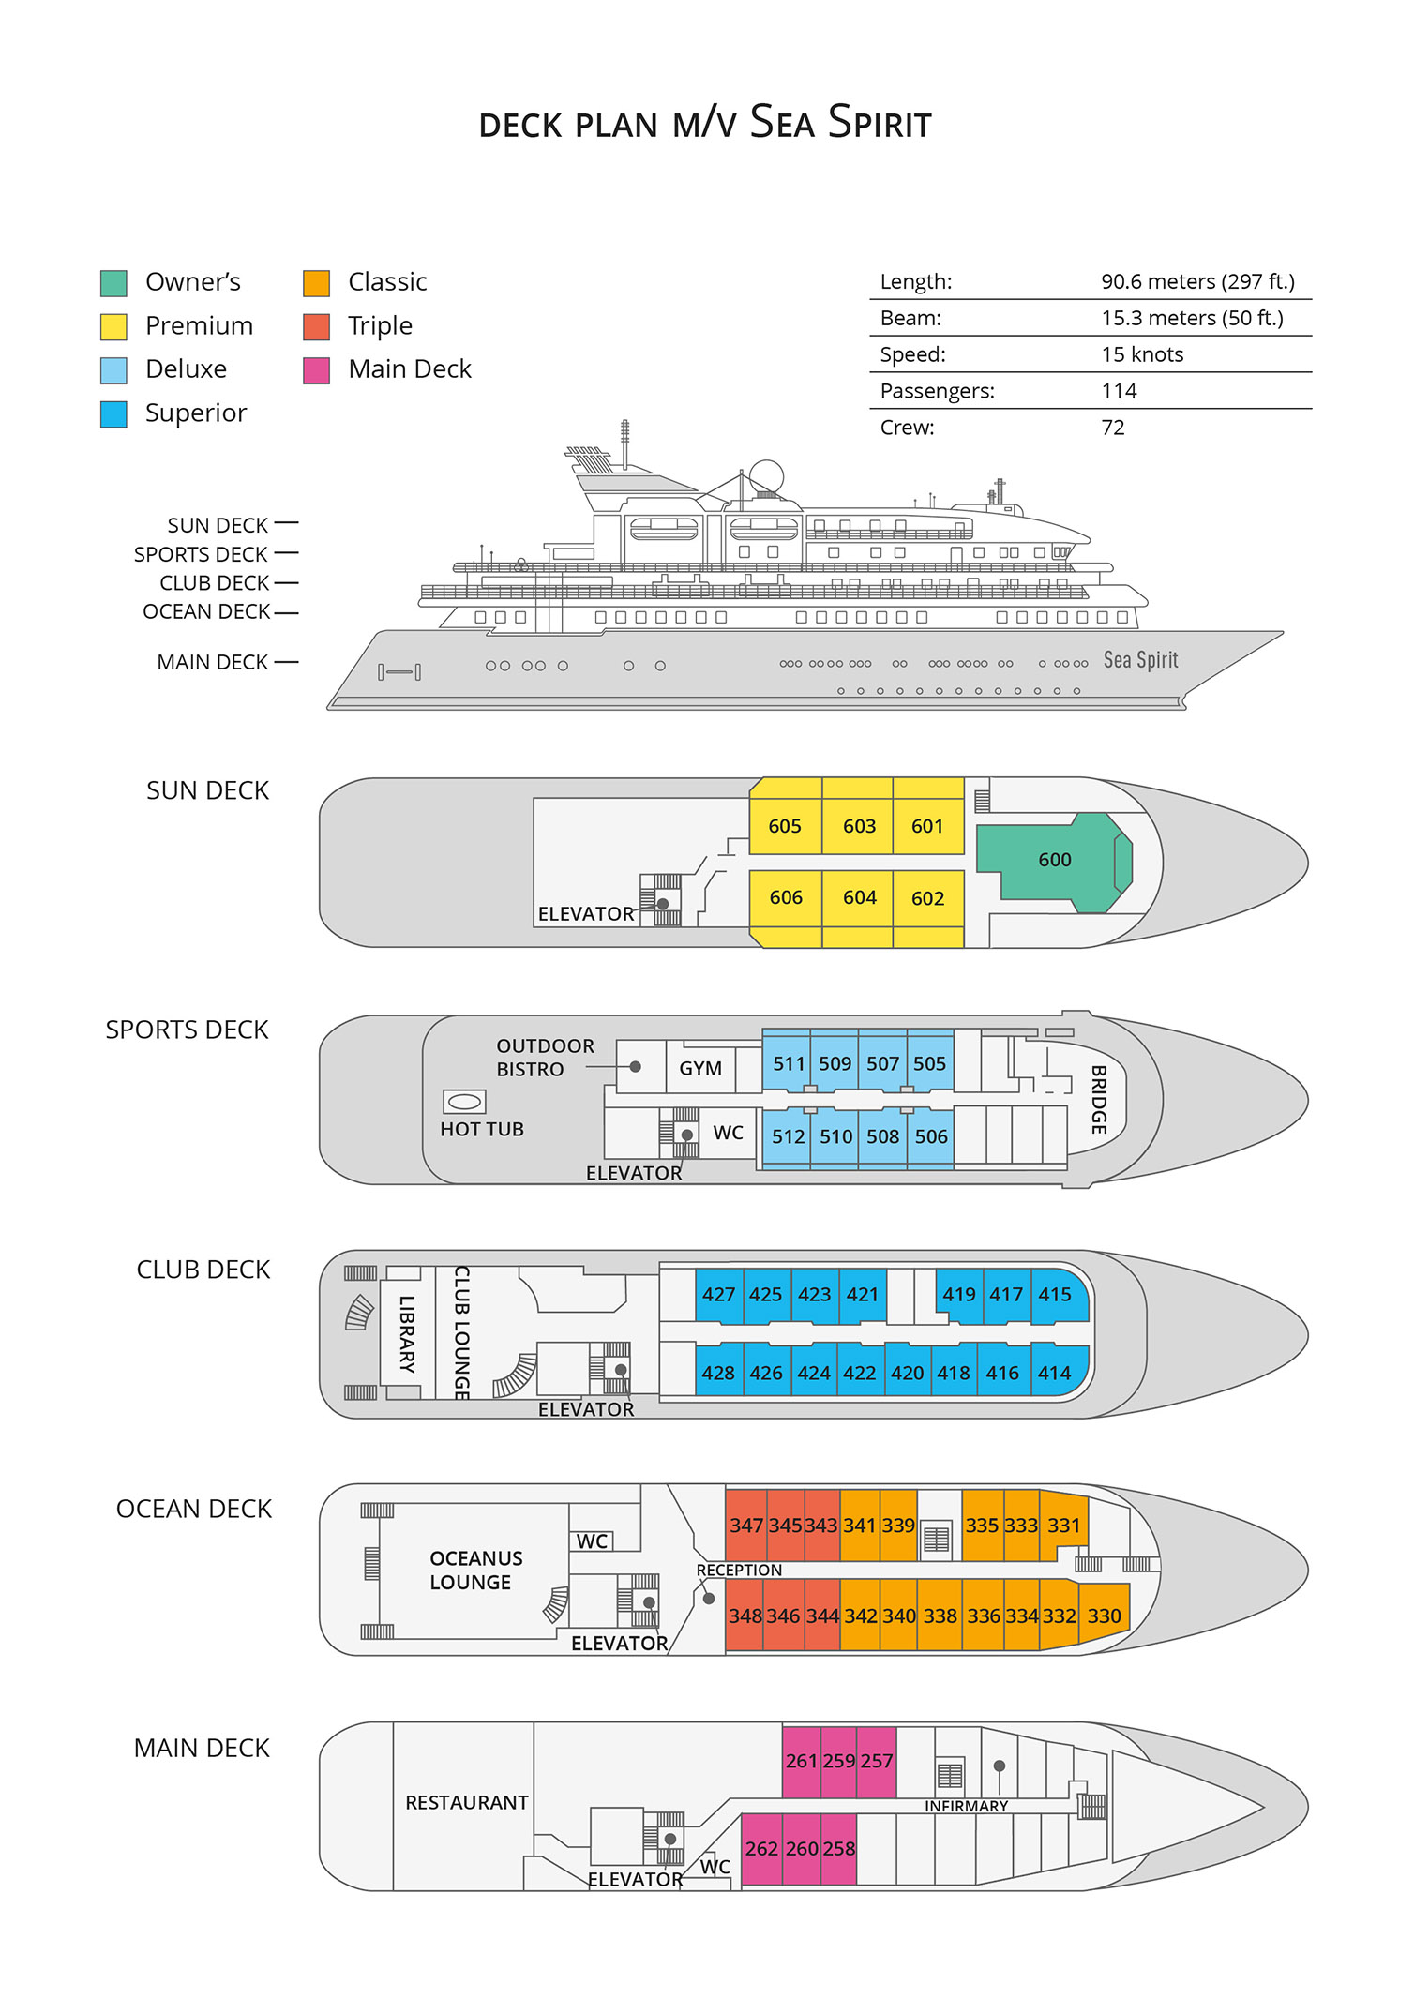

Triple Suite  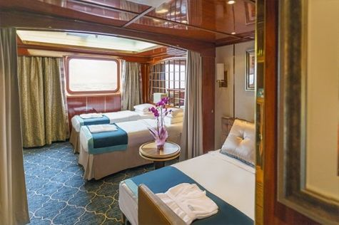  Averaging 21 square metres/226 square feet, these staterooms have two twins and a comfortable sofa bed. The twins also convert to a King, if desired. Located on Oceanus Deck, these suites have a picture window, two wardrobes and en suite facilities. Amenities include: in-room safe, refrigerator, satellite telephone access, TV/DVD, individual temperature control, and hair dryer. | Main Deck Suite  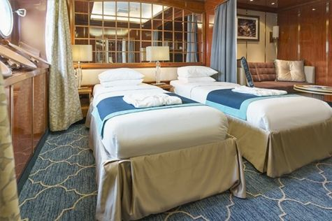  Averaging 23 square metres/248 square feet, Main Deck cabins are equipped with either two twins or a King Size bed. They are located on the Main Deck with a minimum of two portholes for exterior views. Amenities include: en suite facilities, in-room safe, refrigerator, satellite telephone access, TV/DVD individual temperature control and hair dryer.
Single Suite  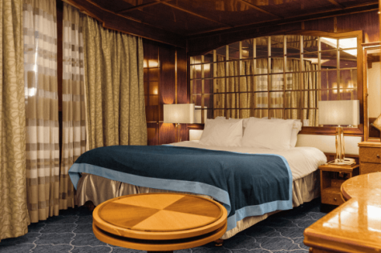  Averaging 21 square meters/226 square feet, these cabins are located on the Oceanus Deck. They feature a picture window (it may be covered during rough sea crossings), two wardrobes, and a King Size bed. Amenities include: en suite facilities, in-room safe, refrigerator, satellite telephone access, TV/VCR, individual temperature control, and hair dryer. | Classic Suite  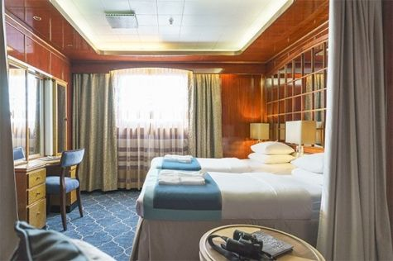  Averaging 21 square metres/226 square feet, these cabins are located on the Oceanus Deck. They feature a picture window, two wardrobes and a choice of either two twin beds or a King Size bed. Amenities include: en suite facilities, in-room safe, refrigerator, satellite telephone access, TV/DVD, individual temperature control and hair dryer.
Superior Suite  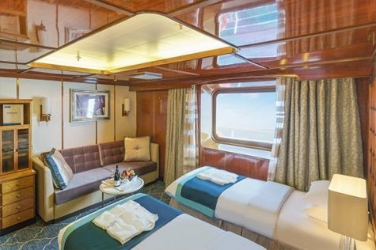  Superior Suites are located on the Club Deck. Averaging 20 square metres/ 215 square feet, these cabins feature two twin beds or a King Size bed. The picture window overlooks an outside walkway on the Club Deck. Amenities include: en suite facilities, walk-in closet or wardrobe, in-room safe, refrigerator, satellite telephone access, TV/DVD, individual temperature control, hair dryer. | Deluxe Suite  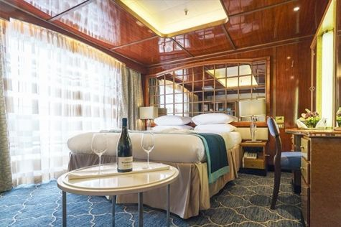  The Deluxe Suites with balconies are located on the Sports Deck. Averaging 24 square metres/ 258 square feet means plenty of room. Choose from either two twin beds or a King Size bed. A sliding glass door leads to a private balcony. These suites feature a walk-in closet or wardrobe. Amenities include en suite facilities, in-room safe, refrigerator, satellite telephone access, TV/DVD, individual temperature control, and a hair dryer.
Premium Suite  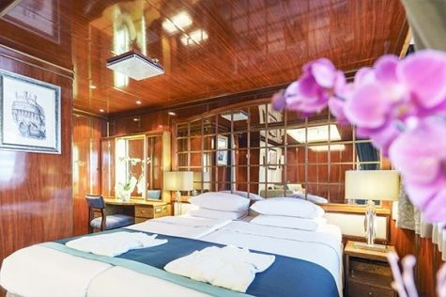  The Premium Suites are located on the Sun Deck. Averaging a generous 30 square metres/ 323 square feet, with two twin beds or a King Size bed. Access the private balcony by a sliding glass door. Amenities include: en suite facilities, lounge area, in-room safe, refrigerator, satellite telephone access, TV/DVD, individual temperature control, and hair dryer. | Owners Suite  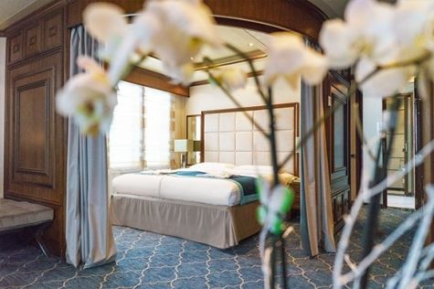  Super-spacious (63 square metres/ 678 square feet) elegant suite on the Sun Deck. Designed for entertaining, the Owner's Suite has a separate living room with game and meeting area. A BOSE stereo system provides background music, or watch videos on the HD plasma TV. Sliding glass doors lead to a private deck. Refresh in the jetted bathtub in en suite facilities. Slumber in the King Size bed. A sofa bed can accommodate a third person.

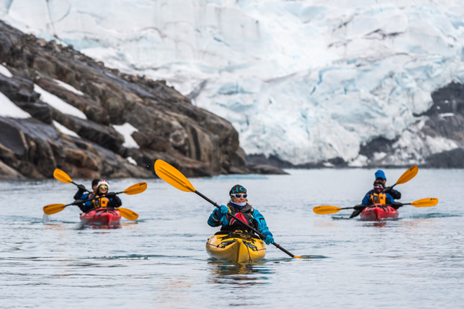 | Sea Kayaking  Kayaking fee $655 - A$885 - £505 - €625  Sea Kayak Club is typically offered on voyages that include High Arctic destinations such as Greenland, Svalbard (Spitsbergen), Franz Josef Land, or a combination of these thrilling places. Experience calving glaciers in Svalbard, cathedral-like icebergs in Greenland, or labyrinthine expanses of sea ice in the Arctic Ocean, all from our sturdy and stealthy sea kayaks. Join us for an unscripted kayaking adventure as we explore rugged coastlines and remote waters that very few people have ever paddled.
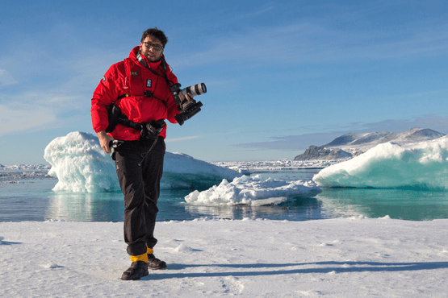 | Photography  Free option  The Polar Regions are perhaps the most photogenic on earth, with countless beautiful scenes presenting themselves every day. Endless expanses of ice, beaches crowded with seals or penguins, sunsets over unbroken horizons, starlit skies, and even the majestic northern lights – they all present fantastic photographic opportunities – and in order to make sure that you come home with some spectacular images we offer you the chance to learn and practice your photography alongside an experienced professional.  Our expert Photographer will be on hand to answer your questions and give advice, both in the form of on-board lectures and workshops on shore. Explore the key elements of photography in a fun and relaxed setting, with plenty of opportunities for questions and feedback. Learn how to see light in a new way and experiment with the techniques of composition and framing.

Rates Include  1 pre-voyage hotel night;  Group transfer to the ship on day of embarkation;  Shipboard accommodation;  All meals on board throughout the voyage;  Tea and coffee station 24 hours daily;  All scheduled landings/excursions (subject to weather and ice conditions);  Leadership throughout the voyage by our experienced Expedition Leader and Expedition Team;  Branded Poseidon Expeditions parka;  Rubber boots for shore landings for the time of the cruise;  Welcome and Farewell cocktails;  All port fees;  Group transfer to airport or central location upon disembarkation;  Pre-departure materials;  Digital Voyage Log;  Emergency Evacuation Insurance to a maximum benefit of USD 150,000 per person. | Rates Do Not Include  Airfare;  Visa and passport fees. For this trip Russian visa is required. See your country’s Russian consulate or embassy for details;  Luggage and trip cancellation insurance;  Soft drinks and alcoholic beverages other than those for special events and celebrations;  Personal expenses such as laundry and telecommunication charges;  Staff gratuities.
Itinerary, landings and all other activities during the cruise depend strongly on ice and weather conditions and are subject to the decisions of the Expedition Leader and the Captain of the vessel. Encounters with any mentioned wildlife cannot be guaranteed.

