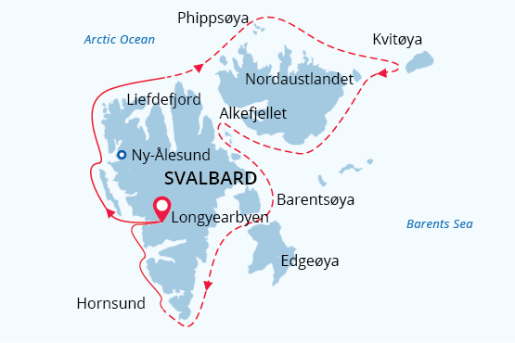

Svalbard Circumnavigation and Kvitøya
In-Depth Arctic Expedition & Polar Bear Safari
22 Jul - 04 Aug 2022
14 days
Embarkation: Longyearbyen (Svalbard)
Disembarkation: Longyearbyen (Svalbard)
M/v Sea Spirit
Activities:

Itinerary
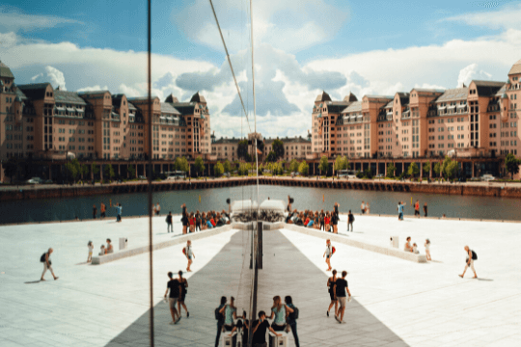Day 1: Arrival to Oslo (hotel night)
Welcome to Oslo, which in 2019 was awarded the prestigious title “Green Capital of Europe”. We’ve arranged a comfortable stay for you at an Oslo Airport hotel so that you’re conveniently close for your flight to Longyearbyen on Day 2.
If you’re adventurous and have the time, take the handy airport train into central Oslo – it’s a 20-minute ride and trains depart and arrive frequently during the day. Near Oslo Central Station are shops, cafes, the Botanical Garden, cultural attractions and the attractive waterfront area.
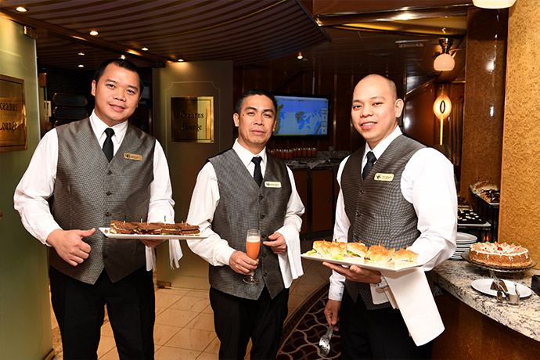Day 2: Welcome Aboard!
Today you have a flight to Longyearbyen, the administrative center of Svalbard and starting point of our Arctic expedition! At the Longyearbyen airport, you will be greeted by our staff and transferred to the pier where we will warmly welcome you aboard the deluxe expedition vessel M/V Sea Spirit. Get settled in your spacious suite and explore the ship that will be your comfortable home during the extraordinary adventure to come. Once underway, a full schedule of events kicks off with informative briefings and introductions from your expedition staff. After the first of many delicious dinners on board, step out onto the open decks to admire the gorgeous scenery in endless evening light as we pass through the wildlife-rich waters of Isfjorden, one of the largest fjords in Svalbard.
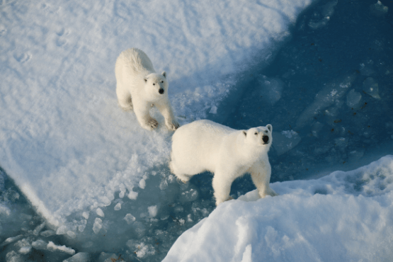Day 3-13: Arctic wilderness Polar Bear search
During our expedition, we hope to experience the many facets of this incredible High Arctic territory. Our exact schedule and route will be shaped by the weather, sea ice and experience of our expedition leader and captain. At the peak of the summer season, we will almost certainly find the ice conditions to be favorable for a full circumnavigation, so we will make an attempt to go around Spitsbergen, the largest island of the Svalbard archipelago and even to the northeastern most part of the archipelago – Kvitøya. Much of the pristine nature of Spitsbergen is protected by a system of national parks, and we will try to visit some of them during the voyage. Below, please find a brief summary of what we might expect.
Human habitation – rare along our route – can be found at Ny Ålesund, a former mining town and airship base that is now home to an international community of Arctic researchers. This is one of the world’s most northerly settlements where we find a museum, gift shop and post office.
Northwest Spitsbergen National Park is the crown jewel of Svalbard’s scenic wonders. Here we find deep fjords flanked by serrated mountain ranges and immense tidewater glaciers calving icebergs into turquoise waters. The skies are filled with millions of murres, guillemots and little auks, whose eggs are just now hatching at countless breeding colonies located on small islands, mountainsides and sea cliffs within the park. This is also a great time to encounter marine mammals, including beluga whales and various Arctic seals. Set among this incredible scenery and wildlife activity, we also find evidence of Svalbard’s earliest sealers and whalers.
On this departure, we will go to the eastern and northern regions of the Svalbard Archipelago – infrequently visited aboard expedition ships – experiencing the isolation and beautiful remoteness of Svalbard’s Arctic wilderness areas.
We will explore Kvitøya (White Island), the most rarely visited and closest island to Franz Josef Land. This island, almost completely covered by ice, became the final resting place of the balloon expedition of the Swedish polar explorer Salomon August Andrée. Kvitøya is not always accessible to expedition ships, but it may provide another opportunity to observe polar bears in their natural habitat. Another site we hope to explore will be Karl XII Öya, which is the northernmost part of Svalbard. Polar explorers Alfred Gabriel Nathorst and Adolf Erik Nordenskiöld visited this remote island in the 19th century, and now we hope to explore it on a Zodiac cruise.
During this voyage, we expect to encounter significant sea ice concentrations in the enormous Northwest Svalbard Nature Reserve. In this remote and isolated region, ice can persist very late into the summer. This reserve covers the rugged northwestern parts of Spitsbergen and the entirety of Nordaustlandet, the second largest island in Svalbard. Here we find the massive Austfonna ice cap, part of which meets the sea along the 45-kilometer ice cliff known as Bråsvellbreen—one of the great wonders of the Arctic world. The polar desert environment supports little in the way of vegetation but hosts prodigious numbers of seabirds at breeding sites such as the spectacular sea cliffs of Alkefjellet. The probability of encountering polar bears and walrus in this icy wilderness is very high.
Southeast Svalbard Nature Reserve is truly a pristine and rarely visited wilderness containing hundreds of uninhabited islands. On the large islands of Edgeøya and Barentsøya, broad tundra valleys support the territory’s densest population of endemic Svalbard reindeer. The valleys are also important breeding areas for ground-nesting birds such as geese, eiders and sandpipers. Arctic foxes prowl the vast landscape, seeking to provide food for their young cubs, who are just now emerging from their dens. Shallow, murky seas are ideal feeding grounds for walrus, which can be seen resting in large numbers on gently sloping beaches. Historical sites throughout the islands provide glimpses into the region’s bygone era of trapping and hunting.
South Spitsbergen National Park is a vast region of varied landscapes including polar deserts and impassible mountain ranges. The centerpiece of this park is Hornsund, a picture-perfect fjord where countless mighty glaciers cascade from soaring mountaintops into icy inlets. The park also includes the southern shores of Bellsund, a picturesque bay where we find the remains of historical whaling operations, including wooden boats, cabins, and thousands of whale bones — a scene from the distant past, literally frozen in time.
Throughout the park, there is always a high probability of wildlife sightings. There are also plenty of opportunities for exhilarating hiking through wild polar landscapes offering fascinating geological stories. Wildflowers will be at their peak during this time.
Because of its extended length, this ambitious and in-depth Svalbard circumnavigation expedition cruise offers a comprehensive view of the Arctic’s many faces. Every day offers something new and exciting. We will not miss a single opportunity to encounter amazing Arctic wildlife, to witness incredible polar scenery, and to walk in the footsteps of historic expeditions that came before.

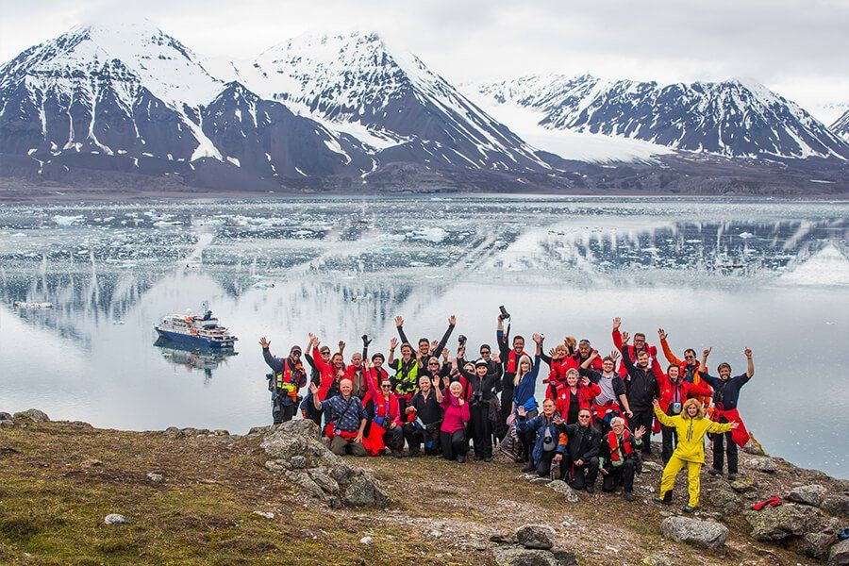Day 14: Disembarkation in Longyearbyen, Svalbard
After filling up with one last buffet breakfast on board, we bid you farewell in Longyearbyen. We provide transfers to the airport and flight to Oslo. By this time, you may already be making plans for your next amazing trip with us into the polar worlds!

M/v Sea Spirit
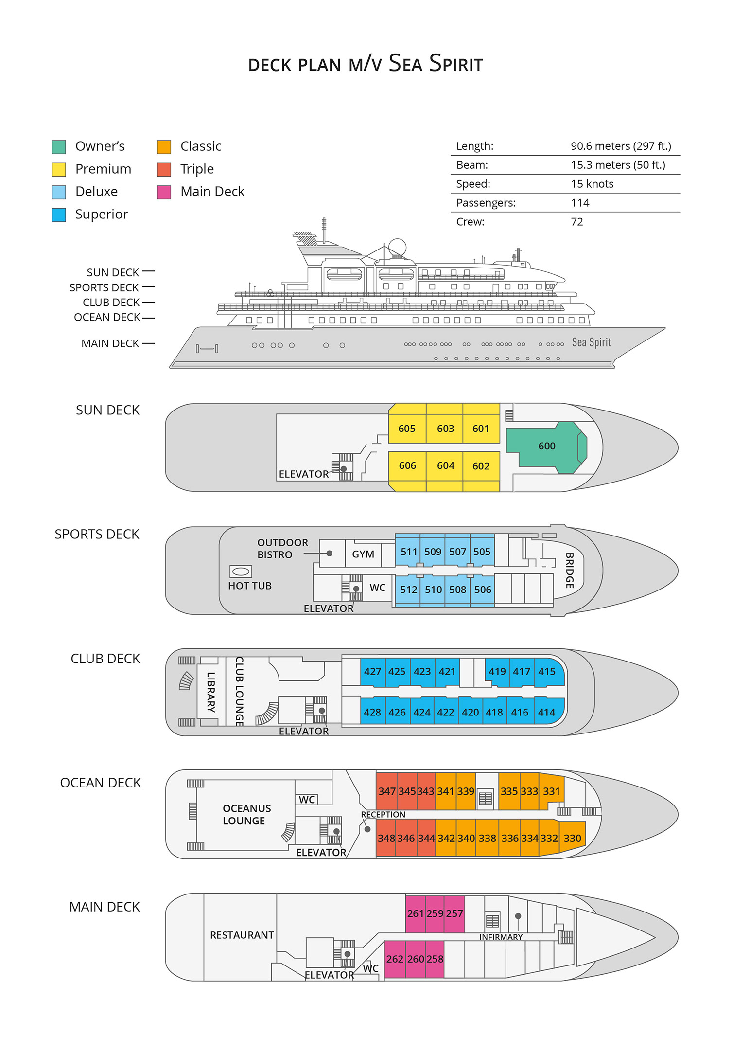

Triple Suite  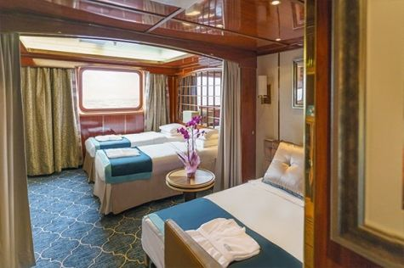  Averaging 21 square metres/226 square feet, these staterooms have two twins and a comfortable sofa bed. The twins also convert to a King, if desired. Located on Oceanus Deck, these suites have a picture window, two wardrobes and en suite facilities. Amenities include: in-room safe, refrigerator, satellite telephone access, TV/DVD, individual temperature control, and hair dryer. | Main Deck Suite  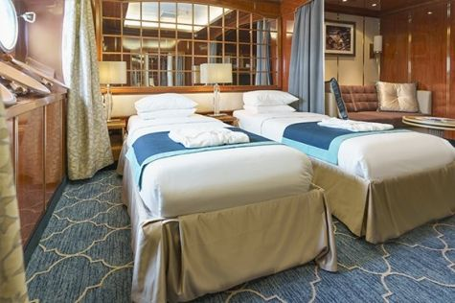  Averaging 23 square metres/248 square feet, Main Deck cabins are equipped with either two twins or a King Size bed. They are located on the Main Deck with a minimum of two portholes for exterior views. Amenities include: en suite facilities, in-room safe, refrigerator, satellite telephone access, TV/DVD individual temperature control and hair dryer.
Single Suite  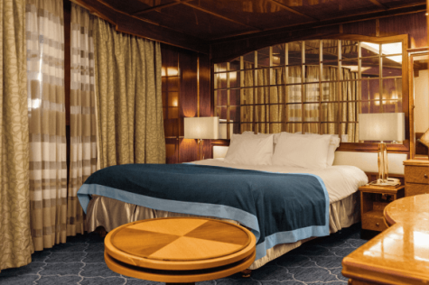  Averaging 21 square meters/226 square feet, these cabins are located on the Oceanus Deck. They feature a picture window (it may be covered during rough sea crossings), two wardrobes, and a King Size bed. Amenities include: en suite facilities, in-room safe, refrigerator, satellite telephone access, TV/VCR, individual temperature control, and hair dryer. | Classic Suite  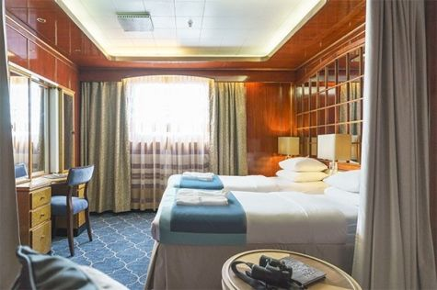  Averaging 21 square metres/226 square feet, these cabins are located on the Oceanus Deck. They feature a picture window, two wardrobes and a choice of either two twin beds or a King Size bed. Amenities include: en suite facilities, in-room safe, refrigerator, satellite telephone access, TV/DVD, individual temperature control and hair dryer.
Superior Suite  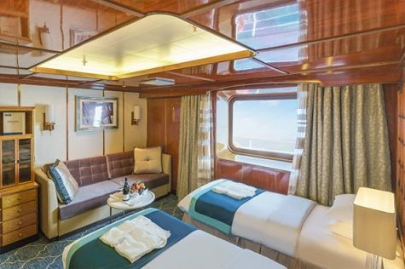  Superior Suites are located on the Club Deck. Averaging 20 square metres/ 215 square feet, these cabins feature two twin beds or a King Size bed. The picture window overlooks an outside walkway on the Club Deck. Amenities include: en suite facilities, walk-in closet or wardrobe, in-room safe, refrigerator, satellite telephone access, TV/DVD, individual temperature control, hair dryer. | Deluxe Suite  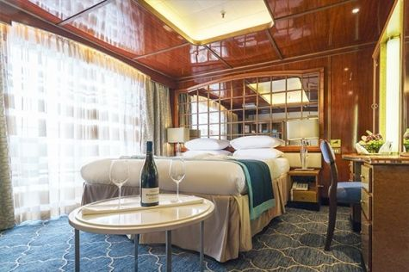  The Deluxe Suites with balconies are located on the Sports Deck. Averaging 24 square metres/ 258 square feet means plenty of room. Choose from either two twin beds or a King Size bed. A sliding glass door leads to a private balcony. These suites feature a walk-in closet or wardrobe. Amenities include en suite facilities, in-room safe, refrigerator, satellite telephone access, TV/DVD, individual temperature control, and a hair dryer.
Premium Suite  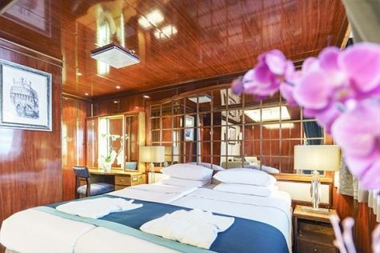  The Premium Suites are located on the Sun Deck. Averaging a generous 30 square metres/ 323 square feet, with two twin beds or a King Size bed. Access the private balcony by a sliding glass door. Amenities include: en suite facilities, lounge area, in-room safe, refrigerator, satellite telephone access, TV/DVD, individual temperature control, and hair dryer. | Owners Suite  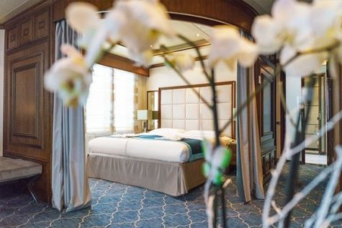  Super-spacious (63 square metres/ 678 square feet) elegant suite on the Sun Deck. Designed for entertaining, the Owner's Suite has a separate living room with game and meeting area. A BOSE stereo system provides background music, or watch videos on the HD plasma TV. Sliding glass doors lead to a private deck. Refresh in the jetted bathtub in en suite facilities. Slumber in the King Size bed. A sofa bed can accommodate a third person.

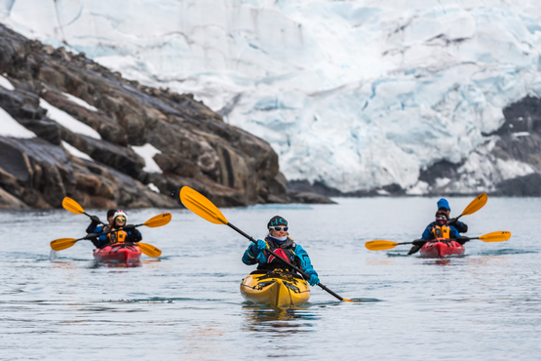 | Sea Kayaking  Kayaking fee $655 - A$885 - £505 - €625  Sea Kayak Club is typically offered on voyages that include High Arctic destinations such as Greenland, Svalbard (Spitsbergen), Franz Josef Land, or a combination of these thrilling places. Experience calving glaciers in Svalbard, cathedral-like icebergs in Greenland, or labyrinthine expanses of sea ice in the Arctic Ocean, all from our sturdy and stealthy sea kayaks. Join us for an unscripted kayaking adventure as we explore rugged coastlines and remote waters that very few people have ever paddled.
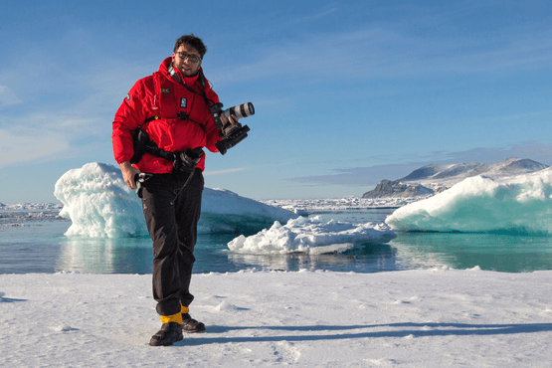 | Photography  Free option  The Polar Regions are perhaps the most photogenic on earth, with countless beautiful scenes presenting themselves every day. Endless expanses of ice, beaches crowded with seals or penguins, sunsets over unbroken horizons, starlit skies, and even the majestic northern lights – they all present fantastic photographic opportunities – and in order to make sure that you come home with some spectacular images we offer you the chance to learn and practice your photography alongside an experienced professional.  Our expert Photographer will be on hand to answer your questions and give advice, both in the form of on-board lectures and workshops on shore. Explore the key elements of photography in a fun and relaxed setting, with plenty of opportunities for questions and feedback. Learn how to see light in a new way and experiment with the techniques of composition and framing.

Rates Include  Round trip Oslo - Longyearbyen - Oslo air transportation;  1 pre-voyage night on Day 1 in the Radisson Blu Airport Hotel, Oslo Gardermoen;  Group transfer to the ship for embarkation on Day 2;  Shipboard accommodation;  All meals on board throughout the voyage;  Tea and coffee station 24 hours daily;  All scheduled landings/excursions (subject to weather and ice conditions);  Leadership throughout the voyage by our experienced Expedition Leader and Expedition Team;  Branded Poseidon Expeditions parka;  Rubber boots for shore landings for the time of the cruise;  Welcome and Farewell cocktails;  All port fees;  Group transfer to airport or central location upon disembarkation;  Pre-departure materials;  Wi-Fi on board. | Rates Do Not Include  Airfare;  Visa and passport fees;  Luggage and trip cancellation insurance;  Soft drinks and alcoholic beverages other than those for special events and celebrations;  Personal expenses such as laundry and telecommunication charges;  Mandatory Emergency Evacuation Insurance to a minimum benefit of US$ 200,000 per person;  Kayaking;  The cost of any applicable medical tests (such as COVID-19) or vaccinations required either by a national government or Poseidon Expeditions before, during or after the cruise;  Staff gratuities.
Itinerary, landings and all other activities during the cruise depend strongly on ice and weather conditions and are subject to the decisions of the Expedition Leader and the Captain of the vessel. Encounters with any mentioned wildlife cannot be guaranteed.

