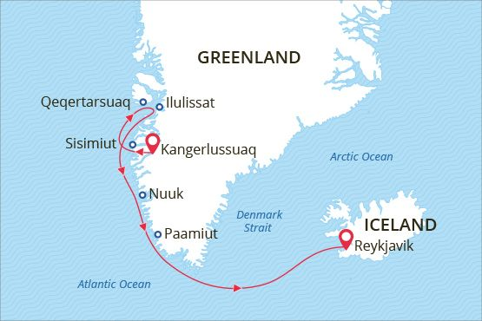

South & West Greenland and Disko Bay
Welcome to the Land of Vikings
06 Jun - 17 Jun 2018
12 days
Embarkation: Kangerlussuaq (Greenland)
Disembarkation: Reykjavik (Iceland)
M/v Sea Spirit
Activities:

Itinerary
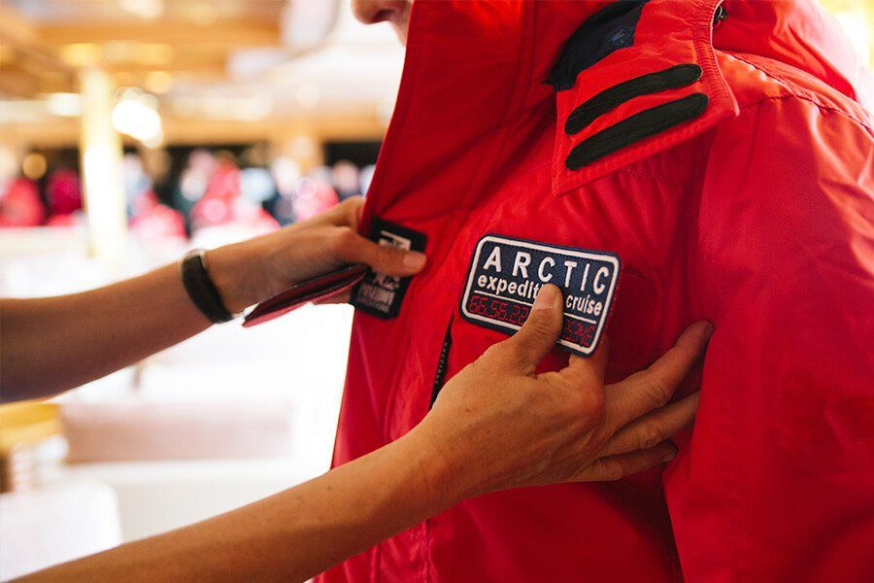Day 1: Embarkation in Kangerlussuaq, Greenland
The town of Kangerlussuaq is more or less only the airport. Though the Greenland ice cap “knocking at the door” of the town and colourful houses make it a special place. In the afternoon we welcome you aboard the luxury expedition ship M/V Sea Spirit. Explore the ship and get comfortable in your home away from home for the extraordinary adventure to come. Savor the anticipation of your Arctic dreams coming true as we slip our moorings and sail out of the picturesque fjord.
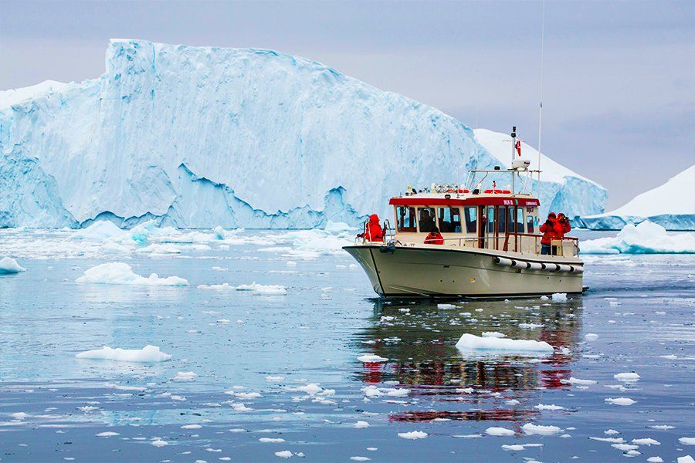Day 2-9: Disko Bay and West Greenland
Though settlements abound in this part of Greenland, unpredictable weather and dearth of docking facilities nevertheless make this a real expedition. As such, our route and exploration opportunities along this coast are heavily dependent on the weather and ice conditions we encounter. Our experienced captain and expedition leader decide the itinerary and continually adjust plans as conditions and opportunities warrant. You can be sure that the best possible advantage will be taken of the circumstances presented to us by Nature in this wild and remote region. Possible sites of exploration include:
Qeqertarsuaq — Located on volcanic Disko Island, the small town of Qeqertarsuaq enjoys views of basaltic mountains and the huge icebergs of Disko Bay. Founded in 1773 as a whaling station, Qeqertarsuaq is one of the oldest towns in Greenland. Cultural attractions include a distinctive octagonal church called the «Lord’s Ink Pot».
Ilulissat — Formerly called Jakobshavn, the town of Ilulissat is best known for unbelievable quantities of icebergs issuing from the nearby Ilulissat Icefjord, into which one of the world’s fastest moving and most active glaciers calves 46 cubic kilometers of ice annually. Attractions in town include the Inuit Art Museum, which contains a large collection of paintings by Greenlandic, Faroese, and Danish artists.
Sisimiut — Located north of the Arctic Circle, the second-largest town in Greenland boasts a youthful, urban vibe and is also is known for adventure sports, especially dog sledding. The Sisimiut Museum offers insight into the local culture and a history of human habitation dating back 4,500 years.
Nuuk — Also known as Godthåb, Nuuk is the capital and largest city of Greenland. It has a population of over 16,000, making it one of the smallest capital cities in the world by population. It is also the world’s northernmost capital, located only a few kilometers further north than Reykjavík. The famous Qilakitsoq mummies can be seen at the Greenlandic National Museum.
Qaqortoq — Formerly called Julianehåb, the town of Qaqortoq is the most populous town in southern Greenland. Colorful historical buildings, such as the former blacksmith shop that now houses the Qaqortoq Museum, reflect the town’s Danish colonial past. Greenland’s oldest fountain and numerous stone sculptures can be found around town.
Hvalsey — The island of Hvalsey is the site of Greenland’s largest and best-preserved Norse ruins. According to the Icelandic Book of Settlements, the farmstead was established in the late 10th century by Erik the Red’s uncle, Thorkell Farserkur. Most impressive among the remains are the walls of an exceptionally well-built stone church.
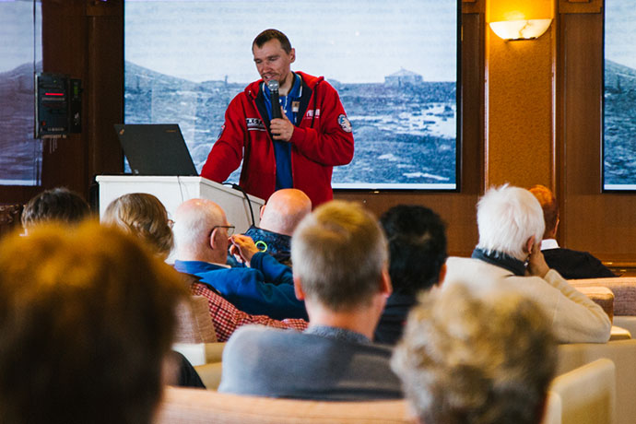Day 10-11: At sea
After our amazing time in West Greenland we head toward Iceland. Presentations and workshops by our expert staff, as well as our range of onboard recreation facilities, ensure that these days at sea are not idly spent. Seabird viewing and whale sightings can be enjoyed from panoramic open decks as well as exterior stateroom windows and balconies.
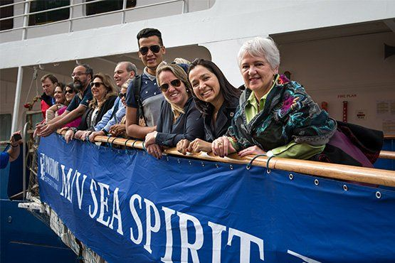Day 12: Disembarkation in Reykjavík, Iceland
After breakfast we say farewell in Reykjavík, the capital of Iceland and ending point of our expedition. We provide a transfer to the international airport or to the city center if you wish to spend another day or more in Iceland before flying home. From Reykjavík the entire country is accessible through day tours or longer journeys by rental car. The options for additional adventures are endless!

Special guest
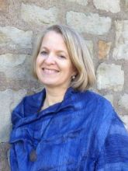Joanna Kafarowski, PhD
Geographer, Writer
Joanna has worked extensively with Indigenous women in the Arctic and has a passion for the North. She has a strong interest in women in polar history and is the author of “The Polar Adventures of a Rich American Dame A Life of Louise Arner Boyd" (Dundurn Press, 2017) and editor of "Gender, Culture and Northern Fisheries" (Canadian Circumpolar Institute, 2009). She is a Fellow of the Royal Geographical Society and a Member of the Society of Woman Geographers.

M/v Sea Spirit
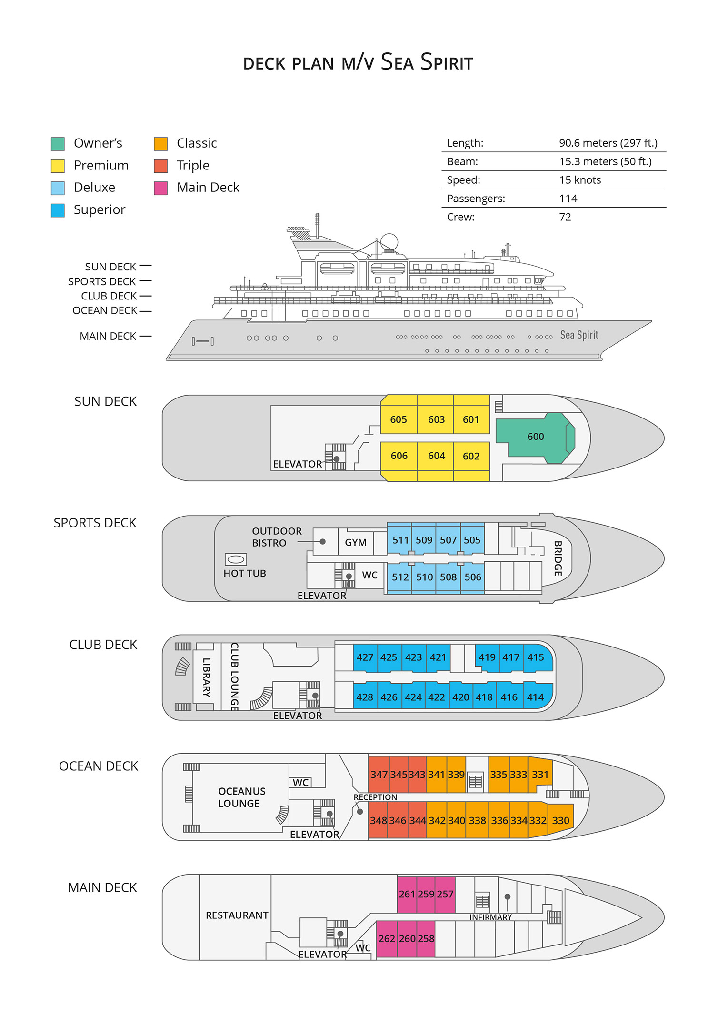

Triple Suite  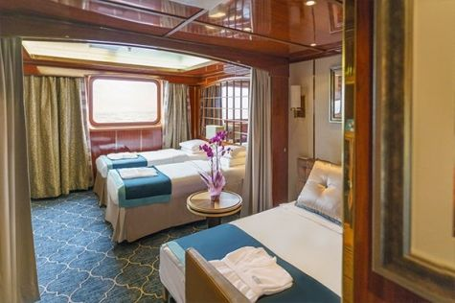  Averaging 21 square metres/226 square feet, these staterooms have two twins and a comfortable sofa bed. The twins also convert to a King, if desired. Located on Oceanus Deck, these suites have a picture window, two wardrobes and en suite facilities. Amenities include: in-room safe, refrigerator, satellite telephone access, TV/DVD, individual temperature control, and hair dryer. | Main Deck Suite  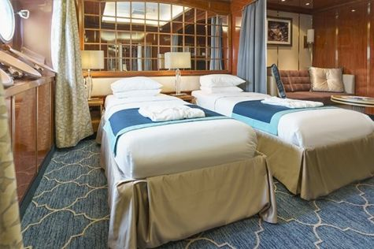  Averaging 23 square metres/248 square feet, Main Deck cabins are equipped with either two twins or a King Size bed. They are located on the Main Deck with a minimum of two portholes for exterior views. Amenities include: en suite facilities, in-room safe, refrigerator, satellite telephone access, TV/DVD individual temperature control and hair dryer.
Single Suite  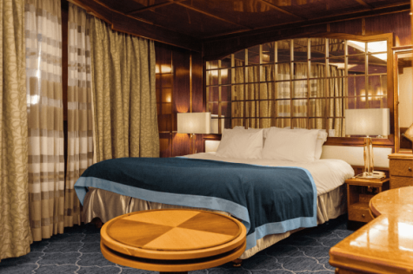  Averaging 21 square meters/226 square feet, these cabins are located on the Oceanus Deck. They feature a picture window (it may be covered during rough sea crossings), two wardrobes, and a King Size bed. Amenities include: en suite facilities, in-room safe, refrigerator, satellite telephone access, TV/VCR, individual temperature control, and hair dryer. | Classic Suite  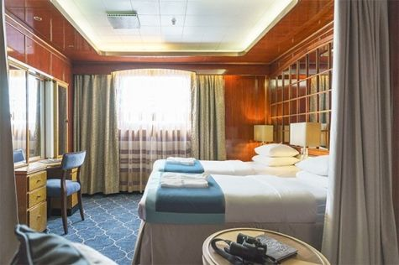  Averaging 21 square metres/226 square feet, these cabins are located on the Oceanus Deck. They feature a picture window, two wardrobes and a choice of either two twin beds or a King Size bed. Amenities include: en suite facilities, in-room safe, refrigerator, satellite telephone access, TV/DVD, individual temperature control and hair dryer.
Superior Suite  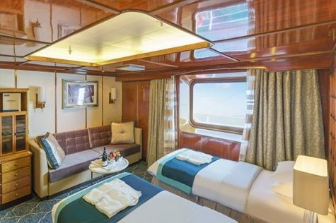  Superior Suites are located on the Club Deck. Averaging 20 square metres/ 215 square feet, these cabins feature two twin beds or a King Size bed. The picture window overlooks an outside walkway on the Club Deck. Amenities include: en suite facilities, walk-in closet or wardrobe, in-room safe, refrigerator, satellite telephone access, TV/DVD, individual temperature control, hair dryer. | Deluxe Suite  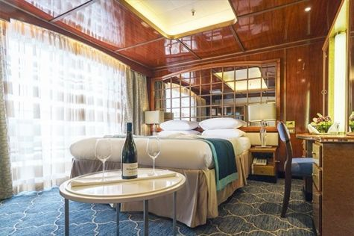  The Deluxe Suites with balconies are located on the Sports Deck. Averaging 24 square metres/ 258 square feet means plenty of room. Choose from either two twin beds or a King Size bed. A sliding glass door leads to a private balcony. These suites feature a walk-in closet or wardrobe. Amenities include en suite facilities, in-room safe, refrigerator, satellite telephone access, TV/DVD, individual temperature control, and a hair dryer.
Premium Suite  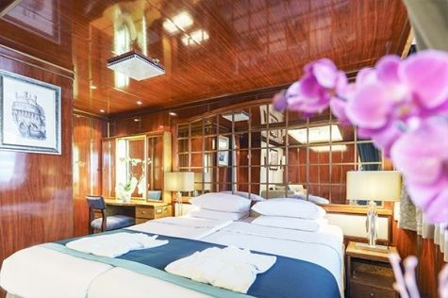  The Premium Suites are located on the Sun Deck. Averaging a generous 30 square metres/ 323 square feet, with two twin beds or a King Size bed. Access the private balcony by a sliding glass door. Amenities include: en suite facilities, lounge area, in-room safe, refrigerator, satellite telephone access, TV/DVD, individual temperature control, and hair dryer. | Owners Suite  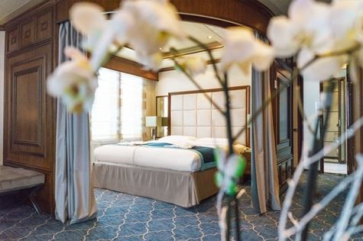  Super-spacious (63 square metres/ 678 square feet) elegant suite on the Sun Deck. Designed for entertaining, the Owner's Suite has a separate living room with game and meeting area. A BOSE stereo system provides background music, or watch videos on the HD plasma TV. Sliding glass doors lead to a private deck. Refresh in the jetted bathtub in en suite facilities. Slumber in the King Size bed. A sofa bed can accommodate a third person.

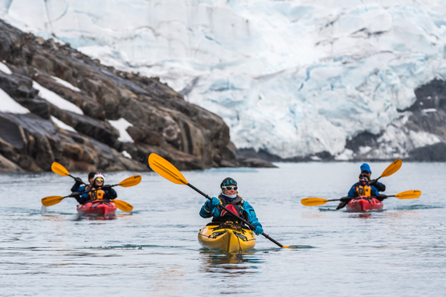 | Sea Kayaking  Kayaking fee $655 - A$885 - £505 - €625  Sea Kayak Club is typically offered on voyages that include High Arctic destinations such as Greenland, Svalbard (Spitsbergen), Franz Josef Land, or a combination of these thrilling places. Experience calving glaciers in Svalbard, cathedral-like icebergs in Greenland, or labyrinthine expanses of sea ice in the Arctic Ocean, all from our sturdy and stealthy sea kayaks. Join us for an unscripted kayaking adventure as we explore rugged coastlines and remote waters that very few people have ever paddled.
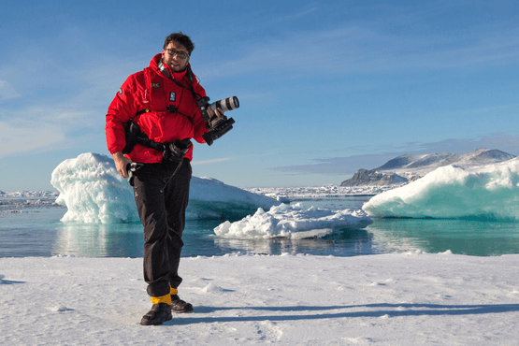 | Photography  Free option  The Polar Regions are perhaps the most photogenic on earth, with countless beautiful scenes presenting themselves every day. Endless expanses of ice, beaches crowded with seals or penguins, sunsets over unbroken horizons, starlit skies, and even the majestic northern lights – they all present fantastic photographic opportunities – and in order to make sure that you come home with some spectacular images we offer you the chance to learn and practice your photography alongside an experienced professional.  Our expert Photographer will be on hand to answer your questions and give advice, both in the form of on-board lectures and workshops on shore. Explore the key elements of photography in a fun and relaxed setting, with plenty of opportunities for questions and feedback. Learn how to see light in a new way and experiment with the techniques of composition and framing.

Rates Include  Group transfer to the ship on day of embarkation;  Shipboard accommodation;  All meals on board throughout the voyage;  Tea and coffee station 24 hours daily;  All scheduled landings/excursions (subject to weather and ice conditions);  Museum entrance fee;  Leadership throughout the voyage by our experienced Expedition Leader and Expedition Team;  Branded Poseidon Expeditions parka;  Rubber boots for shore landings for the time of the cruise;  Welcome and Farewell cocktails;  All port fees;  Group transfer to airport or central location upon disembarkation;  Pre-departure materials;  Digital Voyage Log;  Emergency Evacuation Insurance to a maximum benefit of USD 150,000 per person. | Rates Do Not Include  Air flights other than included;  Visa and passport fees (if applicable);  Luggage and trip cancellation insurance;  Soft drinks and alcoholic beverages other than those for special events and celebrations;  Personal expenses such as laundry and telecommunication charges;  Staff gratuities.
Itinerary, landings and all other activities during the cruise depend strongly on ice and weather conditions and are subject to the decisions of the Expedition Leader and the Captain of the vessel. Encounters with any mentioned wildlife cannot be guaranteed.

