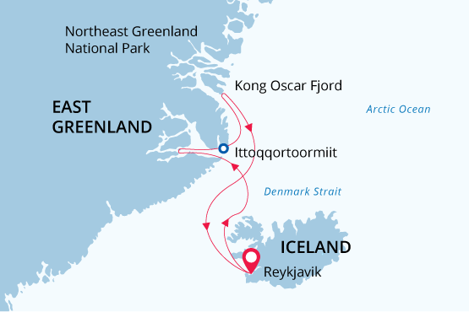

East Greenland
Fjords and Northern Lights
22 Aug - 05 Sep 2023
15 days
Embarkation: Reykjavik (Iceland)
Disembarkation: Reykjavik (Iceland)
M/v Sea Spirit
Activities:

Itinerary
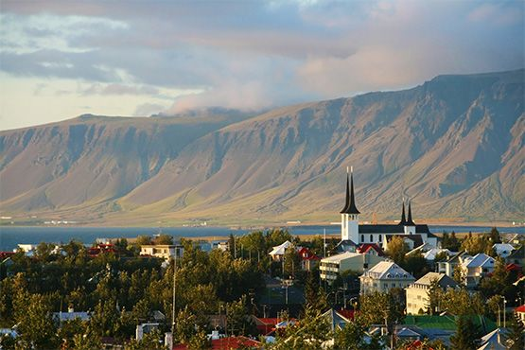Day 1: Arrival in Reykjavík, Iceland (hotel night)
Welcome to Reykjavík, the world's northernmost capital city! We’ve arranged a hotel accommodation where you can rest after your flight and get ready for our upcoming Arctic adventures. Still have some energy left? Then use this opportunity to explore the city, which offers various points of interest and attractions for visitors. Enjoy the panoramic city view from the Perlan observation deck, the futuristic Hallgrímskirkja church towering over the city, cozy houses with colorful tin roofs, narrow streets, historic relics of the Viking era and breathtaking landscapes surrounding Reykjavik. We bet you’ll fall in love at first sight! Walk along Laugavegur, Reykjavik’s main shopping street, or visit the Whales of Iceland exhibition and the National Museum. For dinner Reykjavík offers countless options to enjoy an authentic Icelandic meal.
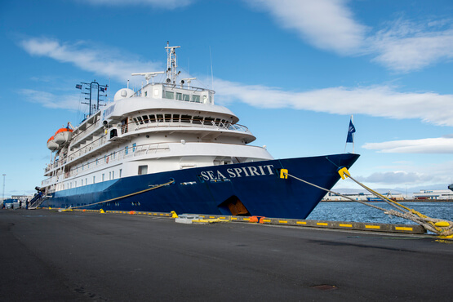Day 2: Welcome Aboard!
After breakfast at your hotel, the morning is yours to explore the city. Take a leisurely stroll through peaceful gardens or appreciate the abundant birdlife at Tjörnin, a placid lake in the heart of the city. You can also use do some last-minute shopping for souvenirs and other necessities. Just don’t go overboard with your clothing purchases: you’ll soon be presented with your very own expedition parka that you can keep and waterproof boots to borrow for the duration of the cruise. Our expedition starts in the afternoon. You’ll be transferred to the pier where our expedition team will offer a warm welcome aboard our comfortable vessel M/V Sea Spirit. Get settled into your spacious cabins and explore the ship — It’ll be your home away from home during the extraordinary adventure to come. After departure, we’ll kick off our adventure with a full schedule of info briefings and introductions from the expedition staff. After a sumptuous dinner, step out onto the open decks to admire the spectacular views as we sail through Faxaflói. And keep your eyes open for whale encounters!
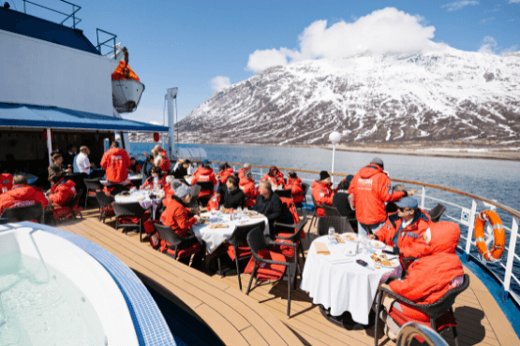Day 3: Across the Greenland Sea
From Reykjavik we head southwest across the Greenland Sea toward East Greenland. In these far northern latitudes, we may encounter sea ice any time of the year, even in August. We’ll keep an eye out for iconic marine mammals.
In previous eras, large numbers of various species of whales lived in the Greenland Sea. However, due to hunting (which was conducted up until the 20th century), these gentle giants were on the verge of extinction. Fortunately, populations are now recovering and, with a little bit of luck, we’ll spot them on our cruise.
Want to learn more about the unique flora and fauna of the Arctic? Become an Arctic expert in no time with our onboard lectures and briefings!
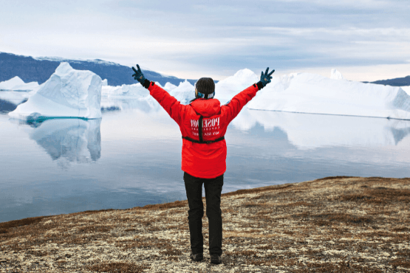Day 4-7: Northeast Greenland National Park
East Greenland is famous for its giant icebergs the size of ten-story buildings, huge mountains, blooming tundra landscapes and the best spots in the world to see northern lights. Get ready for an unforgettable adventure, but remember — our exact itinerary heavily depends on weather and sea ice conditions. Rest assured, our experienced captain and expedition leader will take advantage of every opportunity to see wildlife, discover incredible scenery and land ashore.
You’ll see Northeast Greenland National Park, an absolute bucket list item on your East Greenland cruise! This park is not just remote; it is of a massive scale – more than 100 times the size of Yellowstone National Park and larger than all but 29 nations around the globe. Just imagine: miles and miles of untouched wilderness in the world’s largest and northernmost national park! We’ll sail through ice floes alongside the snowy peaks of the Franz Josef Fjord and Kong Oscar Fjord, and Zodiacs will carry us to the most inaccessible spots for landings on pristine polar beaches.
Due to its remoteness, fewer than 1,000 travelers visit Northeast Greenland National Park each year, so count yourself among the fortunate few to witness such a spectacular area.
Tidewater glaciers create colossal icebergs that float with the wind and tide throughout the fjord system. We’ll be stepping ashore to explore the fields of multicolored tundra which are home to musk oxen and Arctic hare. These landscapes — vast, open, and seemingly untouched since the beginning of time — are a hiker’s paradise. Throughout this area, we also find ancient Thule archeological sites, historical trappers’ huts and modern Inuit hunters’ cabins.
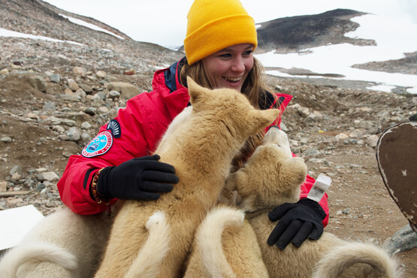Day 8-12: Through the waters of Scoresby Sund
This part of our voyage focuses on the spectacular fjords, coasts and islands of Scoresby Sund. While sailing the waterways of this stunning fjord system, we are constantly watching out for marine mammals, including a variety of seals, walruses and narwhals, which can be spotted at any time. Narrow passages, colossal icebergs in sparkling blue waters and polychromatic mountains capped with fresh snow - a trip through Scoresby Sund sets a new standard for “scenic.” We’ll take advantage of summer weather to go ashore as often as possible for hiking, photography or simply enjoying landscapes found nowhere else on earth.
Small sheltered harbors like Hekla Havn and breathtaking landscapes of Vikingebugt will give you amazing photo ops. And don’t forget to sign up for kayaking right when booking the cruise so you don’t miss out on exploring this beautiful area at your own pace.
We plan to visit the modern Inuit village of Ittoqqortoormiit, the only permanent settlement in the region and one of the most remote communities in the world. The village boasts a wonderful museum, bookstore, handmade crafts for sale, post office and an abundance of Greenlandic sled dogs.
It’s late August and the short Arctic summer in East Greenland is almost over, which means as the night falls, the darkening sky becomes a stage for nature’s greatest celestial performance — the Northern Lights. East Greenland is one of the best places in the Arctic to view this otherworldly natural phenomenon, so don’t miss out on it! Step out onto the deck at night and hopefully you’ll get to see these magic lights dancing in the sky.
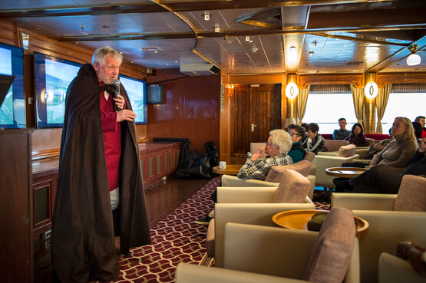Day 13: On the way back to Iceland
By now you’ve surely fallen in love with East Greenland, but it’s time to head back across the Denmark Strait toward Iceland. Presentations and workshops by our expert staff, as well as our range of onboard recreation facilities, ensure that this day at sea is not idly spent. Enjoy an abundance of seabirds and whale watching from our panoramic open deck and your cabin’s balconies.
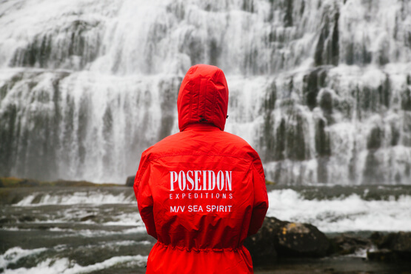Day 14: Dynjandi waterfalls - the jewel of the Westfjords
Welcome back to Iceland! Today is the last day of our expedition and we are going to spend it to the fullest! Our Zodiacs will take us to the Dynjandi waterfalls, also known as “the Jewel of the Westfjords.” Dynjandi means ‘thunderous’ in Icelandic and you will soon understand why the falls got this name. These majestic waterfalls cascade approximately 100 m, falling in a trapezoidal shape: Dynjandi is twice as wide at the bottom than on top and looks exactly like a beautiful bridal veil.
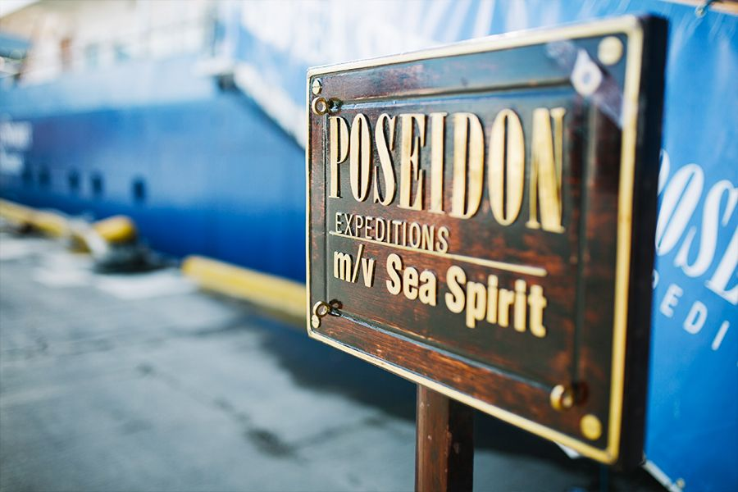Day 15: Disembarkation in Reykjavík, Iceland
Our adventure concludes at the port of Reykjavík. We disembark and provide transfer to the airport or to the city center in case you plan to extend your stay in Iceland. It is always sad to say goodbye, but why not join us on another expedition, like to Antarctica for example? We’ll be delighted to welcome you aboard again on one of our future journeys!

Special guest
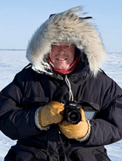Norbert Rosing
Nature and wildlife photographer
The roots of Norbert's great story "In the Realm of the Polar Bears" were laid in spring 1988. Since then, the Arctic theme has become his hobby, his passion, his life. More than fifty trips took him to Northern Canada, Svalbard and Greenland - always close to the wonders of this breathtaking world.
His picture "Polar Bear at Ease" became an icon and is now offered by the National Geographic Fine Art Gallery. Magazines such as GEO and National Geographic printed his pictures. Norbert Rosing is also known for his excellent multivision lectures.
In 2015 he became the godfather of the polar bear twin "Nobby" at Hellabrunn Zoo in Munich.

M/v Sea Spirit
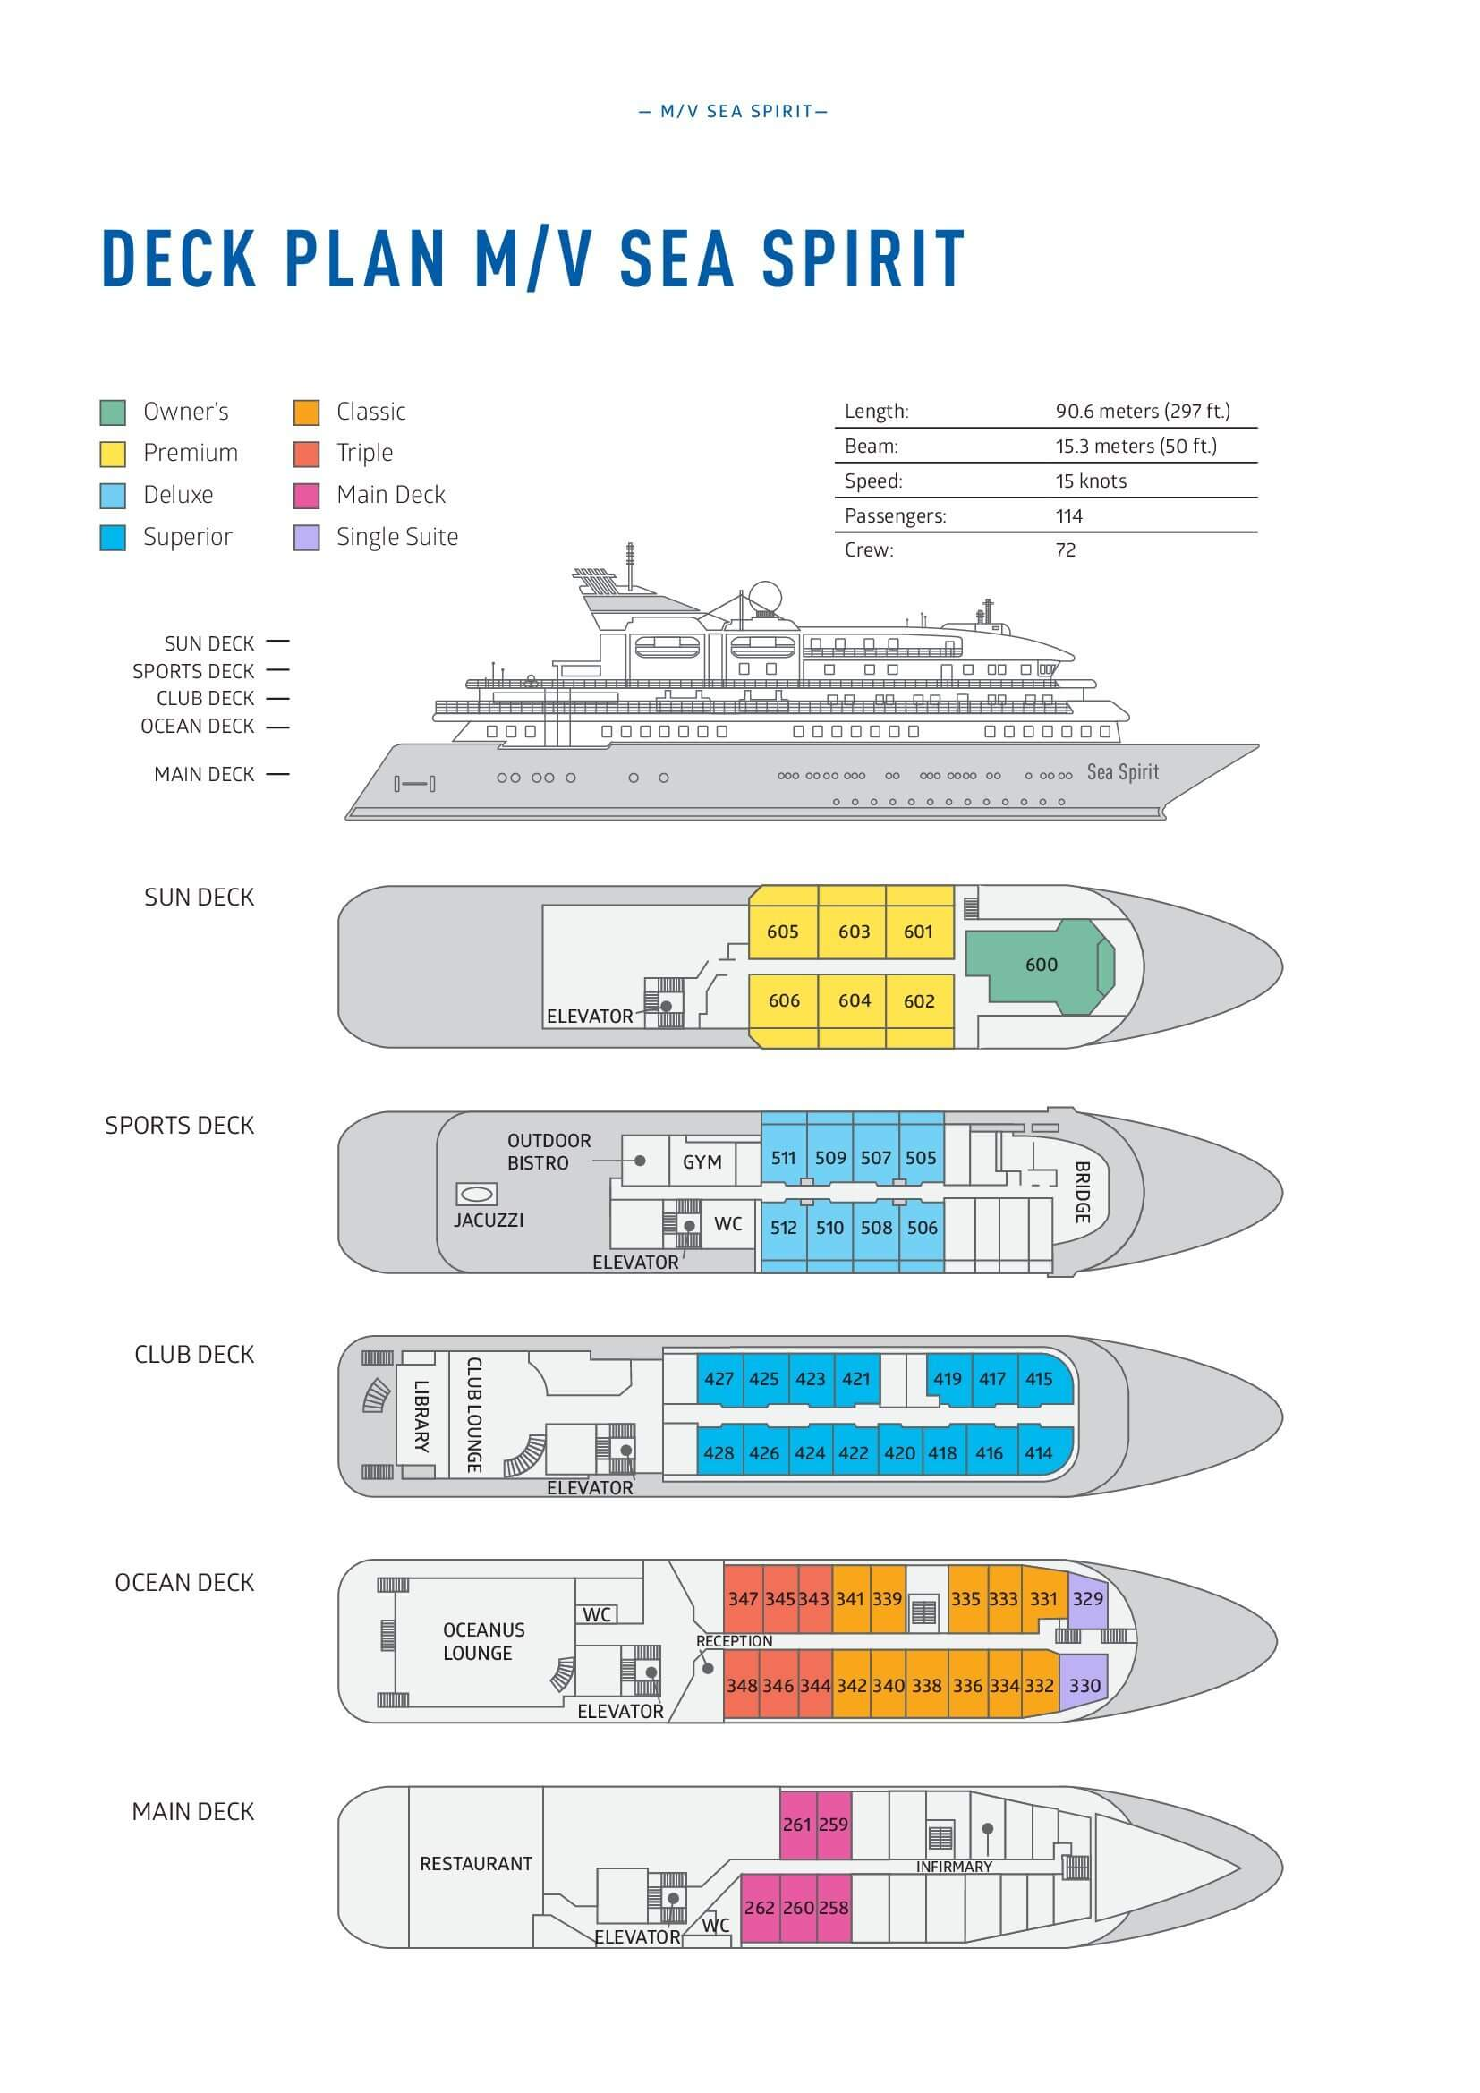

Triple Suite  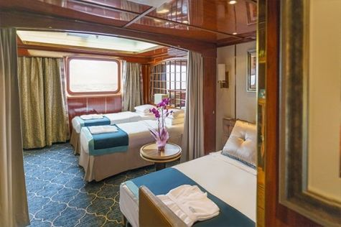  Averaging 21 square metres/226 square feet, these staterooms have two twins and a comfortable sofa bed. The twins also convert to a King, if desired. Located on Oceanus Deck, these suites have a picture window, two wardrobes and en suite facilities. Amenities include: in-room safe, refrigerator, satellite telephone access, TV/DVD, individual temperature control, and hair dryer. | Main Deck Suite  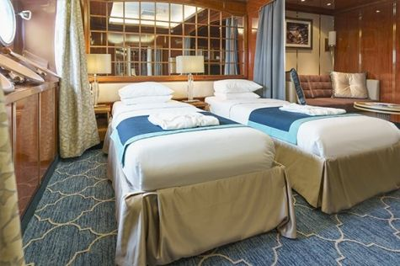  Averaging 23 square metres/248 square feet, Main Deck cabins are equipped with either two twins or a King Size bed. They are located on the Main Deck with a minimum of two portholes for exterior views. Amenities include: en suite facilities, in-room safe, refrigerator, satellite telephone access, TV/DVD individual temperature control and hair dryer.
Single Suite  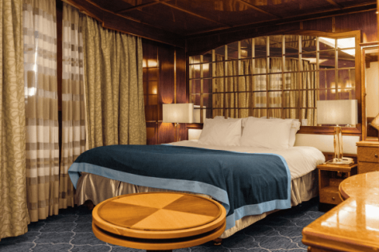  Averaging 21 square meters/226 square feet, these cabins are located on the Oceanus Deck. They feature a picture window (it may be covered during rough sea crossings), two wardrobes, and a King Size bed. Amenities include: en suite facilities, in-room safe, refrigerator, satellite telephone access, TV/VCR, individual temperature control, and hair dryer. | Classic Suite  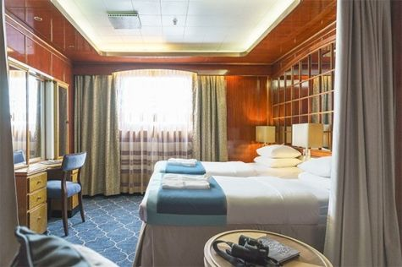  Averaging 21 square metres/226 square feet, these cabins are located on the Oceanus Deck. They feature a picture window, two wardrobes and a choice of either two twin beds or a King Size bed. Amenities include: en suite facilities, in-room safe, refrigerator, satellite telephone access, TV/DVD, individual temperature control and hair dryer.
Superior Suite  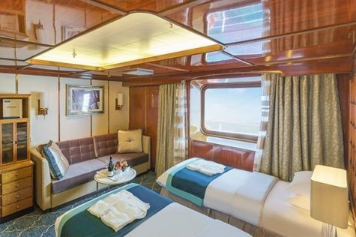  Superior Suites are located on the Club Deck. Averaging 20 square metres/ 215 square feet, these cabins feature two twin beds or a King Size bed. The picture window overlooks an outside walkway on the Club Deck. Amenities include: en suite facilities, walk-in closet or wardrobe, in-room safe, refrigerator, satellite telephone access, TV/DVD, individual temperature control, hair dryer. | Deluxe Suite  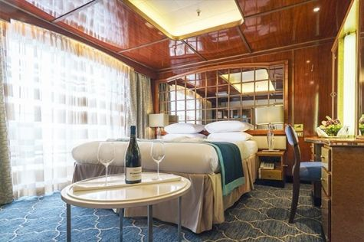  The Deluxe Suites with balconies are located on the Sports Deck. Averaging 24 square metres/ 258 square feet means plenty of room. Choose from either two twin beds or a King Size bed. A sliding glass door leads to a private balcony. These suites feature a walk-in closet or wardrobe. Amenities include en suite facilities, in-room safe, refrigerator, satellite telephone access, TV/DVD, individual temperature control, and a hair dryer.
Premium Suite  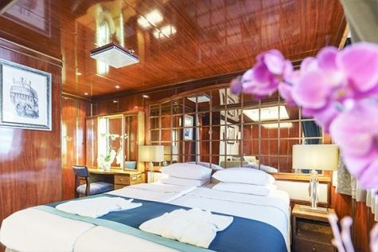  The Premium Suites are located on the Sun Deck. Averaging a generous 30 square metres/ 323 square feet, with two twin beds or a King Size bed. Access the private balcony by a sliding glass door. Amenities include: en suite facilities, lounge area, in-room safe, refrigerator, satellite telephone access, TV/DVD, individual temperature control, and hair dryer. | Owners Suite  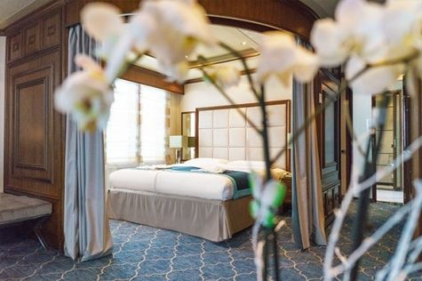  Super-spacious (63 square metres/ 678 square feet) elegant suite on the Sun Deck. Designed for entertaining, the Owner's Suite has a separate living room with game and meeting area. A BOSE stereo system provides background music, or watch videos on the HD plasma TV. Sliding glass doors lead to a private deck. Refresh in the jetted bathtub in en suite facilities. Slumber in the King Size bed. A sofa bed can accommodate a third person.

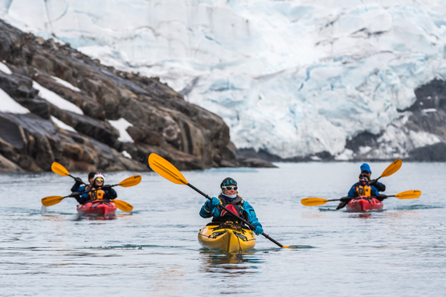 | Sea Kayaking  Kayaking fee $655 - A$885 - £505 - €625  Sea Kayak Club is typically offered on voyages that include High Arctic destinations such as Greenland, Svalbard (Spitsbergen), Franz Josef Land, or a combination of these thrilling places. Experience calving glaciers in Svalbard, cathedral-like icebergs in Greenland, or labyrinthine expanses of sea ice in the Arctic Ocean, all from our sturdy and stealthy sea kayaks. Join us for an unscripted kayaking adventure as we explore rugged coastlines and remote waters that very few people have ever paddled.
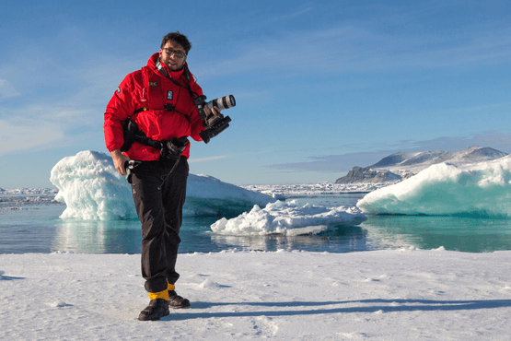 | Photography  Free option  The Polar Regions are perhaps the most photogenic on earth, with countless beautiful scenes presenting themselves every day. Endless expanses of ice, beaches crowded with seals or penguins, sunsets over unbroken horizons, starlit skies, and even the majestic northern lights – they all present fantastic photographic opportunities – and in order to make sure that you come home with some spectacular images we offer you the chance to learn and practice your photography alongside an experienced professional.  Our expert Photographer will be on hand to answer your questions and give advice, both in the form of on-board lectures and workshops on shore. Explore the key elements of photography in a fun and relaxed setting, with plenty of opportunities for questions and feedback. Learn how to see light in a new way and experiment with the techniques of composition and framing.

Rates Include  1 pre-voyage night on Day 1 in Grand Hotel Reykjavik;  Group transfer to the ship for embarkation on Day 2;  Shipboard accommodation;  All meals on board throughout the voyage;  Tea and coffee station 24 hours daily;  All scheduled landings/excursions (subject to weather and ice conditions);  Leadership throughout the voyage by our experienced Expedition Leader and Expedition Team;  Branded Poseidon Expeditions parka;  Rubber boots for shore landings for the time of the cruise;  Welcome and Farewell cocktails;  All port fees;  Group transfer to Keflavik International Airport (KEF) or centrally located hotel for luggage storage right after disembarkation;  Pre-departure materials;  Digital Voyage Log;  Wi-Fi on board. | Rates Do Not Include  Airfare;  Transfers from the airport to the hotel at beginning of the program;  Visa and passport fees (if applicable);  Luggage and trip cancellation insurance;  Soft drinks and alcoholic beverages other than those for special events and celebrations;  Personal expenses such as laundry and telecommunication charges;  Mandatory Emergency Evacuation Insurance to a minimum benefit of US$ 200,000 per person;  Kayaking;  The cost of any applicable medical tests (such as COVID-19) or vaccinations required either by a national government or Poseidon Expeditions before, during or after the cruise;  Staff gratuities.
Itinerary, landings and all other activities during the cruise depend strongly on ice and weather conditions and are subject to the decisions of the Expedition Leader and the Captain of the vessel. Encounters with any mentioned wildlife cannot be guaranteed.

