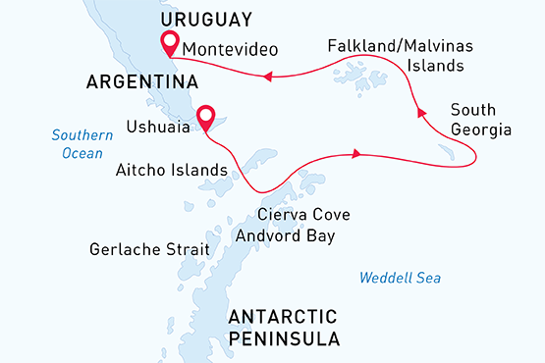

Falklands, South Georgia & Antarctica
Antarctic Wildlife Adventure
25 Feb - 18 Mar 2020
23 days
Embarkation: Ushuaia (Argentina)
Disembarkation: Montevideo (Uruguay)
M/v Sea Spirit
Activities:

Itinerary
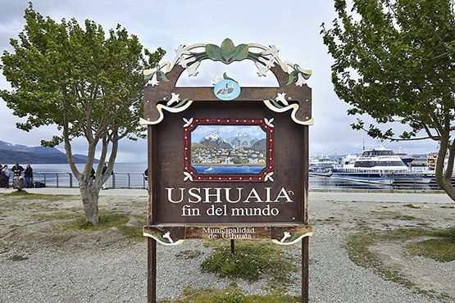Day 1: Ushuaia, Argentina (hotel night)
The small city of Ushuaia is the perfect starting point for our expedition cruise to Antarctica, South Georgia and the Falkland/Malvinas Islands. Located near the southern tip of South America, it boasts beautiful views of the Andres Mountains and the Beagle Channel. Stroll the lively main street of cafes, shops and outfitters, perhaps picking up a last-minute item for your voyage, or enjoying a typical Argentine grill entrée at one of the many casual restaurants. If you arrive early, you will want to visit beautiful Tierra del Fuego National Park.
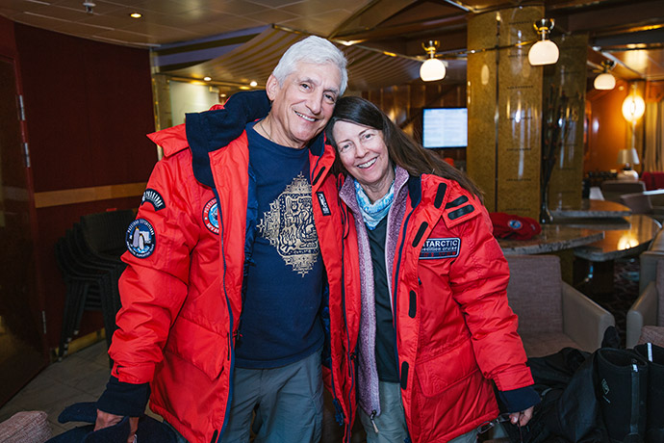Day 2: Embarkation in Ushuaia
In the afternoon we embark the Sea Spirit and set sail down the scenic Beagle Channel. Explore the ship and get comfortable in your home away from home for the extraordinary adventure to come.
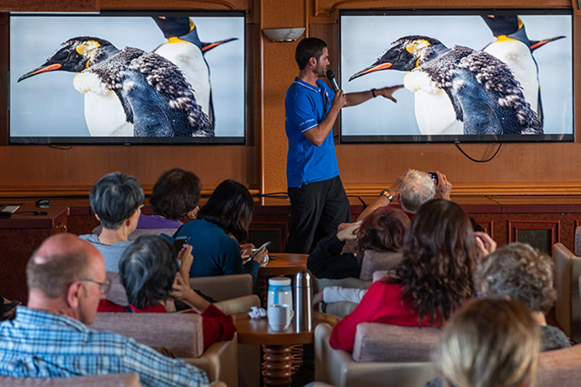Day 3-4: Drake Passage
Through presentations and informal conversations, our team of experts on Antarctic wildlife, history and geology will enlighten you about what we’ll expect to see in the days ahead. Keep a sharp eye out as we cross the Antarctic Convergence, where ocean dynamics create a unique zone of marine life and activity. In the early evening of the fourth day, weather and sea conditions permitting, we plan to have our first landing in the South Shetland Islands.
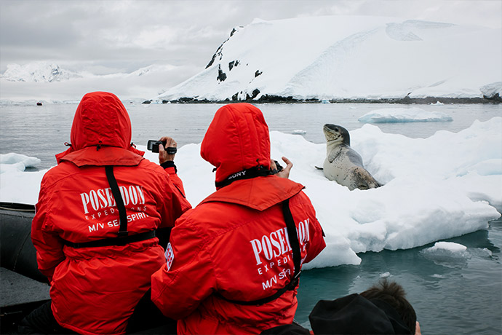Day 5-8: The Antarctic Continent and the South Shetlands
In the region of the South Shetland Islands and Antarctic Peninsula we get a great variety of opportunities to actively explore the unique wildlife and breathtaking scenery. With nearly 200 recognized sites here we use all our experience to offer you the best places and ways to explore the enchanting world of the Sixth Continent. A flexible planning is a key to successful expedition. Our Captain and Expedition Leader will do their best to show you all the faces of Antarctica. We hope to tick off 5 penguin /6 seal / several whale species in Antarctic check-list. While cruising along narrow Antarctic waterways we admire huge icebergs of different shapes, sizes and colours. We visit scientific stations representing several different countries and learn about Antarctic scientific researches straight from the source. Of course setting foot on the actual Antarctic Continent is also on agenda.
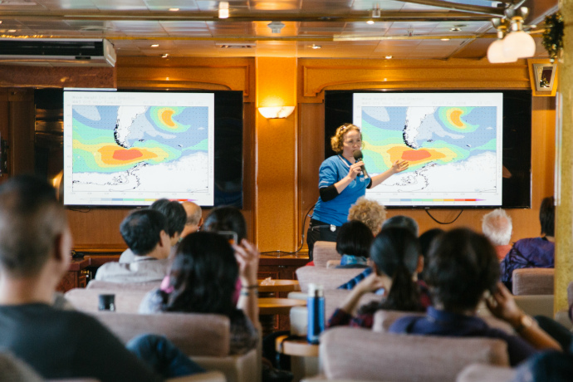Day 9-10: Scotia Sea
More informative presentations are in store today, as we head northeast toward South Georgia.
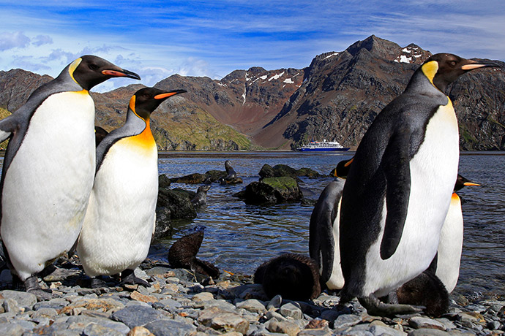Day 11-15: South Georgia
For many, South Georgia is a not-to-be-missed destination within the Antarctic region. These sub-Antarctic islands are mountain peaks emerging from the Scotia Arc, an underwater mountain chain that extends from the Andes to the White Continent. Shaped like a long and narrow whalebone, the islands are home to:

- Four seal species – southern elephant seal, Antarctic fur seal, Weddell seal, and leopard seal.

- Several whale species – southern right whales, humpbacks, fin whales, sperm whales, killer whales orcas, and southern bottlenose whales.

- Antarctic seabirds, about 46% of the world's breeding population of grey headed albatrosses; northern giant petrels, white chinned petrels and Antarctic prions. Most of the world's population of the South Georgia blue eyed shags live there, some 7,500 pairs.

- Penguins – around half the world's population of macaroni penguins, along with 100,000 pairs of Gentoo penguins and about 6,000 breeding pairs of Chinstrap penguins.
The most attractive residents of the South Georgia are King penguins with their orange-yellow crowns. The total number of King penguins is around 400,000 breeding pairs. We spend three days among the alpine landscapes and penguins colonies. We will also visit to the historic settlement of Grytviken. With its whaling-era remnants and Earnest Shackleton’s gravesite, the one-time whaling town is one of the highlights of South Georgia.
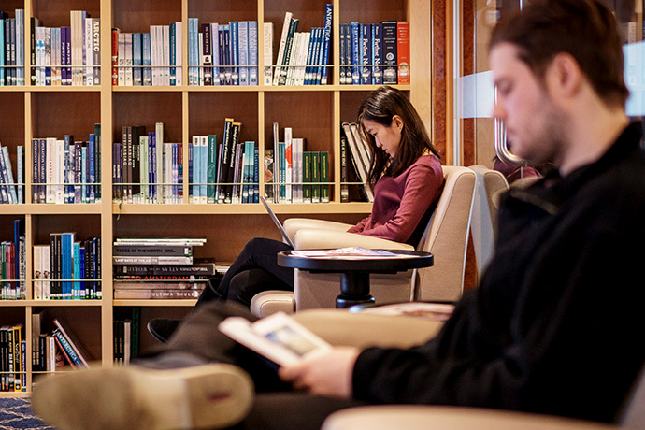Day 16-17: At sea
From South Georgia we head west toward the Falkland Islands. Presentations and workshops by our expert staff, as well as our range of onboard recreation facilities, ensure that these days at sea are not idly spent.
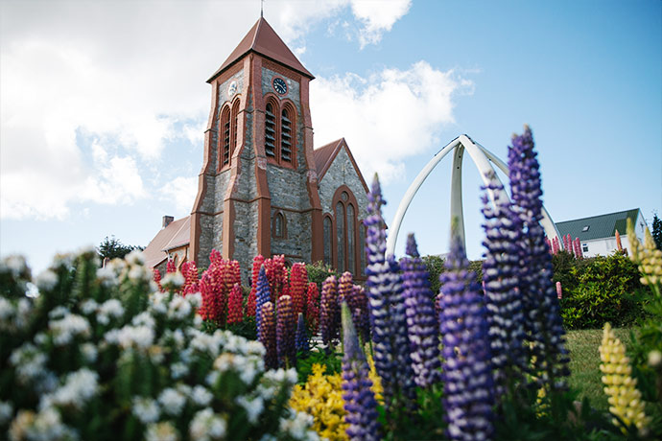Day 18-19: The Falklands
The Falkland Islands offer an unforgettable vista of moors and rugged coastlines carved by the South Atlantic, where the wildlife and plant life form a link between Patagonia and Antarctica. On the beaches, elephant seals are a spectacular sight when battling among themselves to establish territories or just simply relaxing. Sea lions and fur seals are also common sights. As many as a million penguins nest in the Falklands every summer, representing five of the world’s seventeen species – King, Gentoo, Rockhopper, Magellanic and Macaroni. What’s more, for the Gentoo, the Falklands are home to the largest population on Earth. Look for black-browed albatrosses nesting on grassy hillsides overlooking the sea. The capital of the Falklands Port Stanley is the southernmost British outpost in the world. With many reminders of its British heritage such as red phone booths and English pubs, the town boasts other unusual sights like a whalebone arch and shipwrecks along the coast.
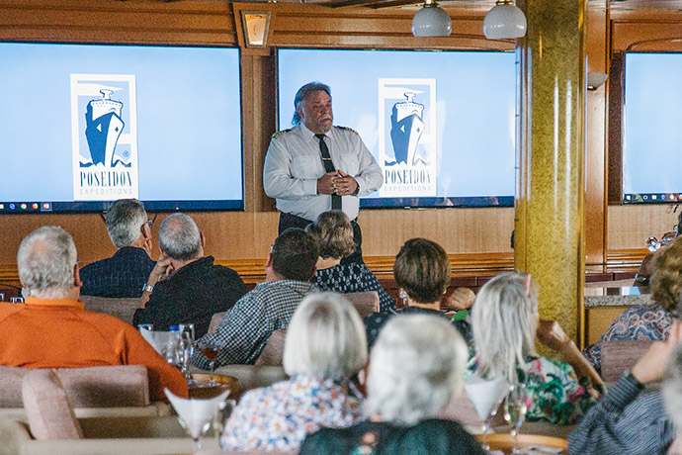Day 20-22: Southern Ocean
Reality begins to set in during this final sea passage separating the magic world we’ve just explored from the rest of the world we’ll soon be rejoining. Refresh your memories through a photo exchange with newfound friends, and bid farewell to seabirds and whales that you can identify more easily now.
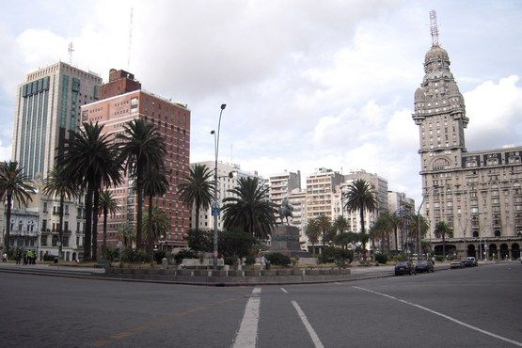Day 23: Disembarkation in Montevideo (Uruguay)
Morning disembarkation in Montevideo. Right after the disembarkation we provide group transfer to the Montevideo airport or the city centre.

M/v Sea Spirit
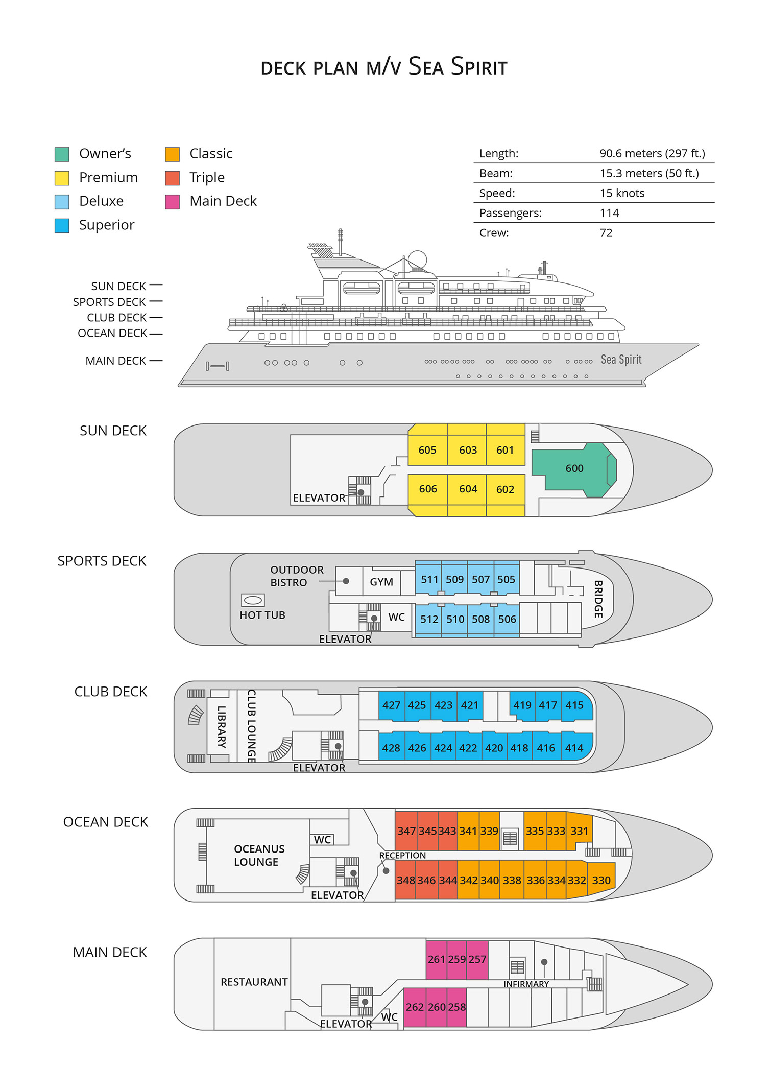

Triple Suite  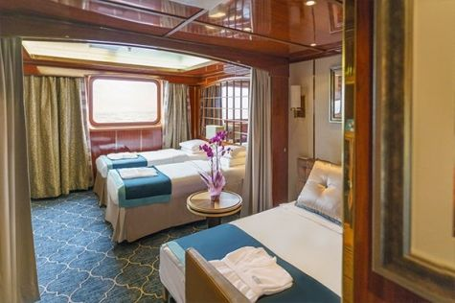  Averaging 21 square metres/226 square feet, these staterooms have two twins and a comfortable sofa bed. The twins also convert to a King, if desired. Located on Oceanus Deck, these suites have a picture window, two wardrobes and en suite facilities. Amenities include: in-room safe, refrigerator, satellite telephone access, TV/DVD, individual temperature control, and hair dryer. | Main Deck Suite  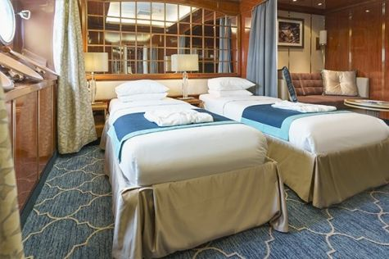  Averaging 23 square metres/248 square feet, Main Deck cabins are equipped with either two twins or a King Size bed. They are located on the Main Deck with a minimum of two portholes for exterior views. Amenities include: en suite facilities, in-room safe, refrigerator, satellite telephone access, TV/DVD individual temperature control and hair dryer.
Single Suite  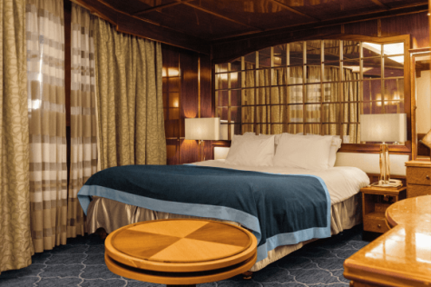  Averaging 21 square meters/226 square feet, these cabins are located on the Oceanus Deck. They feature a picture window (it may be covered during rough sea crossings), two wardrobes, and a King Size bed. Amenities include: en suite facilities, in-room safe, refrigerator, satellite telephone access, TV/VCR, individual temperature control, and hair dryer. | Classic Suite  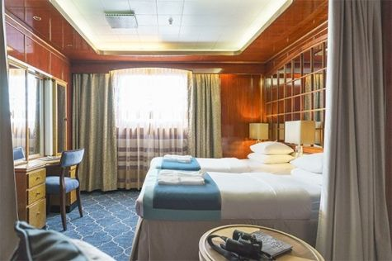  Averaging 21 square metres/226 square feet, these cabins are located on the Oceanus Deck. They feature a picture window, two wardrobes and a choice of either two twin beds or a King Size bed. Amenities include: en suite facilities, in-room safe, refrigerator, satellite telephone access, TV/DVD, individual temperature control and hair dryer.
Superior Suite  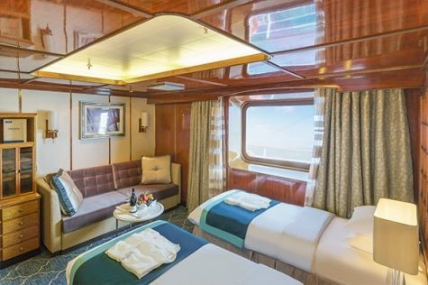  Superior Suites are located on the Club Deck. Averaging 20 square metres/ 215 square feet, these cabins feature two twin beds or a King Size bed. The picture window overlooks an outside walkway on the Club Deck. Amenities include: en suite facilities, walk-in closet or wardrobe, in-room safe, refrigerator, satellite telephone access, TV/DVD, individual temperature control, hair dryer. | Deluxe Suite  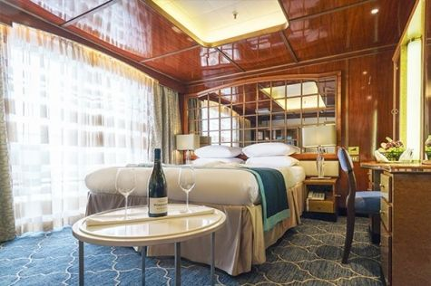  The Deluxe Suites with balconies are located on the Sports Deck. Averaging 24 square metres/ 258 square feet means plenty of room. Choose from either two twin beds or a King Size bed. A sliding glass door leads to a private balcony. These suites feature a walk-in closet or wardrobe. Amenities include en suite facilities, in-room safe, refrigerator, satellite telephone access, TV/DVD, individual temperature control, and a hair dryer.
Premium Suite  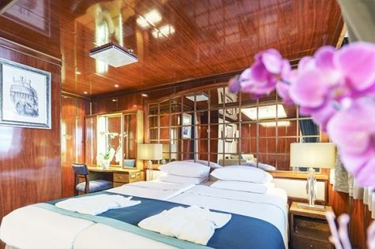  The Premium Suites are located on the Sun Deck. Averaging a generous 30 square metres/ 323 square feet, with two twin beds or a King Size bed. Access the private balcony by a sliding glass door. Amenities include: en suite facilities, lounge area, in-room safe, refrigerator, satellite telephone access, TV/DVD, individual temperature control, and hair dryer. | Owners Suite  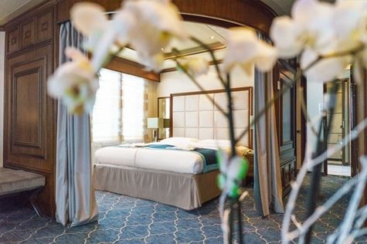  Super-spacious (63 square metres/ 678 square feet) elegant suite on the Sun Deck. Designed for entertaining, the Owner's Suite has a separate living room with game and meeting area. A BOSE stereo system provides background music, or watch videos on the HD plasma TV. Sliding glass doors lead to a private deck. Refresh in the jetted bathtub in en suite facilities. Slumber in the King Size bed. A sofa bed can accommodate a third person.

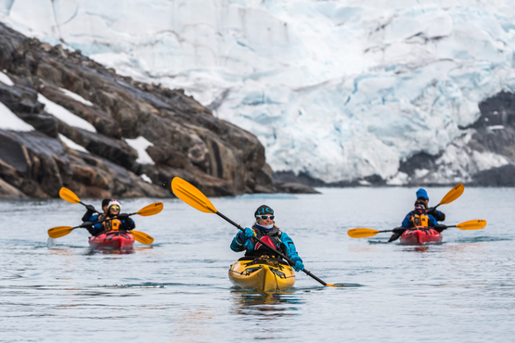 | Sea Kayaking  Kayaking fee $895 - A$1210 - £690 -€855  Antarctica is a paddlers’ paradise. The White Continent boasts some of the world’s most impressive landscapes and is home to incredible marine wildlife. Sea Kayak Club members will have the opportunity to paddle through tranquil waters filled with glittering icebergs and porpoising penguins while surrounded by magnificent glaciers and mountains.  The protected and picturesque waters of the Antarctic Peninsula offer the best sea kayaking opportunities in Antarctica. Sea Kayak Club is also offered on selected voyages to South Georgia, where members may have the rare opportunity to encounter the island’s legendary abundance of wildlife from a kayaker’s perspective, if the area’s notoriously inclement weather permits.
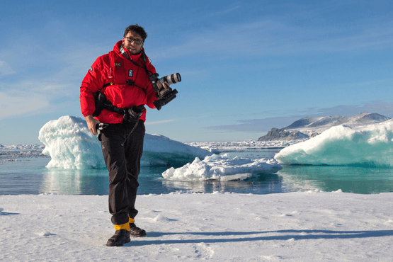 | Photography  Free option  The Polar Regions are perhaps the most photogenic on earth, with countless beautiful scenes presenting themselves every day. Endless expanses of ice, beaches crowded with seals or penguins, sunsets over unbroken horizons, starlit skies, and even the majestic northern lights – they all present fantastic photographic opportunities – and in order to make sure that you come home with some spectacular images we offer you the chance to learn and practice your photography alongside an experienced professional.  Our expert Photographer will be on hand to answer your questions and give advice, both in the form of on-board lectures and workshops on shore. Explore the key elements of photography in a fun and relaxed setting, with plenty of opportunities for questions and feedback. Learn how to see light in a new way and experiment with the techniques of composition and framing.

Rates Include  1 pre-voyage night on Day 1 in Arakur Ushuaia Resort and Spa Hotel;  Group transfer from the airport to the hotel on the day prior to embarkation;  Group transfer to the ship for embarkation on Day 2;  Shipboard accommodation;  All meals on board throughout the voyage;  Tea and coffee station 24 hours daily;  All scheduled landings/excursions (subject to weather and ice conditions);  Leadership throughout the voyage by our experienced Expedition Leader and Expedition Team;  Branded Poseidon Expeditions parka;  Rubber boots for shore landings for the time of the cruise;  Welcome and Farewell cocktails;  All port fees;  Group transfer to airport or central location upon disembarkation;  Ferry from Montevideo and transfer to the airport in Buenos Aires upon disembarkation (for passengers flying out from BA)  Pre-departure materials;  Digital Voyage Log; | Rates Do Not Include  Airfare;  Transfers from the airport to the hotel if arriving prior to Day 1 of the program;  Visa and passport fees (if applicable);  Luggage and trip cancellation insurance;  Soft drinks and alcoholic beverages other than those for special events and celebrations;  Personal expenses such as laundry and onboard communication (telephone calls, faxes, and e-mail service);  Fuel surcharge may be applied for all bookings;  Emergency Evacuation Insurance to a minimum benefit of USD 200,000;  Staff gratuities;  Kayaking;  Pre- or post-cruise travel expenses.
Itinerary, landings and all other activities during the cruise depend strongly on ice and weather conditions and are subject to the decisions of the Expedition Leader and the Captain of the vessel. Encounters with any mentioned wildlife cannot be guaranteed.

