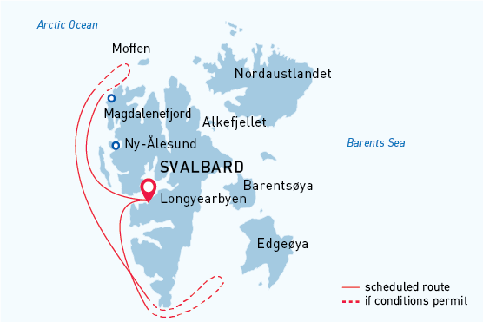

West Svalbard & Polar Ice Edge
Arctic Wildlife Safari
06 Jun - 15 Jun 2022
10 days
Embarkation: Longyearbyen (Svalbard)
Disembarkation: Longyearbyen (Svalbard)
M/v Sea Spirit
Activities:

Itinerary
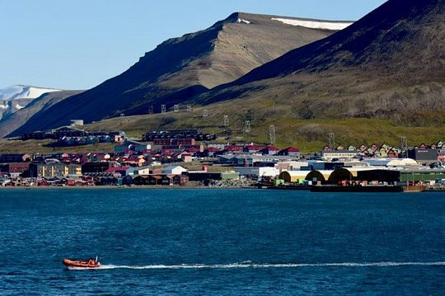Day 1: Arrival in Longyearbyen, Svalbard (hotel night)
Welcome to Longyearbyen, the administrative center of Svalbard and starting point of our Arctic expedition! At the Longyearbyen airport, you will be greeted by our staff and transferred to a quality hotel, which has been arranged by us and is included in the price of the itinerary. You will then be free to explore the charming, walkable town center.
We recommend starting your discovery of this fascinating Norwegian High Arctic territory at the excellent Svalbard Museum, where you can also purchase hard-to-find polar books and maps. Afterward, you can enjoy an excellent dinner at one of Longyearbyen’s many delightful restaurants. If you are still awake at midnight, you will notice the sun has not set. In fact, the sun will not set for the entire duration of our time in Svalbard.
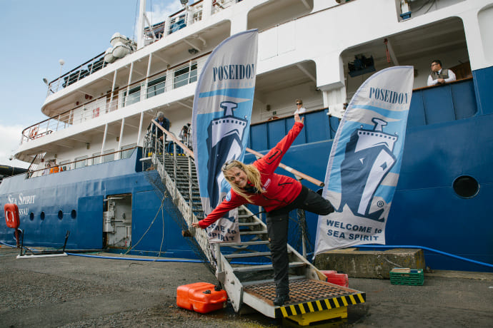Day 2: Welcome Aboard!

After breakfast at your hotel, the morning is yours to enjoy Longyearbyen. Take in the views of icy fjords and glaciated mountains surrounding this historic former coal-mining town. Take advantage of shopping for souvenirs or some last-minute necessities such as cold-weather gear. Just remember, you will soon receive your very own parka to keep and waterproof boots to borrow on board the ship. For lunch, Longyearbyen offers quick and easy meal options including the most northerly pizzas and kebabs in the world.

In the afternoon, you will be transferred to the pier where we will warmly welcome you aboard the deluxe expedition vessel M/V Sea Spirit. Get settled in your spacious suite and explore the ship that will be your comfortable home during the extraordinary adventure to come. After getting underway, a full schedule of events kicks off with informative briefings and introductions from your expedition staff. After the first of many delicious dinners on board, step out onto the open decks to admire the gorgeous scenery in 24-hour daylight as we pass through the wildlife-rich waters of Isfjorden.

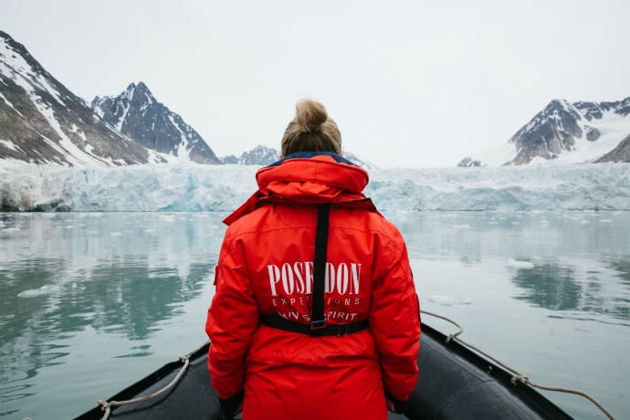Day 3-9: West Svalbard and Polar Ice Edge
The itinerary for this voyage focuses on the spectacular fjords, coasts and islands of western Spitsbergen, the main island of the Svalbard archipelago. This area contains Svalbard’s most impressive scenery and some of the Arctic’s best wildlife viewing opportunities. Our exact schedule and route will be shaped by the weather and ice conditions we encounter. Polar bears and other iconic Arctic animals can be spotted at anytime, anywhere in our area of exploration.
One of the pristine natural areas on this itinerary is South Spitsbergen National Park, a vast region of varied landscapes including polar deserts and impassible mountain ranges. The centerpiece of this park is Hornsund, a picture-perfect fjord where countless mighty glaciers cascade from soaring mountaintops into icy inlets. At this time of year, we are sure to encounter fast ice—that is, sea ice that is fastened to the shore. This situation offers an excellent chance of observing polar bears on the hunt for ringed seals. The park also includes the southern shores of Bellsund, a picturesque bay where we find the remains of historical whaling operations, including wooden boats, cabins and thousands of whale bones—a scene from the distant past, literally frozen in time. This area also offers great hiking opportunities through landscapes rich with Arctic flora and birdlife, as well as fascinating geology.
Also on our route is Northwest Spitsbergen National Park, the crown jewel of Svalbard’s scenic wonders. Here we find deep fjords flanked by serrated mountain peaks and immense tidewater glaciers calving icebergs into turquoise waters. The whole area is alive with migratory Arctic seabirds. On this voyage, we are just in time to witness the return of millions of murres, guillemots and little auks to the small islands, mountainsides and sea cliffs where they breed within the park. This is also a great area to encounter marine mammals, including various kinds of whales and Arctic seals. Set among this incredible scenery and wildlife activity, we also find evidence of Svalbard’s earliest sealers and whalers.
Our area of exploration also includes gorgeous Forlandet National Park. Here we find Prins Karls Forland, one of the best places in Svalbard to observe herds of walrus hauled out on land. Also along the route is North Isforden National Park, where we have the chance to observe endemic Svalbard reindeer grazing and Arctic fox romping in lush tundra meadows.
Human habitation along our route can be found at Ny Ålesund, a former mining town and airship base that is now home to an international community of Arctic researchers. This is one of the world’s most northerly settlements where we find a museum, gift shop and post office.
In addition to exploring the terrestrial environment and inshore waterways of western Spitsbergen, we make a special effort to reach the edge of the polar pack ice. At this dynamic boundary between solid sea ice and open ocean, we have an unparalleled opportunity to witness the dramatic interplay between polar bears and seals. We will take the ship as close as safely possible to the jumbled and constantly shifting ice floes in the hope of observing polar bears hunting in their preferred habitat. At this time of year, the ice edge is not far from mainland Spitsbergen and our sailing time in open seas will be relatively short.
The West Svalbard and Polar Ice Edge route offers a stunning variety of Arctic landscapes and animals with minimal sailing time between excursions. Every day offers something new and exciting. We will not miss a single opportunity to encounter amazing Arctic wildlife, to witness incredible polar scenery, and to walk in the footsteps of historic expeditions that came before.
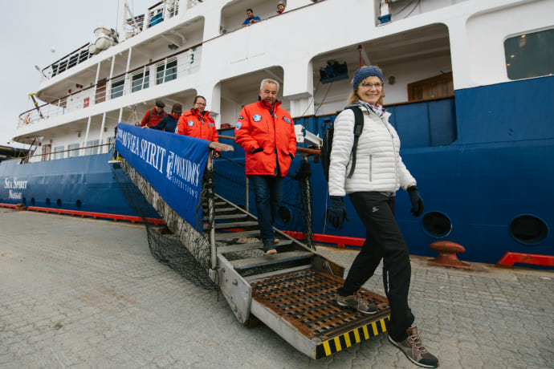Day 10: Disembarkation in Longyearbyen, Svalbard
After filling up with one last buffet breakfast on board, we bid you farewell in Longyearbyen. We provide transfers to the airport or to the town center in case you plan to stay longer in Svalbard. By this time, you may already be making plans for your next amazing trip with us into the polar worlds!

M/v Sea Spirit
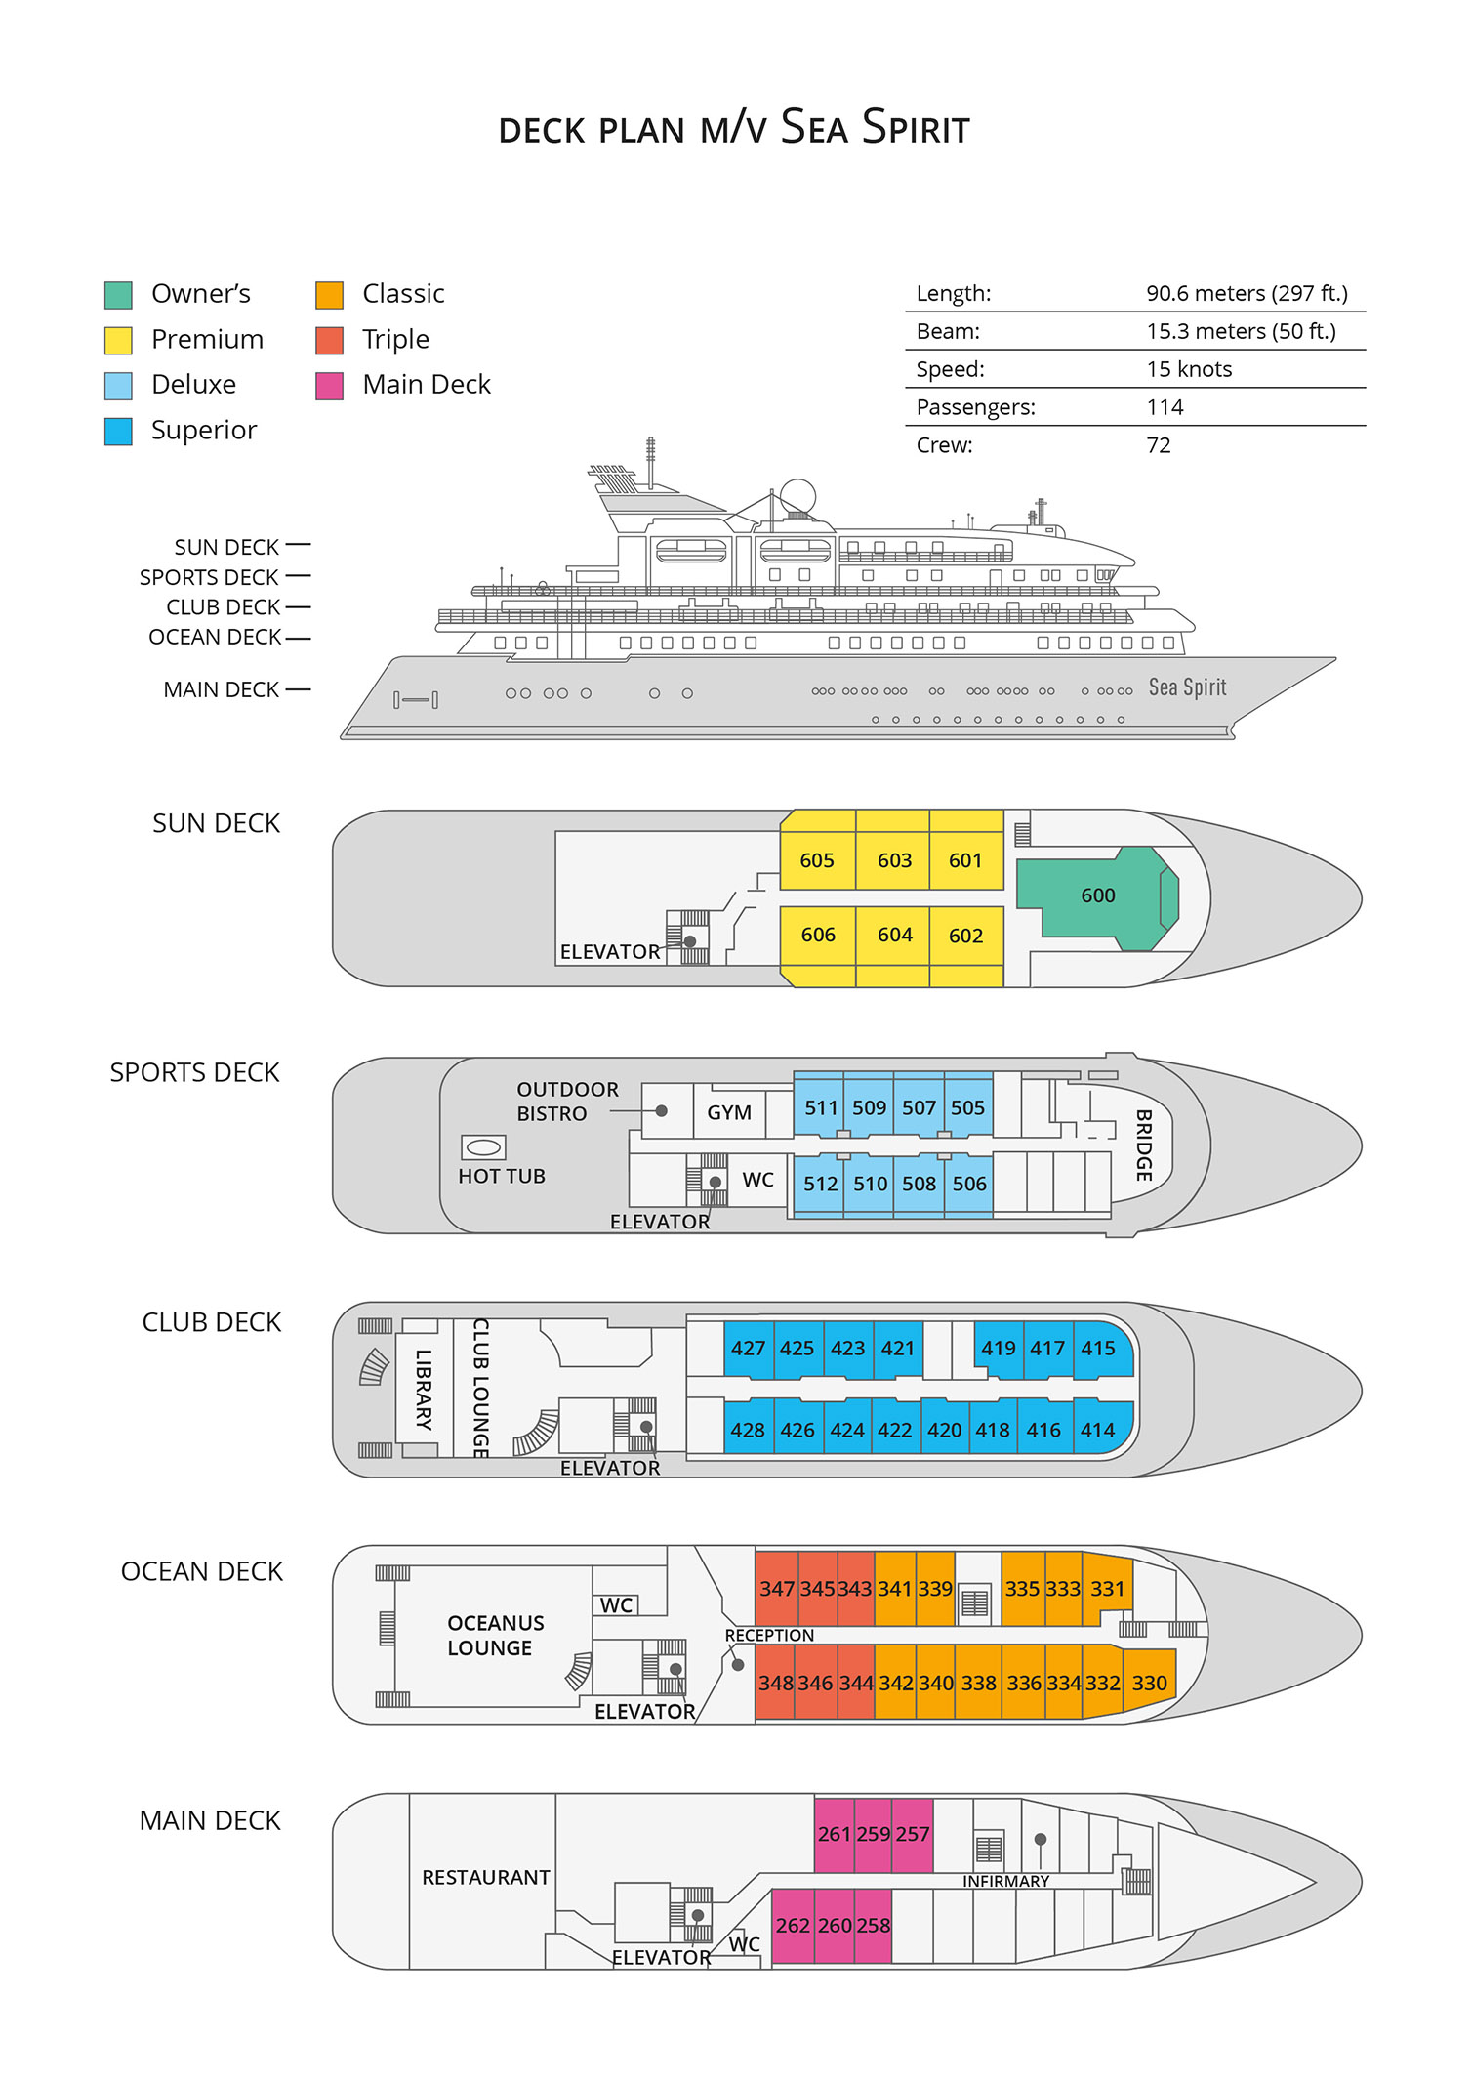

Triple Suite  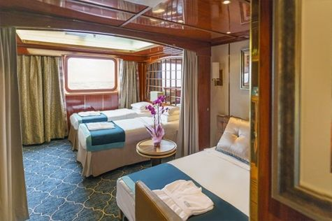  Averaging 21 square metres/226 square feet, these staterooms have two twins and a comfortable sofa bed. The twins also convert to a King, if desired. Located on Oceanus Deck, these suites have a picture window, two wardrobes and en suite facilities. Amenities include: in-room safe, refrigerator, satellite telephone access, TV/DVD, individual temperature control, and hair dryer. | Main Deck Suite  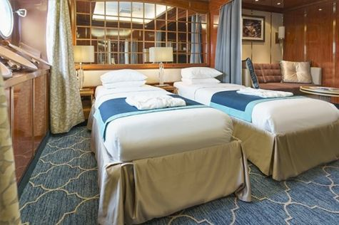  Averaging 23 square metres/248 square feet, Main Deck cabins are equipped with either two twins or a King Size bed. They are located on the Main Deck with a minimum of two portholes for exterior views. Amenities include: en suite facilities, in-room safe, refrigerator, satellite telephone access, TV/DVD individual temperature control and hair dryer.
Single Suite  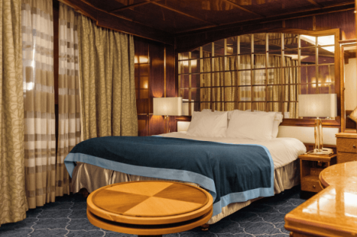  Averaging 21 square meters/226 square feet, these cabins are located on the Oceanus Deck. They feature a picture window (it may be covered during rough sea crossings), two wardrobes, and a King Size bed. Amenities include: en suite facilities, in-room safe, refrigerator, satellite telephone access, TV/VCR, individual temperature control, and hair dryer. | Classic Suite  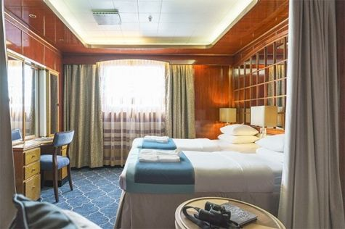  Averaging 21 square metres/226 square feet, these cabins are located on the Oceanus Deck. They feature a picture window, two wardrobes and a choice of either two twin beds or a King Size bed. Amenities include: en suite facilities, in-room safe, refrigerator, satellite telephone access, TV/DVD, individual temperature control and hair dryer.
Superior Suite  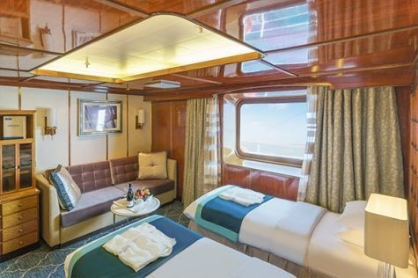  Superior Suites are located on the Club Deck. Averaging 20 square metres/ 215 square feet, these cabins feature two twin beds or a King Size bed. The picture window overlooks an outside walkway on the Club Deck. Amenities include: en suite facilities, walk-in closet or wardrobe, in-room safe, refrigerator, satellite telephone access, TV/DVD, individual temperature control, hair dryer. | Deluxe Suite  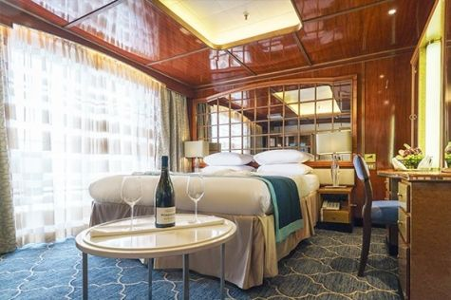  The Deluxe Suites with balconies are located on the Sports Deck. Averaging 24 square metres/ 258 square feet means plenty of room. Choose from either two twin beds or a King Size bed. A sliding glass door leads to a private balcony. These suites feature a walk-in closet or wardrobe. Amenities include en suite facilities, in-room safe, refrigerator, satellite telephone access, TV/DVD, individual temperature control, and a hair dryer.
Premium Suite  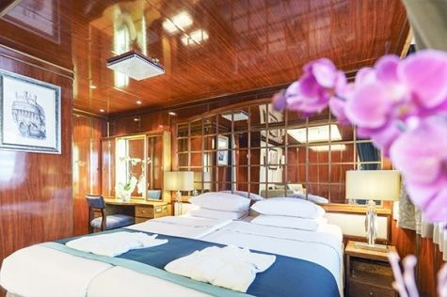  The Premium Suites are located on the Sun Deck. Averaging a generous 30 square metres/ 323 square feet, with two twin beds or a King Size bed. Access the private balcony by a sliding glass door. Amenities include: en suite facilities, lounge area, in-room safe, refrigerator, satellite telephone access, TV/DVD, individual temperature control, and hair dryer. | Owners Suite  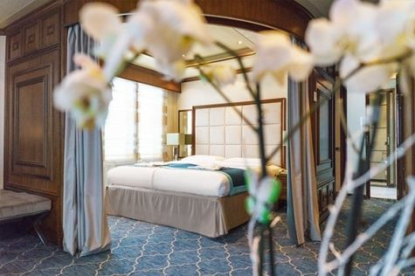  Super-spacious (63 square metres/ 678 square feet) elegant suite on the Sun Deck. Designed for entertaining, the Owner's Suite has a separate living room with game and meeting area. A BOSE stereo system provides background music, or watch videos on the HD plasma TV. Sliding glass doors lead to a private deck. Refresh in the jetted bathtub in en suite facilities. Slumber in the King Size bed. A sofa bed can accommodate a third person.

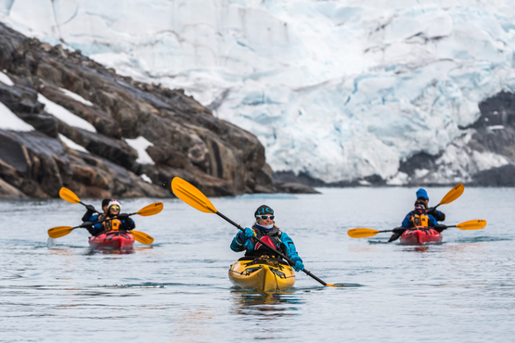 | Sea Kayaking  Kayaking fee $655 - A$885 - £505 - €625  Sea Kayak Club is typically offered on voyages that include High Arctic destinations such as Greenland, Svalbard (Spitsbergen), Franz Josef Land, or a combination of these thrilling places. Experience calving glaciers in Svalbard, cathedral-like icebergs in Greenland, or labyrinthine expanses of sea ice in the Arctic Ocean, all from our sturdy and stealthy sea kayaks. Join us for an unscripted kayaking adventure as we explore rugged coastlines and remote waters that very few people have ever paddled.
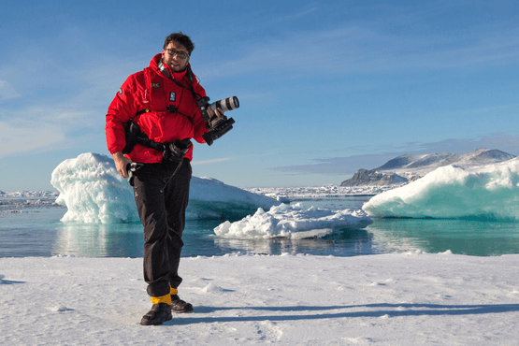 | Photography  Free option  The Polar Regions are perhaps the most photogenic on earth, with countless beautiful scenes presenting themselves every day. Endless expanses of ice, beaches crowded with seals or penguins, sunsets over unbroken horizons, starlit skies, and even the majestic northern lights – they all present fantastic photographic opportunities – and in order to make sure that you come home with some spectacular images we offer you the chance to learn and practice your photography alongside an experienced professional.  Our expert Photographer will be on hand to answer your questions and give advice, both in the form of on-board lectures and workshops on shore. Explore the key elements of photography in a fun and relaxed setting, with plenty of opportunities for questions and feedback. Learn how to see light in a new way and experiment with the techniques of composition and framing.

Rates Include  1 pre-voyage night on Day 1 in a hotel in Longyearbyen;  Group transfer from the airport to the hotel on the day prior to embarkation;  Group transfer to the ship for embarkation on Day 2;  Shipboard accommodation;  All meals on board throughout the voyage;  Tea and coffee station 24 hours daily;  All scheduled landings/excursions (subject to weather and ice conditions);  Leadership throughout the voyage by our experienced Expedition Leader and Expedition Team;  Branded Poseidon Expeditions parka;  Rubber boots for shore landings for the time of the cruise;  Welcome and Farewell cocktails;  All port fees;  Group transfer to airport or central location upon disembarkation;  Pre-departure materials;  Digital Voyage Log;  Wi-Fi on board. | Rates Do Not Include  Airfare;  Transfers from the airport to the hotel if arriving prior to Day 1 of the program;  Visa and passport fees (if applicable);  Luggage and trip cancellation insurance;  Soft drinks and alcoholic beverages other than those for special events and celebrations;  Personal expenses such as laundry and telecommunication charges;  Mandatory Emergency Evacuation Insurance to a minimum benefit of US$ 200,000 per person;  Kayaking;  The cost of any applicable medical tests (such as COVID-19) or vaccinations required either by a national government or Poseidon Expeditions before, during or after the cruise;  Staff gratuities.
Itinerary, landings and all other activities during the cruise depend strongly on ice and weather conditions and are subject to the decisions of the Expedition Leader and the Captain of the vessel. Encounters with any mentioned wildlife cannot be guaranteed.

