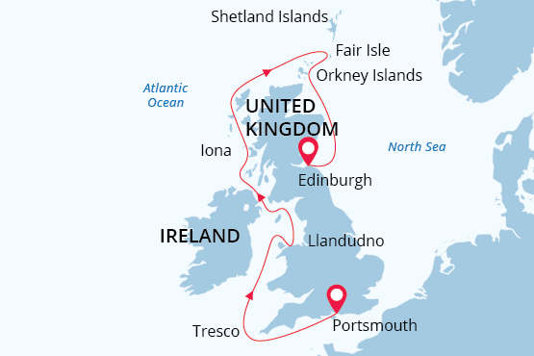

Best of British Isles
Best of British Isles
08 May - 20 May 2024
13 days
Embarkation: Portsmouth (England)
Disembarkation: Edinburgh (Scotland)
M/v Sea Spirit
Activities:

Itinerary
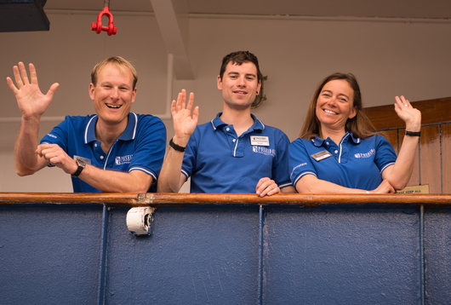Day 1 (May 8): Arrival in Heathrow Airport, London
Welcome to England and the start of your British Isles cruise! Our included pre-cruise hotel night is designed to allow for a relaxing motorcoach transfer to Portsmouth the next morning. You’ll receive information about the time and place to meet the motorcoach at the hotel.
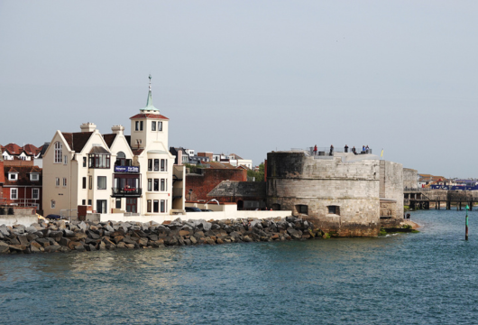Day 2 (May 9): Embarkation in Portsmouth, England
Look for the Poseidon representative in the hotel’s lobby, who will direct you to our chartered motorcoach that will take us to Portsmouth. Considered the home of the Royal Navy, its rich maritime heritage sets the mood for the beginning of our exciting voyage. In the afternoon we welcome you aboard the deluxe expedition ship Sea Spirit.
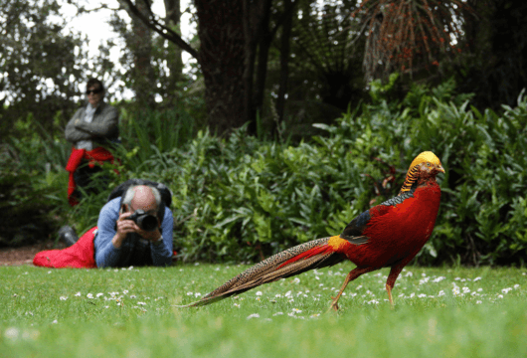Day 3 (May 10): Tresco, Scilly Isles, England
The Isles of Scilly is a group of small islands off the coast of Cornwall boasting mild weather, secluded beaches, enchanting wildlife and a relaxed lifestyle. On the lovely, sand-fringed island of Tresco, Bronze Age burial sites and romantic 17th-century castle ruins reveal a long and dramatic history. On the hallowed grounds of a Benedictine abbey we discover the exquisite Tresco Abbey Garden with its spectacular collection of more than 20,000 exotic plants from all corners of the world. Delightful cafés and local shops enrich your experience even further.
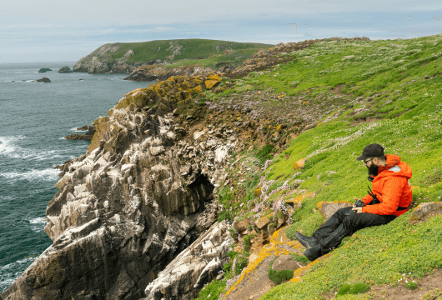Day 4-5 (May 11-12): Republic of Ireland
Dunmore East is a popular tourist and fishing village in County Waterford on Ireland’s southeastern coast. From here it is a short journey through scenic countryside to the House of Waterford Crystal. Here you can take a guided tour of the factory to see the master craftsmen at work as well as the world’s largest collection of their wares. Also nearby is Mount Congreve, a magnificent 18th-century Georgian estate and botanical gardens containing thousands of plant species on 70 acres of intensively planted woodland and a four-acre walled garden.
Our plan is to visit the the Saltee Islands. The larger island, Great Saltee, is the most famous bird sanctuary in Ireland. These Islands are privately owned and are one of the world's major bird sanctuaries. The Saltees are a haven for sea birds, nurturing an impressive array of Gannets and Gulls to Puffins and Manx Shearwaters. They also lie on an important migratory route and a popular stopping-off place for spring and autumn migrants

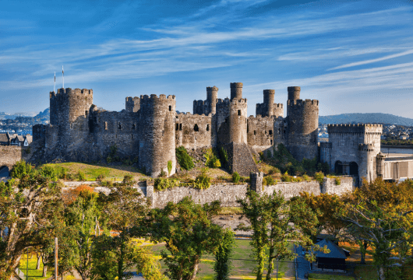Day 6 (May 13): Llandudno, Wales
Our port for today is the vibrant seaside town of Llandudno in the north of Wales. From here we embark on a scenic overland tour of Snowdonia National Park. We drive through some of the wildest and most dramatic landscapes in Britain as we discover craggy mountains, stunning waterfalls, crystal clear lakes, dense woodlands and flowering meadows. Snowdonia is also renowned for wildlife including otters, water voles, wild ponies and rare birds such as dotterel and peregrine falcon. We enjoy a delightful stop at the charming and distinctively Welsh town of Betws-y-Coed in the Gwydyr Forest.
Visit to the Conwy Castle is also on our list. UNESCO considers Conwy to be one of "the finest examples of late 13th century and early 14th century military architecture in Europe", and it is classed as a World Heritage site. Divided into an Inner and an Outer Ward, it is defended by eight large towers and two barbicans, with a postern gate leading down to the river, allowing the castle to be resupplied from the sea.

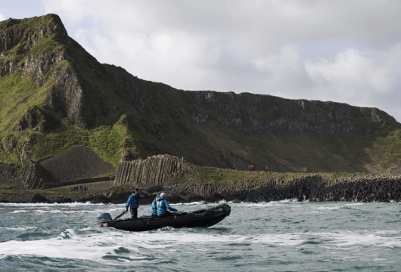Day 7 (May 14): Portrush, Northern Ireland
Today we disembark at the small seaside resort town of Portrush in Northern Ireland. We travel overland to the world-famous Giant’s Causeway. Here we discover a geological masterpiece—40,000 closely packed hexagonal basalt columns of varying heights descending like a staircase into the sea. According to legend, the columns are the remains of a causeway built by a giant. In this area we are also able to spot various seabirds such as fulmar, petrel, cormorant, shag, redshank, guillemot and razorbill.
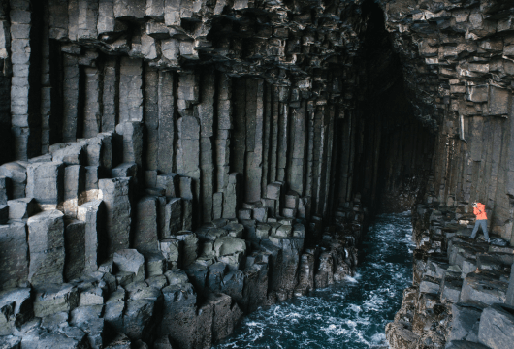Day 8 (May 15): Inner Hebrides, Scotland
Weather permitting, we also plan to visit the uninhabited island of Staffa. This island of volcanic origin is easily recognized by its striking colonnade of hexagonal basalt pillars. Here we hope to explore the island’s most famous feature, Fingal’s Cave. Reaching deep into the island, the undulating sea plays upon the stunning matrix of columnar basalt to create an eerie melody which was the inspiration for Felix Mendelssohn’s Hebrides Overture. The rugged island also provides nesting sites for seabirds including guillemots, razorbills and puffins.
Today we also explore beautiful and serene Iona, a small island in the Inner Hebrides just off the Isle of Mull in western Scotland. At the gorgeous Iona Abbey, founded in 563 AD, we are spellbound by one of Scotland’s most historic and sacred sites and indeed one of the oldest Christian religious centers in Western Europe. The adjacent graveyard is said to be the final resting place of numerous medieval kings, including Macbeth. In addition to its historical and religious significance, Iona is well known for its soul-soothing tranquility, white sand beaches and excellent birdwatching.
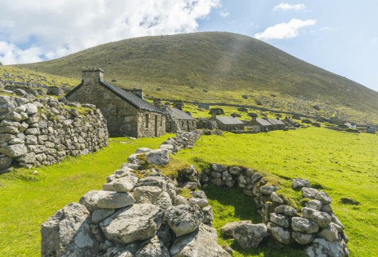Day 9 (May 16): St. Kilda, Outer Hebrides, Scotland
The Outer Hebrides, also known as the Western Isles, are a chain of dramatically rugged islands off the west coast of mainland Scotland. The most isolated of these is St Kilda. This remote and stormravaged island was continuously inhabited for at least two millennia by peoples of extraordinary hardiness. But as the modern world closed in after World War I, the remaining inhabitants chose to evacuate. Now we find only their rough stone buildings and distinctive storehouses called cleitean, all set amidst some of the most dramatic island scenery in the British Isles. Nature-lovers will be delighted, as the island is home to hundreds of thousands of seabirds, two early types of sheep, and over 130 species of flowering plants. We’ll also plan for a close cruise-by of Stac Lee, a sea stack about four miles northeast of St. Kilda’s main island of Hirta. It is home to part of the world’s largest colony of northern gannet. When St. Kilda had a permanent population, islanders would come here, precariously leaping ashore to hunt birds and gather eggs

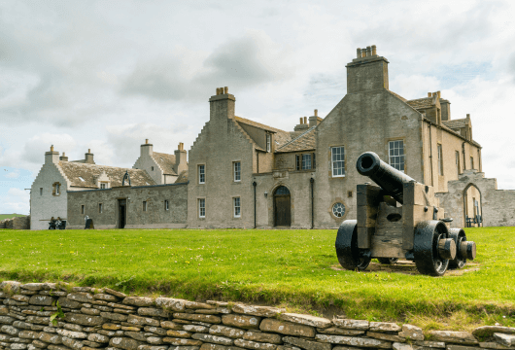Day 10 (May 17): Kirkwall, Orkneys
Today, we’ll disembark in Stromness for an overland tour of Mainland, the largest of the Orkney Islands off the northeastern coast of Scotland. Attractions such as the well-preserved 5000-year-old village site at Skara Brae and the ancient Ring of Brodgar within the UNESCO World Heritage Site “Heart of Neolithic Orkney” showcase the world-class cultural heritage of the island. We finish our island tour in the charming village of Kirkwall, where find the landmark Saint Magnus Cathedral, built in the Romanesque style in the 12th century. You will also have free time to roam the old streets of Kirkwall and enjoy its unique atmosphere before we head to our next destination.
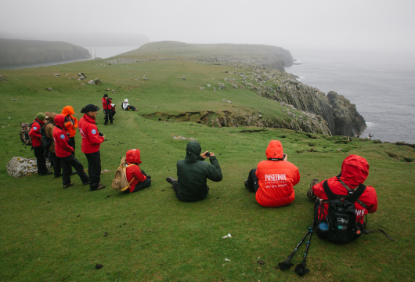Day 11 (May 18): Fair Island
On Fair Isle—an isolated island of rolling moorlands and rugged coastlines—one is easily enchanted by historic crofts, picturesque lighthouses, and friendly locals. The island is famous among birders for its abundance of British birds and for its numerous records of eastern rarities and migrants.
Fair Isle is also one of Europe’s best places to watch seabirds, especially puffins, at close range.
Additionally, the island is notable for the abundance and diversity of its wildflowers. Seals are also commonly seen in its bays. Finally, during our visit it will be possible to see and purchase articles hand-knitted in the intricate and distinctive style for which Fair Isle has been celebrated for hundreds of years.
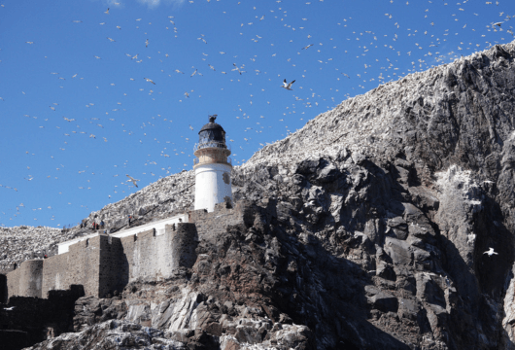Day 12 (May 19): Isle of May, Scotland, Bass Rock
Isle of May and Bass Rock... Both of these uninhabited islands are in the outer part of the Firth of Forth in the east of Scotland. The Isle of May is a national nature reserve and includes significant colonies of puffins, guillemots, razorbills, shags, cormorants and terns. Harbor seals and grey seals can be spotted along the shores. There are also some historic architectural sites, including St. Ardin’s Chapel, the lighthouse and the Low and Light Cottages.
The island known as “the Bass” plays host to over 150,000 northern gannets in the breeding season, making it the world’s largest colony of these magnificent birds. The island’s steep walls are white with guano and the sky all around is darkened by the vast multitude of seabirds in flight. Our voyage is perfectly timed to coincide with this amazing spectacle—truly one of the wildlife wonders of the world.

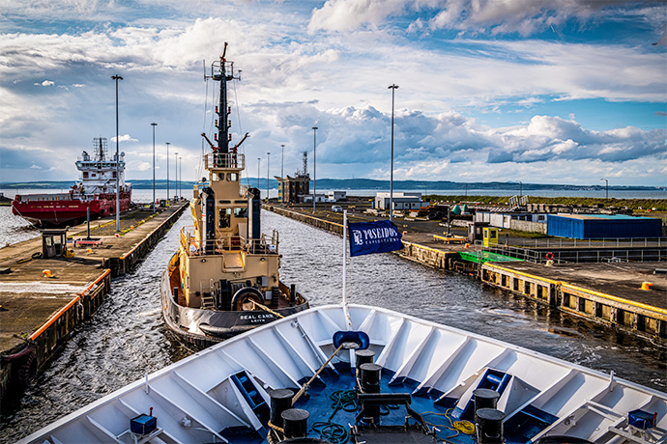Day 13 (May 20): Disembarkation in Edinburgh, Scotland
After breakfast on board Sea Spirit we say farewell in Leith, Edinburgh’s vibrant port district. We provide transfers to the airport or to Edinburgh city center if you wish to spend more time in the wonderful capital of Scotland.

Special guest
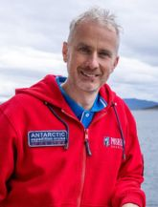David Steel
Ornithologist
David is a professional ornithologist from Durham, England. His passion for seabirds has taken him across the British Isles and around the world. After spending 14 years on the remote Farne Islands, David now lives on Scotland's Isle of May, where he works as reserve manager.
David, an experienced guide, will lead the guests along the coast of the isles, sharing his wealth of knowledge.

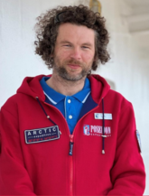Kevin Morgans
Wildlife Photographer
Kevin Morgan's work with Atlantic puffins recently won the prestigious portfolio prize in Bird Photographer of the Year, along with a category win in Golden Turtle and multiple awarded images in Mont Photo, Environmental Photographer of the Year, Nature’s Best Photography, and Nature Image Awards, to name a few. Just recently, his book, "Puffins: Life on the Atlantic Edge," was published. Kevin has a passion for photographing UK wildlife, but his journeys have taken him further afield across Europe, Canada, and the Polar Regions in search of wildlife. He is an experienced guide who has been running 1-1 and group workshops for many years, utilizing this experience to share his knowledge of the natural world and the best techniques to capture it.
During the cruise, Kevin will give engaging lectures and share his photography tips with everyone on board.

M/v Sea Spirit
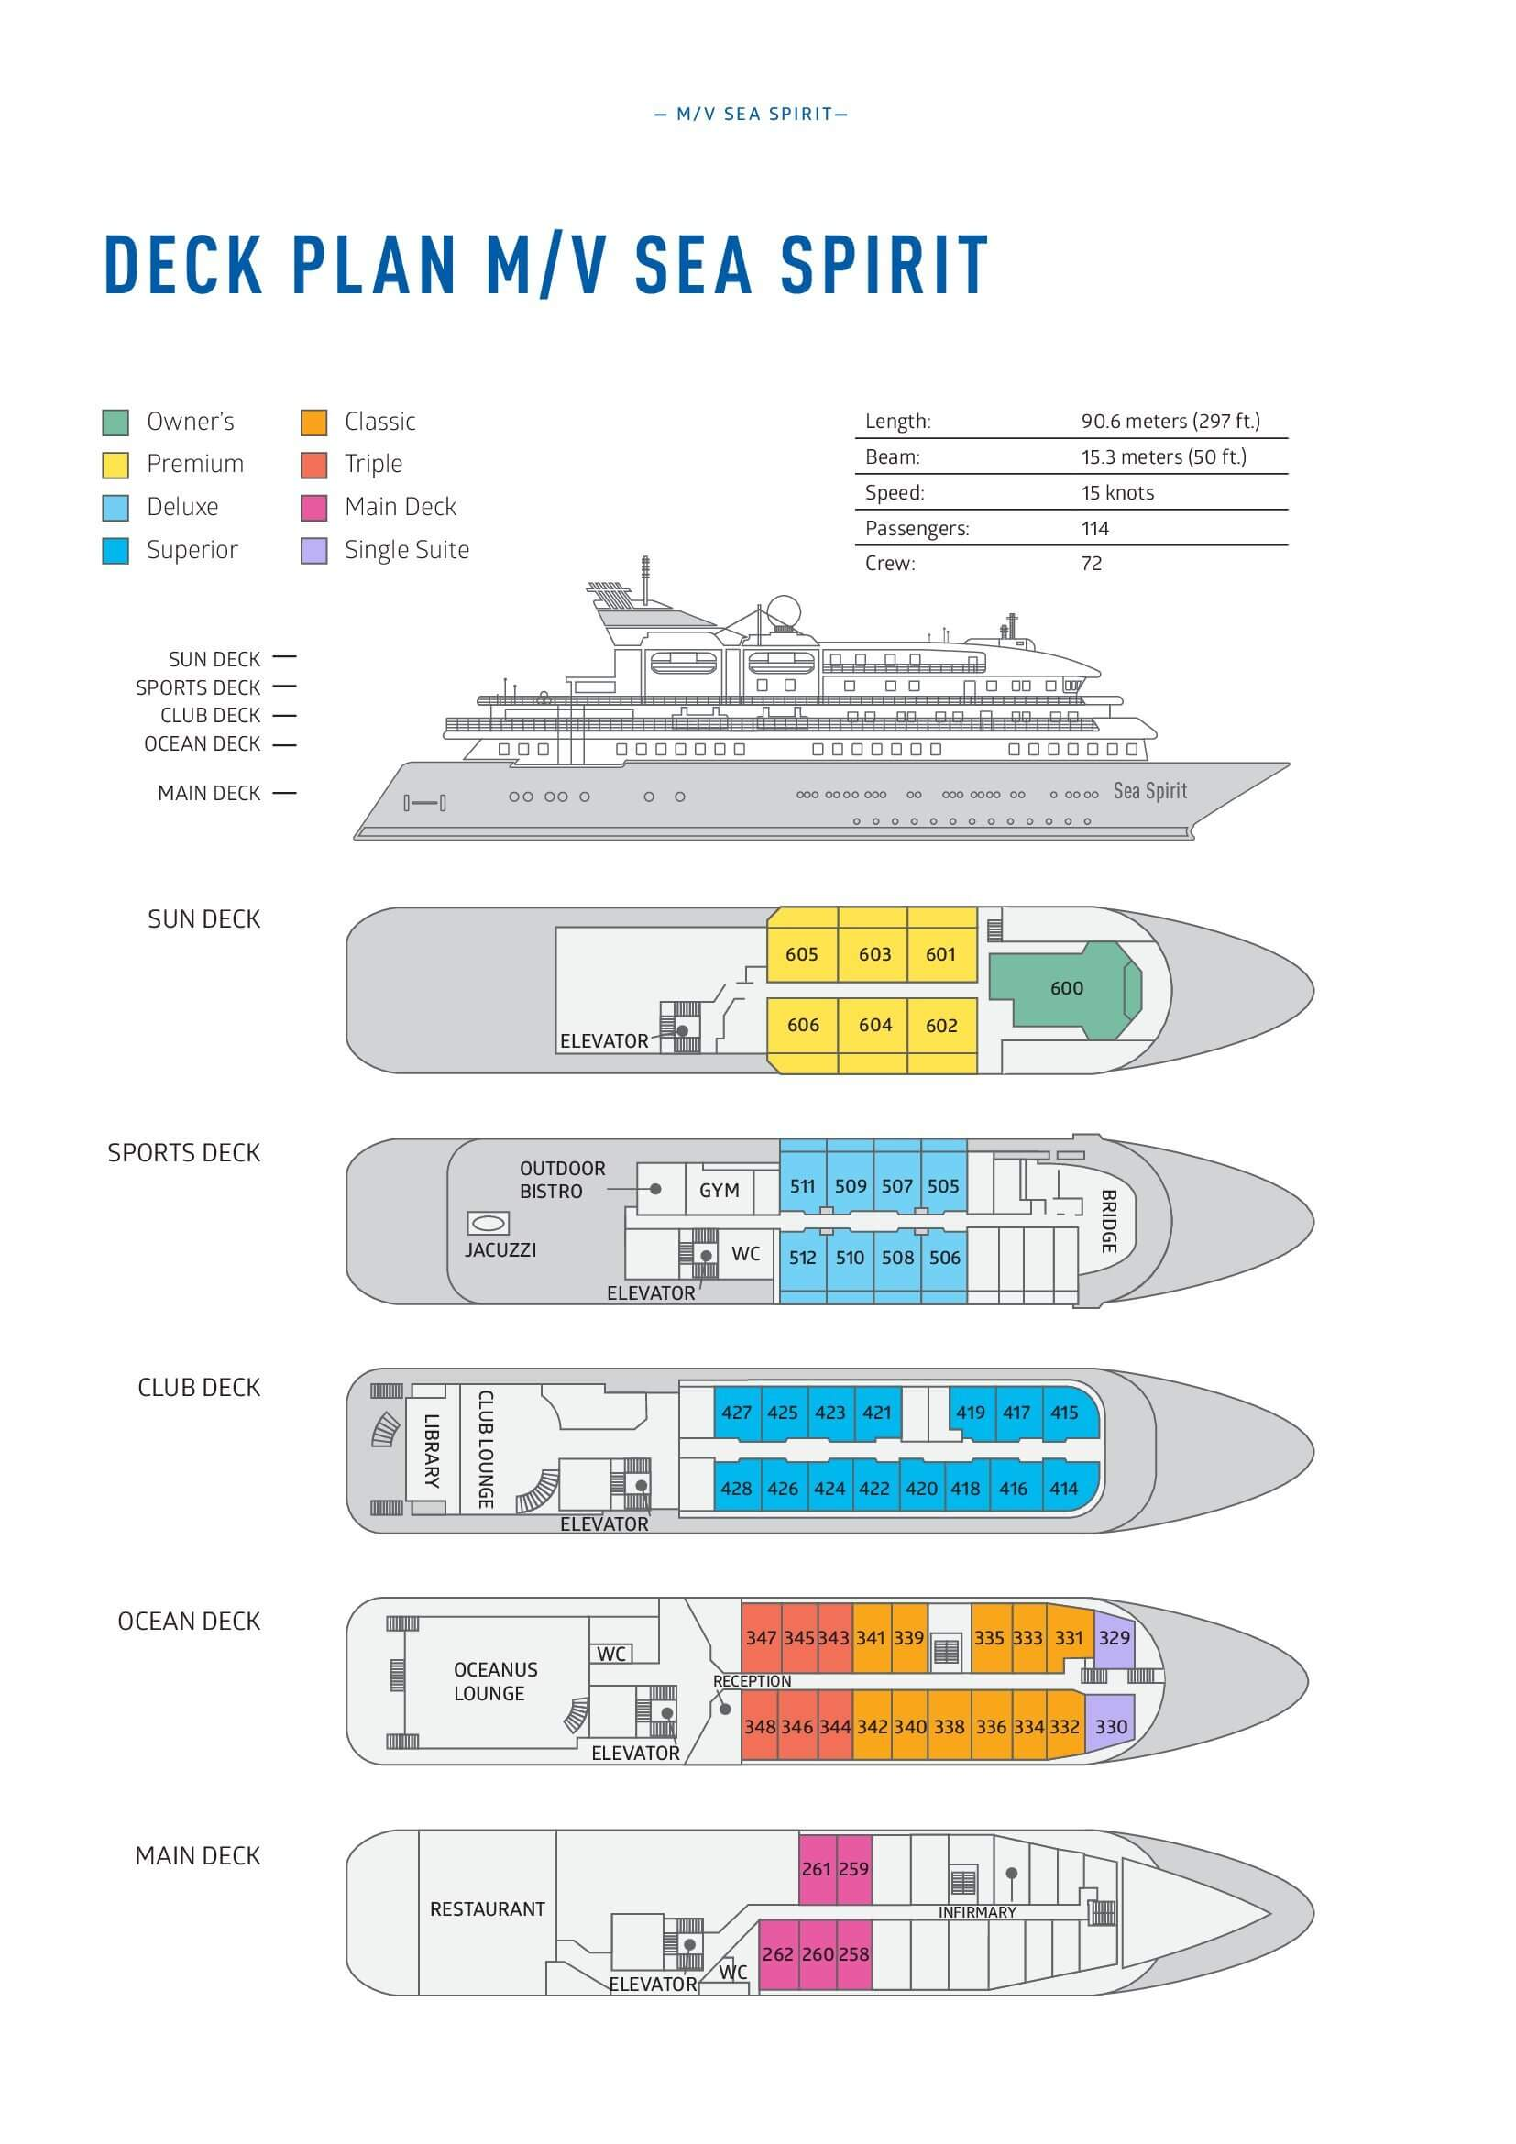

Triple Suite  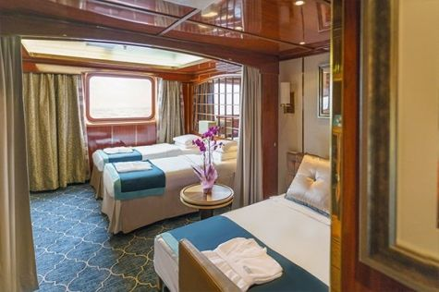  Averaging 21 square metres/226 square feet, these staterooms have two twins and a comfortable sofa bed. The twins also convert to a King, if desired. Located on Oceanus Deck, these suites have a picture window, two wardrobes and en suite facilities. Amenities include: in-room safe, refrigerator, satellite telephone access, TV/DVD, individual temperature control, and hair dryer. | Main Deck Suite  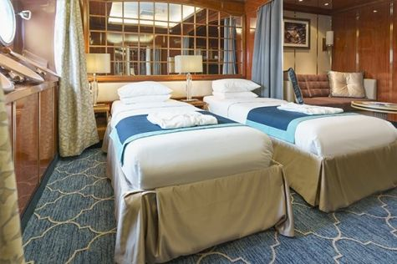  Averaging 23 square metres/248 square feet, Main Deck cabins are equipped with either two twins or a King Size bed. They are located on the Main Deck with a minimum of two portholes for exterior views. Amenities include: en suite facilities, in-room safe, refrigerator, satellite telephone access, TV/DVD individual temperature control and hair dryer.
Single Suite  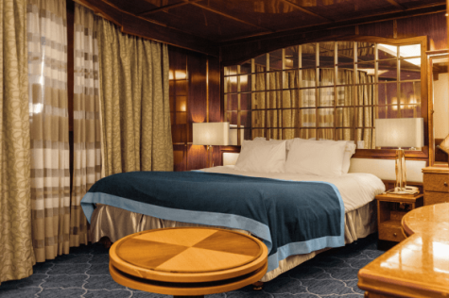  Averaging 21 square meters/226 square feet, these cabins are located on the Oceanus Deck. They feature a picture window (it may be covered during rough sea crossings), two wardrobes, and a King Size bed. Amenities include: en suite facilities, in-room safe, refrigerator, satellite telephone access, TV/VCR, individual temperature control, and hair dryer. | Classic Suite  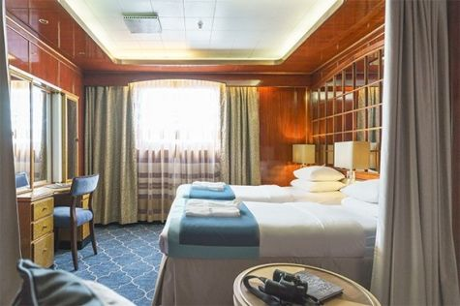  Averaging 21 square metres/226 square feet, these cabins are located on the Oceanus Deck. They feature a picture window, two wardrobes and a choice of either two twin beds or a King Size bed. Amenities include: en suite facilities, in-room safe, refrigerator, satellite telephone access, TV/DVD, individual temperature control and hair dryer.
Superior Suite  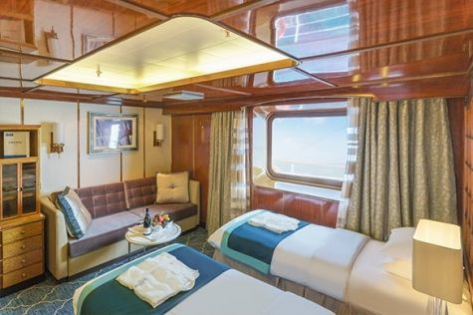  Superior Suites are located on the Club Deck. Averaging 20 square metres/ 215 square feet, these cabins feature two twin beds or a King Size bed. The picture window overlooks an outside walkway on the Club Deck. Amenities include: en suite facilities, walk-in closet or wardrobe, in-room safe, refrigerator, satellite telephone access, TV/DVD, individual temperature control, hair dryer. | Deluxe Suite  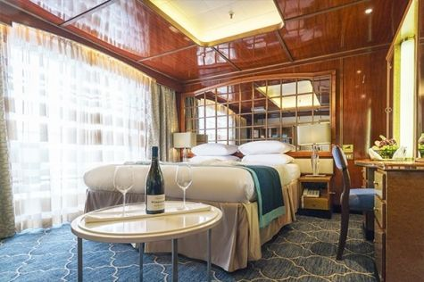  The Deluxe Suites with balconies are located on the Sports Deck. Averaging 24 square metres/ 258 square feet means plenty of room. Choose from either two twin beds or a King Size bed. A sliding glass door leads to a private balcony. These suites feature a walk-in closet or wardrobe. Amenities include en suite facilities, in-room safe, refrigerator, satellite telephone access, TV/DVD, individual temperature control, and a hair dryer.
Premium Suite  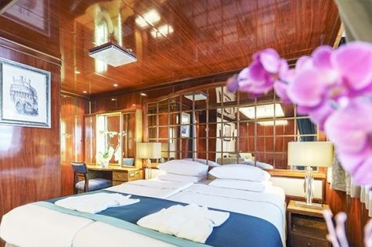  The Premium Suites are located on the Sun Deck. Averaging a generous 30 square metres/ 323 square feet, with two twin beds or a King Size bed. Access the private balcony by a sliding glass door. Amenities include: en suite facilities, lounge area, in-room safe, refrigerator, satellite telephone access, TV/DVD, individual temperature control, and hair dryer. | Owners Suite  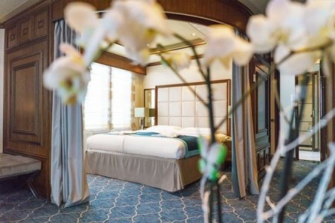  Super-spacious (63 square metres/ 678 square feet) elegant suite on the Sun Deck. Designed for entertaining, the Owner's Suite has a separate living room with game and meeting area. A BOSE stereo system provides background music, or watch videos on the HD plasma TV. Sliding glass doors lead to a private deck. Refresh in the jetted bathtub in en suite facilities. Slumber in the King Size bed. A sofa bed can accommodate a third person.

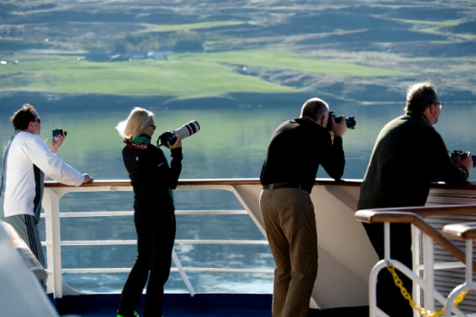 | Photography  FREE OPTION  This voyage offers a wealth of subjects for photographers of all levels and interests. Our included photography program gives you the chance to learn and practice your skills alongside a professional photographer. Zoom out to capture dramatic landscapes of sweeping moorland and rugged coastlines or go macro to expose the beauty of flowers. You will get plenty of practice with the special art of architectural photography as well. From historical monuments to colorful puffins, the sights on this voyage will make a photographer out of anyone. Our expert will be there to help you make the most of the bounty in your viewfinder.

Rates
Triple Suite | Main Deck Suite | Single Suite | Classic Suite | Superior Suite | Deluxe Suite | Premium Suite | Owners Suite
US$ 5 995 | US$ 8 295 | US$ 12 395 | US$ 8 795 | US$ 8 995 | US$ 10 095 | US$ 11 095 | US$ 14 195

Cruise rates are quoted per person. Sharing is available in Triple, Main Deck, Classic, and Superior Suites. If you prefer a cabin for yourself, the following categories are available with the single supplement: x1.7 for Main Deck, Classic, and Superior Suites; x2 for Deluxe, Premium, and Owner's Suite.

Rates Include  1 pre-voyage hotel night;  Group transfer to Portsmouth on the day of embarkation;  Shipboard accommodation;  All meals on board throughout the voyage;  Tea and coffee station 24 hours daily;  All scheduled landings/excursions (subject to weather conditions);  Leadership throughout the voyage by our experienced Expedition Leader and Expedition Team;  Branded Poseidon Expeditions windbreaker jacket;  Rubber boots for shore landings for the time of the cruise;  Welcome and Farewell cocktails;  All port fees;  Group transfer to airport or central location right after disembarkation;  Pre-departure materials;  Digital Voyage Log;  Wi-Fi on board. | Rates Do Not Include  Airfare;  Visa and passport fees (if applicable);  Luggage and trip cancellation insurance;  Soft drinks and alcoholic beverages other than those for special events and celebrations;  Personal expenses such as laundry and telecommunication charges;  The cost of any applicable medical tests (such as COVID-19) or vaccinations required either by a national government or Poseidon Expeditions before, during or after the cruise;  Mandatory emergency evacuation insurance to a minimum coverage of US$ 100,000 per person;  Staff gratuities.
Itinerary, landings and all other activities during the cruise depend strongly on weather conditions and are subject to the decisions of the Expedition Leader and the Captain of the vessel. Encounters with any mentioned wildlife cannot be guaranteed.

