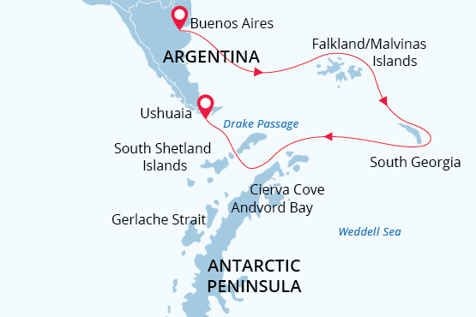

Falklands, South Georgia & Antarctica
Antarctic Awakening
21 Oct - 12 Nov 2022
23 days
Embarkation: Buenos Aires (Argentina)
Disembarkation: Ushuaia (Argentina)
M/v Sea Spirit
Activities:

Itinerary
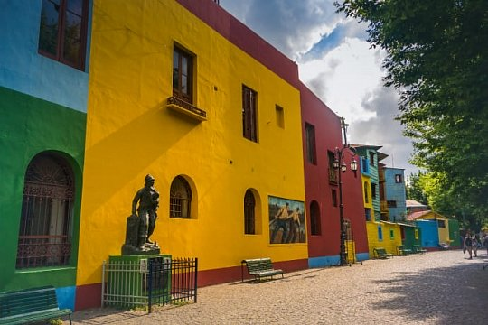Day 1: Buenos Aires, Argentina (hotel night)
Welcome to Buenos Aires, the capital of Argentina. The name of the city can be translated as "fair winds" but it is also referred to as the "Paris of South America". This is an exuberant brew of traditions, languages and different types of culltures. Upon your arrival at the airport we provide a transfer to your hotel, which has been arranged by us and is included in the price of the voyage. For the rest of the day you are free to explore this welcoming city.

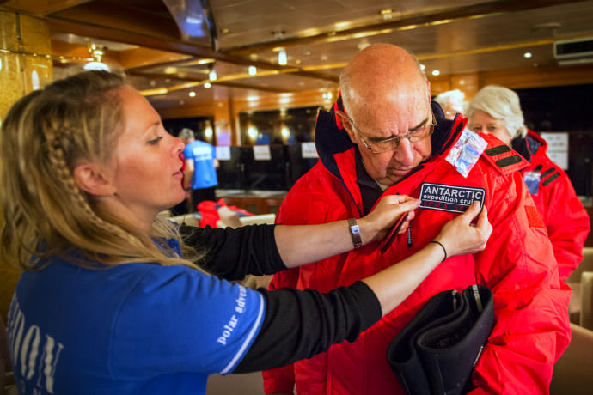Day 2: Embarkation in Buenos Aires
We provide a group transfer to the pier and welcome you aboard the deluxe expedition ship M/V Sea Spirit. Explore the ship and get comfortable in your home away from home for the extraordinary adventure to come. Savor the anticipation of your Antarctic dreams coming true as we slip our moorings and sail toward a true wilderness where wildlife abounds.
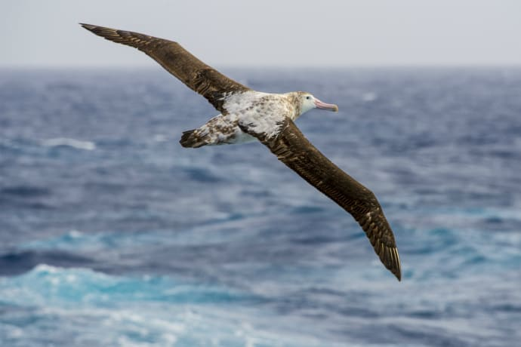Day 3-6: South Atlantic Ocean
As we head south, ocean breezes become cooler and seabirds become more abundant. We keep a sharp eye out for cetaceans such as Commerson’s dolphins and southern right whales in these productive southern seas. The ship’s stabilizing fins provide comfort in the event of rough weather. Presentations by our expert naturalists and historians prepare you for our arrival in the Falkland Islands.
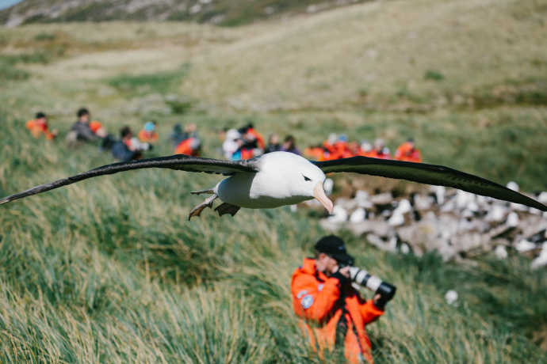Day 7-8: Falkland Islands
Our exploration of the Falklands includes visiting the isolated outlying islands. These bleakly beautiful isles are havens for wildlife. Large colonies of seabirds, perched on windy bluffs overlooking azure seas, are easily accessible by hiking over lush meadows. At this time, black-browed albatross has returned to the islands and are just starting to lay their eggs amongst the tussocks while feisty rockhopper penguins leap up surf-battered cliffs to start building their nests nearby.
On sandy beaches below, gentoo penguins are also starting to lay their eggs while king penguin chicks of all ages look on. They are joined by female elephant seals suckling their newborn pups. Just offshore, you may see Peale’s dolphins and even killer whales patrolling the coasts. A wide range of land birds, including the endemic Cobb’s wren and inquisitive striated caracara, contribute to an abundance of wildlife that will leave nature lovers breathless.
On these days we intend to come alongside the wharf at Stanley, the historic capital of the Falkland Islands. Attractions within pleasant walking distance along the waterfront promenade include the Falkland Islands Museum, the governor’s house, various war memorials, quality gift shops, and charming pubs. Christ Church Cathedral features an impressive whalebone arch and dramatic views of shipwrecks in the harbor.
We also plan to offer an excursion to Gypsy Cove, a national nature reserve where white sand beaches are frequented by numerous bird species, including the endemic Falklands flightless steamer duck. Here you can also see Magellanic penguins, who have just started to lay their eggs in burrows by the seashore.
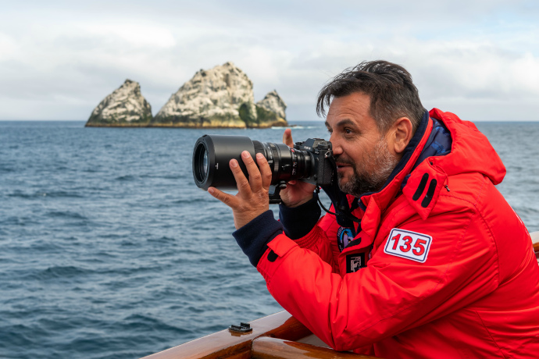Day 9-10: Southern Ocean
We sail east toward South Georgia, passing the remote, seabird-covered pinnacles known as Shag Rocks on the way. We also cross the Antarctic Convergence, the biological boundary of the Southern Ocean. Briefings, bio-security procedures and presentations by our lecture staff prepare you for our arrival in South Georgia.
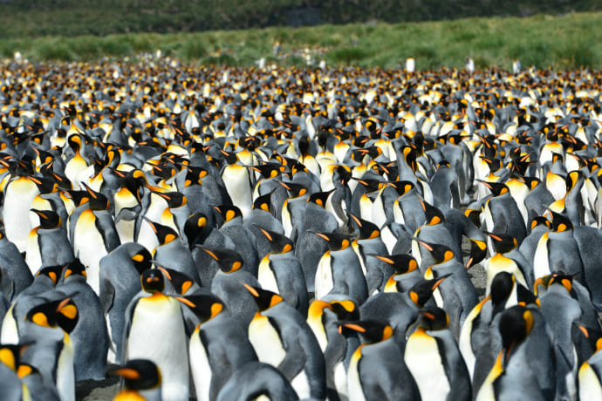Day 11-14: South Georgia Island
The next five days will be devoted to the exploration of the unique and spectacular wilderness of South Georgia, home to some of the greatest concentrations of wildlife on the planet. This isolated subantarctic island is said to host upwards of 100 million seabirds, including numerous species of albatross, penguins, prions, petrels, shags, skuas, gulls and terns. Among these is one of the largest flying birds in the world—the wandering albatross. Here you have the opportunity to see large downy chicks stretching their wings after spending the long Antarctic winter on snowy nests overlooking the wild Southern Ocean.
On South Georgia’s legendary beaches, king penguins are gathered in huge colonies that stretch from sandy shorelines to the foothills of glaciated mountains. Also at this time, hundreds of thousands of macaroni penguins are coming ashore to start their breeding season. Rare birds such as the endemic South Georgia pipit and yellow-billed pintail round out the list of 78 bird species found across the territory. The successfully completed rat eradication program has made this wilderness even more pristine and rich with birdlife.
South Georgia is also home to staggering numbers of southern elephant seals and Antarctic fur seals. At this time, thousands of massive bull elephant seals are defending and occasionally fighting to maintain their harems of females, who have recently given birth. Meanwhile, male fur seals are just arriving to stake out their mating territories. Once hunted nearly to extinction, large whales are also returning to the bountiful seas surrounding South Georgia. With the whalers long gone, the historical whaling station of Grytviken is now home to the excellent South Georgia Museum. Here you will also find the grave of Sir Ernest Shackleton, heroic polar explorer and leader of the famous Endurance expedition.
In this rugged yet accessible environment, superb wildlife viewing is best complemented by active adventure. There are many opportunities for guided treks through this snowy wilderness, including the famous Shackleton Walk. For sea kayakers, the wildlife-rich waters of South Georgia offer the chance to paddle with hordes of seals and penguins in some of the world’s most scenic waterways.
This is expedition cruising at its most authentic. Our precise route and exploration opportunities are dependent on weather in this wild and remote corner of the world. Our experienced captain and expedition leader will continually adjust plans to take maximum advantage of the conditions and circumstances at hand. You can be sure that we will take every safe opportunity to go ashore in this challenging environment.

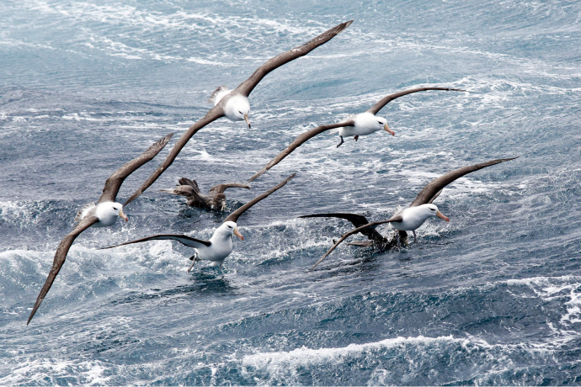Day 15-16: Scotia Sea
After our amazing time in South Georgia, we proceed southwest toward Antarctica. We keep a constant lookout for humpback and fin whales along the way. The majestic wandering albatross and other graceful subantarctic seabirds are common in these waters and can readily be viewed from panoramic open decks and balconies.
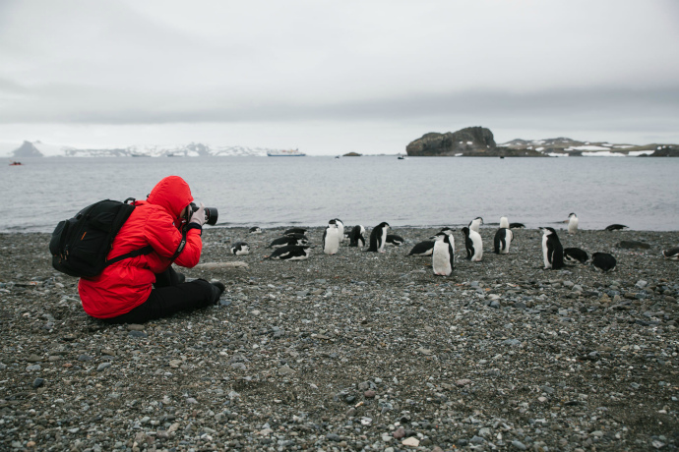Day 17-20: South Shetland Islands and Antarctic Peninsula
During the next five days, we go to the area of the Antarctic Peninsula. This region contains some of the world’s most impressive scenery and the best wildlife viewing in Antarctica. Sheltered bays and channels sparkle with ice and reflect towering mountain peaks coated in permanent snow and immense glaciers. Icebergs of every size and description complete an image of incomparable beauty. Waters rich with krill are home to huge numbers of marine mammals and seabirds. The whole area is alive with penguins foraging at sea and forming large rookeries at special places on land.
The South Shetland Islands are the northernmost islands in Antarctica and will be our primary area of exploration. This wildly beautiful island chain contains many landing sites with historical significance and abundant wildlife. Among them is Elephant Island, where men from Shackleton’s Endurance expedition spent the winter of 1916. We continue west to King George Island, home to numerous Antarctic research bases of various nationalities, some with gift shops and post offices.
Weather and ice permitting, we also hope to visit the supremely picturesque Gerlache Strait area of the Antarctic Peninsula, a pristine wilderness of spectacular white landscapes, colossal icebergs, obliging marine mammals and bustling penguin colonies. Here we have a chance to land on the continent of Antarctica.
Throughout this area, we encounter gentoo, chinstrap and Adélie penguins, sometimes nesting side by side. At this time of the season, all three species are busy courting and mating. This is a good time to observe the importance of pebbles in penguin culture, as prized nesting material to be stolen from rivals and given to mates. Also at this time, very high concentrations of sea ice provide more opportunities for seals and penguins to congregate on ice floes, a situation that attracts killer whales. Photographers will appreciate the pristine appearance of fresh, undisturbed snow across the landscape in this early summer month.
Antarctica is a true wilderness with unpredictable weather and ever-changing ice conditions, which will dictate our route and exploration opportunities. With more than 17 hours of daylight per day, we seize every chance to experience excellent wildlife viewing and amazing scenery via Zodiac cruises and shore excursions.
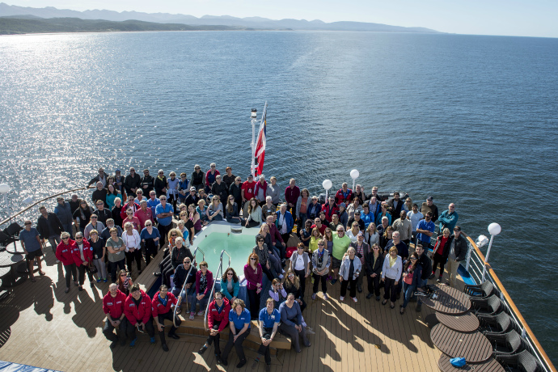Day 21-22: Drake Passage
It is now time to head north across the Drake Passage toward South America, but the adventure is not quite over. Seabirds are our constant companions and there is always the possibility of whale encounters in these wild waters. This is also the time for festivities such as the Captain’s Farewell Cocktail and the end-of-voyage slideshow. Finally, as we enter the calm Beagle Channel, we enjoy a night of smooth sailing toward Ushuaia.
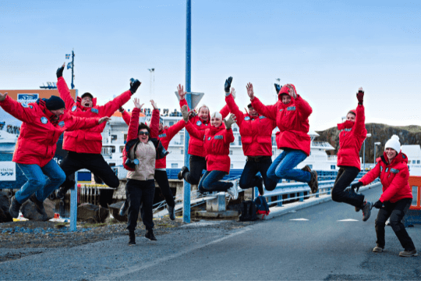Day 23: Disembarkation in Ushuaia, Argentina
After a final delicious breakfast on board, we bid you a fond farewell in Ushuaia, the southernmost city in the world. We provide a group transfer to the airport or to the city center if you wish to spend more time in Tierra del Fuego. As you look back on your wonderful experience in the Falklands, South Georgia and Antarctica, you may already be looking forward to your next polar adventure!

M/v Sea Spirit
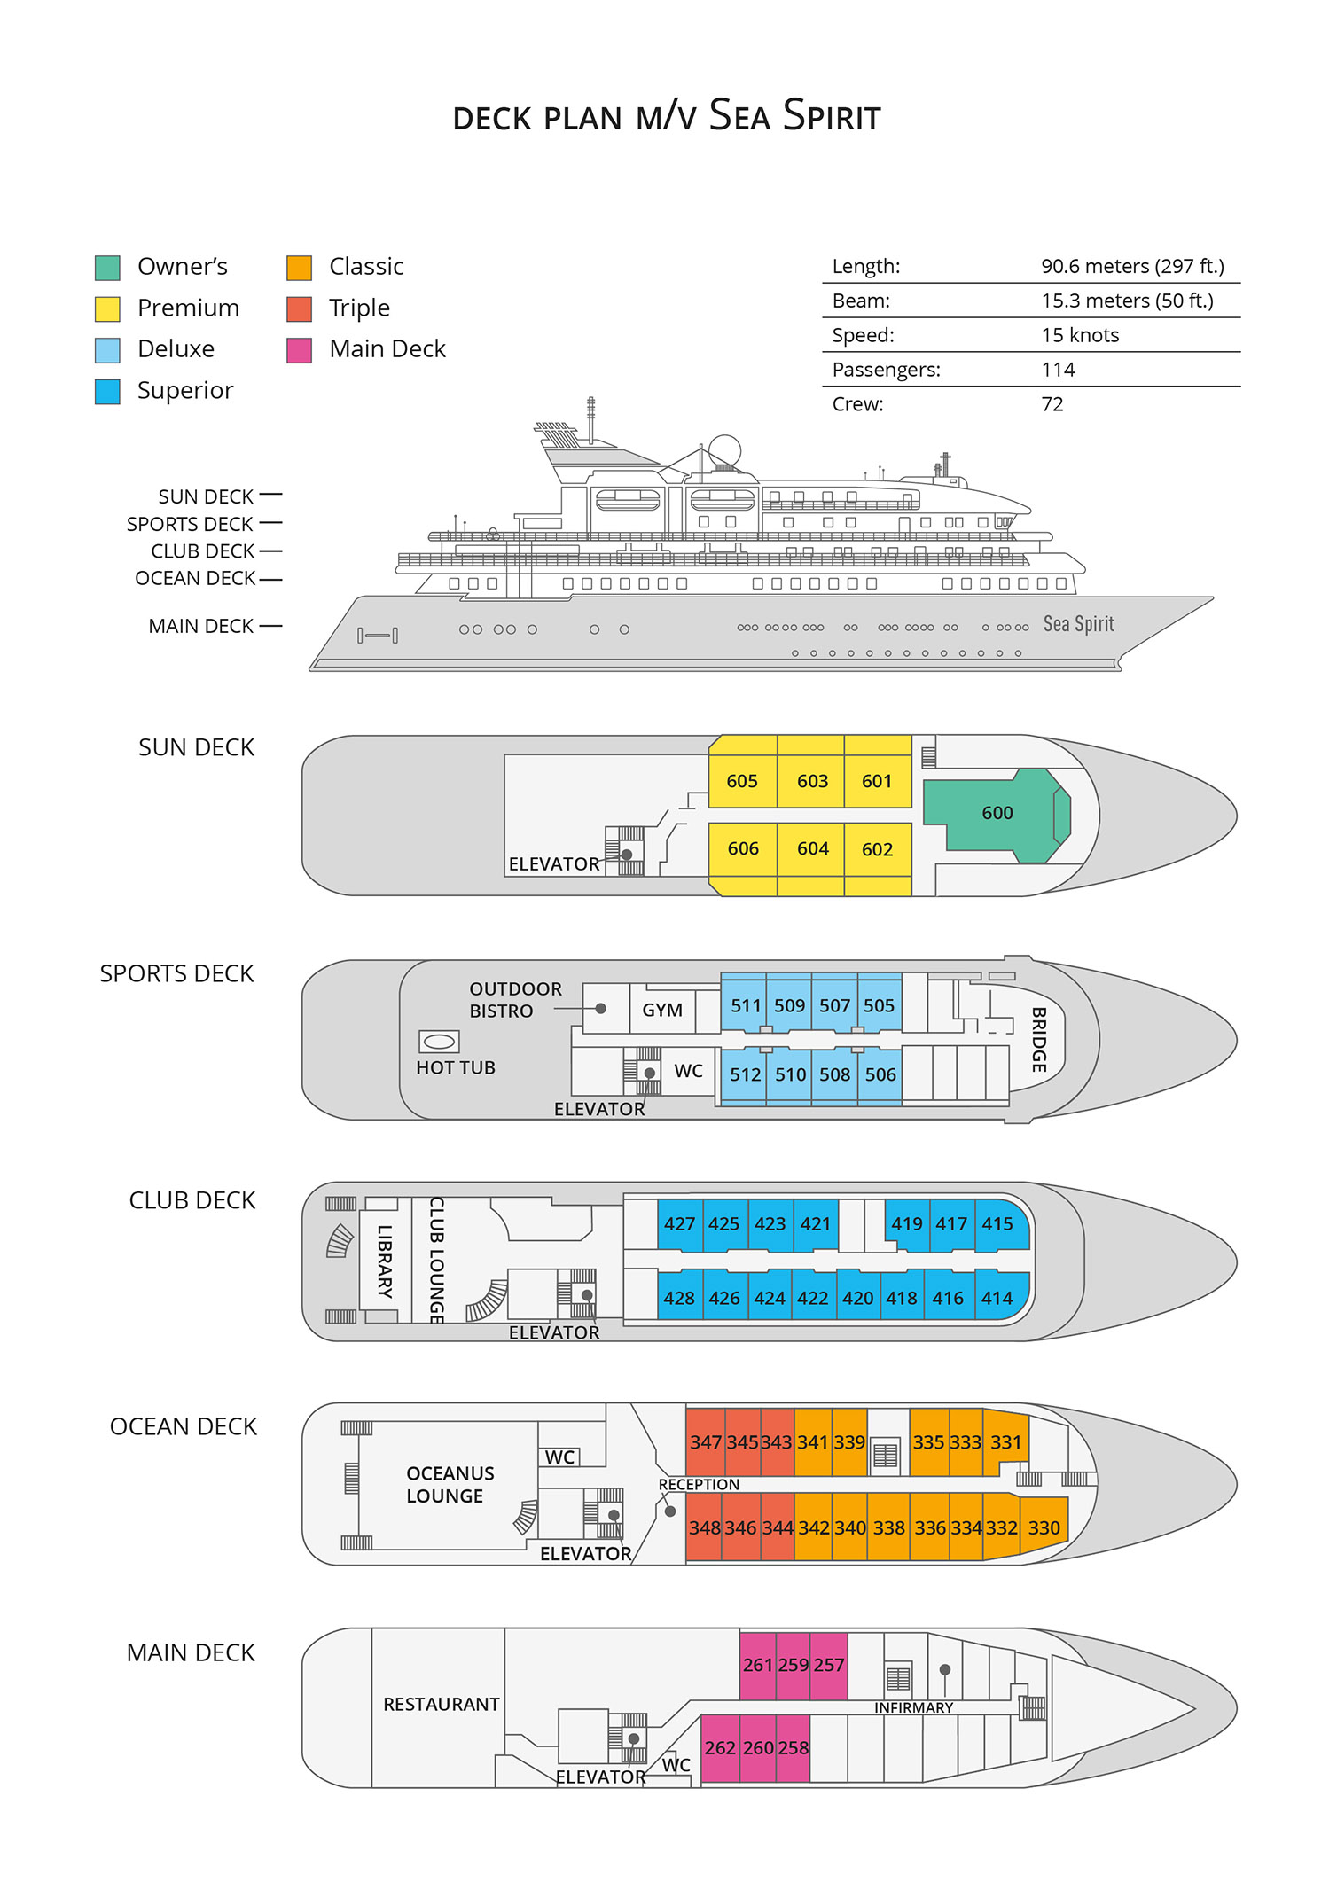

Triple Suite  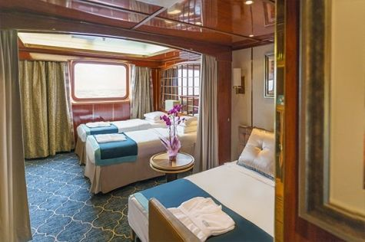  Averaging 21 square metres/226 square feet, these staterooms have two twins and a comfortable sofa bed. The twins also convert to a King, if desired. Located on Oceanus Deck, these suites have a picture window, two wardrobes and en suite facilities. Amenities include: in-room safe, refrigerator, satellite telephone access, TV/DVD, individual temperature control, and hair dryer. | Main Deck Suite  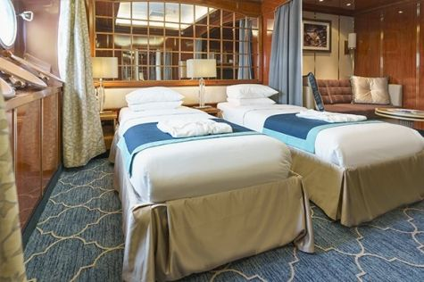  Averaging 23 square metres/248 square feet, Main Deck cabins are equipped with either two twins or a King Size bed. They are located on the Main Deck with a minimum of two portholes for exterior views. Amenities include: en suite facilities, in-room safe, refrigerator, satellite telephone access, TV/DVD individual temperature control and hair dryer.
Single Suite  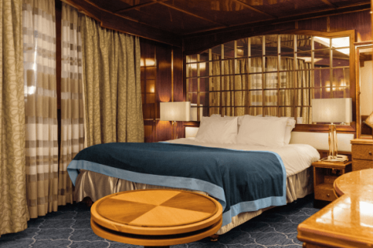  Averaging 21 square meters/226 square feet, these cabins are located on the Oceanus Deck. They feature a picture window (it may be covered during rough sea crossings), two wardrobes, and a King Size bed. Amenities include: en suite facilities, in-room safe, refrigerator, satellite telephone access, TV/VCR, individual temperature control, and hair dryer. | Classic Suite  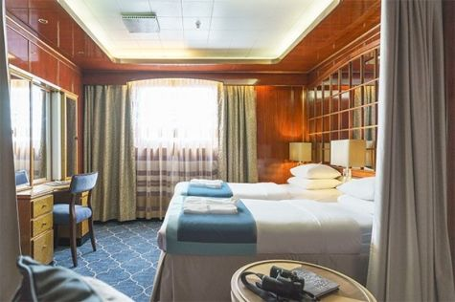  Averaging 21 square metres/226 square feet, these cabins are located on the Oceanus Deck. They feature a picture window, two wardrobes and a choice of either two twin beds or a King Size bed. Amenities include: en suite facilities, in-room safe, refrigerator, satellite telephone access, TV/DVD, individual temperature control and hair dryer.
Superior Suite  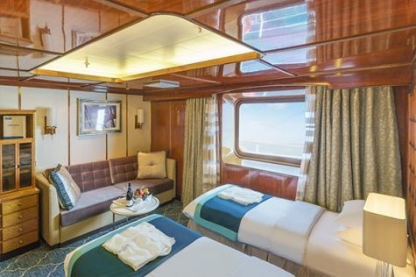  Superior Suites are located on the Club Deck. Averaging 20 square metres/ 215 square feet, these cabins feature two twin beds or a King Size bed. The picture window overlooks an outside walkway on the Club Deck. Amenities include: en suite facilities, walk-in closet or wardrobe, in-room safe, refrigerator, satellite telephone access, TV/DVD, individual temperature control, hair dryer. | Deluxe Suite  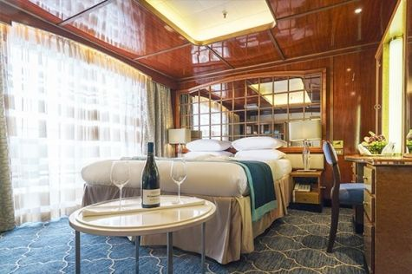  The Deluxe Suites with balconies are located on the Sports Deck. Averaging 24 square metres/ 258 square feet means plenty of room. Choose from either two twin beds or a King Size bed. A sliding glass door leads to a private balcony. These suites feature a walk-in closet or wardrobe. Amenities include en suite facilities, in-room safe, refrigerator, satellite telephone access, TV/DVD, individual temperature control, and a hair dryer.
Premium Suite  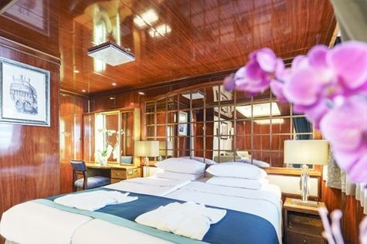  The Premium Suites are located on the Sun Deck. Averaging a generous 30 square metres/ 323 square feet, with two twin beds or a King Size bed. Access the private balcony by a sliding glass door. Amenities include: en suite facilities, lounge area, in-room safe, refrigerator, satellite telephone access, TV/DVD, individual temperature control, and hair dryer. | Owners Suite  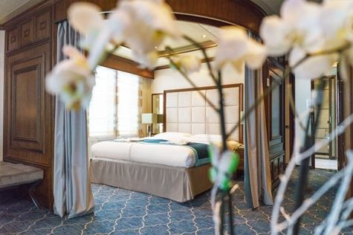  Super-spacious (63 square metres/ 678 square feet) elegant suite on the Sun Deck. Designed for entertaining, the Owner's Suite has a separate living room with game and meeting area. A BOSE stereo system provides background music, or watch videos on the HD plasma TV. Sliding glass doors lead to a private deck. Refresh in the jetted bathtub in en suite facilities. Slumber in the King Size bed. A sofa bed can accommodate a third person.

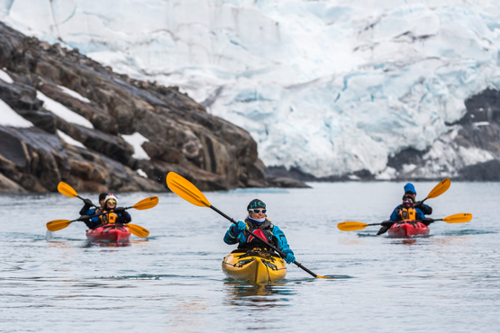 | Sea Kayaking  Kayaking fee $895 - A$1210 - £690 -€855  Antarctica is a paddlers’ paradise. The White Continent boasts some of the world’s most impressive landscapes and is home to incredible marine wildlife. Sea Kayak Club members will have the opportunity to paddle through tranquil waters filled with glittering icebergs and porpoising penguins while surrounded by magnificent glaciers and mountains.  The protected and picturesque waters of the Antarctic Peninsula offer the best sea kayaking opportunities in Antarctica. Sea Kayak Club is also offered on selected voyages to South Georgia, where members may have the rare opportunity to encounter the island’s legendary abundance of wildlife from a kayaker’s perspective, if the area’s notoriously inclement weather permits.
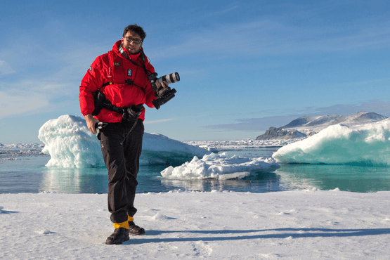 | Photography  Free option  The Polar Regions are perhaps the most photogenic on earth, with countless beautiful scenes presenting themselves every day. Endless expanses of ice, beaches crowded with seals or penguins, sunsets over unbroken horizons, starlit skies, and even the majestic northern lights – they all present fantastic photographic opportunities – and in order to make sure that you come home with some spectacular images we offer you the chance to learn and practice your photography alongside an experienced professional.  Our expert Photographer will be on hand to answer your questions and give advice, both in the form of on-board lectures and workshops on shore. Explore the key elements of photography in a fun and relaxed setting, with plenty of opportunities for questions and feedback. Learn how to see light in a new way and experiment with the techniques of composition and framing.

Rates Include  1 pre-voyage night at the Alvear Art Hotel on Day 1 with breakfast (tourist accommodation tax included);  Group transfer from the airport to the hotel on the day prior to embarkation;  Group transfer to the ship for embarkation on Day 2;  Shipboard accommodation;  All meals on board throughout the voyage;  Tea and coffee station 24 hours daily;  All scheduled landings/excursions (subject to weather and ice conditions);  Leadership throughout the voyage by our experienced Expedition Leader and Expedition Team;  Branded Poseidon Expeditions parka;  Rubber boots for shore landings for the time of the cruise;  Welcome and Farewell cocktails;  All port fees;  Group transfer to airport or central location right after disembarkation;  Pre-departure materials;  Digital Voyage Log;  Wi-Fi on board. | Rates Do Not Include  Airfare;  Transfers from the airport to the hotel if arriving prior to Day 1 of the program;  Visa and passport fees (if applicable);  Luggage and trip cancellation insurance;  Soft drinks and alcoholic beverages other than those for special events and celebrations;  Personal expenses such as laundry and telephone calls;  Fuel surcharge may be applied for all bookings;  Mandatory Emergency Evacuation Insurance to a minimum benefit of US$ 200,000 per person;  Staff gratuities;  Kayaking;  The cost of any applicable medical tests (such as COVID-19) or vaccinations required either by a national government or Poseidon Expeditions before, during or after the cruise;  Pre- or post-cruise travel expenses.
Itinerary, landings and all other activities during the cruise depend strongly on ice and weather conditions and are subject to the decisions of the Expedition Leader and the Captain of the vessel. Encounters with any mentioned wildlife cannot be guaranteed.

