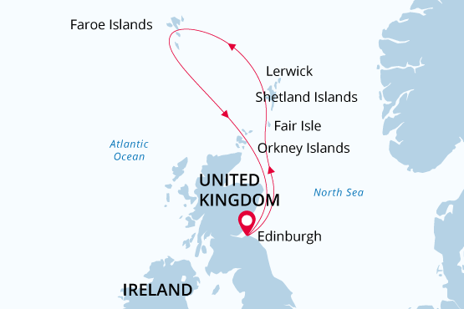

British Isles & Faroes
Wild Islands & Lands of Legends
17 May - 28 May 2025
12 days
Embarkation: Edinburgh (Scotland)
Disembarkation: Edinburgh (Scotland)
M/v Sea Spirit
Activities:

Itinerary
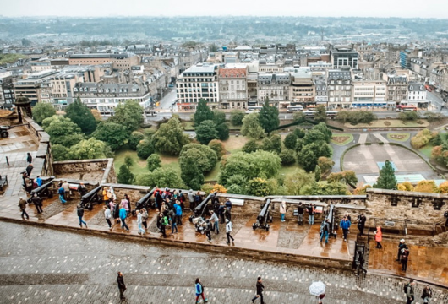Day 1 (May 17): Arrival in Edinburgh, Scotland (hotel night)
Welcome to Edinburgh, the capital of Scotland and starting point of our expedition. To provide you with more time to enjoy this metropolis rich in history and culture, we’ve arranged pre-cruise hotel accommodations. Relax and take a stroll through town, enjoying both medieval and classic 18th-century architecture. The famous Edinburgh Castle rises majestically above it all.
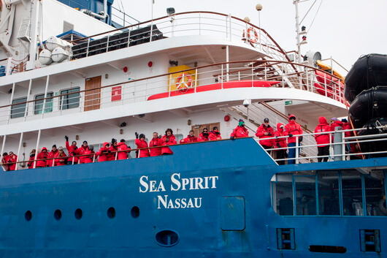Day 2 (May 18): Welcome Aboard!
Enjoy the morning and early afternoon at leisure. Each corner of Edinburgh’s old streets opens beautiful unexpected vistas of green hills or a blue flash of the distant sea. In the afternoon, you will be transferred from the hotel to the ship in the nearby Port of Leith. Before dinner, there’s time to explore the Sea Spirit, your home-away-from home for the next days.
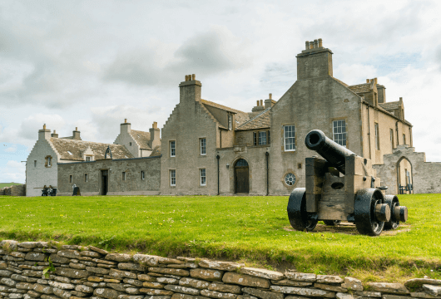Day 3 (May 19): Kirkwall
Kirkwall is a small, quiet town, with a gentle pace of life. The town is the capital of the remote and amazing Orkney archipelago. Kirkwall is first mentioned in Orkneyinga saga in 1046. Such a long history has left a rich heritage that we explore today. The most famous are the sandstone St Magnus Cathedral, considered the finest medieval building in the north of Scotland, the Bishop’s Palace and the Earl’s Palace. Included tour “Ancient treasures of Orkney with St Magnus Cathedral.” Depart Kirkwall and head into the west of Mainland, Orkney’s largest island. This tour passes through the gentle rolling landscape of Orkney and into the Neolithic Heartland of Orkney; an area designated as a World Heritage Site due to its wealth of pre-historic archaeology. Passing the Standing Stones of Stenness, we will stop at the Ring of Brodgar; a huge ceremonial circle of stones dating back almost 5000 years. We then continue on to the 5000-year-old village of Skara Brae, beautifully interpreted in the visitor centre. See the remarkable dwellings revealed from beneath the sand dunes by storms only 150 years ago. Hear some of the stories from your guide today en route back to Kirkwall. Once back in the island capital we will take a tour of St Magnus Cathedral, built by the Vikings during their 500 year reign over the islands.
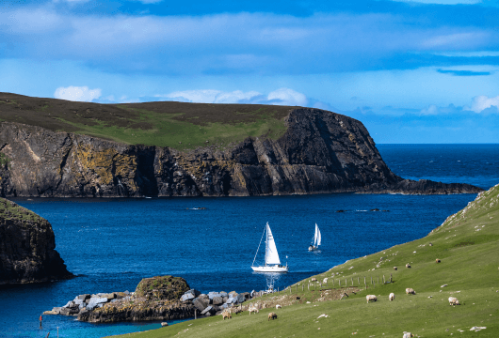Day 4 (May 20): Fair Isle, Shetland Islands
On Fair Isle—an isolated island of rolling moorlands and rugged coastlines—one is easily enchanted by historic crofts, picturesque lighthouses, and friendly locals.The island is famous among birders for its abundance of British birds and for its numerous records of eastern rarities and migrants. Fair Isle is also one of Europe’s best places to watch seabirds, especially puffins, at close range. Additionally, the island is notable for the abundance and diversity of its wildflowers. Seals are also commonly seen in its bays. Finally, during our visit it will be possible to see and purchase articles hand-knitted in the intricate and distinctive style for which Fair Isle has been celebrated for hundreds of years.
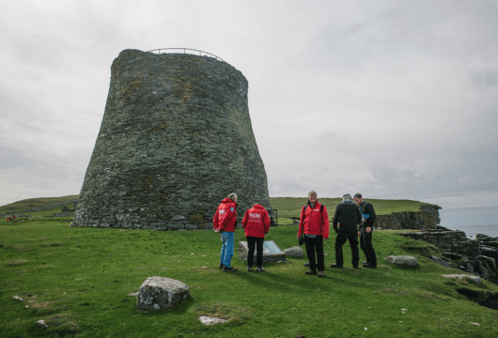Day 5 (May 21): Lerwick
We come alongside at the port of Lerwick; on Mainland, the largest of the Shetland Islands. On a walking tour of this historic town we visit the award-winning Shetland Museum to learn all about Shetland’s fascinating heritage and culture. From here we take a scenic overland coach ride through the fertile countryside of Dunrossness to discover Shetland’s best destinations. Birders will relish the opportunity to visit the historic lighthouse at Sumburgh Head, the southernmost point of Mainland Shetland. These rugged cliffs attract thousands of seabirds and the grassy slopes above are particularly great for enjoying close encounters with puffins amongst beautiful wildflowers. Also on the itinerary is Jarlshof, one of the most remarkable archaeological sites in the British Isles. Here we discover beautifully preserved stone structures spanning 5,000 years of human settlement, including Bronze Age oval houses, Pictish wheelhouses, an Iron Age broch, a Viking longhouse and a mediaeval farmhouse.

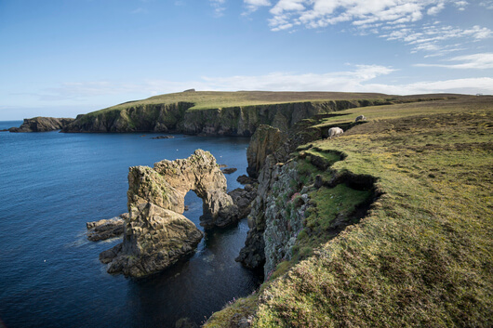Day 6 (May 22): Papa Stour and Foula
Lost in the Atlantic Ocean, Foula, one of the Shetland Islands, is a perfect destination for birdwatching. Foula cliffs are home to numerous seabirds, including the largest colony of great skuas in Great Britain. However, birds are not the only treasure of the island. Foula is rich with folklore and history.
Another item on our bucket list today is Papa Stour, another island, which forms part of the Shetland islands.
Erosion of Papa Stour’s soft volcanic rocks has sculptured an extraordinary cliff scenery including a variety of caves, stacks, arches and blowholes, all supporting a range of marine flora and fauna.
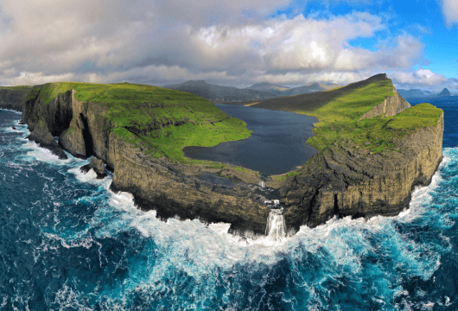Day 7-10 (May 23-26): Faroe Islands
National Geographic Traveler had designated Faroe Islands as “authentic, unspoiled and likely to remain so”. It seems that the Nature spares no colours in “painting” the islands. Deep-green hills, bright blue sea, colourful houses and boats, orange-red puffins’ beaks make the sceneries unforgettable, meanwhile traditional wooden dwellings with turf roofs look like they belong in a fairy tale.
The rugged Faroese are proud of their Viking heritage and their love of the sea. We will explore the archipelago including Tórshavn, the capital and largest city of Faroe Islands. This would include a visit to Kirkjubøur, the ecclesiastical and cultural center of the Faroes in the Middle Ages. It was the site of the Bishop’s residence until the Reformation, when the Faroese diocese was abolished. The imposing Gothic ruin of the late 13th-century Saint Magnus Cathedral still dominates the site. The Roykstovan, standing on the wide, stone foundation of a portion of the Bishop’s palace, has been the home of farmers in Kirkjubøur for centuries and occupied by the same Faroese family for 17 generations.
Our expedition team will earch for remote areas of the archipelago to visit or pause, where we can take advantage of the ship and possibly Zodiacs to see bird cliffs and other natural wonders that are otherwise difficult to access.
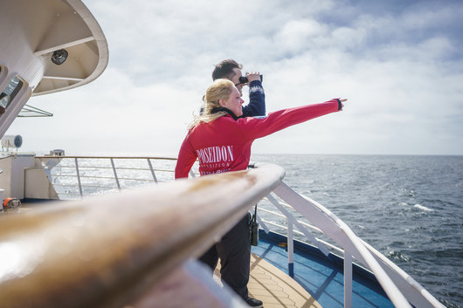Day 11 (May 27): At Sea
Do not lose your time aboard! Learn more about the unique flora and fauna of the British Isles. Become a real expert in no time with our onboard lectures and briefings!
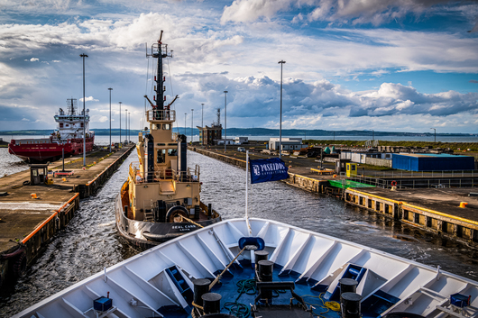Day 12 (May 28): Disembarkation in Edinburgh, Scotland
After breakfast on board Sea Spirit we say farewell in Leith, Edinburgh’s vibrant port district. We provide transfers to the airport or to Edinburgh city center if you wish to spend more time in the wonderful capital of Scotland.

M/v Sea Spirit
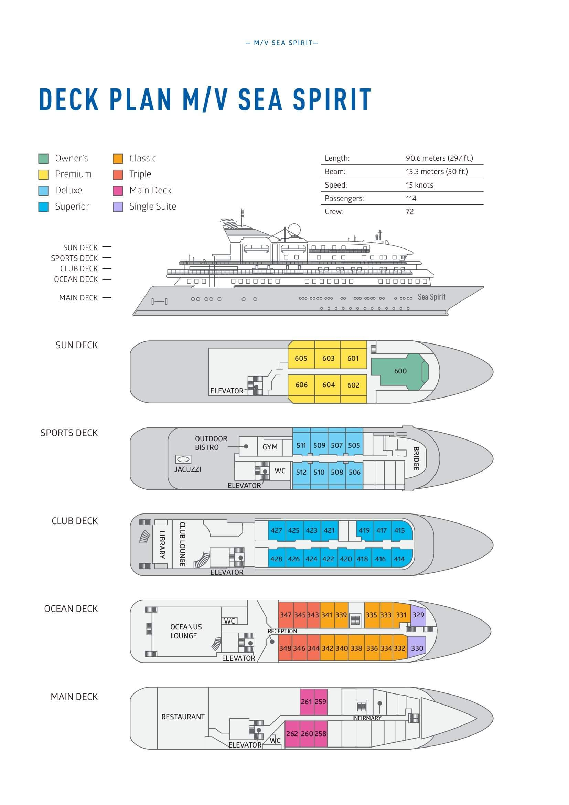

Triple Suite  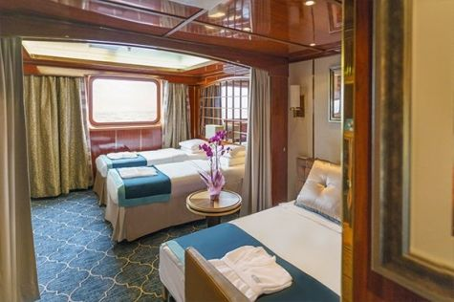  Averaging 21 square metres/226 square feet, these staterooms have two twins and a comfortable sofa bed. The twins also convert to a King, if desired. Located on Oceanus Deck, these suites have a picture window, two wardrobes and en suite facilities. Amenities include: in-room safe, refrigerator, satellite telephone access, TV/DVD, individual temperature control, and hair dryer. | Main Deck Suite  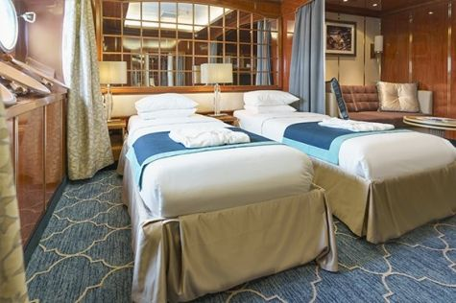  Averaging 23 square metres/248 square feet, Main Deck cabins are equipped with either two twins or a King Size bed. They are located on the Main Deck with a minimum of two portholes for exterior views. Amenities include: en suite facilities, in-room safe, refrigerator, satellite telephone access, TV/DVD individual temperature control and hair dryer.
Single Suite  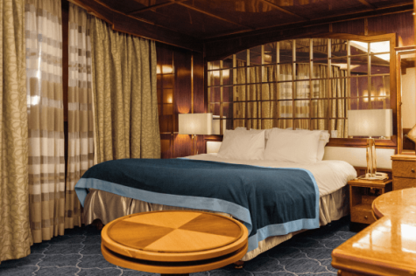  Averaging 21 square meters/226 square feet, these cabins are located on the Oceanus Deck. They feature a picture window (it may be covered during rough sea crossings), two wardrobes, and a King Size bed. Amenities include: en suite facilities, in-room safe, refrigerator, satellite telephone access, TV/VCR, individual temperature control, and hair dryer. | Classic Suite  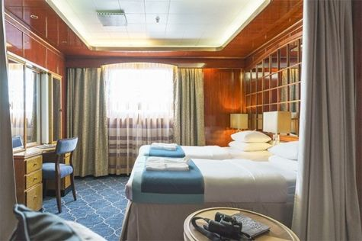  Averaging 21 square metres/226 square feet, these cabins are located on the Oceanus Deck. They feature a picture window, two wardrobes and a choice of either two twin beds or a King Size bed. Amenities include: en suite facilities, in-room safe, refrigerator, satellite telephone access, TV/DVD, individual temperature control and hair dryer.
Superior Suite  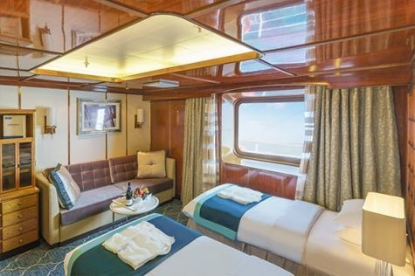  Superior Suites are located on the Club Deck. Averaging 20 square metres/ 215 square feet, these cabins feature two twin beds or a King Size bed. The picture window overlooks an outside walkway on the Club Deck. Amenities include: en suite facilities, walk-in closet or wardrobe, in-room safe, refrigerator, satellite telephone access, TV/DVD, individual temperature control, hair dryer. | Deluxe Suite  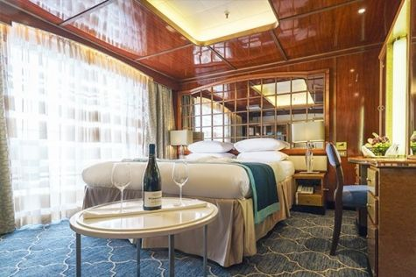  The Deluxe Suites with balconies are located on the Sports Deck. Averaging 24 square metres/ 258 square feet means plenty of room. Choose from either two twin beds or a King Size bed. A sliding glass door leads to a private balcony. These suites feature a walk-in closet or wardrobe. Amenities include en suite facilities, in-room safe, refrigerator, satellite telephone access, TV/DVD, individual temperature control, and a hair dryer.
Premium Suite  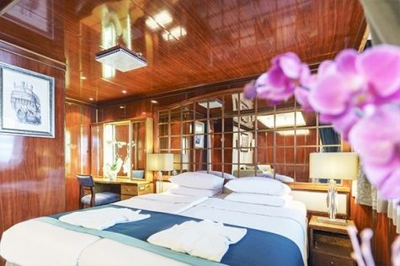  The Premium Suites are located on the Sun Deck. Averaging a generous 30 square metres/ 323 square feet, with two twin beds or a King Size bed. Access the private balcony by a sliding glass door. Amenities include: en suite facilities, lounge area, in-room safe, refrigerator, satellite telephone access, TV/DVD, individual temperature control, and hair dryer. | Owners Suite  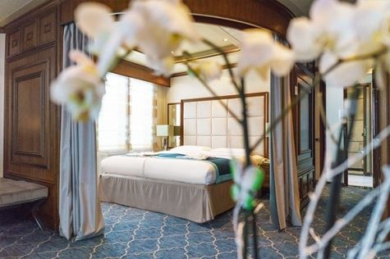  Super-spacious (63 square metres/ 678 square feet) elegant suite on the Sun Deck. Designed for entertaining, the Owner's Suite has a separate living room with game and meeting area. A BOSE stereo system provides background music, or watch videos on the HD plasma TV. Sliding glass doors lead to a private deck. Refresh in the jetted bathtub in en suite facilities. Slumber in the King Size bed. A sofa bed can accommodate a third person.

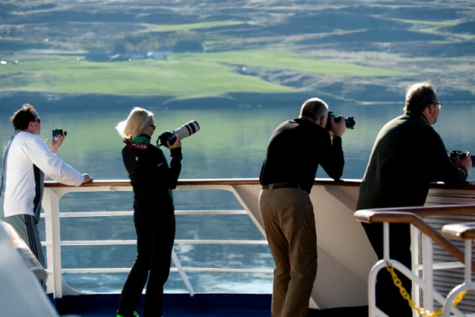 | Photography  FREE OPTION  This voyage offers a wealth of subjects for photographers of all levels and interests. Our included photography program gives you the chance to learn and practice your skills alongside a professional photographer. Zoom out to capture dramatic landscapes of sweeping moorland and rugged coastlines or go macro to expose the beauty of flowers. You will get plenty of practice with the special art of architectural photography as well. From historical monuments to colorful puffins, the sights on this voyage will make a photographer out of anyone. Our expert will be there to help you make the most of the bounty in your viewfinder.

Rates
Triple Suite | Main Deck Suite | Single Suite | Classic Suite | Superior Suite | Deluxe Suite | Premium Suite | Owners Suite
US$ 5 595 | US$ 7 795 | US$ 11 595 | US$ 8 295 | US$ 8 395 | US$ 9 495 | US$ 10 395 | US$ 13 295
US$ 4 756 | US$ 6 626 | US$ 9 856 | US$ 7 051 | US$ 6 716 | US$ 7 596 | US$ 8 316 | US$ 10 636
* Super Early Bird discount (15% off on Triple, Main Deck, Single, and Classic Suites; 20% off on Superior, Deluxe, Premium, and Owner’s Suites) is available for new bookings confirmed by June 30, 2024.
Cruise rates are quoted per person. Sharing is available in Triple, Main Deck, Classic, and Superior Suites. If you prefer a cabin for yourself, the following categories are available with the single supplement: x1.7 for Main Deck, Classic, and Superior Suites; x2 for Deluxe, Premium, and Owner's Suite.

Rates Include  1 pre-voyage night on Day 1;  Group transfer to the ship on day of embarkation;  Group transfer to airport or central location upon disembarkation;  Shipboard accommodation;  All scheduled landings/excursions;  Leadership throughout the voyage by our Expedition Leader and Expedition Team;  Wi-Fi on board;  All meals on board throughout the voyage;  Tea and coffee station 24 hours daily;  Branded Poseidon Expeditions windbreaker jacket;  Rubber boots for shore landings for the time of the cruise;  Welcome and Farewell cocktails;  All port fees;  Pre-departure materials;  Digital Voyage Log. | Rates Do Not Include  Airfare;  Visa and passport fees (if applicable);  Luggage and trip cancellation insurance;  Soft drinks and alcoholic beverages other than those for special events and celebrations;  Fuel surcharge may be applied for all bookings;  Personal expenses such as laundry and telecommunication charges;  Mandatory Emergency Evacuation Insurance to a minimum benefit of US$ 200,000 per person;  Staff gratuities.
Itinerary, landings and all other activities during the cruise depend strongly on weather conditions and are subject to the decisions of the Expedition Leader and the Captain of the vessel. Encounters with any mentioned wildlife cannot be guaranteed.

