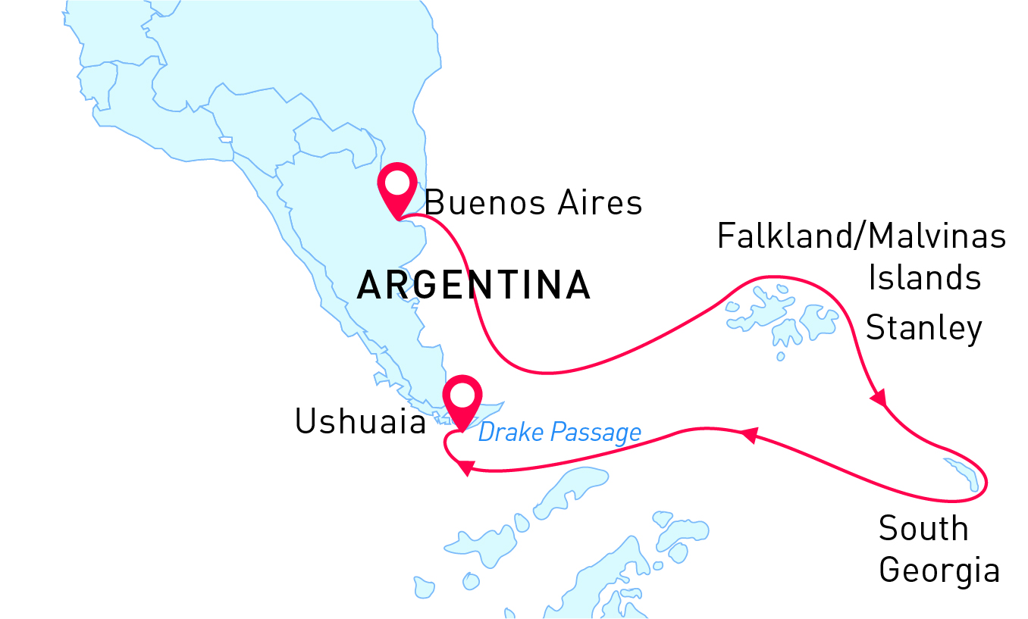

Falklands & South Georgia
Best of the Southern Ocean
21 Oct - 10 Nov 2025
21 days
Embarkation: Buenos Aires (Argentina)
Disembarkation: Ushuaia (Argentina)
M/v Sea Spirit
Activities:

Itinerary
Day 1 (Oct 21): Arrival in Buenos Aires, Argentina (hotel night)
Our adventure starts in Buenos Aires, the capital of Argentina. Explore this beautiful city and enjoy a good rest in the hotel we have organized for you. Tomorrow, you will board the Sea Spirit and sail towards remote Subantarctic islands
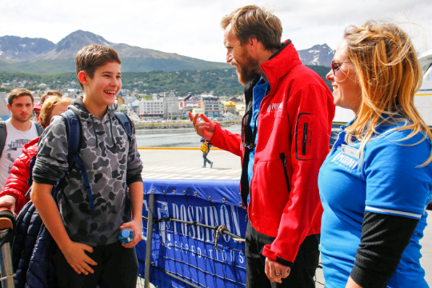Day 2 (Oct 22): Welcome Aboard!
Enjoy breakfast at your hotel and get ready for an exciting day. Today, we set sail on our beautiful Sea Spirit towards the Subantarctic islands.
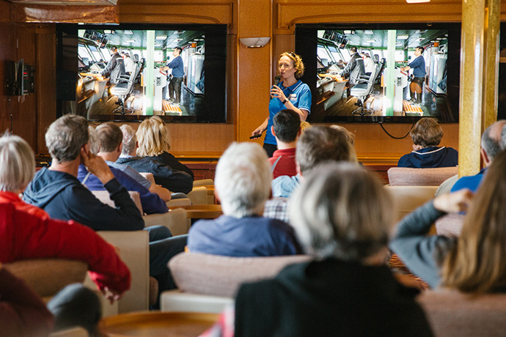Day 3-5 (Oct 23-25): At sea
As we sail towards the subantarctic islands, make the most of your time! Attend our captivating presentations from experts, familiarize yourself with our Sea Spirit, and get ready for our arrival at a wildlife paradise.
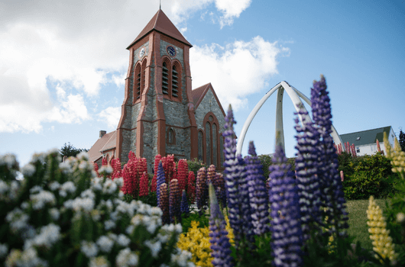Day 6-8 (Oct 26-28): Falkland Islands
The remote and sparsely-populated Falkland Islands are a birders’ paradise. The Falklands are also a great place to observe marine mammals. The waters around the archipelago are home to cetaceans such as Peale’s dolphins and Commerson’s dolphins. Our exact route and exploration opportunities are dependent on weather among these isolated and windswept islands.

We also intend to visit the port of Stanley, the charmingly British capital of the Falkland Islands. Attractions within pleasant walking distance along the waterfront promenade include the Falkland Islands Museum, the governor’s house, a cathedral with impressive whalebone arch outside, a war memorial, quality gift shops, pubs, and views of shipwrecks in the harbor.

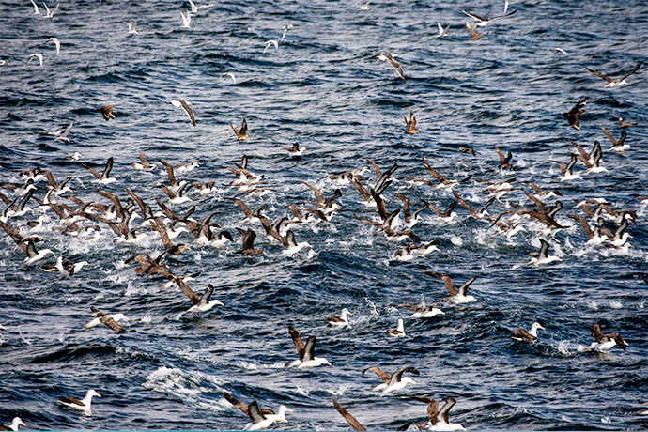Day 9-10 (Oct 29-30): Southern Ocean
From the Falkland Islands we head east toward South Georgia. We will cross the Antarctic Convergence, the biological boundary of the Southern Ocean. Briefings, bio-security procedures, and lectures from our experts prepare you for our arrival in South Georgia.
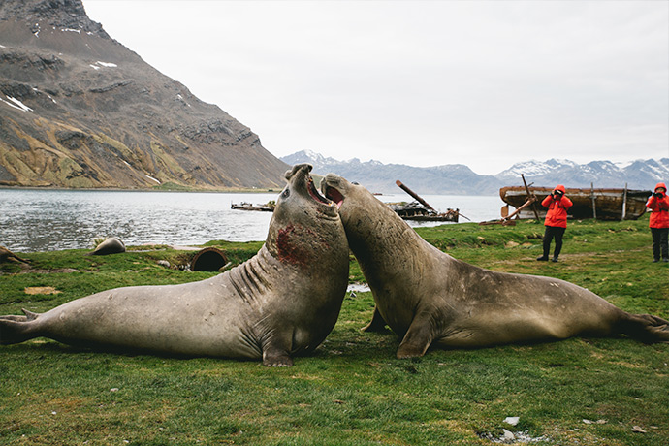Day 11-16 (Oct 31 - Nov 5): South Georgia Island
This is expedition cruising at its most authentic. Our route and exploration opportunities in South Georgia are heavily dependent on the weather conditions we encounter. Our experienced captain and expedition leader decide the itinerary and continually adjust plans as conditions and opportunities warrant. You can be sure that the best possible advantage will be taken of the circumstances presented to us by nature in this wild and remote corner of the world. We take every safe opportunity to go ashore in this amazing place.
South Georgia is a scenic wilderness and an unrivaled paradise for subantarctic wildlife viewing. The islands are said to host upwards of 100 million seabirds, including numerous species of albatross, penguins, prions, petrels and terns. On beaches such as those at Salisbury Plain and St. Andrews Bay, over 100,000 elephant seals and three million fur seals jostle for space among innumerable penguins including stately king penguins and sprightly macaroni penguins. The recently completed rat eradication program is sure to make this wilderness even more pristine and rich with birdlife.
The bountiful waters surrounding South Georgia are also inhabited by an increasing number of whales. The historical whaling station of Grytviken is now home to the excellent South Georgia Museum managed by the South Georgia Heritage Trust. Grytviken is also the final resting place of Ernest Shackleton, the legendary polar explorer.
Our days in South Georgia are filled with memorable excursions, sumptuous meals, presentations by our experts, and enough incredible scenery and wildlife to fill your camera and overwhelm your emotions.
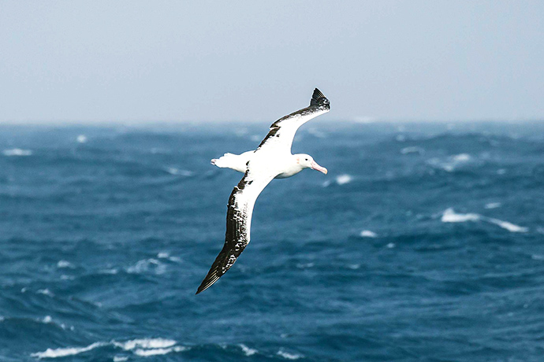Day 17-20 (Nov 6-9): Southern Ocean
As you sail, immerse yourself in fascinating presentations from our expert staff and bond with fellow travelers. On the open deck, marvel at the sight of birds and marine mammals that grace our journey. South polar skuas, snow petrels, and albatrosses may escort our vessel, enhancing your experience with their majestic presence. The encounter with sea ice adds a dramatic backdrop to your adventure. Approaching the Drake Passage, the seabirds you saw at the beginning of your voyage reappear, offering a full-circle experience of natural wonder.
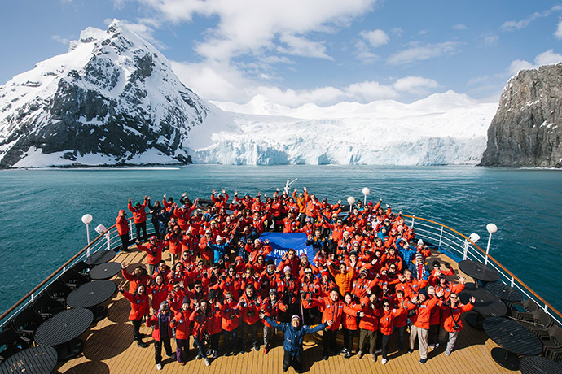Day 21 (Nov 10): Disembarkation in Ushuaia, Argentina
After breakfast we say farewell in the city of Ushuaia. We provide a group transfer to the airport or to the town center if you wish to spend more time here. As you look back on your wonderful experience, you may already be looking forward to your next incredible polar adventure!

M/v Sea Spirit
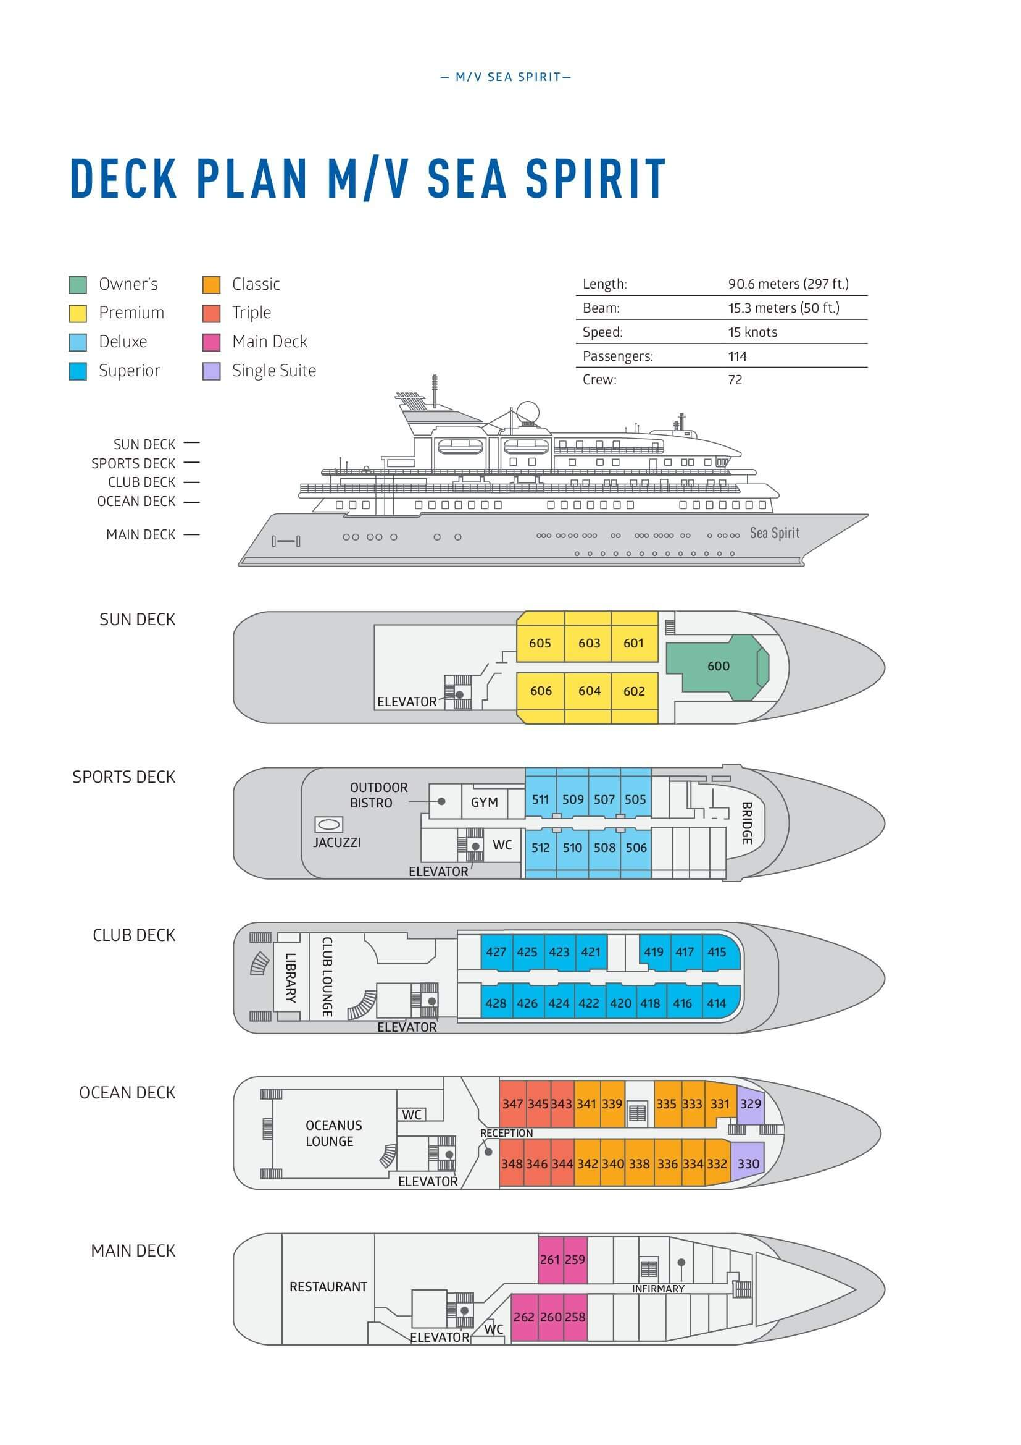

Triple Suite  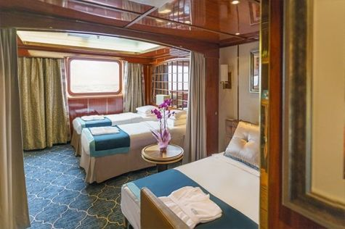  Averaging 21 square metres/226 square feet, these staterooms have two twins and a comfortable sofa bed. The twins also convert to a King, if desired. Located on Oceanus Deck, these suites have a picture window, two wardrobes and en suite facilities. Amenities include: in-room safe, refrigerator, satellite telephone access, TV/DVD, individual temperature control, and hair dryer. | Main Deck Suite  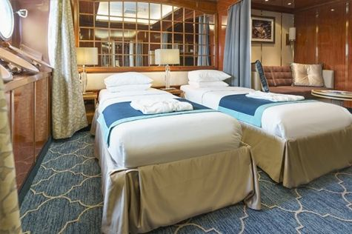  Averaging 23 square metres/248 square feet, Main Deck cabins are equipped with either two twins or a King Size bed. They are located on the Main Deck with a minimum of two portholes for exterior views. Amenities include: en suite facilities, in-room safe, refrigerator, satellite telephone access, TV/DVD individual temperature control and hair dryer.
Single Suite  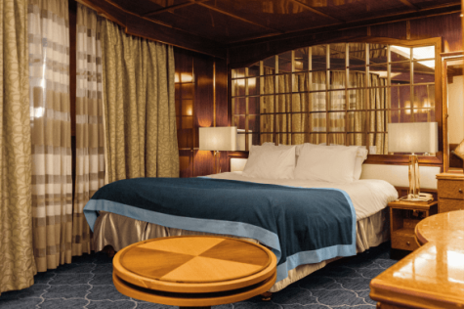  Averaging 21 square meters/226 square feet, these cabins are located on the Oceanus Deck. They feature a picture window (it may be covered during rough sea crossings), two wardrobes, and a King Size bed. Amenities include: en suite facilities, in-room safe, refrigerator, satellite telephone access, TV/VCR, individual temperature control, and hair dryer. | Classic Suite  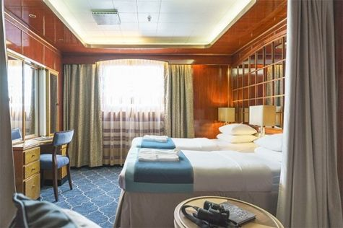  Averaging 21 square metres/226 square feet, these cabins are located on the Oceanus Deck. They feature a picture window, two wardrobes and a choice of either two twin beds or a King Size bed. Amenities include: en suite facilities, in-room safe, refrigerator, satellite telephone access, TV/DVD, individual temperature control and hair dryer.
Superior Suite  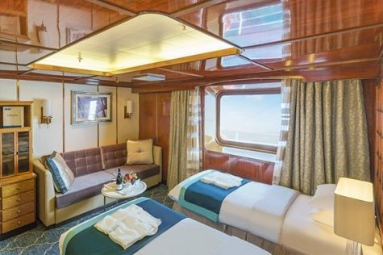  Superior Suites are located on the Club Deck. Averaging 20 square metres/ 215 square feet, these cabins feature two twin beds or a King Size bed. The picture window overlooks an outside walkway on the Club Deck. Amenities include: en suite facilities, walk-in closet or wardrobe, in-room safe, refrigerator, satellite telephone access, TV/DVD, individual temperature control, hair dryer. | Deluxe Suite  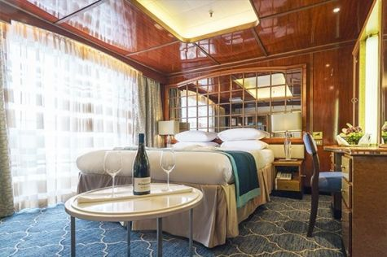  The Deluxe Suites with balconies are located on the Sports Deck. Averaging 24 square metres/ 258 square feet means plenty of room. Choose from either two twin beds or a King Size bed. A sliding glass door leads to a private balcony. These suites feature a walk-in closet or wardrobe. Amenities include en suite facilities, in-room safe, refrigerator, satellite telephone access, TV/DVD, individual temperature control, and a hair dryer.
Premium Suite  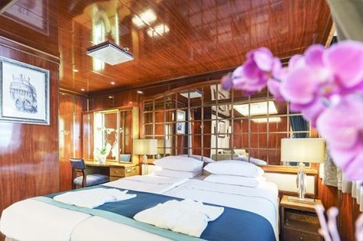  The Premium Suites are located on the Sun Deck. Averaging a generous 30 square metres/ 323 square feet, with two twin beds or a King Size bed. Access the private balcony by a sliding glass door. Amenities include: en suite facilities, lounge area, in-room safe, refrigerator, satellite telephone access, TV/DVD, individual temperature control, and hair dryer. | Owners Suite  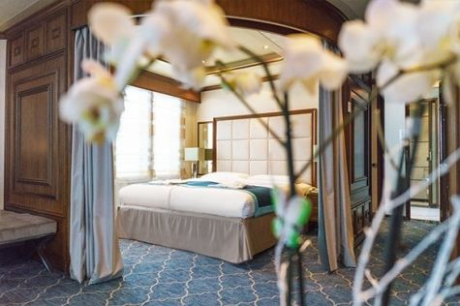  Super-spacious (63 square metres/ 678 square feet) elegant suite on the Sun Deck. Designed for entertaining, the Owner's Suite has a separate living room with game and meeting area. A BOSE stereo system provides background music, or watch videos on the HD plasma TV. Sliding glass doors lead to a private deck. Refresh in the jetted bathtub in en suite facilities. Slumber in the King Size bed. A sofa bed can accommodate a third person.

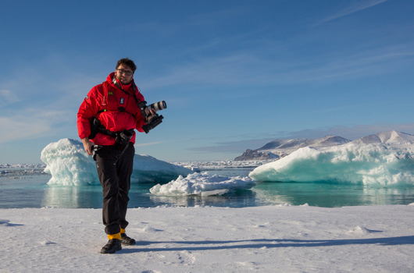 | Photography  What to expect on your photo tour  A polar cruise designed for photographers of all skill levels is a perfect way to experience the beauty and grandeur of the polar regions while also improving your photography skills.  - Watch breathtaking scenery and mesmerizing landscapes in one of the most remote places on Earth  - See the contrast of unique locations and their iconic wildlife  - Join our onboard photo workshops and get guidance from professional photographers  - Learn about the history and most significant spots in the area, and capture polar exploration history on your camera  - See an abundance of wildlife  - Discover the best wildlife viewing and photo ops with your expedition team and our onboard naturalists  - Scout the best locations on foot, on Zodiac excursions or while kayaking  - Our professional expedition team and experienced captain will maneuver and bring you safely to the places with the best photo ops
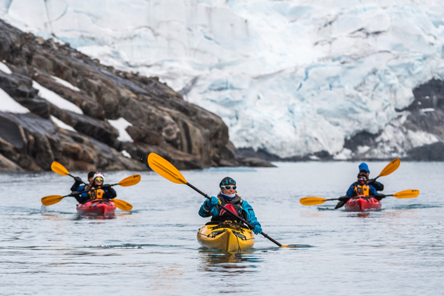 | Sea Kayaking  Kayaking fee $995 - €870 - A$1500 - £800  Antarctica is a paddlers’ paradise. The White Continent boasts some of the world’s most impressive landscapes and is home to incredible marine wildlife. Sea Kayak Club members will have the opportunity to paddle through tranquil waters filled with glittering icebergs and porpoising penguins while surrounded by magnificent glaciers and mountains.  The protected and picturesque waters of the Antarctic Peninsula offer the best sea kayaking opportunities in Antarctica. Sea Kayak Club is also offered on selected voyages to South Georgia, where members may have the rare opportunity to encounter the island’s legendary abundance of wildlife from a kayaker’s perspective, if the area’s notoriously inclement weather permits.

Rates
Triple Suite | Main Deck Suite | Single Suite | Classic Suite | Superior Suite | Deluxe Suite | Premium Suite | Owners Suite
US$ 15 095 | US$ 19 995 | US$ 29 995 | US$ 21 395 | US$ 21 795 | US$ 24 295 | US$ 26 095 | US$ 32 995
US$ 12 831 | US$ 16 996 | US$ 25 496 | US$ 18 186 | US$ 17 436 | US$ 19 436 | US$ 20 876 | US$ 26 396
* Super Early Bird discount (15% off on Triple, Main Deck, Single, and Classic Suites; 20% off on Superior, Deluxe, Premium, and Owner’s Suites) is available for new bookings confirmed by June 30, 2024.
Cruise rates are quoted per person. Sharing is available in Triple, Main Deck, Classic, and Superior Suites. If you prefer a cabin for yourself, all cabin categories are available with the single supplement: x1.5.

Rates Include  1 pre-voyage hotel night on Day 1 in Buenos Aires;  Group transfer from the airport to the hotel on the day prior to embarkation;  Group transfer to the ship for embarkation on Day 2;  Shipboard accommodation;  IAATO fees and governmental taxes.  All meals on board throughout the voyage;  Tea and coffee station 24 hours daily;  All scheduled landings/excursions (subject to weather and ice conditions);  Leadership throughout the voyage by our experienced Expedition Leader and Expedition Team;  Branded Poseidon Expeditions parka;  Rubber boots for shore landings for the time of the cruise;  Welcome and Farewell cocktails;  All port fees;  Group transfer to airport or central location right after disembarkation;  Pre-departure materials;  Digital Voyage Log;  Wi-Fi on board. | Rates Do Not Include  Airfare;  Transfers from the airport to the hotel if arriving prior to Day 1 of the program;  Visa and passport fees (if applicable);  Luggage and trip cancellation insurance;  Soft drinks and alcoholic beverages other than those for special events and celebrations;  Personal expenses such as laundry and telephone calls;  Fuel surcharge may be applied for all bookings;  Mandatory Emergency Evacuation Insurance to a minimum benefit of US$ 200,000 per person;  Staff gratuities;  Kayaking;  The cost of any applicable medical tests (such as COVID-19) or vaccinations required either by a national government or Poseidon Expeditions before, during or after the cruise;  Pre- or post-cruise travel expenses.
Itinerary, landings and all other activities during the cruise depend strongly on ice and weather conditions and are subject to the decisions of the Expedition Leader and the Captain of the vessel. Encounters with any mentioned wildlife cannot be guaranteed.

