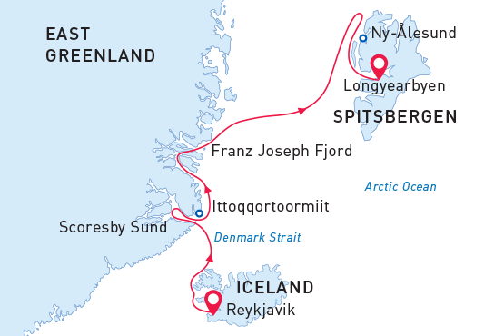

Svalbard, Greenland & Iceland
Arctic Odyssey
22 Aug - 04 Sep 2025
14 days
Embarkation: Reykjavik (Iceland)
Disembarkation: Longyearbyen (Svalbard)
M/v Sea Spirit
Activities:

Itinerary
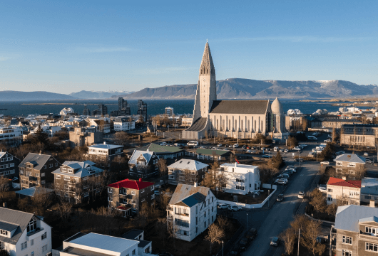Day 1 (Aug 22): Arrival to Reykjavík (hotel night)
Welcome to Reykjavík, the world's northernmost capital city! We’ve arranged a hotel accommodation where you can rest after your flight and get ready for our upcoming Arctic adventures. Still have some energy left? Then use this opportunity to explore the city, which offers various points of interest and attractions for visitors. Enjoy the panoramic city view from the Perlan observation deck, the futuristic Hallgrímskirkja church towering over the city, cozy houses with colorful tin roofs, narrow streets, historic relics of the Viking era and breathtaking landscapes surrounding Reykjavik.
We bet you’ll fall in love at first sight! Walk along Laugavegur, Reykjavik’s main shopping street, or visit the Whales of Iceland exhibition and the National Museum. For dinner Reykjavík offers countless options to enjoy an authentic Icelandic meal.
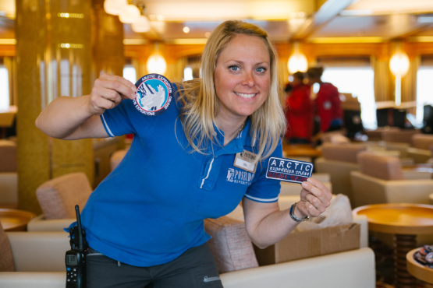Day 2 (Aug 23): Embarkation in Reykjavík
After breakfast at your hotel, the morning is yours to explore the city. Our expedition starts in the afternoon. You’ll be transferred to the pier where our expedition team will offer a warm welcome aboard our comfortable vessel M/V Sea Spirit. Get settled into your spacious cabins and explore the ship — It’ll be your home away from home during the extraordinary adventure to come. After departure, we’ll kick off our adventure with a full schedule of info briefings and introductions from the expedition staff. After a sumptuous dinner, step out onto the open decks to admire the spectacular views as we sail through Faxaflói. And keep your eyes open for whale encounters!
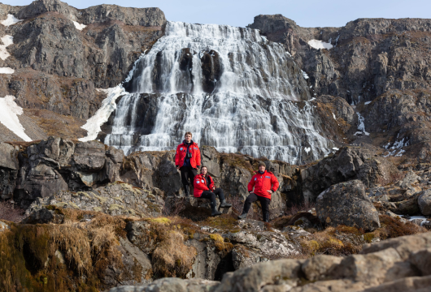Day 3 (Aug 24): Westfjords, Iceland
Today we are going to explore the beautiful Vestfirðir (Westfjords) of Iceland. This remote and sparsely populated region of crenulated coastlines, voluminous waterfalls and rugged mountains sees only 10% of Iceland’s visitors. Deep fjords are home to whales while estuaries abound with seals and birdlife.
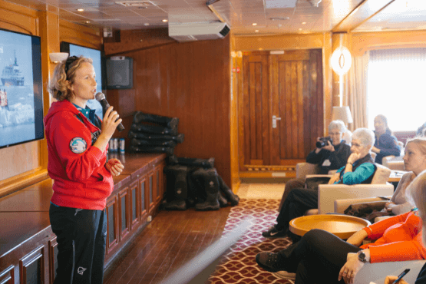Day 4 (Aug 25): At sea
From Iceland we head toward East Greenland, crossing the Arctic Circle on the way. Presentations and workshops by our expert staff, as well as our range of onboard recreation facilities, ensure that this day at sea is not idly spent. Seabird viewing and whale sightings can be enjoyed from panoramic open decks as well as exterior stateroom windows and balconies.
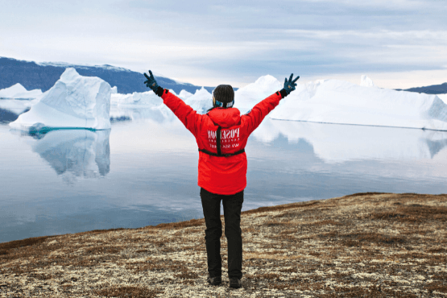Day 5-8 (Aug 26 - 29): East Greenland Adventure
This is expedition cruising at its most authentic. Our itinerary and exploration opportunities in East Greenland are dependent on weather and sea ice conditions. Again you can be sure that our experienced captain and expedition leader will take advantage of every opportunity to experience excellent wildlife viewing, to discover incredible scenery, and to go ashore wherever possible. The Franz Josef Fjord and Kong Oscar Fjord systems are part of Northeast Greenland National Park, the world’s largest national park. Scoresby Sund is the largest and longest fjord system in the world. We anticipate exploring these fjord systems to the extent made possible by ever-changing ice conditions.
Deep fjords and narrow channels, flanked by ice-clad peaks up to 2000 meters high, reach far into the mountainous heart of Greenland. On shore, fields of multicolored tundra are home to musk oxen and Arctic hare. The landscape—vast, open, and seemingly untouched since the beginning of time—is a hikers’ paradise. Throughout this area we also find ancient Thule archeological sites, historical trappers’ huts, and modern Inuit hunters’ cabins.
The Inuit village of Ittoqqortoormiit is the only permanent settlement in the region. The community boasts an excellent museum, a gift shop, a post office, an abundance of Greenlandic sled dogs, and of course the opportunity to meet Inuit people.
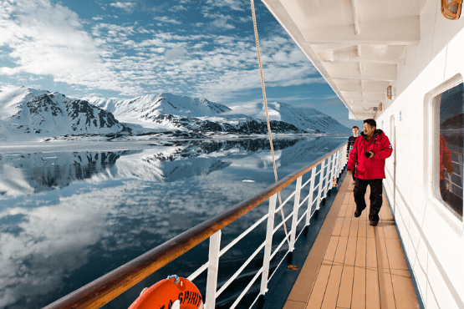Day 9-10 (Aug 30 - Aug 31): At Sea
After our amazing time in East Greenland we head toward Svalbard. All along the way we remain vigilant for sightings of marine mammals such as whales and seals.
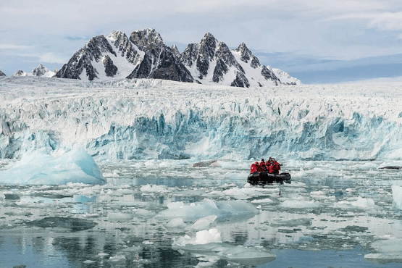Day 11-13 (Sept 1 - 3): Exploration of Svalbard
In Svalbard, the High Arctic wilderness comes alive, offering an authentic expedition experience. Our route and exploration opportunities depend on the ever-changing weather and sea ice conditions. With our skilled captain and expedition leader, we adapt the itinerary to seize the best opportunities presented by Nature in this remote and untamed corner of the Arctic.
We anticipate exploring in the northwestern part of the island of Spitsbergen. This area contains the archipelago’s most impressive scenery and some of the Arctic’s best wildlife viewing opportunities. Immense tidewater glaciers calve icebergs into turquoise waters. Fields of flowering tundra are home to grazing reindeer and playful Arctic fox. Bountiful inshore and offshore waters are home to a wide variety of marine mammals. Polar Bears can be spotted anytime, anywhere in and around Svalbard.
Also in this area is Ny Ålesund, a former mining town that is now home to an international community of Arctic researchers, complete with museum, gift shop, and post office. This was also a staging area for historic attempts to discover the North Pole.
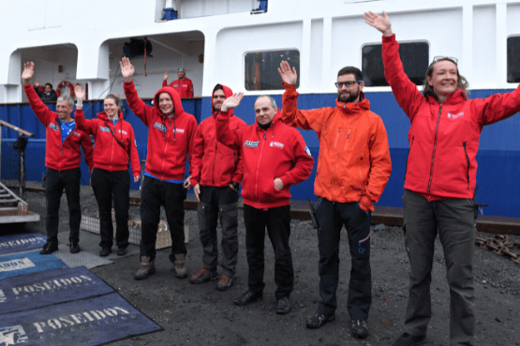Day 14 (Sept 4): Disembarkation in Longyearbyen
After filling up with one last buffet breakfast on board, we bid you farewell in Longyearbyen and provide transfer to the airport or central location. By this time, you may already be making plans for your next amazing trip with us into the polar worlds!

M/v Sea Spirit
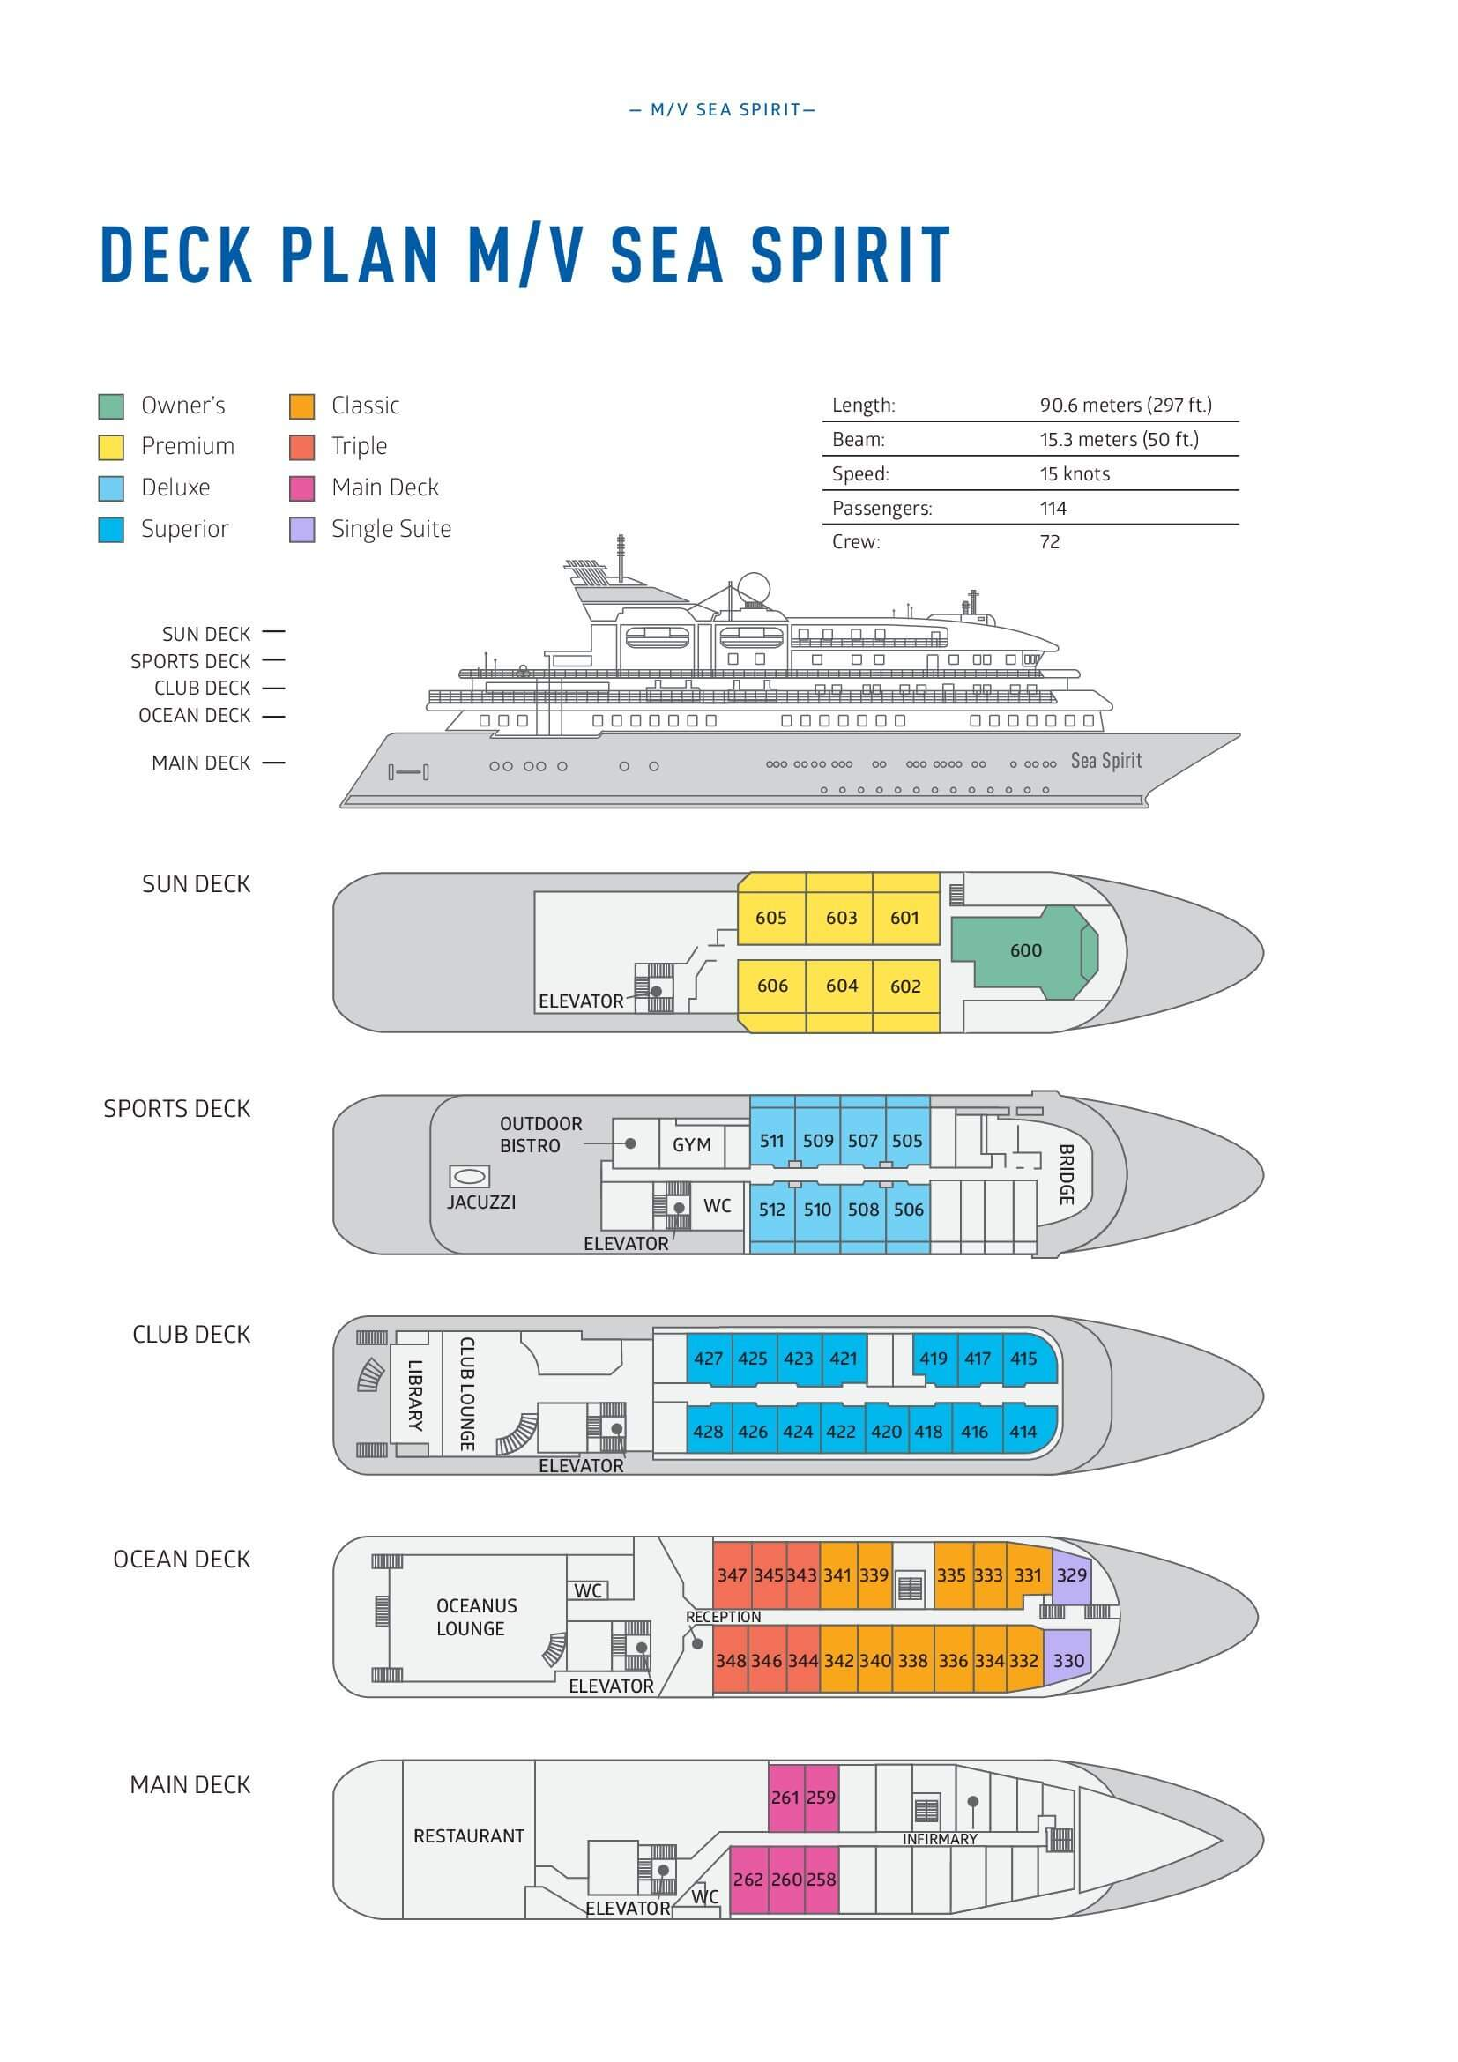

Triple Suite  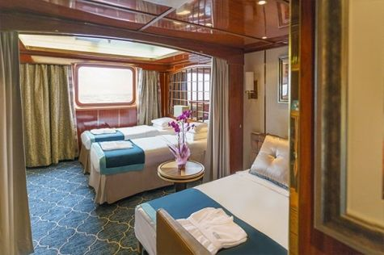  Averaging 21 square metres/226 square feet, these staterooms have two twins and a comfortable sofa bed. The twins also convert to a King, if desired. Located on Oceanus Deck, these suites have a picture window, two wardrobes and en suite facilities. Amenities include: in-room safe, refrigerator, satellite telephone access, TV/DVD, individual temperature control, and hair dryer. | Main Deck Suite  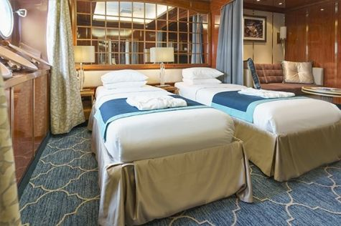  Averaging 23 square metres/248 square feet, Main Deck cabins are equipped with either two twins or a King Size bed. They are located on the Main Deck with a minimum of two portholes for exterior views. Amenities include: en suite facilities, in-room safe, refrigerator, satellite telephone access, TV/DVD individual temperature control and hair dryer.
Single Suite  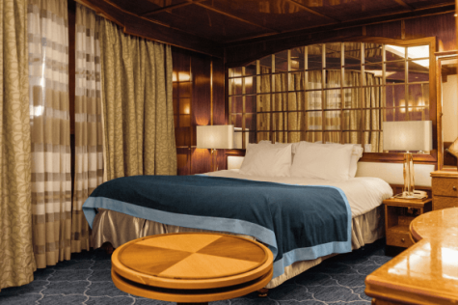  Averaging 21 square meters/226 square feet, these cabins are located on the Oceanus Deck. They feature a picture window (it may be covered during rough sea crossings), two wardrobes, and a King Size bed. Amenities include: en suite facilities, in-room safe, refrigerator, satellite telephone access, TV/VCR, individual temperature control, and hair dryer. | Classic Suite  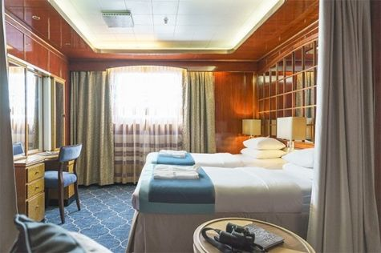  Averaging 21 square metres/226 square feet, these cabins are located on the Oceanus Deck. They feature a picture window, two wardrobes and a choice of either two twin beds or a King Size bed. Amenities include: en suite facilities, in-room safe, refrigerator, satellite telephone access, TV/DVD, individual temperature control and hair dryer.
Superior Suite  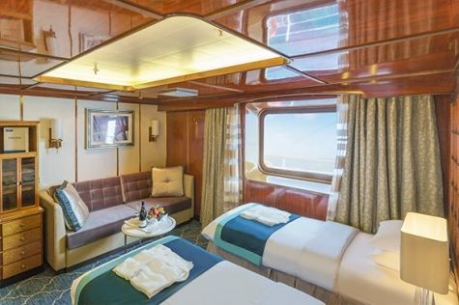  Superior Suites are located on the Club Deck. Averaging 20 square metres/ 215 square feet, these cabins feature two twin beds or a King Size bed. The picture window overlooks an outside walkway on the Club Deck. Amenities include: en suite facilities, walk-in closet or wardrobe, in-room safe, refrigerator, satellite telephone access, TV/DVD, individual temperature control, hair dryer. | Deluxe Suite  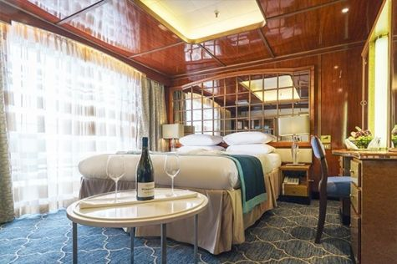  The Deluxe Suites with balconies are located on the Sports Deck. Averaging 24 square metres/ 258 square feet means plenty of room. Choose from either two twin beds or a King Size bed. A sliding glass door leads to a private balcony. These suites feature a walk-in closet or wardrobe. Amenities include en suite facilities, in-room safe, refrigerator, satellite telephone access, TV/DVD, individual temperature control, and a hair dryer.
Premium Suite  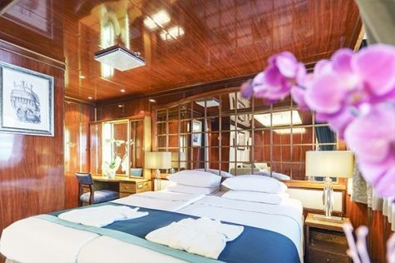  The Premium Suites are located on the Sun Deck. Averaging a generous 30 square metres/ 323 square feet, with two twin beds or a King Size bed. Access the private balcony by a sliding glass door. Amenities include: en suite facilities, lounge area, in-room safe, refrigerator, satellite telephone access, TV/DVD, individual temperature control, and hair dryer. | Owners Suite  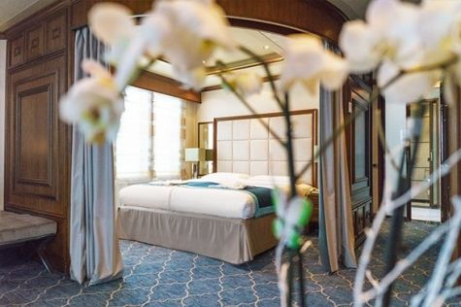  Super-spacious (63 square metres/ 678 square feet) elegant suite on the Sun Deck. Designed for entertaining, the Owner's Suite has a separate living room with game and meeting area. A BOSE stereo system provides background music, or watch videos on the HD plasma TV. Sliding glass doors lead to a private deck. Refresh in the jetted bathtub in en suite facilities. Slumber in the King Size bed. A sofa bed can accommodate a third person.

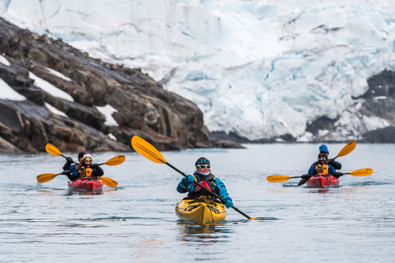 | Sea Kayaking  Kayaking fee $795 - €695 - A$1200 - £650  Sea Kayaking is typically offered on voyages that include High Arctic destinations such as Greenland, Svalbard (Spitsbergen), Franz Josef Land, or a combination of these thrilling places. Experience calving glaciers in Svalbard, cathedral-like icebergs in Greenland, or labyrinthine expanses of sea ice in the Arctic Ocean, all from our sturdy and stealthy sea kayaks. Join us for an unscripted kayaking adventure as we explore rugged coastlines and remote waters that very few people have ever paddled.
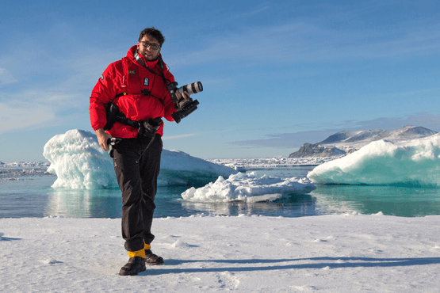 | Photography  Free option  The Polar Regions are perhaps the most photogenic on earth, with countless beautiful scenes presenting themselves every day. Endless expanses of ice, beaches crowded with seals or penguins, sunsets over unbroken horizons, starlit skies, and even the majestic northern lights – they all present fantastic photographic opportunities – and in order to make sure that you come home with some spectacular images we offer you the chance to learn and practice your photography alongside an experienced professional.  Our expert Photographer will be on hand to answer your questions and give advice, both in the form of on-board lectures and workshops on shore. Explore the key elements of photography in a fun and relaxed setting, with plenty of opportunities for questions and feedback. Learn how to see light in a new way and experiment with the techniques of composition and framing.

Rates Include  1 pre-voyage night on Day 1 in Reykjavik;  Group transfer to the ship for embarkation on Day 2;  Shipboard accommodation;  All meals on board throughout the voyage;  Tea and coffee station 24 hours daily;  All scheduled landings/excursions (subject to weather and ice conditions);  Leadership throughout the voyage by our experienced Expedition Leader and Expedition Team;  Branded Poseidon Expeditions parka;  Rubber boots for shore landings for the time of the cruise;  Welcome and Farewell cocktails;  All port fees;  Group transfer to airport or central location right after disembarkation;  Pre-departure materials;  Digital Voyage Log;  Wi-Fi on board.  AECO fees and governmental taxes. | Rates Do Not Include  Airfare;  Visa and passport fees (if applicable);  Transfers from the airport to the hotel at beginning of the program;  Luggage and trip cancellation insurance;  Soft drinks and alcoholic beverages other than those for special events and celebrations;  Personal expenses such as laundry and telecommunication charges;  Fuel surcharge may be applied for all bookings;  Mandatory Emergency Evacuation Insurance to a minimum benefit of US$ 200,000 per person;  Kayaking;  Staff gratuities.
Itinerary, landings and all other activities during the cruise depend strongly on ice and weather conditions and are subject to the decisions of the Expedition Leader and the Captain of the vessel. Encounters with any mentioned wildlife cannot be guaranteed.

